**Chapter 1**

**The Human Organism**

## Student Learning Outcomes

After reading this chapter, students should be able to:

1.1A Define *anatomy* and describe the levels at which anatomy can be studied.

1.1B Define *physiology* and describe the levels at which physiology can be studied.

1.1C Explain the importance of the relationship between structure and function.

1.2A Name the six levels of organization of the body and describe the major characteristics of each level.

1.2B List the 11 organ systems, identify their components, and describe the major functions of each system.

1.3A List and define the six characteristics of life

1.4A Explain why it is important to study other organisms along with humans.

1.5A Define *homeostasis* and explain why it is important for proper body function.

1.5B Describe a negative-feedback mechanism and give an example.

1.5C Describe a positive-feedback mechanism and give an example.

1.6A Describe a person in the anatomical position.

1.6B Define the directional terms for the human body and use them to locate specific body structures.

1.6C Know the terms for the parts and regions of the body.

1.6D Name and describe the three major planes of the body.

1.6E Name and describe the three major ways to cut an organ.

1.6F Describe the major trunk cavities and their divisions.

1.6G Locate organs in their specific cavity, abdominal quadrant, or region.

1.6H Describe the serous membranes, their locations, and their functions.

## Chapter Outline

* 1. **Anatomy and Physiology**

1. Anatomy is the study of the body’s structures.

* Developmental anatomy considers anatomical changes from conception to adulthood. Embryology focuses on the first 8 weeks of development.
* Cytology examines cells, and histology examines tissues.
* Gross anatomy studies organs from either a systemic or a regional perspective.

1. Surface anatomy uses superficial structures to locate deeper structures, and anatomical imaging is a noninvasive technique for identifying deep structures.
2. Physiology is the study of the body’s functions. It can be approached from a cellular or a systems point of view.
3. Pathology deals with all aspects of disease. Exercise physiology examines changes caused by exercise.

**1.2 Structural and Functional Organization of the Human Body**

1. Basic chemical characteristics are responsible for the structure and functions of life.
2. Cells are the basic structural and functional units of all living organisms. Organelles are small structures within cells that perform specific functions.
3. Tissues are composed of groups of cells of similar structure and function and the materials surrounding them. The four primary tissue types are epithelial, connective, muscle, and nervous tissues.
4. Organs are structures composed of two or more tissues that perform specific functions.
5. Organs are arranged into the 11 organ systems of the human body (see figure 1.3).
6. Organ systems interact to form a whole, functioning organism.

**1.3 Characteristics of Life**

Humans share many characteristics with other organisms, such as organization, metabolism, responsiveness, growth, development, and reproduction.

**1.4 Biomedical Research**

Much of our knowledge about humans is derived from research on other organisms.

**1.5 Homeostasis**

Homeostasis is the condition in which body functions, body fluids, and other factors of the internal environment are maintained at levels suitable to support life.

**Negative Feedback**

1. Negative-feedback mechanisms maintain homeostasis.
2. Many negative-feedback mechanisms consist of a receptor, a control center, and an effector.

**Positive Feedback**

1. Positive-feedback mechanisms usually increase deviations from normal.
2. Although a few positive-feedback mechanisms normally exist in the body, some positive-feedback mechanisms are harmful.
3. Normal positive-feedback mechanisms include blood clotting and childbirth labor. Harmful positive-feedback examples include decreased blood flow to the heart.
   1. **Terminology and the Body Plan**

**Body Positions**

1. A human standing erect with the face directed forward, the arms hanging to the sides, and the palms facing forward is in the anatomical position.
2. A person lying face upward is supine; a person lying face downward is prone.

**Directional Terms**

Directional terms always refer to the anatomical position, no matter what the actual position of the body (see table 1.2).

**Body Parts and Regions**

1. The body can be divided into a central region, consisting of the head, neck, and trunk, and the upper limbs and lower limbs.
2. Superficially, the abdomen can be divided into quadrants or into nine regions. These divisions are useful for locating internal organs or describing the location of a pain or a tumor.

**Planes**

* 1. Planes of the Body
* A sagittal plane divides the body into right and left parts. A median plane divides the body into equal right and left halves.
* A transverse (horizontal) plane divides the body into superior and inferior portions.
* A frontal (coronal) plane divides the body into anterior and posterior parts.
  1. Sections of an Organ
* A longitudinal section of an organ divides it along the length of the organ.
* A transverse (cross) section cuts at a right angle to the length of the organ.
* An oblique section cuts across the length of the organ at an angle other than a right angle.

**Body Cavities**

The body contains two types of internal cavities: the dorsal and ventral body cavities.

1. The dorsal body cavity contains the cranial cavity and the vertebral canal.
2. The ventral body cavity houses the thoracic cavity and the abdominopelvic cavity. The mediastinum subdivides the thoracic cavity.
3. The diaphragm separates the thoracic and abdominal cavities.
4. Pelvic bones surround the pelvic cavity.

**Serous Membranes**

1. Serous membranes line the trunk cavities. The parietal portion of a serous membrane lines the wall of the cavity, and the visceral portion is in contact with the internal organs.
   * The serous membranes secrete fluid, which fills the space between the visceral and parietal membranes. The serous membranes protect organs from friction.
   * The pericardial cavity surrounds the heart, the pleural cavities surround the lungs, and the peritoneal cavity surrounds certain abdominal and pelvic organs.
2. Mesenteries are parts of the visceral peritoneum that hold the abdominal organs in place and provide a passageway for blood vessels and nerves to the organs.
3. Retroperitoneal organs are located “behind” the parietal peritoneum.

## Topics Related to the Study of Anatomy and Physiology

The use of animals in research is relevant, and the students may have strong opinions about the ethical issues involved. Discuss pros and cons (including financial considerations) for alternatives to animal experimentation, such as tissue culture and computer simulation.

Anatomical anomalies can be used for discussion concerning the concept of normal. Anatomy and physiology are replete with references to normal and abnormal structures and values. Students will benefit from the clarification of the meaning of the word “normal" as it will be used within the context of the course.

Newspaper, magazine, or internet sources related to the new imaging technologies can help students appreciate the amount of knowledge of anatomy and physiology a diagnostician must possess in order to interpret those potentially meaningless images. Use table 1.1, Anatomical Imaging, as the starting point for a homework assignment to find out more information.

There are excellent photographs throughout the text that illustrate technological advances in imaging techniques. The advents of the electron microscope, patch-clamping, micro-electrodes, and radio-immunoassay have increased our ability to investigate cell structures and cell membrane transport. The newest scanning tunneling electron microscopes have taken resolution down to the level of individual molecules. Class discussion could focus on the intriguing area of cellular research.

|  |
| --- |
| Themes in Chapter 1 |
| **Structure and Function** |
| Medical Terminology“When in Rome…” is a concept that could be applied to knowing and using anatomical and medical terminology. Students must use their language in order to communicate with other scientists and healthcare professionals. Students need to learn that there is value in the precision of anatomical terminology. The notion that the body is a collection of interlocking parts is a concept foreign to many students, who view the body as a singular and solid entity. Students may not realize there is a connection between the words that are used in class and their own bodies. Point out the valuable list of prefixes, suffixes, and combining forms on the back cover of the book and the Glossary (pages G-1 to G-3) that will help them gain a mastery of this “new” language. Also useful is Table 1.2, Directional Terms for Humans. |
| **Homeostasis** |
| Feedback Spend time on the concepts of positive and negative feedback to ensure student understanding. Provide examples in addition to those provided in the text. Ask students to think about and then discuss examples of events that push the body out of homeostasis and how the body returns to homeostasis. Discuss ways the body can be helped to return to homeostasis in emergencies. Be sure students understand how to interpret the Process Figure 1.4, Negative-Feedback Mechanism: Body Temperature, and Homeostasis Figure 1.5, Negative-Feedback Control of Body Temperature, because this format is used throughout the book and can be an invaluable tool in understanding complex body processes. |
| Cell Theory and Biochemistry |
| Students must assimilate this foundational knowledge before they can grasp more complex physiological processes like cell membrane transport and cell-to-cell communication. Stress the pivotal position of cells and biochemistry in understanding higher levels of organization. |
| Changes Through Time |
| Students must grasp the difference between structures/parts and functions/processes. Introduce the element of time and the possibility of change through time (moment to moment, over the life span, and evolutionarily) in both structures and functions. |

**Learning Outcomes Correlation with Predict Question Types**

|  |  |  |  |  |
| --- | --- | --- | --- | --- |
| **Question Type** | **Question #** | **Bloom's level** | **Learning Outcome** | |
| Learn to Predict |  | Application | 1.5a,b |
| Predict | 1 | Evaluation | 1.5a,b |
| Predict | 2 | Evaluation | 1.2a |
| Predict | 3 | Evaluation | 1.5a,b |
| Predict | 4 | Comprehension | 1.5b |
| Predict | 5 | Comprehension | 1.5b,c |
| Predict | 6 | Comprehension | 1.6a,b |

Predict 7 Comprehension 1.6b

Predict 8 Comprehension 1.6f,g,h

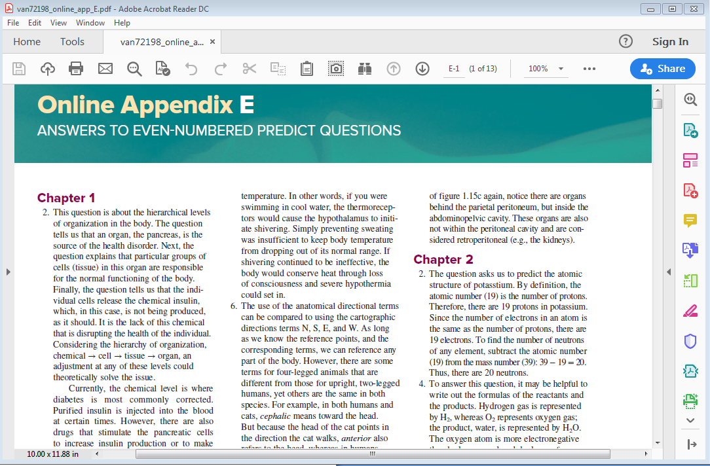

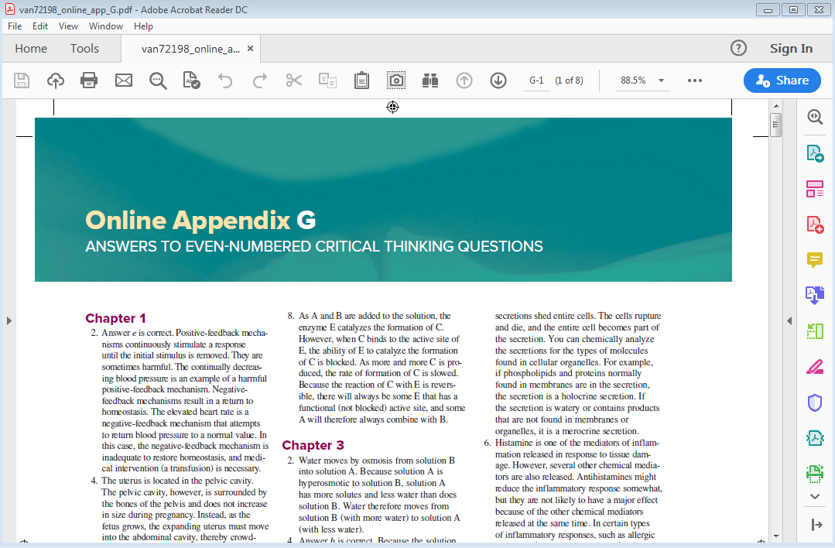

**Interactive Case Studies and the Human Body (11-20)**

**The Male Body**

**Case Study 11**

**Hematology**

*Polycythemia*

Answers:

1. The disorder of this individual is polycythemia.
2. The arterial O2 saturation and erythropoietin levels are important in confirming that the increased hematocrit is not due to hypoxemia or an abnormally elevated erythropoietin level. The O2 saturation level would indicate if there is a physiologic stimulus for the increased erythrocyte production.
3. Phlebotomy is the letting of blood for transfusion pheresis, diagnostic testing, or experimental procedures.
4. Phlebotomy (removal of the whole blood) removes both blood cells and plasma. The plasma volume is replaced within days, whereas the erythrocytes take several weeks to be replaced.
5. Myelosuppressive therapy is therapy for the suppression of the bone marrow's production of blood cells and platelets.
6. Myelosuppressive therapy may be needed to suppress the erythrocyte production in the myeloid tissue if the hematocrit continues to rise after the phlebotomies.

**Interactive Case Studies and the Human Body (1-10)**

**The Female Body**

**Case Study 1**

**Hematology**

*AIDS*

Answers:

1. This individual has Acquired Immunodeficiency Syndrome (AIDS) caused by the Human Immunodeficiency Virus (HIV).
2. The hematocrit abnormality is caused by the dehydration.
3. Some current treatments include: AZT (Zidovudine) and ddI (Didanosine), both antiretroviral agents which slow the replication of the virus, prevent occurrence or recurrence of opportunistic infections, and boost the immune system.
4. The individual is experiencing hypokalemia prior to treatment.
5. This abnormal potassium level could cause cardiac arrhythmias due to the hyperpolarization of the resting membrane potential.