**Answers to Even-Numbered Problems**

**Chapter 1**

2. A population is the entire universe of people, places, or objects a researcher wishes to study. Populations are typically too large to study directly; it is too time consuming, too expensive, or simply impossible to collect data on every unit within the population.

4. Replication is important in science because replication validates the original findings and demonstrates that they are not a fluke or limited to a particular set of circumstances. Replication builds confidence in the accuracy and generalizability of the original findings.

6. [Student-generated answers will vary; instructors evaluate case by case]

8. This research would be exploratory, since the researcher is investigating a new area. Her inquiry would be open ended rather than relying on hypotheses.

10. GIGO stands for “garbage in, garbage out.” It relates to statistics in two ways. First, high-quality data can be ruined if the wrong statistical analysis is applied to them. Second, even the most leading-edge statistical technique cannot salvage poor data. Data have to be collected using scientifically sound methods and have to be analyzed using correct statistical procedures.

**First Two Pages from Ch14**

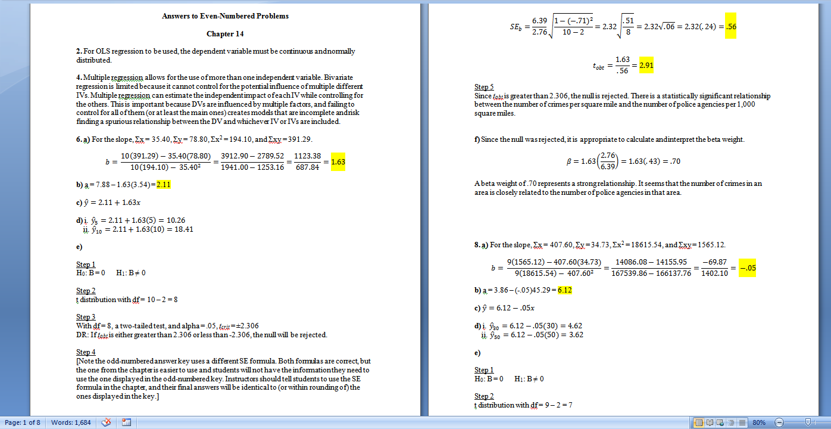

Lecture Notes

# Chapter 1: Introduction to the Use of Statistics in Criminal Justice and Criminology

## Learning Objectives

* 1-1: Explain how data collected using scientific methods are different from anecdotes and other nonscientific information.
* 1-2: List and describe the types of research in criminal justice and criminology.
* 1-3: Explain the difference between the research methods and statistical analysis.
* 1-4: Define samples and populations.
* 1-5: Describe probability sampling.
* 1-6: List and describe the three major statistics software packages.

## Chapter Summary

This book is divided into three parts. Part I covers descriptive statistics. Part II describes the theoretical basis for statistics in criminal justice and criminology: probability and probability distributions. Part III of the book merges the concepts learned in Parts I and II to form the discussion on inferential hypothesis testing.

## Annotated Chapter Outline

1. What Do Criminal Justice and Criminology Researchers Study?
2. Statistical methods are the backbone of criminal justice and criminology as fields of scientific inquiry.
3. Statistics enable the construction and expansion of knowledge about criminality and the criminal justice system.
4. Research that tests theories or examines criminal justice phenomena and is published in academic journals and books is the basis for most of what we know about criminal offending and the system that has been designed to deal with it.
5. The Uniform Crime Reports (UCR)
6. The Federal Bureau of Investigation (FBI) collects annual data on crimes reported to police agencies nationwide and maintains the Uniform Crime Reports (UCR).
7. Crimes are sorted into eight index offenses: homicide, rape, robbery, aggravated assault, burglary, larceny-theft, motor vehicle theft, and arson.
8. The National Crime Victimization Survey (NCVS)
9. The Bureau of the Census conducts the periodic NCVS under the auspices of BJS to estimate the number of criminal incidents that transpire each year and to collect information about crime victims.
10. Science: Basic Terms and Concepts
11. Science is the process of systematically collecting reliable information and developing knowledge using techniques and procedures that are accepted by other scientists in a discipline.
12. Science is grounded in methods--research results are trustworthy only when the procedures used to arrive at them are considered correct by experts in the scientific community.
13. Types of Scientific Research in Criminal Justice and Criminology
14. Theories are proposed explanations for certain events.
15. Hypotheses are small “pieces” of theories that must be true in order for the entire theory to hold up.
16. Evaluation research is undertaken when a new policy, program, or intervention is put into place and researchers want to know whether the intervention accomplished its intended purpose.
17. Exploratory research occurs when there is limited knowledge about a certain phenomenon; researchers essentially embark into unfamiliar territory when they attempt to study this social event.
18. Descriptive research is done solely for the purpose of describing a particular phenomenon as it occurs in a sample.
19. Software Packages for Statistical Analysis
20. The most common in criminal justice and criminology research are SPSS, Stata, and SAS.
21. Each of these packages has strengths and weaknesses. Simplicity and ease of use makes SPSS a good place to start for people new to statistical analysis. Stata is a powerful program excellent for regression modeling. The SAS package is the best one for extremely large data sets.
22. Organization of the Book
23. Part I covers descriptive statistics.
24. Part II describes the theoretical basis for statistics in criminal justice and criminology: probability and probability distributions.
25. Part III of the book merges the concepts learned in Parts I and II to form the discussion on inferential hypothesis testing.

Discussion Questions

# Chapter 1: Introduction to the Use of Statistics in Criminal Justice and Criminology

1. What is the difference between research methods and statistical analysis? How are these concepts connected to each other?

2. Discuss probability sampling. Why is it important? How could not using probability sampling affect the goals of research?

3. What are some advantages to Uniform Crime Reports (UCR) data? Some weaknesses?

4. Why is replication important in research? What are the benefits of studies that can be replicated? What are the disadvantages when studies cannot be replicated?