

Instructor’s Manual

with Test Items and suggested sources and videos

Understanding Violence and Victimization

7th edition

Robert J. Meadows

Boston Columbus Indianapolis New York San Francisco Upper Saddle River
Amsterdam CapeTown Dubai London Madrid Milan Munich Paris Montreal
Toronto Delhi Mexico City Sao Paulo Sydney Hong Kong Seoul Singapore Taipei Tokyo

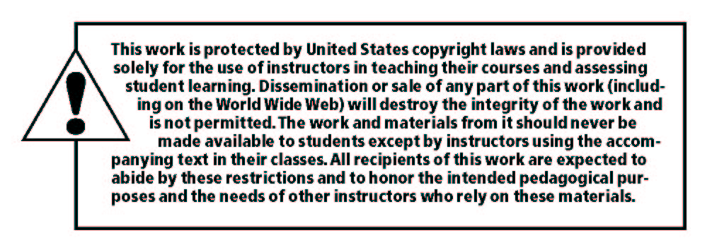
_____________________________________________________________________
Copyright © 2019 by Pearson Education, Inc. or its affiliates. All Rights Reserved. Printed in the United States of America. This publication is protected by copyright, and permission should be obtained from the publisher prior to any prohibited reproduction, storage in a retrieval system, or transmission in any form or by any means, electronic, mechanical, photocopying, recording, or otherwise. For information regarding permissions, request forms and the appropriate contacts within the Pearson Education Global Rights & Permissions Department, please visit www.pearsoned.com/permissions/.

Microsoft® Excel and PowerPoint are trademarks of the Microsoft Corporation.

Instructors of classes using Peterson, Construction Estimating Using Excel, may reproduce material from the instructor’s manual for classroom use.

10 9 8 7 6 5 4 3 2 1

ISBN-13: 978-0-13-487046-5
ISBN-10: 0-13-487046-8

Contents

Chapter 1 Measuring and Understanding Violence 1

Chapter 2 Victimization Theory 5

Chapter 3 Victims of Familiar Violence 9

Chapter 4 Nonfamilial Violence and Victimization 13

Chapter 5 Institutional and Workplace Violence 18

Chapter 6 School Violence and Victimization 23

Chapter 7 Criminal Justice and Injustice 27

Chapter 8 Human Trafficking and Victimization 31

Chapter 9 Firearms and Victimization 35

Chapter 10 Responding to Criminal Victimization 39
Chapter One:
Measuring and Understanding Violence
This chapter discusses the many reasons for interpersonal violence. The risk factors such as family backgrounds, personal characteristics, and socioeconomic status are also explored. Students should conduct research on a convicted criminal (serial killer, rapist, mass murderer, etc.) and identify what influences (individual, familial, and community) contributed to his/her offenses. Sources of data on victimization are also provided. It is recommended that the instructor introduce students to the various sources of crime data (Uniform Crime Reports (UCR), National Center for the Analysis of Violent Crime (NCAVC), National Crime Victimization Survey (NCVS), etc.). What are some of the strengths and weaknesses of each source?
I. Student Learning Objectives:
- Be able to explain the meaning of violent crime
- Learn about reported and unreported crime
- Learn about the fear of crime
- Become familiar with some general reasons for violent behavior
- Understand the dynamics of violence
II. Sample Multiple-Choice Questions:
1. Americans’ fear of crime victimization relates strongly to two distinct factors:
a. Socioeconomic status and level of education
b. Income and level of education
c. Income and sex*
d. Socioeconomic status and gender
2. One limitation of the Uniform Crime Report (UCR) is:
a. It details only reported crime*
b. Universities/colleges are not required to report offenses
c. Indexed crimes are not categorized by type of crime
d. The UCR does not provide data on the nature and extent of reported crime rates in a given community
3. The dark figure of crime refers to:
a. All reported crimes to the police
b. Crimes committed by juveniles
c. Unreported crimes*
d. Both a and b
4. According to information provided by the U.S. Department of Justice, which of the following is not true?
a. Males are most often the victims and perpetrators of homicides
b. Blacks are more likely than whites to be homicide victims and homicide perpetrators
c. Most murders were interracial*
d. Blacks are more likely than whites to commit homicide
5. Which of the following is a nationwide data center designed to collect, collate, and analyze information about crimes of violence—specifically murder?
a. National Crime Victimization Survey
b. Uniform Crime Reports
c. Violent Criminal Apprehension Program*
d. Violence Center
6. The National Crime Victimization Survey (NCVS) chronicles all of the following information except:
a. The amount of crime that occurs in school
b. So-called victimless crimes*
c. The relationship between the victim and the offender
d. Profiles of crime victims
7. Which of the following is not one of the stages of violentization?
a. Brutalization
b. Premeditation*
c. Belligerency
d. Violent coaching
8. Which of the following is not part of the three-level social-ecological model?
a. Individual
b. Familial
c. Psychological*
d. Community
9. Among females, what disorder has been reported as one of the top disorders prison inmates (between 25% and 50%) are diagnosed with linking the disorder with their criminal behavior?
a. Depression
b. Borderline personality disorder*
c. Post-traumatic stress disorder
d. Schizophrenia
10. People with attention deficit hyperactivity disorder (ADHD) have lower levels of dopamine in the brain, which influences all the following except:
a. Risk-taking behavior
b. Unacceptable social behavior and crime
c. Poor academic achievement
d. Higher self-esteem and acceptance*
11. Data on twin and adoptee studies found that:
a. There was no association between adopted children’s criminal behavior and their birth parents criminal behavior
b. Almost 50% of the adoptees whose mother had a criminal record also had a record of criminal behavior themselves by age 18*
c. About 80% of males with a criminal record had an adopted mother with a criminal record
d. Both b and c
12. Research on the monoamine oxidase A (MAOA) gene found all of the following except:
a. Those with low expression of MAOA were more impulsive
b. People with low expression of MAOA had different brain size and activity
c. Activity of those parts of the brain in males with low expression of MAOA differed more than their female counterparts
d. Those with low expression of MAOA are born to commit violence*
13. Injury to the brain may contribute to aggressive behavior, especially if this region is affected because it harms the ability to plan and reason:
a. Prefrontal cortex*
b. Auditory cortex
c. Occipital lobe
d. Parietal lobe
14. Which of the following facts about familial influences is not true?
a. The rise in violent crime parallels the rise in families abandoned by fathers
b. The type of aggression and hostility demonstrated by a future criminal is often foreshadowed in unusual aggressiveness as early as age five or six
c. High-crime neighborhoods are characterized by high concentrations of families abandoned by mothers*
d. The future criminal tends to be an individual rejected by other children as early as the first grade
15. Social disorganization theory states the following except:
a. Delinquency rates are higher in lower class neighborhoods
b. Delinquency rates are higher in areas with the highest rates of prostitution
c. Delinquency rates are higher in suburban communities*
d. Delinquency rates are higher in communities with a large percent of minority families receiving public assistance
III. Sample Essay and Discussion Questions:
1. Explain why only some violent crimes are reported to police. What factors determine whether a crime is reported? Are reporting rates different for personal and property crimes? If so, why?
2. Why are some people more fearful of crime than others? Do you believe that the media promotes fear? Explain.
3. Develop an argument that genetics is a powerful factor in predicting behavior.
4. Discuss why some individuals raised in violent dysfunctional families or communities do not become violent.
5. Research a case study of a violent offender and determine the effect of individual, familial, and community levels in his or her violent behavior.
6. Is there a relationship between the social media and violence?
7. Are certain mental conditions attributed to violence more prevalent in men or women?
8. Are the reported police shootings of blacks due to racism or other factors?
9. Do a search of violent crime rates in America. Is violent crime increasing or decreasing?
10. Discuss the relationship between post-traumatic stress disorder and victimization.
11. How does violence and crime affect a community, and how does a community promote violence?

