**Chapter 1** **End-of-Chapter Assignment and Lab Solutions**

**Multiple Choice Questions**

1. (LO 1-2) Which is the lowest level of skills in Bloom’s Taxonomy?
   1. Create
   2. **Remember**
   3. Apply
   4. Analyze
2. (LO 1-2) Which is the highest level of skills in Bloom’s Taxonomy?
   1. **Create**
   2. Apply
   3. Analyze
   4. Understand
3. (LO 1-2) Which is the appropriate ordering of skills in Bloom’s Taxonomy, where the “>” symbol means higher order skills?
   1. Remember > Apply
   2. Apply > Analyze
   3. Analyze > Evaluate
   4. **Create > Analyze**
4. (LO 1-3) Which component of the AMPS model most appropriately addresses the axiom, “Your data won’t speak unless you ask it the right data analytics questions”?
   1. **Ask the Question**
   2. **M**aster the Data
   3. **P**erform the Analysis
   4. **S**hare the Story
5. (LO 1-3) Which component of the AMPS model most appropriately addresses the question of the best way to communicate data analytics findings with a decision maker?
   1. **A**sk the Question
   2. **M**aster the Data
   3. **P**erform the Analysis
   4. **Share the Story**
6. (LO 1-3) What type of question is predicting whether a company will go bankrupt in the coming two years?
   1. What happened? What is happening?
   2. Why did it happen? What are the root causes of past results?
   3. **Will it happen in the future? What is the probability something will happen? Is it forecastable?**
   4. What should we do based on what we expect will happen? How do we optimize our performance based on potential constraints?”
7. (LO 1-3) What type of question is choosing to take certain tax deductions based on the way managers believe tax legislation will change in the near future?
   1. What happened? What is happening?
   2. Why did it happen? What are the root causes of past results?
   3. Will it happen in the future? What is the probability something will happen? Is it forecastable?
   4. **What should we do based on what we expect will happen? How do we optimize our performance based on potential constraints?”**
8. (LO 1-3) What type of question is finding the detail to more clearly understand why net income is decreasing when revenues are increasing?
   1. What happened? What is happening?
   2. **Why did it happen? What are the root causes of past results?**
   3. Will it happen in the future? What is the probability something will happen? Is it forecastable?
   4. What should we do based on what we expect will happen? How do we optimize our performance based on potential constraints?”
9. (LO 1-3) What type of question is determining how much a company paid for state and federal income tax?
   1. **What happened? What is happening?**
   2. Why did it happen? What are the root causes of past results?
   3. Will it happen in the future? What is the probability something will happen? Is it forecastable?
   4. What should we do based on what we expect will happen? How do we optimize our performance based on potential constraints?”
10. (LO 1-3) A ______________ might be used to evaluate which journal entries are outliers.
    1. regression analysis
    2. Benford’s law analysis
    3. **histogram**
    4. sum function (Excel SUM())

**Discussion Questions**

1. (LO 1-1) The computer is better at automated, repetitive tasks since it can be programmed. The computer is also not subject to fatigue and can process massive amounts of data easier than a human can. Most of the value-added tasks and higher order thinking skills, such as analyzing, evaluating and creating, are performed better by human accountants because they are not easily programmed by a set of fixed rules. The ability to recognize tradeoffs, evaluating alternatives, and evaluating ad hoc facts are all better performed by humans.
2. (LO 1-2) The skills taught in the introduction to financial accounting were the lower order thinking skills (noted in Bloom’s Taxonomy) such as remembering, understanding and applying. Application of journal entries, computing trial balances, recording transactions, bank reconciliation, etc. are all examples of lower order skills.
3. (LO 1-3) Accountants understand the tradeoffs between relevant data and reliable data (such as that data which might exhibit more representational faithfulness).

Accountants also understand the tradeoffs between unstructured and structured data, data internal or external to the company, and even the potential cost of acquiring and processing the data as compared to the potential value provided by use of the data.

1. (LO 1-3) Mastering the data includes accessing, cleaning, and transforming the data needed to prepare the data for analysis.
2. (LO 1-3) Data analytics might be viewed as successively peeling the layer of an onion. By peeling the first layer of the onion, you now are able to see the next layer and evaluate it and remove it to get to the third layer, etc. Often times, the AMPS model must be performed multiple times, refining the question (Ask the Question), possibly considering different types of data (Master the Data), performing additional analysis (Perform the Analysis) and retelling the story in each iteration (Sharing the Story) before the issue/problem/challenge can be finally addressed with some confidence.
3. (LO 1-3) Descriptive analysis reports what happened. Generally, evaluating the revenues and earnings performance starts with descriptive analysis and continues with diagnostic analysis to understand “Why it happened”.

**Brief Exercises**

1. **(LO1-1, LO1-2): Match the data analytics term to its data analytics definition:**

|  |  |
| --- | --- |
| **Data Analytics Term** | **Data Analytics Definition** |
| **Bloom’s Taxonomy** | An explanation ofhierarchical forms of thinking and learning skills in education |
| **data analytics** | The process of evaluating data with the purpose of drawing conclusions to address all types of questions, including accounting questions. |
| **dynamic** | Characterized by constant update, change, or activity. |
| **information overload** | Access or exposure to too much information to be able to process. |
| **static** | Characterized by the lack of constant update, change, or activity. |

1. **(LO1-3): Match the components of the AMPS model to data analytics tasks.**

|  |  |
| --- | --- |
| **Data Analytics Task** | **AMPS Model Component (i.e., Ask the Question, Master the Data, Perform the Analysis, Share the Story)** |
| Dashboard providing daily sales in the Pacific Northwest. | Share the Story |
| Checking the data for errors and missing data items before the data is analyzed. | Master the Data |
| Vendor trying to decide which product they should sell at Walmart. | Ask the Question |
| Using a histogram to evaluate whether journal entries were entered by an unauthorized employee. | Perform the Analysis |
| Deciding the best way to communicate the data analysis findings to management. | Share the Story |

1. **(LO1-3): Match the components of the AMPS model to data analytics tasks.**

|  |  |
| --- | --- |
| **Data Analytics Task** | **AMPS Model Component (i.e., Ask the Question, Master the Data, Perform the Analysis, Share the Story)** |
| Deciding which question to ask that might help management best assess strategy. | Ask the Question |
| Running a regression analysis to evaluate the impact of advertising. | Perform the Analysis |
| Extracting data from the financial reporting system and prep for use in a pivot table. | Master the Data |
| Publishing financial statements store-by-store. | Share the Story |
| Analyzing how profits will change if gasoline prices go up in the coming year. | Perform the Analysis |

**Problems**

1. **(LO1-2): Match the components of the AMPS model to data analytics tasks.**

|  |  |  |
| --- | --- | --- |
| **Component of Bloom’s Taxonomy** | **Bloom’s Taxonomy Component (Remember, Understand, Apply, Analyze, Evaluate, Create)** | **Who has the advantage in this component? (Human or Machine)** |
| Judging the value of information or ideas. | Evaluate | Human |
| Recognizing and recalling facts. | Remember | Machine |
| Combining parts to make a new whole. | Create | Human |
| Applying the facts, rules, concepts and ideas. | Apply | Machine |
| Breaking down information into component parts. | Analyze | Human |
| Comprehending what the facts mean. | Understand~~ing~~ | Machine |

1. **(LO1-3): For each of the questions below, categorize them as one of the following question types:** 
   1. What happened? What is happening?
   2. Why did it happen? What are the root causes of past results?
   3. Will it happen in the future? What is the probability something will happen? Is it forecastable?
   4. What should we do, based on what we expect will happen? How do we optimize our performance based on potential constraints?”

|  |  |
| --- | --- |
| **Data Analytics Question** | **Question Type** |
| How much did we pay in federal taxes last year? | 1. What happened? What is happening? |
| If we have all 12/31 year-end audit clients, how will we organize our audit work in the new year? | 1. What should we do, based on what we expect will happen? How do we optimize our performance based on potential constraints?” |
| Can the IRS find those individuals or corporations evading taxes using predictive techniques? | 1. Will it happen in the future? What is the probability something will happen? Is it forecastable? |
| Did the airline company’s on-time departures improve this past month? | 1. What happened? What is happening? |
| Can our variance analysis help explain why the labor expenses increased over the past year? | 1. Why did it happen? What are the root causes of past results? |

1. **(LO 1-3)** For each of the questions below, categorize the appropriate statistical technique that should be used to perform the analysis.
2. Regression analysis
3. Benford’s Law
4. What-if/Goal Seek
5. Histogram
6. PivotTable

|  |  |
| --- | --- |
| **Data Analytics Question** | **Statistical Technique** |
| Finding the frequency of all transactions, from the minimum to the maximum | d. Histogram |
| Looking for potentially fraudulent transactions | b. Benford’s Law |
| Minimizing tax payment based on expected changes in tax legislation | c. What-if/Goal Seek |
| Segregating Total Costs into Fixed and Variable Cost Components | a. Regression analysis |
| Displaying total accounts receivable balance by days overdue (aging) | e. PivotTable |

1. **(LO1-3):** Which of the following components of the AMPS model would each data analytics question be?
   1. Ask the Question
   2. Master the Data
   3. Perform the Analysis
   4. Share the Story

|  |  |
| --- | --- |
| **Data Analytics Question** | **Which component of the AMPS Model?** |
| Management wants answers on why certain products are unprofitable | Ask the Question |
| The data has lots of missing data | Master the Data |
| Should we report this with a graph or in a table? | Share the Story |
| The analysis was done using a sort command | Perform the Analysis |
| The data comes from last year’s financial statements | Master the Data |
| A dashboard is used to communicate the results | Share the Story |
| Which audit tests were performed on the data | Perform the Analysis |

**Lab 1-1 Solution**

**Lab 1-1 Submission**

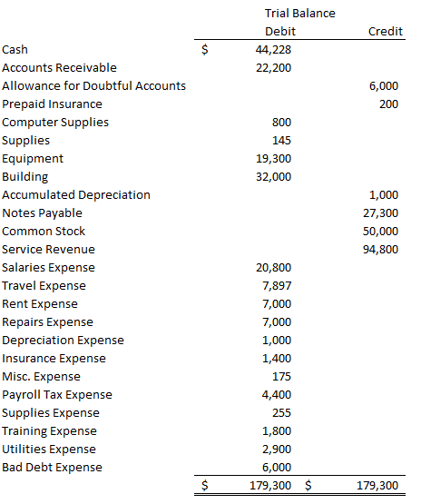

Check to ensure that total debits equal total credits and complete the trial balance.

**Lab 1-1 Multiple Choice Questions**

1. What are the total credits for the final trial balance?
   1. 297,927
   2. **179,300**
   3. Cannot be calculated
2. What is used in Excel to compute total debits and total credits from the transactions?
   1. SUM() function
   2. Calculator
   3. AVG() function
   4. **Pivot Table**
3. What is used in Excel to compute Net Debits and Net Credits?
   1. **Calculated Fields, Items and Sets**
   2. SUM() function
   3. Calculator
   4. AVG() function
4. Which asset, in the normal course of business, should not have a credit balance as shown in the trial balance?
   1. Accumulated Depreciation
   2. **Prepaid insurance**
   3. Allowance for Doubtful Accounts
5. What is the calculation for the Net Credits computation in the Calculated Fields, Items and Sets?
   1. IF(Debit>Credit, Debit – Credit)
   2. IF(Debit>Credit, Credit –Debit)
   3. **IF(Credit>Debit, Credit – Debit)**
   4. IF(Credit>Debit, Debit – Credit)

**Lab 1-1 Alt Submission**

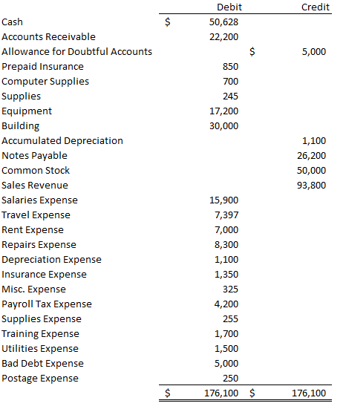

**Lab 1-1 Alt Multiple Choice Questions**

1. What are the total credits for the final trial balance?
   1. 284,477
   2. **176,100**
   3. Cannot be calculated
2. How much is total liabilities in the trial balance?
3. 76,200
4. 32,300
5. **26,200**
6. 176,100
7. In a trial balance, the total debits should equal total credits.
8. **True**
9. False
10. A trial balance includes accounts from the ___________ and _____________ .
11. Income statement, balance sheet and statement of cash flows
12. **Income statement and balance sheet**
13. Balance sheet and statement of cash flows
14. Income statement and statement of cash flows.
15. What is the calculation for the Net Debits computation in the Calculated Fields, Items and Sets?
16. IF(Credit>Debit, Credit – Debit)
17. IF(Credit>Debit, Debit – Credit)
18. **IF(Debit>Credit, Debit – Credit)**
19. IF(Debit>Credit, Credit –Debit)

**Lab 1-2 Solution**

**Lab 1-2 Submission**

Take a screenshot of the depreciation schedule for 2022 and label it “Lab 1-2 Submission 1.jpg”.

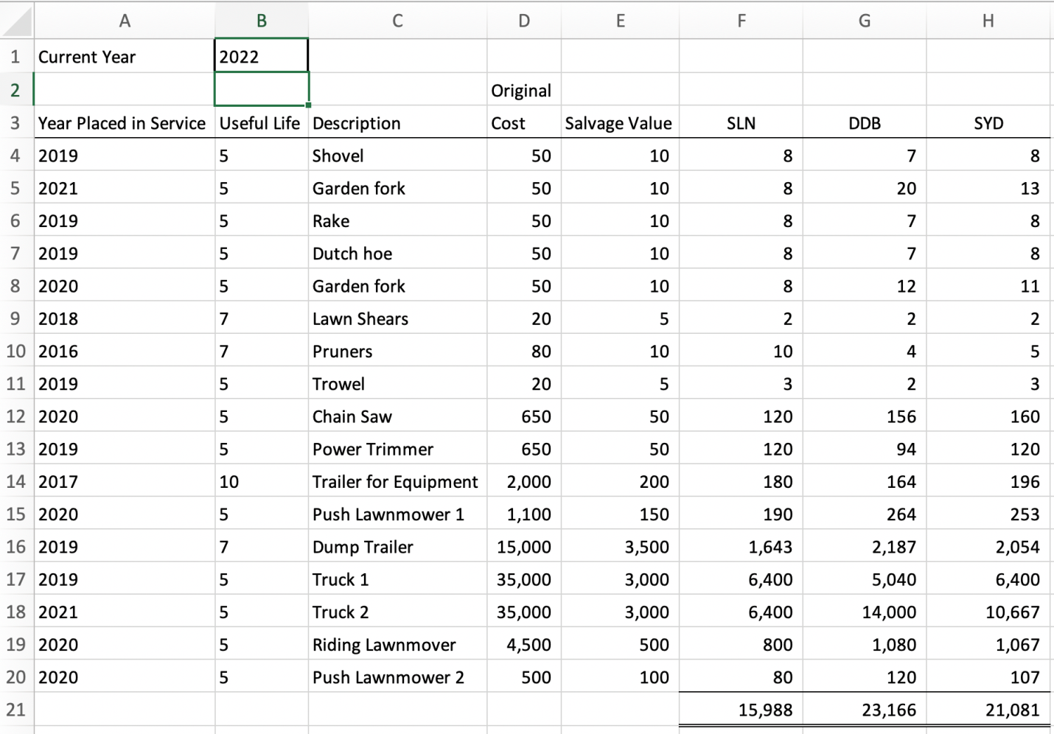

1. The lab presumes the depreciation expense for the year 2022. If we replace “2023” for “2022” in cell B1, we can compute the depreciation expense for the year 2023. Take a screenshot of the depreciation schedule for 2023 and label it “Lab 1-2 Submission 2.jpg”

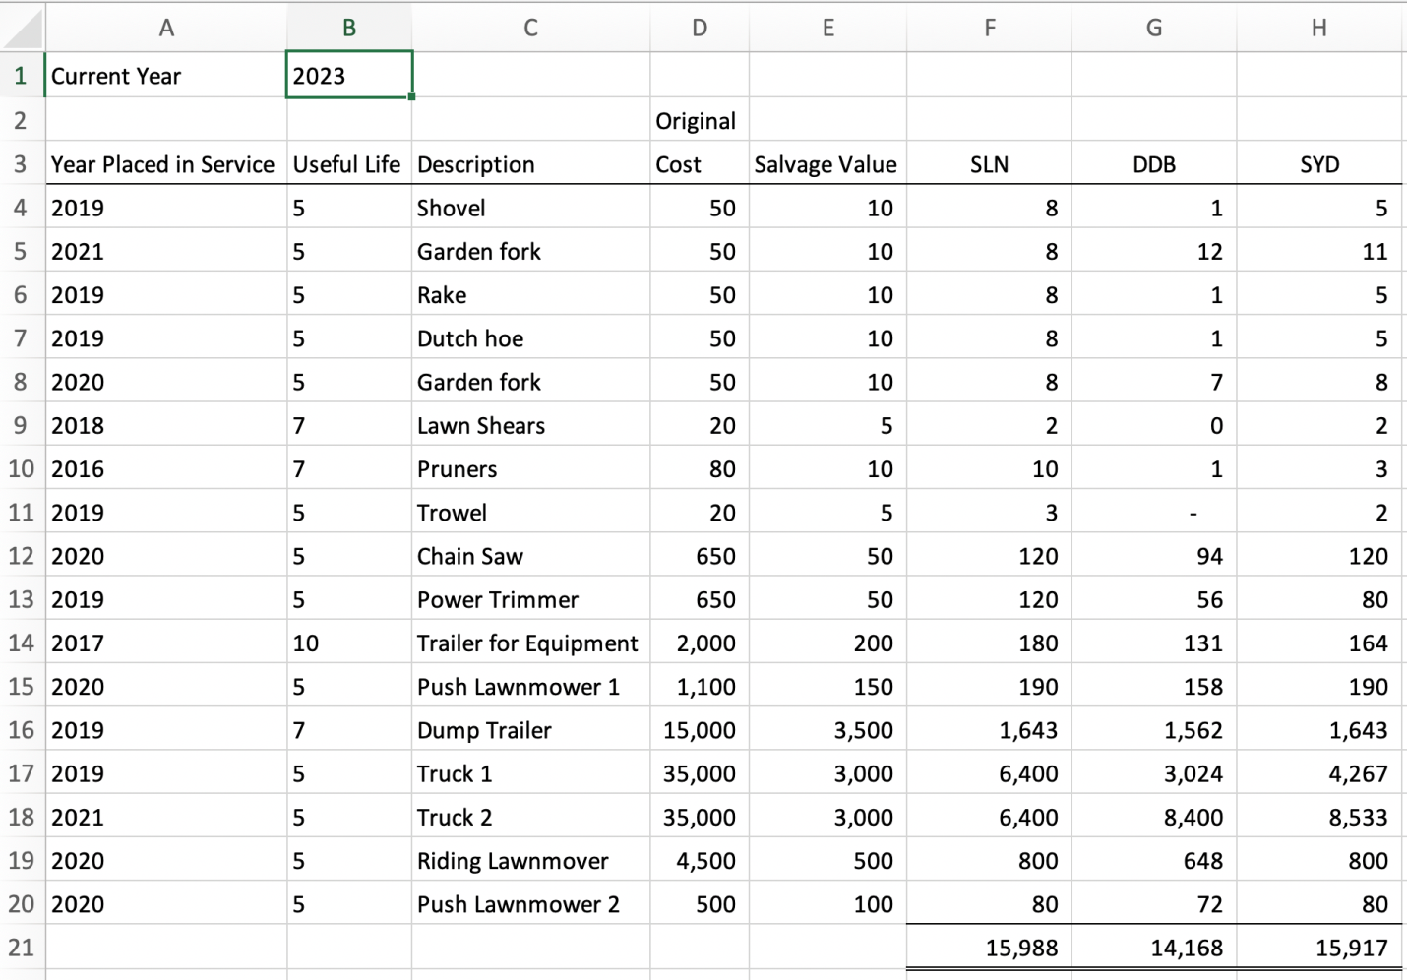

**Lab 1-2 Multiple Choice Questions**

1. Which truck had higher straight-line depreciation expense than double-declining balance depreciation expense in 2022?
   1. **Truck 1**
   2. Truck 2
   3. Dump Trailer
2. Which method calculated the most depreciation expense for the “Trailer for Equipment” in 2022?
   1. **Sum-of-the-Year’s Digits**
   2. Double Declining Depreciation
   3. Straight-Line Depreciation
3. Overall, for 2022, which depreciation method had the least depreciation expense?
   1. **Straight-Line Depreciation**
   2. Sum-of-the-Year’s Digits
   3. Double Declining Depreciation
4. The lab presumes the depreciation expense for the year 2022. If we replace “2023” for “2022” in cell B1, we can compute the depreciation expense for the year 2023. What is the straight-line depreciation for 2023 assuming no assets are added or disposed during the year?
   1. **15,988**
   2. 14,168
   3. 15,917
   4. 23,166
5. The lab presumes the depreciation expense for the year 2022. If we replace “2023” for “2022” in cell B1, we can compute the depreciation expense for the year 2023. What is the double declining balance depreciation for 2023 assuming no assets are added or disposed during the year?
   1. **14,168**
   2. 15,988
   3. 15,917
   4. 23,166

**Lab 1-2 Alt Submission**

1. Take a screenshot of the depreciation schedule for 2022 and label it “Lab 1-2 Alt Submission 1.jpg”.

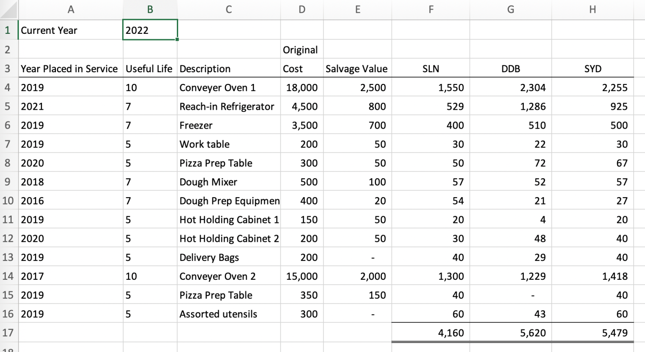

1. The lab presumes the depreciation expense for the year 2022. If we replace “2023” for “2022” in cell B1, we can compute the depreciation expense for the year 2023. Take a screenshot of the depreciation schedule for 2023 and label it “Lab 1-2 Alt Submission 2.jpg”.

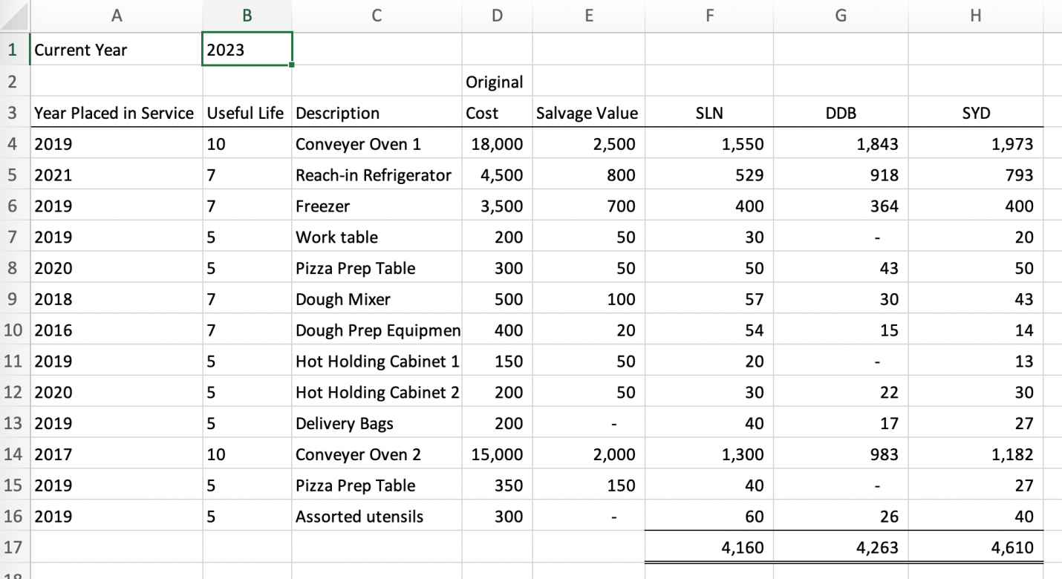

**Lab 1-2 Alt Multiple Choice Questions**

1. What is the 2022 double-declining balance depreciation expense for conveyer oven 1?
   1. **$2,304**
   2. $1,550
   3. $2,255
   4. $1,843
2. What is the total depreciation expense using sum-of-the-years’ digits for 2022?
   1. **$5,479**
   2. $5,620
   3. $4,160
   4. $4,610
3. Which asset has $1,300 straight line depreciation expense in 2022?
   1. **Conveyer Oven 2**
   2. Freezer
   3. Reach-In Refrigerator
   4. Conveyer Oven 1
4. Which asset has $43 sum-of-the-year’s digit’s depreciation in 2023?
   1. **Dough mixer**
   2. Delivery bags
   3. Work table
   4. Dough prep equipment
5. Which assets have zero double declining balance depreciation in 2023?
   1. **Work table, hot holding cabinet 1 and pizza prep table**
   2. Work table, hot holding cabinet 2 and assorted utensils
   3. Dough mixer, hot holding cabinet 2 and assorted utensils
   4. Dough mixer, hot holding cabinet 1 and pizza prep table

**Lab 1-3 Solution**

**Lab 1-3 Submission**

1. Take a screenshot of the top 20 lines of your 360-month amortization schedule and label it “Lab 1-3 Submission.jpg”.

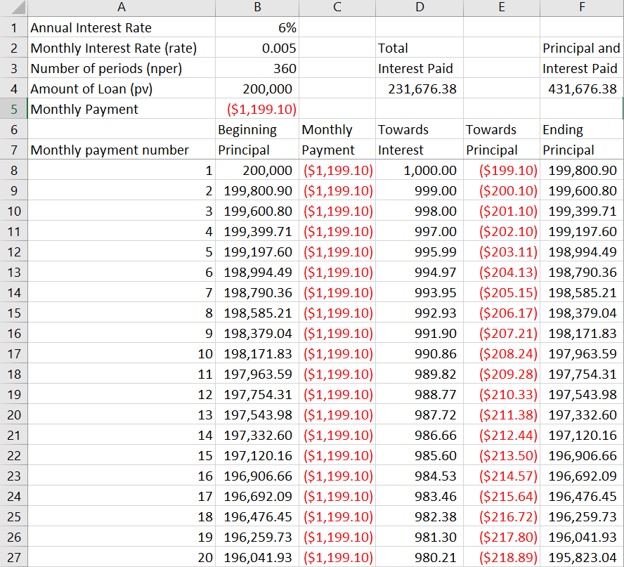

**Lab 1-3 Multiple Choice Questions**

1. What is the amount of interest paid in monthly payment number 25?
   1. **$974.68**
   2. $975.80
   3. $972.43
   4. $973.56
2. What is the amount that goes toward paying down principal in monthly payment number 20?
   1. **$218.89**
   2. $217.80
   3. $219.99
   4. $980.21
3. What is the amount of ending principal after the 359th monthly payment?
   1. **$1,193.14**
   2. $0
   3. $5.97
   4. $2,380.33
4. What is the amount of ending principal after the 360th monthly payment?
   1. **$0**
   2. $1,193.14
   3. $5.97
   4. $2,380.33
5. What would be the monthly payment for a $200,000 mortgage loan for 360 months, and at 7% annual interest?
   1. **$1,330.60**
   2. $1,199.10
   3. $14,000.00
   4. $1,064.48

**Alt Lab 1-3 Submission**

1. Take a screenshot of the top 20 lines of your 180-month amortization schedule and label it “Lab 1-3 Alt Submission 1.jpg”.

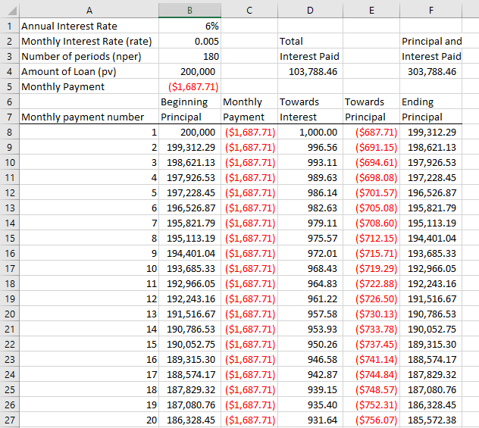

1. Take a screenshot of the top 20 lines of your 96-month amortization schedule and label it “Lab 1-3 Alt Submission 2.jpg”.

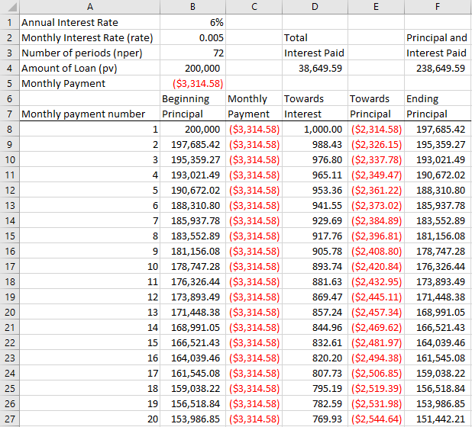

**Lab 1-3 Alt Multiple Choice Questions**

1. What would be the monthly payment for 180 months, 6% annual interest and a $200,000 loan?
   1. **$1,687.71**
   2. $3,314.58
   3. $1,199.10
   4. $1,064.48
2. What would be the monthly payment for 72 months, 6% annual interest and a $200,000 loan?
   1. **$3,314.58**
   2. $1,687.71
   3. $1,199.10
   4. $1,064.48
3. For the 180-month mortgage, what is the amount that goes toward paying down principal in monthly payment number 20?
   1. **$756.07**
   2. $759.04
   3. $931.64
   4. $752.31
4. For the 72-month mortgage, what is the amount of interest expense in monthly payment number 3?
   1. **$976.80**
   2. $2,337.78
   3. $965.11
   4. $993.11
5. What is the total amount of interest paid over the life of the 180-month mortgage?
   1. **$103,788.46**
   2. $38,649.59
   3. $238,649.59
   4. $303,788.46

Lab Solutions Files

