1. Perform the indicated operation and reduce to the lowest terms.
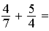

Complete the following.

2. Arrange the following decimals from largest to smallest: 0.33, 0.045, 0.7.

Perform the following computations. If the questions do not have a whole number as the answer, compute to the third decimal place, and round to the second decimal place.

3.

Perform the indicated operations. Reduce fractions in answers to the lowest terms.

4. 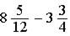

5. Convert 0.45 to a fraction in the lowest terms.

6. Perform the indicated operation and reduce to the lowest terms.
​
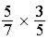

7. Perform the indicated operation and round the answer to the nearest tenths place.
​
123.56 78

8. Find the least common denominator for the following pair of fractions.
​
,

9. Find the least common denominator for the following pair of fractions.
​
,

Perform the indicated operations. Reduce fractions in answers to the lowest terms.

10.

11. Perform the indicated operation.
6.3 100

12. Convert to a decimal.

Perform the following computations. If the questions do not have a whole number as the answer, compute to the third decimal place, and round to the second decimal place.

13.

Perform the indicated operations. Reduce fractions in answers to the lowest terms.

14. 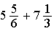

15. 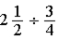

16. Convert the following decimal to a fraction and reduce to the lowest terms.
​
0.09

17. Convert to a decimal and round to the nearest hundredths place.

18. Convert the following fraction to a decimal and round to the nearest tenth.
​

Perform the following computations. If the questions do not have a whole number as the answer, compute to the third decimal place, and round to the second decimal place.

19.

20. Perform the indicated operation and round the answer to the tenths place.

Perform the following computations. If the questions do not have a whole number as the answer, compute to the third decimal place, and round to the second decimal place.

21.

Complete the following.

22. Arrange the following fractions from smallest to largest: , , .

23. Perform the indicated operation and reduce to the lowest term.
​
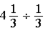

24. Perform the indicated operation.
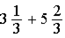

25. Perform the indicated operation and reduce to the lowest term.
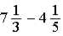

26. After surgery, a patient drinks 2 fluid ounces of clear liquids every 2 hours. How many fluid ounces will the patient drink in 8 hours?

27. Perform the indicated operation.
​
350 0.07

28. Perform the indicated operation and reduce to the lowest terms.
​
4 2 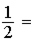

29. Convert the following fraction to a decimal and convert to the lowest terms.
​
0.175

30. Convert the following fraction to a decimal and round to the nearest hundredth
​

Complete the following.

31. Arrange the following decimals from largest to smallest: 1.5, 0.25, 1.025.

32. Arrange the following fractions from smallest to largest: , , .

33. Perform the indicated operation.
​
25 0.4

34. Convert 0.125 to a fraction in the lowest terms.

Answer Key
1. 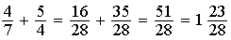

2. 0.7, 0.33, 0.045

3. 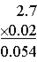
or 0.05 (rounded)

4. 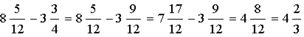

5. 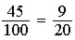
​

6. 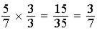

7. 123.56 78 = 9,637.68 = 9,637.7

8. LCD = 33
​

9. LCD = 30

10. 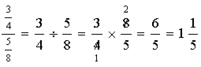

11. 6.3 100 = 630

12. 4 8 = 0.5
​

13. 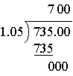

14. 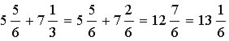

15. 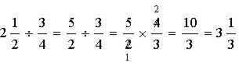

16. 0.09 = 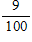

17. 5 8 = 0.625 = 0.63
​

18. 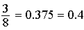
​

19. 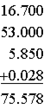
or 75.58 (rounded)

20.

21. 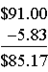

22. , ,

23. 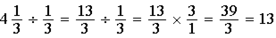

24. 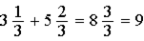

25. 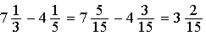

26. 8 hours divided by every 2 hours = 4 doses
2 4 = = = 10 fluid ounces

27. 350 0.07 = 5,000

28. 4 2 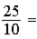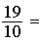1

29. 0.175 = 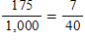

30. 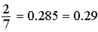

31. 1.5, 1.025, 0.25​

32. , ,
​

33. 25 0.4 = 62.5

34. 



