Indicate whether the statement is true or false.

1. If every place on Earth were identical, we would not need a spatial perspective.
 | a. | True
 | b. | False

2. Modern globalization both makes people more alike and enables recognition of the differences between groups of people.
 | a. | True
 | b. | False

3. A typical dispersed settlement form would be a city.
 | a. | True
 | b. | False

4. Ford and Griffin's model of the Latin American city conforms to all cities in that region.
 | a. | True
 | b. | False

5. Placelessness is something experienced at a war memorial.
 | a. | True
 | b. | False

6. When you go to your polling place, you are visiting a node in a functional region.
 | a. | True
 | b. | False

7. Groups that form in opposition to the dominant culture, such as hip-hop or punks, are referred to as diaspora.
 | a. | True
 | b. | False

8. Blaut and Ormrod have argued that non-diffusion is more prevalent than diffusion.
 | a. | True
 | b. | False

9. Scholars of possibilism believe that the higher the technological level of a culture, the stronger the influences of the physical environment.
 | a. | True
 | b. | False

10. A good example of a functional node is your state or provincial capital.
 | a. | True
 | b. | False

11. Vernacular regions often lack the organization necessary for functional regions.
 | a. | True
 | b. | False

12. Cowboys are an example of folk culture in the United States.
 | a. | True
 | b. | False

13. Transnational migration is uncommon in a globalizing world.
 | a. | True
 | b. | False

14. Natural hazards are often the result of a combination of natural and human-influenced (or human-created) forces.
 | a. | True
 | b. | False

15. Globalization is a key shaper of culture and is in turn shaped by it.
 | a. | True
 | b. | False

16. Globalization is solely a modern phenomenon.
 | a. | True
 | b. | False

17. McDonald's is an example of popular culture.
 | a. | True
 | b. | False

18. Ultimately, agricultural patterns cannot be explained by the characteristics of the land and climate alone.
 | a. | True
 | b. | False

19. Geographers who study power and ideology tend to focus more on diversity within cultures rather than on differences between cultures.
 | a. | True
 | b. | False

20. Vernacular regions, like most regions, generally lack sharp borders.
 | a. | True
 | b. | False

21. Modern mass media have greatly accelerated diffusion, augmenting the impact of time–distance decay.
 | a. | True
 | b. | False

22. The ancient Kingdom of Zimbabwe was located in what is modern-day Botswana and Namibia.
 | a. | True
 | b. | False

23. A vernacular region is sometimes based on a specific economic, political, or historical characteristic.
 | a. | True
 | b. | False

24. The relationship between people and nature is a two-way interaction, in which each affects and is affected by the other.
 | a. | True
 | b. | False

25. Stepwise migration refers to the phenomenon of migrants going back to their place of origin after long-term residency elsewhere.
 | a. | True
 | b. | False

26. Google Maps on your phone can track your location using the signal from two satellites that find you in time and space.
 | a. | True
 | b. | False

27. In general, migration follows a pattern from areas of low employment or low wages toward areas of higher employment or higher wages.
 | a. | True
 | b. | False

28. The word space is employed mostly by those who build models, while the word place is used mostly by those with a more humanistic view of geography.
 | a. | True
 | b. | False

29. Culture is best understood as a process, not as a static, fixed pattern.
 | a. | True
 | b. | False

30. The adoption of new innovations generally increases with distance and time, a phenomenon known as friction of distance.
 | a. | True
 | b. | False

31. Vernacular regions are usually homogeneous.
 | a. | True
 | b. | False

32. If a human geographer studies the landscape produced by a human community, that landscape reflects the culture of this group.
 | a. | True
 | b. | False

33. The study of contemporary human geography is best understood in the context of cultures (plural) rather than a fixed, singular culture in any given region.
 | a. | True
 | b. | False

34. Food preferences and crop choices are influenced by survival needs alone, not belief systems.
 | a. | True
 | b. | False

35. The modern-day country of Zimbabwe took its name from the Great Zimbabwe National Monument.
 | a. | True
 | b. | False

36. The increase in greenhouse gas emissions and resulting climate change is one of the key events of the Pleistocene.
 | a. | True
 | b. | False

37. Rural farming areas generally tend to be highly nucleated.
 | a. | True
 | b. | False

38. The Great Zimbabwe National Monument was built completely without mortar.
 | a. | True
 | b. | False

39. Environmental determinism was used as a justification for European colonial activity.
 | a. | True
 | b. | False

40. World crop distributions can be explained by land and climate characteristics alone.
 | a. | True
 | b. | False

41. Technology allows humans mastery of the physical environment.
 | a. | True
 | b. | False

42. Globalization means that, as a whole, people across the world are becoming quite similar in terms of their general level of well-being.
 | a. | True
 | b. | False

43. The best conceptual approach to the global diffusion of the H1N1 virus would be hierarchical diffusion and contagious diffusion reinforcing each other.
 | a. | True
 | b. | False

44. It is possible to understand a culture removed from its physical setting.
 | a. | True
 | b. | False

45. The cultural landscape offers possibilities for subjective, artistic impression as well as objective, scholarly analysis.
 | a. | True
 | b. | False

46. A functional region is culturally homogeneous.
 | a. | True
 | b. | False

47. Cultures are always internally homogeneous because individual humans never think in exactly the same manner.
 | a. | True
 | b. | False

48. Hierarchical diffusion and contagious diffusion often work together.
 | a. | True
 | b. | False

49. Most models often conform precisely to reality.
 | a. | True
 | b. | False

50. While functional regions have a core and periphery, formal regions do not.
 | a. | True
 | b. | False

51. The term globalization includes not only a set of causes but also a set of effects and the relationships among them.
 | a. | True
 | b. | False

52. Understanding why people are solemn and quiet at cemeteries is to understand how cemeteries create a sense of place.
 | a. | True
 | b. | False

53. Knowing the latitude and longitude will provide you with the relative location of a place.
 | a. | True
 | b. | False

54. Agricultural patterns are based, in part, on cultural preferences.
 | a. | True
 | b. | False

55. From ground level, the most visible evidence of a particular cultural landscape is architecture.
 | a. | True
 | b. | False

56. Greater mobility allows for more cultural diversification.
 | a. | True
 | b. | False

57. A formal region is relatively heterogeneous with regard to six or more cultural traits.
 | a. | True
 | b. | False

58. Functional regions are characterized by functional homogeneity.
 | a. | True
 | b. | False

59. Most paintings from the Italian Renaissance feature agricultural workers.
 | a. | True
 | b. | False

60. The term cultural ecology is useful in understanding how the environment determines the culture of the people who live there.
 | a. | True
 | b. | False

61. Architecture and style in the cultural landscape are of minor importance to human geographers.
 | a. | True
 | b. | False

62. Globalization means that an ever-greater proportion of social life is organized on a global scale.
 | a. | True
 | b. | False

63. Formal regions are defined by border zones rather than sharp edges.
 | a. | True
 | b. | False

64. In some instances, the physical environment is the sole determinant of human behaviors and beliefs.
 | a. | True
 | b. | False

65. Formal and functional regions generally coincide spatially.
 | a. | True
 | b. | False

66. The term interdependence implies that the interdependent nations are equal in terms of economic development and the well-being of the populations.
 | a. | True
 | b. | False

67. Native Americans are folk cultures, but not indigenous cultures.
 | a. | True
 | b. | False

68. Strip malls reflect a certain cultural in the landscape.
 | a. | True
 | b. | False

69. Human geographers only study culture of indigenous peoples.
 | a. | True
 | b. | False

Indicate the answer choice that best completes the statement or answers the question.

70. The spread of people, ideas, or things from one location to other locations where these items are not initially found is:
 | a. | diffusion
 | b. | interaction
 | c. | ecology
 | d. | teleology

71. The devastation of the 2011 earthquake and tsunami in Japan illustrates that idea that:
 | a. | humans in technologically advanced societies have dominance over nature
 | b. | even technologically advanced societies cannot completely master nature
 | c. | nature will always conquer the barriers that humans make to protect themselves
 | d. | poorer countries cannot build enough protection to prevent the smallest disasters

72. People's interaction with nature is visibly expressed in:
 | a. | topophilia
 | b. | culture regions
 | c. | models
 | d. | the cultural landscape

73. Airports that have museum exhibits specific to the history of the city or state in which they are located are attempting to overcome:
 | a. | placelessness
 | b. | popular culture
 | c. | folk culture
 | d. | nonmaterial culture

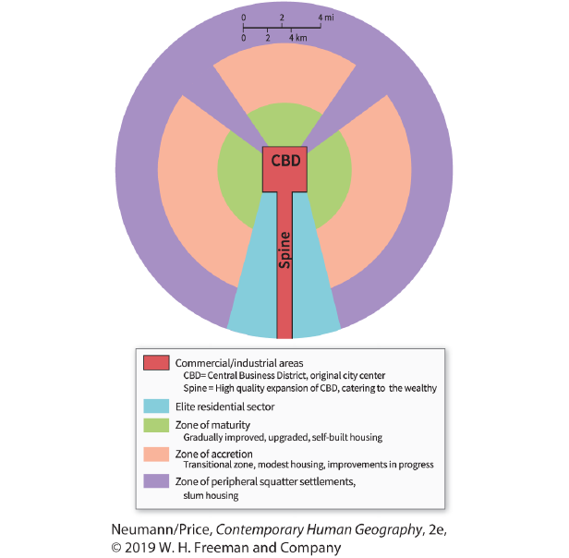

74. According to this model, housing for the poorest people is MOST likely to be found in Sector:
 | a. | zone of maturity
 | b. | elite residential sector
 | c. | zone of accretion
 | d. | zone of peripheral squatter settlements

75. Why has there been a decline in tourism to the Great Zimbabwe National Monument in recent years?
 | a. | political uncertainty and turmoil in Zimbabwe
 | b. | much of it was burned down by terrorists
 | c. | a racist government denies that it was built by an African culture
 | d. | conflicts between the United Nations and the Zimbabwean government

76. Which statement is NOT a component of Blaut and Ormrod's critique of Hägerstrand's diffusion theories?
 | a. | Nondiffusion is more prevalent than diffusion.
 | b. | Not all innovations are equally beneficial to all people throughout geographic space.
 | c. | Traditional models do not provide enough emphasis on cultural and environmental variables.
 | d. | Information by its very nature produces diffusion.

77. The study of the spatial arrangement of roads, buildings, and other features constructed by the people who inhabit an area is the study of:
 | a. | dispersal
 | b. | architectural styles
 | c. | land-division patterns
 | d. | settlement forms

78. Understanding the political, economic, and cultural effects of the distribution of Catholicism around the world is a way to examine:
 | a. | spatial modeling
 | b. | ecological systems
 | c. | cultural landscapes
 | d. | spatial patterns

79. Within a formal region, the cultural traits tend to be strongest:
 | a. | at the core
 | b. | in the periphery
 | c. | on the outskirts
 | d. | in the border zone

80. The hallmark of a formal region is cultural:
 | a. | diversity
 | b. | stratification
 | c. | harmony
 | d. | homogeneity

81. Which is NOT an example of a functional region?
 | a. | religion
 | b. | county
 | c. | city
 | d. | precinct

82. How many satellites are necessary for a GPS receiver to be precisely located in time and space?
 | a. | 12
 | b. | 4
 | c. | 1
 | d. | 5

83. Which areas tend to be MOST nucleated?
 | a. | rural areas
 | b. | farm areas
 | c. | urban areas
 | d. | suburban areas

84. The outdated idea that people in the Pacific Islands were lazy or less intelligent than Europeans because of the tropical climate they lived in is known as:
 | a. | environmental determinism
 | b. | possibilism
 | c. | cultural ecology
 | d. | interdependence

85. A region inhabited by people who have one or more traits in common is a:
 | a. | vernacular region
 | b. | continental region
 | c. | formal region
 | d. | functional region

86. A cultural approach to human geography would study all of the following EXCEPT:
 | a. | the ways in which culture is expressed and symbolized on the built landscape
 | b. | the ways in which language, religion, economy, and government vary or remain constant from place to place
 | c. | how people function spatially and identify with place and region
 | d. | how culture remains primarily a divisive force in a multicultural society

87. Human geographers with a social theoretical perspective ask questions about:
 | a. | power and ideology
 | b. | topophilia
 | c. | model building
 | d. | sense of place

88. Why is carbon dioxide categorized as a greenhouse gas?
 | a. | It is mostly located over forests.
 | b. | It traps heat close to the Earth's surface.
 | c. | It is a by-product of photosynthesis.
 | d. | It splits apart and causes warming.

89. While at opposite ends of the emotional spectrum, a joke spreading quickly throughout an office and cholera claiming a victim from every household in a village are both examples of which type of diffusion?
 | a. | hierarchical
 | b. | relocation
 | c. | contact
 | d. | contagious

90. Which statement is NOT true of functional regions?
 | a. | Their borders may or may not be clearly defined.
 | b. | Their interpretation varies widely.
 | c. | They generally do not coincide spatially with formal culture regions.
 | d. | They are concrete rather than abstract entities.

91. According to this model, the elite residential sector lies:
 | a. | in the periphery of the city
 | b. | at the core of the city
 | c. | along the spine leading to/from the central business district
 | d. | in the zone of accretion

92. Which represents a functional region?
 | a. | a region that grows pistachios
 | b. | a region in which Welsh is spoken
 | c. | a region showing the readership of a particular magazine
 | d. | a region in which the descendants of American slaves live

93. In the nineteenth and early twentieth centuries in the United States, which was seen as a symbol of the American national character?
 | a. | the railroad worker
 | b. | the cowboy
 | c. | the shopkeeper
 | d. | the farmer

94. Which would NOT be studied by physical geographers?
 | a. | climate
 | b. | terrain
 | c. | government
 | d. | vegetation

95. Because cultures overlap and mix, formal region boundaries are often:
 | a. | sharp
 | b. | clearly delineated
 | c. | geometric
 | d. | fuzzy

96. Which would NOT be considered a subculture?
 | a. | NASCAR
 | b. | punks
 | c. | Catholics
 | d. | Hip-hop

97. A factor that slows, but does not prevent, diffusion is a(n):
 | a. | time–distance barrier
 | b. | absorbing barrier
 | c. | permeable barrier
 | d. | impermeable barrier

98. The Amish people live mostly in Lancaster County, Pennsylvania, and the surrounding areas. The people of this religious group are known for their simple lifestyles and their rejection of modern conveniences. A map showing the distribution of Amish in Pennsylvania would help to define a(n):
 | a. | vernacular region
 | b. | urban region
 | c. | formal region
 | d. | functional region

99. The "Midwest" and the "South" of the United States are best described as:
 | a. | vernacular regions
 | b. | urban regions
 | c. | formal regions
 | d. | functional regions

100. The pattern of church attendance and the distribution area of a first-run film are:
 | a. | formal regions
 | b. | functional regions
 | c. | relocation regions
 | d. | vernacular regions

101. Which is NOT one of the characteristics typically used by geographers to categorize migration?
 | a. | race (white/non-white)
 | b. | spatial scale (regional/local)
 | c. | time scale (temporary/permanent)
 | d. | distance (long/short)

102. Geographic information systems and remote sensing are examples of:
 | a. | spatial modeling
 | b. | visualization tools
 | c. | theoretical perspectives
 | d. | humanistic geography

103. In popular culture, authority tends to be:
 | a. | religious
 | b. | dispersed
 | c. | secular
 | d. | conservative

104. Most of the images of urban areas on Google Maps are from:
 | a. | satellite images
 | b. | global positioning systems
 | c. | aerial photographs
 | d. | geographic information systems

105. The migration of Europeans into the Western Hemisphere included those people introducing Christianity into the Americas, thereby illustrating the process of this type of diffusion.
 | a. | stimulus
 | b. | hierarchical
 | c. | contagious
 | d. | relocation

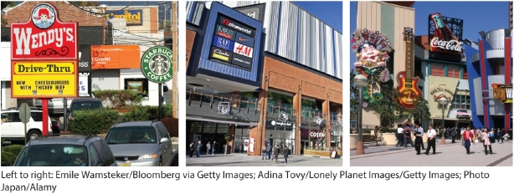

106. Which concept developed by Edward Relph is illustrated in this photo?
 | a. | local consumption culture
 | b. | leisure landscape
 | c. | vernacular culture region
 | d. | Placelessness

107. The effects of diffusion tend to become _____ as they move away from the point of impact.
 | a. | stronger
 | b. | weaker
 | c. | more intense
 | d. | more abstract

108. Which of the following types of data would be analyzed with a geographic information system?
 | a. | voter demographics
 | b. | sales figures at a store
 | c. | road networks
 | d. | household budgets

109. Suppose a man moves from Medellin, Colombia, to Texas in search of work. He spends his working years in Texas and then returns to Colombia upon retirement. His experience reflects which type of migration?
 | a. | internal migration
 | b. | seasonal migration
 | c. | stepwise migration
 | d. | return migration

110. In a large city with multiple neighborhoods at different elevations, one part of the city is located at a higher altitude, and the people living in that neighborhood call it The Hills. The Hills is an example of a:
 | a. | vernacular region
 | b. | continental region
 | c. | formal region
 | d. | functional region

111. Which is NOT an element of nonmaterial culture?
 | a. | myths
 | b. | values
 | c. | beliefs
 | d. | buildings

112. Which is an example of nonmaterial culture?
 | a. | house types
 | b. | eating utensils
 | c. | clothing
 | d. | myths

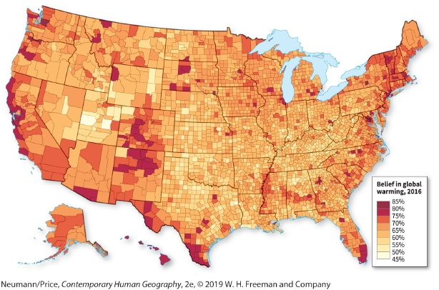

113. Using the framework of environmental perception, why is the spatial pattern of belief in global warming significant?
 | a. | An environmental perceptionist would say that the spatial pattern does not matter.
 | b. | People vote based on their perceptions, which has implications for policy.
 | c. | Areas with higher belief in global warming see more impacts of climate change.
 | d. | Areas with less belief in global warming do not see impacts of climate change.

114. The built forms that human societies created in inhabiting the Earth are part of the:
 | a. | natural landscape
 | b. | ecological landscape
 | c. | ecofeminism
 | d. | cultural landscape

115. Edward Relph's term placelessness refers to:
 | a. | standardization of landscape
 | b. | the merging of suburban and urban landscapes
 | c. | unpopulated regions
 | d. | the fragmentation of lifestyle regions

116. The Great Enclosure in the Great Zimbabwe National Monument is made of:
 | a. | split granite rocks from a nearby quarry expertly fit together
 | b. | clay and gravel mixed together, which deteriorated over time
 | c. | elephant bones and herring bones
 | d. | thatched huts built from palm fronds and local grasses

117. The intensely terraced hills in Southeast Asia are examples of:
 | a. | cultural landscapes
 | b. | environmental determinism
 | c. | the greenhouse effect
 | d. | natural hazards

118. The presence of _____ in a downtown area may contribute to a sense of placelessness.
 | a. | Walmart and McDonald's
 | b. | a local hardware store
 | c. | public parks
 | d. | children

119. Which type of region is organized to operate politically, socially, or economically as one unit?
 | a. | vernacular region
 | b. | continental region
 | c. | formal region
 | d. | functional region

120. Which is NOT a type of region recognized by human geographers?
 | a. | vernacular region
 | b. | continental region
 | c. | formal region
 | d. | functional region

121. The social activities and interactions, ranging from religious rituals to food and clothing preferences, that collectively distinguish group identity are called:
 | a. | cultural traits
 | b. | cultural exhibits
 | c. | cultural practices
 | d. | cultural taboos

122. A region that is perceived to exist by its inhabitants is a:
 | a. | formal region
 | b. | functional region
 | c. | vernacular region
 | d. | cultural region

123. _____ barriers completely halt diffusion.
 | a. | Time–distance decay
 | b. | Permeable
 | c. | Absorbing
 | d. | Osmotic

124. The overall phenomenon responsible for the landscape shown in this photo is:
 | a. | the influence of a continental or worldwide popular culture
 | b. | the tendency for diasporic landscapes to be located in easily accessible areas
 | c. | the lower mobility of people in an era of globalization
 | d. | the presence of thriving folk cultures in large swaths of the United States and Canada

125. Which would NOT be studied by human geographers?
 | a. | religion
 | b. | language
 | c. | government
 | d. | anatomy

126. A community protest against a proposal to build a highway nearby is trying to assert:
 | a. | the meaning and value that people derive from place
 | b. | a new spatial model to justify their opposition
 | c. | the highway will only work at the state scale
 | d. | that democratic processes are not appropriate at the local scale

127. A study that analyzes how sea level rise will impact small islands in the Pacific Ocean is looking at how a global process impacts regional places. This is an example of looking at:
 | a. | spatial modeling
 | b. | different spatial scales
 | c. | environmental determinism
 | d. | abstract space

128. Which is NOT an accurate definition of culture?
 | a. | the complete population of a given county, state, or country
 | b. | a dynamic mix of symbols, beliefs, speech, and practices; a distinctive group identity
 | c. | the local, customary way of doing things (a "way of life")
 | d. | a total way of life held in common by a people, including technology and government

129. Which statement is NOT true of popular culture?
 | a. | The term was coined by the urban elite.
 | b. | It focuses on specific, individual choices.
 | c. | Its material culture tends to be mass-produced.
 | d. | It was made possible by the invention of long-distance communication technologies.

130. The field of geography that examines the ways that indigenous people interact with their environment is called:
 | a. | environmental determinism
 | b. | possibilism
 | c. | cultural ecology
 | d. | ecosystem management

131. The study of human geography is organized around these five geographical concepts or themes:
 | a. | region, mobility, globalization, nature–culture, and cultural landscape
 | b. | climates, soils, globalization, cultural landscape, and region
 | c. | mobility, region, globalization, diplomacy, and cultural landscape
 | d. | mobility, immigration, globalization, nature–culture, and cultural landscape

132. Which perspective on human geography tends to generalize diversity in an effort to reveal processes creating spatial patterns?
 | a. | power and ideology
 | b. | topophilia
 | c. | model building
 | d. | sense of place

133. Sushi originated in Japan, but in the United States, it was originally only consumed in global cities. Since then eating sushi has become common throughout the country. This is an example of:
 | a. | independent invention
 | b. | contagious diffusion
 | c. | formal regional evolution
 | d. | hierarchical diffusion

134. According to the model shown here, middle-class housing is MOST likely to be found in Sector:
 | a. | commercial/ industrial areas
 | b. | elite residential sector
 | c. | zone of peripheral squatter settlements
 | d. | zone of accretion

135. Suppose a set of immigrants moves north from Mexico to California in order to find work in agricultural fields. At the end of the harvesting season, they move back to Mexico. These workers take part in:
 | a. | internal migration
 | b. | seasonal migration
 | c. | stepwise migration
 | d. | return migration

136. When Google Maps is telling us which way to turn to find a destination, it is converting absolute location into:
 | a. | a sense of place
 | b. | geographic information systems
 | c. | relative location
 | d. | global positioning system

137. Formal regions typically exhibit:
 | a. | a core-periphery pattern
 | b. | well-defined boundaries
 | c. | functional nodes
 | d. | a set of culture traits with identical spatial patterns

138. Folk cultures and indigenous cultures have what characteristic in common?
 | a. | They are ingrained in the national identity of their host country.
 | b. | They are associated with geographically isolated areas.
 | c. | Practitioners are ingrained into mainstream society.
 | d. | Their cultures are not reliant upon local materials.

139. Culture is:
 | a. | instinctive behavior
 | b. | inherited, individual behavior
 | c. | genetically derived group behavior
 | d. | learned, collective behavior

140. At a basic level, the vernacular region grows out of:
 | a. | people's sense of belonging to and identification with a specific region
 | b. | cultural homogeneity
 | c. | the nodes of a functional region
 | d. | functional organization

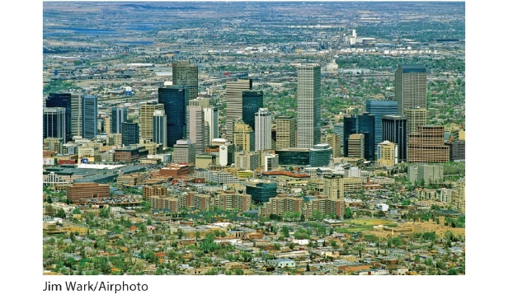

141. A city's downtown area, as pictured here for Denver, is often the _____ of a functional region.
 | a. | edge
 | b. | node
 | c. | model
 | d. | ecosystem

142. A geographer who uses an imaginary situation or abstraction in an attempt to isolate causes is building a:
 | a. | model
 | b. | space vs. place distinction
 | c. | map
 | d. | cartogram

143. Clothing, religious rituals, and food are examples of:
 | a. | environmental determinism
 | b. | cultural practices
 | c. | globalization
 | d. | spatial patterns

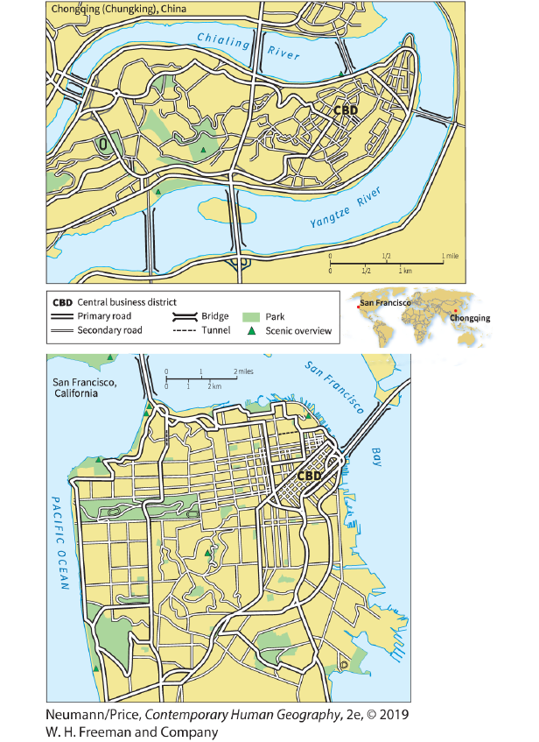

144. According to the figure shown here, Chongqing and San Francisco have all of the following characteristics in common EXCEPT:
 | a. | both were developed on elongated, hilly sites
 | b. | both follow a strict gridiron pattern in their streets
 | c. | both are flanked by water on all but one side
 | d. | both were connected in the twentieth century by bridges to adjacent land across the water

145. Which cultural assumption is NOT built into the typical American or Canadian house?
 | a. | the need for individual privacy
 | b. | the idea that functions (such as cooking and eating) should be kept separate
 | c. | the notion that the household is a hierarchy with the parents in charge
 | d. | the idea that multiple families should live and work together

146. Jews who were expelled from Spain brought their religious beliefs and practices to the new areas in which they settled. This is a case of:
 | a. | expansion diffusion
 | b. | contagious diffusion
 | c. | hierarchical diffusion
 | d. | relocation diffusion

147. Which is NOT a part of culture?
 | a. | genetics
 | b. | ideology
 | c. | technology
 | d. | livelihood

148. Indigenous peoples are often the descendants of the people who lived in a state or territory prior to:
 | a. | the Renaissance
 | b. | colonization
 | c. | the twentieth century
 | d. | the rise of slavery

149. In a hot climate, a certain group of people begins to build their homes with very high ceilings so that hot air will rise upward, away from the living space. They also paint their homes white to reflect sunlight away from their houses. In another area 50 miles away, the people start building homes with high ceilings but do not paint their homes white because they consider the color unlucky. This is an example of:
 | a. | relocation diffusion
 | b. | hierarchical diffusion
 | c. | contagious diffusion
 | d. | stimulus diffusion

150. Each state within the United States, and each province within Canada, can be considered a:
 | a. | vernacular region
 | b. | continental region
 | c. | state region
 | d. | functional region

151. A geographer seeking to understand why people are reserved and quiet at memorials would be examining:
 | a. | power and ideology
 | b. | topophilia
 | c. | model building
 | d. | sense of place

152. The term used to identify mobility as an ongoing set of movements with no particular center or periphery is:
 | a. | migration
 | b. | circulation
 | c. | orientation
 | d. | transnationalism

153. Which is NOT a formal region?
 | a. | a corn-growing county in Iowa
 | b. | a distribution network of the Washington Post
 | c. | a Chinese community in California's San Gabriel Valley
 | d. | the part of Russia called Siberia

154. Understanding how people make meaning from experiences in places is a goal of:
 | a. | spatial modeling
 | b. | topophilia
 | c. | the humanistic perspective
 | d. | regionalism

155. Understanding how human cultures interact with their environment reflects a(n):
 | a. | spatial perspective
 | b. | physical environment
 | c. | ecological perspective
 | d. | environmental determinism

156. The word culture describes:
 | a. | a means of communicating beliefs, practices, and values
 | b. | the interactions between humans and their environments
 | c. | the methods used to navigate between different places
 | d. | traditional practices of indigenous peoples around the world

157. The hippies of the 1960s formed a distinct segment of American society that set itself up in opposition to what it perceived as the problems of the dominant culture. Hippies can be said to have composed a distinctive:
 | a. | subculture
 | b. | culture
 | c. | enclave
 | d. | nonmaterial culture

158. The location of the prime meridian through Greenwich, England, represents:
 | a. | 0° latitude
 | b. | 0° longitude
 | c. | 180° longitude
 | d. | 180° latitude

159. The people of Siberia domesticated reindeer after learning about cattle being domesticated by people to their south. This is an example of which type of diffusion?
 | a. | contagious
 | b. | hierarchical
 | c. | stimulus
 | d. | vernacular

160. The number of formal regions recognized by geographers is:
 | a. | zero
 | b. | approximately 500
 | c. | approximately 20,000
 | d. | infinite

161. Which type of migration crosses country borders?
 | a. | international migration
 | b. | interregional migration
 | c. | intraregional migration
 | d. | internal migration

162. According to the model shown here, the transitional area between the mature zone and the periphery is found in Sector:
 | a. | spine
 | b. | elite residential sector
 | c. | zone of peripheral squatter settlements
 | d. | zone of accretion

163. Televisions, videocassette recorders, and videotapes were not permitted in Afghanistan during the regime of the Taliban. This is an example of:
 | a. | time–distance decay
 | b. | an absorbing barrier to diffusion
 | c. | a permeable barrier to diffusion
 | d. | stimulus diffusion

164. Many people believe that the best example of African architecture south of the Sahara can be found in:
 | a. | Pretoria, South Africa
 | b. | the region of Lake Victoria
 | c. | the Great Zimbabwe National Monument
 | d. | the tiny enclave of Lesotho

165. Which of the following is an example of absolute location?
 | a. | 40.7128°N, 74.0060°W
 | b. | South of Portland
 | c. | 97477-5218
 | d. | Near the St. Louis Arch

166. A folk culture is NOT likely to be:
 | a. | conservative
 | b. | homogeneous
 | c. | steeped in tradition
 | d. | culturally diverse

167. Latitude and longitude coordinates were invented to help people:
 | a. | navigate across oceans
 | b. | find a precise position on earth
 | c. | locate the prime meridian
 | d. | find the north and south poles

168. A geographer asking questions about why laws against loitering on sidewalks are only enforced on some people and not others is asking questions from a:
 | a. | humanistic perspective
 | b. | social theoretical perspective
 | c. | regional perspective
 | d. | spatial modeling perspective

169. Which statement is NOT true of indigenous cultures?
 | a. | They are the result of colonial efforts.
 | b. | They are now minorities in their homelands.
 | c. | They may share some of the material and nonmaterial characteristics that define folk cultures.
 | d. | They typically provide the foundation for a national culture.

170. The Great Migration, which refers to the twentieth-century movement of African Americans from the rural South to the cities of the North and Midwest, was which type of migration?
 | a. | return
 | b. | transnational
 | c. | internal
 | d. | stepwise

171. State capitals and city halls are both examples of:
 | a. | edges
 | b. | nodes
 | c. | peripheral architecture
 | d. | border zones

172. The wide range of beliefs, values, myths, and symbolic meanings of a culture form its:
 | a. | nonmaterial culture
 | b. | material culture
 | c. | subculture
 | d. | diaspora culture

173. Diseases such as HIV/AIDS often spread through:
 | a. | relocation diffusion
 | b. | hierarchical diffusion
 | c. | contagious diffusion
 | d. | stimulus diffusion

174. Large strip mines, greenhouse gas emissions, and large-scale logging are examples of environmental change that have occurred in:
 | a. | the twenty-first century
 | b. | developed countries
 | c. | the last ice age
 | d. | the Anthropocene

175. In order to investigate the spatial pattern of wheat production in the world, a geographer would investigate:
1) climate and soil characteristics
2) available technology
3) cultural preferences
4) food taboos
5) government policies
 | a. | 1 only
 | b. | 1 and 2
 | c. | 3, 4, and 5
 | d. | 1, 2, 3, 4, and 5

176. The term _____ is used to refer to the processes of economic, political, and social integration that have collectively created ties that make a difference to lives around the planet.
 | a. | diffusion
 | b. | ecological development
 | c. | hierarchical organization
 | d. | globalization

177. Suppose a family moves from the Russian countryside to Moscow, and then across the Russian border into Ukraine. This type of migration is:
 | a. | internal migration
 | b. | seasonal migration
 | c. | stepwise migration
 | d. | return migration

178. A culture region that is perceived to exist by its inhabitants is a:
 | a. | vernacular region
 | b. | continental region
 | c. | formal region
 | d. | functional region

179. The designation of Venice as a World Heritage Site indicated that:
 | a. | the city was important in European history
 | b. | landscape is a universally valued expression of culture and identity
 | c. | the United Nations was seeking to control more territory
 | d. | sites where humans dominated nature were worthwhile

180. Which of the following is an example of folk culture?
 | a. | punk rockers in Japan
 | b. | California sushi rolls
 | c. | cowboys in the American West
 | d. | Somali refugees in Kenya

181. Why do geographers "read" the landscape?
 | a. | to understand how landscape is represented in literature
 | b. | to focus on the symbolic qualities of various landscapes
 | c. | to see how agriculture is represented in paintings
 | d. | to see how dominant urban skylines are around the world

182. Kentucky Fried Chicken (KFC) stores now exist in Shanghai, China's largest city, and Beijing, its second major city. Soon, other KFC stores will open in other Chinese cities and towns that are smaller in size in a decreasing order. What type of diffusion does this process illustrate?
 | a. | hierarchical
 | b. | stimulus
 | c. | contagious
 | d. | permeable

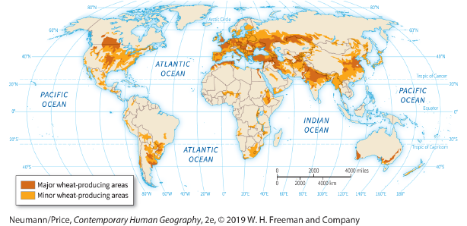

183. Based on the figure, which statement is NOT true?
 | a. | All continents, except Antarctica, contain both major and minor wheat-producing areas.
 | b. | In Africa, the only major wheat-producing area is found in Egypt.
 | c. | More of western Australia is used for producing wheat than eastern Australia.
 | d. | Wheat production in South America is found solely in the southern portion of the continent.

184. Which statement illustrates environmental determinism?
 | a. | Siberia is rich in mineral resources.
 | b. | In the Philippines, Luzon rice farmers terrace the hill slopes.
 | c. | Chile is a mountainous country.
 | d. | The natives are restless because of the hot season.

185. According to the figure, which African country is NOT home to a minor wheat-producing area?
 | a. | Morocco
 | b. | Botswana
 | c. | South Africa
 | d. | Tunisia

186. Within North America, the United States is a very developed country, while Mexico is relatively undeveloped. This is an example of:
 | a. | uneven development
 | b. | globalization
 | c. | hierarchical diffusion
 | d. | an absorbing barrier

187. Human geographers who want to understand how power influences people of different races, genders, or class will commonly use methods such as:
 | a. | literary texts and works of art
 | b. | spatial models
 | c. | interviews and surveys
 | d. | cartography

188. In some Islamic cities, the mosque is by far the largest building in the area, thus showing the importance of religion in the city. In this case, we might say that the mosques are an important part of the:
 | a. | elitist landscape
 | b. | symbolic landscape
 | c. | settlement landscape
 | d. | ecosystem

189. On the tropical rain-forest island of Borneo, some tribes practice slash-and-burn agriculture, while other tribes have chosen to be fishers. This exemplifies:
 | a. | agricultural adoption
 | b. | economic determinism
 | c. | divergent culturalism
 | d. | Possibilism

190. Which of the following is NOT an example of where human activities have worsened a natural hazard?
 | a. | the 2011 earthquake and nuclear plant meltdown in Japan
 | b. | the 2010 earthquake in Haiti
 | c. | Hurricane Maria in Puerto Rico in 2017
 | d. | the eruption of Mount Saint Helens in Washington State in 1980

191. Which concept suggests that a country's population possesses a set of recognizable characteristics or traits that characterize the "core" traits of that country?
 | a. | urban culture
 | b. | national culture
 | c. | national character
 | d. | folk culture

192. The core focus of human geography is:
 | a. | identifying places on a map
 | b. | understanding regional similarities
 | c. | describing cultural practices
 | d. | relationships between people and spaces

193. A(n) _____ culture is one composed of self-identified tribal peoples whose social, cultural, and economic conditions distinguish them from the national society of the country in which they live.
 | a. | folk
 | b. | indigenous
 | c. | rural
 | d. | national

194. People who move back and forth between their home nation and the one to which they have migrated are known as:
 | a. | refugees
 | b. | asylum seekers
 | c. | undocumented workers
 | d. | transnational migrants

Answer Key
1. True

2. True

3. False

4. False

5. False

6. True

7. False

8. True

9. False

10. True

11. True

12. True

13. False

14. True

15. True

16. False

17. True

18. True

19. True

20. True

21. False

22. False

23. True

24. True

25. False

26. False

27. True

28. True

29. True

30. False

31. False

32. True

33. True

34. False

35. True

36. False

37. False

38. True

39. True

40. False

41. False

42. False

43. True

44. False

45. True

46. False

47. False

48. True

49. False

50. False

51. True

52. True

53. False

54. True

55. True

56. True

57. False

58. False

59. False

60. False

61. False

62. True

63. True

64. False

65. False

66. False

67. False

68. True

69. False

70. a

71. b

72. d

73. a

74. d

75. a

76. d

77. d

78. d

79. a

80. d

81. a

82. b

83. c

84. a

85. c

86. d

87. a

88. b

89. d

90. b

91. c

92. c

93. b

94. c

95. d

96. c

97. c

98. c

99. a

100. b

101. a

102. b

103. c

104. c

105. d

106. d

107. b

108. c

109. d

110. a

111. d

112. d

113. b

114. d

115. a

116. a

117. a

118. a

119. d

120. b

121. c

122. c

123. c

124. a

125. d

126. a

127. b

128. a

129. b

130. c

131. a

132. c

133. d

134. d

135. b

136. c

137. a

138. b

139. d

140. a

141. b

142. a

143. b

144. b

145. d

146. d

147. a

148. b

149. d

150. d

151. d

152. b

153. b

154. c

155. c

156. a

157. a

158. b

159. c

160. d

161. a

162. d

163. b

164. c

165. a

166. d

167. b

168. b

169. d

170. c

171. b

172. a

173. c

174. d

175. d

176. d

177. c

178. a

179. b

180. c

181. b

182. a

183. c

184. d

185. b

186. a

187. c

188. b

189. d

190. d

191. b

192. d

193. b

194. d

