Package Title: Testbank

# Course Title: The World Today 8e

## Chapter Number: 01

Question Type: Multiple Choice

1) A large-scale map shows _______________.

a) a small area

b) a large area

c) no relationship between the scale on a map and the size of the area shown

d) an unbalanced area

e) the entire world

Answer: a

Difficulty: Medium

Learning Objective: Explain spatial perspectives, spatial patterns, and the importance of scale.

Standard 1: Bloom's || Knowledge

Section Reference: Geography’s Perspective

2) The ratio of distance on a map to actual ground distance is known as the ____________.

a) map legend

b) map scale

c) map revolution

d) cartographic rule

e) purpose of the map

Answer: b

Difficulty: Medium

Learning Objective: Explain spatial perspectives, spatial patterns, and the importance of scale.

Standard 1: Bloom's || Knowledge

Section Reference: Geography’s Perspective

3) Which of the following statements concerning map scale is false?

a) The fractional scale 1:1,000,000 means one inch on the map represents one million inches on the ground.

b) If the linear scale of a map is twice another, its areal representation is four times larger.

c) To represent a large area on a small map, a small scale is used.

d) Larger-scale maps allow for greater detail in depicting regions and subregions.

e) A map with the fractional scale 1:103,000,000 has a larger scale than one of 1:1,000,000.

Answer: e

Difficulty: Hard

Learning Objective: Explain spatial perspectives, spatial patterns, and the importance of scale.

Standard 1: Bloom's || Application

Section Reference: Geography’s Perspective

4) In Figure 1-3, which of the maps has the largest scale?

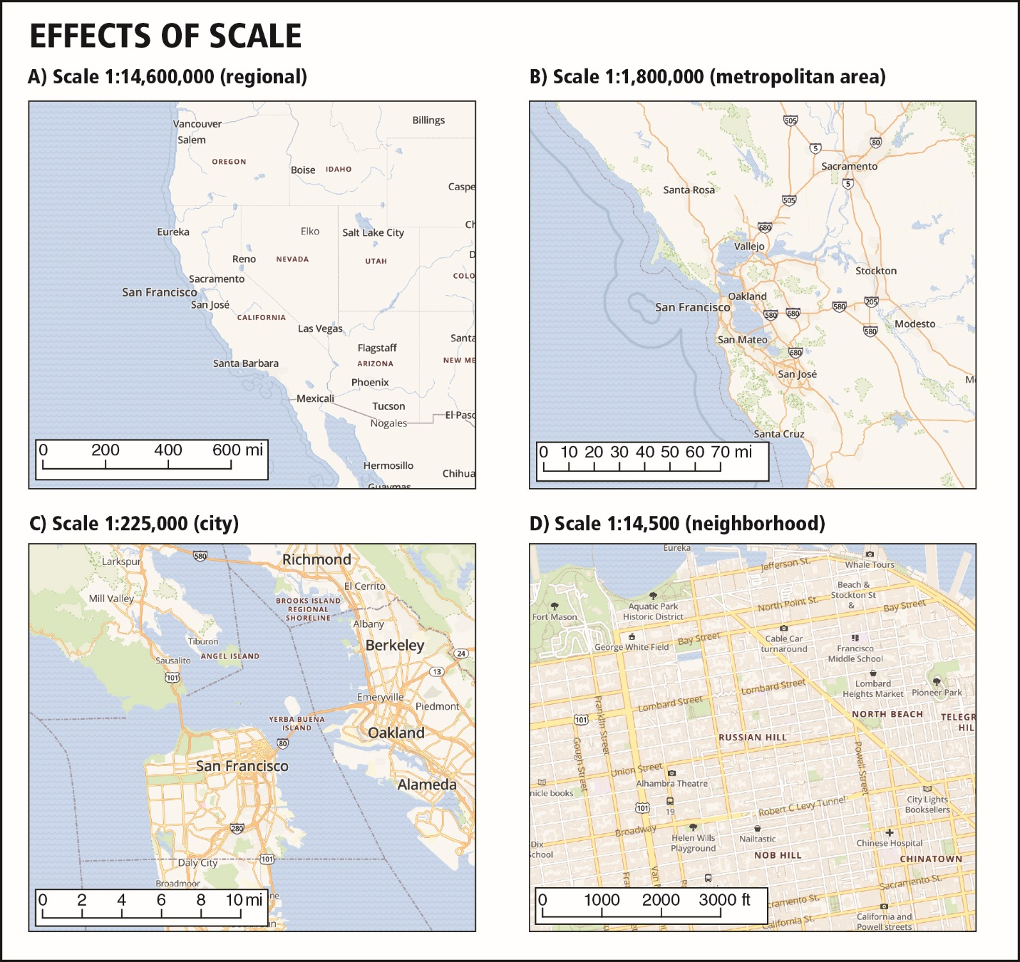

a) Map A

b) Map B

c) Map C

d) Map D

e) They all have the same scale.

Answer: d

Difficulty: Medium

Learning Objective: Explain spatial perspectives, spatial patterns, and the importance of scale.

Standard 1: Bloom's || Application

Section Reference: Geography’s Perspective

5) The area that surrounds and is served by a city is known as its _____________.

a) periphery

b) formal region

c) hinterland

d) core

e) relative location

Answer: c

Difficulty: Easy

Learning Objective: Discuss regions and how they relate to realms and explain the difference between formal and functional regions.

Standard 1: Bloom's || Knowledge

Section Reference: Regions within Realms

6) In regional geography, relative location _______________.

a) is more meaningful and practical than absolute location

b) refers to the latitude of a place

c) refers to the longitudinal position of a place

d) can only be found using a GIS

e) is a type of transition zone

Answer: a

Difficulty: Hard

Learning Objective: Discuss regions and how they relate to realms and explain the difference between formal and functional regions.

Standard 1: Bloom's || Knowledge

Section Reference: Regions within Realms

7) A functional region _______________.

a) is defined on the basis of some variable, such as the area where wheat is grown

b) is exemplified by a city and its hinterland

c) is also known as a formal region

d) has a transition zone at its center

e) is the same as a uniform region

Answer: b

Difficulty: Medium

Learning Objective: Discuss regions and how they relate to realms and explain the difference between formal and functional regions.

Standard 1: Bloom's || Knowledge

Section Reference: Regions within Realms

8) Which of the following statements is INCORRECT?

a) Regions marked by internal homogeneity are classified as formal regions.

b) Regions conceptualized as “spatial systems” are collectively identified as functional regions.

c) A country likely constitutes a formal political region because within its boundaries certain conditions of nationality, law, and political tradition prevail.

d) Functional regions are generally more static and internally immobile than formal regions.

e) Functional regions have a core and a periphery.

Answer: d

Difficulty: Hard

Learning Objective: Discuss regions and how they relate to realms and explain the difference between formal and functional regions.

Standard 1: Bloom's || Knowledge

Section Reference: Regions within Realms

9) The difference between formal and functional regions is _____________________.

a) the nature of the unifying properties: static homogeneity versus functional cohesion

b) the area involved: Formal areas are very large, while functional areas are smaller

c) the formal region is urban in nature, whereas the functional region is rural

d) the age of the regions: The functional region is normally much older than the formal region

e) the formal region characterizes the non-Western world, whereas the functional region is typically European or North American

Answer: a

Difficulty: Medium

Learning Objective: Discuss regions and how they relate to realms and explain the difference between formal and functional regions.

Standard 1: Bloom's || Knowledge

Section Reference: Regions within Realms

10) All regions possess all of the following EXCEPT ____________.

a) absolute location

b) area

c) homogeneity

d) boundaries

e) relative location

Answer: c

Difficulty: Easy

Learning Objective: Discuss regions and how they relate to realms and explain the difference between formal and functional regions.

Standard 1: Bloom's || Knowledge

Section Reference: Regions within Realms

11) Wegener's supercontinent is known as ____________.

a) Tectonica

b) Atlantis

c) Eurasia

d) Pangaea

e) Wegneria

Answer: d

Difficulty: Medium

Learning Objective: Identify the major elements of the natural environment and their general geographic characteristics.

Standard 1: Bloom's || Knowledge

Section Reference: The Physical Setting

12) Which of the following is the process whereby the sun's radiation is trapped in the Earth's atmosphere.

a) desertification

b) continental drift

c) interglaciation

d) greenhouse effect

e) There is no such effect.

Answer: d

Difficulty: Easy

Learning Objective: Identify the major elements of the natural environment and their general geographic characteristics.

Standard 1: Bloom's || Knowledge

Section Reference: The Physical Setting

13) The hypothesis of ________ involves the breakup of a supercontinent that existed hundreds of millions of years ago.

a) volcanic eruption

b) earthquake formation

c) continental drift

d) tectonic ring firing

e) natural hazardification

Answer: c

Difficulty: Easy

Learning Objective: Identify the major elements of the natural environment and their general geographic characteristics.

Standard 1: Bloom's || Knowledge

Section Reference: The Physical Setting

14) The current geologic period is known as the _____________.

a) Wisconsinan

b) Wegnerian

c) Pleistocene

d) Little Ice Age

e) Anthropocene

Answer: e

Difficulty: Medium

Learning Objective: Identify the major elements of the natural environment and their general geographic characteristics.

Standard 1: Bloom's || Knowledge

Section Reference: The Physical Setting

15) Which water body is surrounded by the geologically active Ring of Fire?

a) the North American Great Lakes

b) the Arctic Ocean

c) the Atlantic Ocean

d) the Pacific Ocean

e) the Gulf of Mexico

Answer: d

Difficulty: Easy

Learning Objective: Identify the major elements of the natural environment and their general geographic characteristics.

Standard 1: Bloom's || Knowledge

Section Reference: The Physical Setting

16) Which of the following statements is TRUE?

a) Desertification occurs only on the Eurasian landmass.

b) The climate type of the southwestern United States is similar to that of southwestern Africa.

c) The term *climate* refers to the immediate state of the atmosphere.

d) Alfred Wegener derived the theory of climatic regions.

e) We are currently in the post-Holocene geologic epoch.

Answer: b

Difficulty: Hard

Learning Objective: Identify the major elements of the natural environment and their general geographic characteristics.

Standard 1: Bloom's || Knowledge

Section Reference: The Physical Setting

17) Which of the following statements about the *A* climatesis INCORRECT?

a) They are referred to as humid equatorial climates.

b) They are characterized by heavy precipitation and high year-round temperatures.

c) In the *Af* climate, precipitation rates increase suddenly due to the arrival of the wet monsoon.

d) The *Aw* subtype is identified as savanna.

e) They include monsoon climates.

Answer: c

Difficulty: Hard

Learning Objective: Identify the major elements of the natural environment and their general geographic characteristics.

Standard 1: Bloom's || Knowledge

Section Reference: The Physical Setting

18) Savanna environments belong to the general climate type known as _____________.

a) dry

b) humid cold

c) humid temperate

d) humid equatorial

e) polar

Answer: d

Difficulty: Medium

Learning Objective: Identify the major elements of the natural environment and their general geographic characteristics.

Standard 1: Bloom's || Knowledge

Section Reference: The Physical Setting

19) The prevailing midlatitude climatic type in the southeastern United States, Western Europe, southern Brazil, northern Argentina, and eastern China, is the _______________.

a) humid cold

b) semiarid moderate

c) humid temperate

d) dry winter tundra

e) dry summer savanna

Answer: c

Difficulty: Medium

Learning Objective: Identify the major elements of the natural environment and their general geographic characteristics.

Standard 1: Bloom's || Knowledge

Section Reference: The Physical Setting

20) According to Figure 1-5, which location has the least amount of volcanic activity?

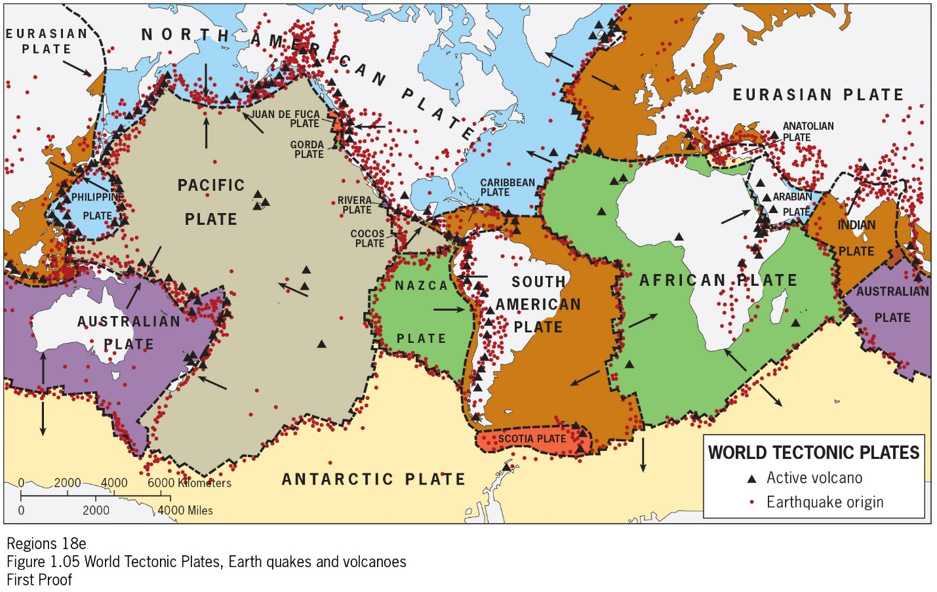

a) the United States

b) South America

c) Subsaharan Africa

d) East Asia

e) Australia

Answer: e

Difficulty: Easy

Learning Objective: Identify the major elements of the natural environment and their general geographic characteristics.

Standard 1: Bloom's || Application

Section Reference: The Physical Setting

21) Certain continents are readily linked with a dominant physical feature. For example:

1. North America and the Appalachian Mountains
2. Asia and the Himalayas
3. South America with the Congo River Basin
4. Africa and the Arabian Desert
5. Europe and the Andes Mountains

Answer: b

Difficulty: Medium

Learning Objective: Identify the major elements of the natural environment and their general geographic characteristics.

Standard 1: Bloom's || Application

Section Reference: The Physical Setting

22) Friction between which two tectonic plates is likely to have caused the earthquake in Nepal in Spring, 2015?

1. African and Arabian
2. Indian and Eurasian
3. South American and Nazca
4. Pacific and Australian
5. North American and Pacific

Answer: b

Difficulty: Medium

Learning Objective: Identify the major elements of the natural environment and their general geographic characteristics.

Standard 1: Bloom's || Application

Section Reference: The Physical Setting

23) According to the world map (Figure 1-1), despite having no major mountain ranges, this continent where the Rift Valley complex is located on average has a high elevation:

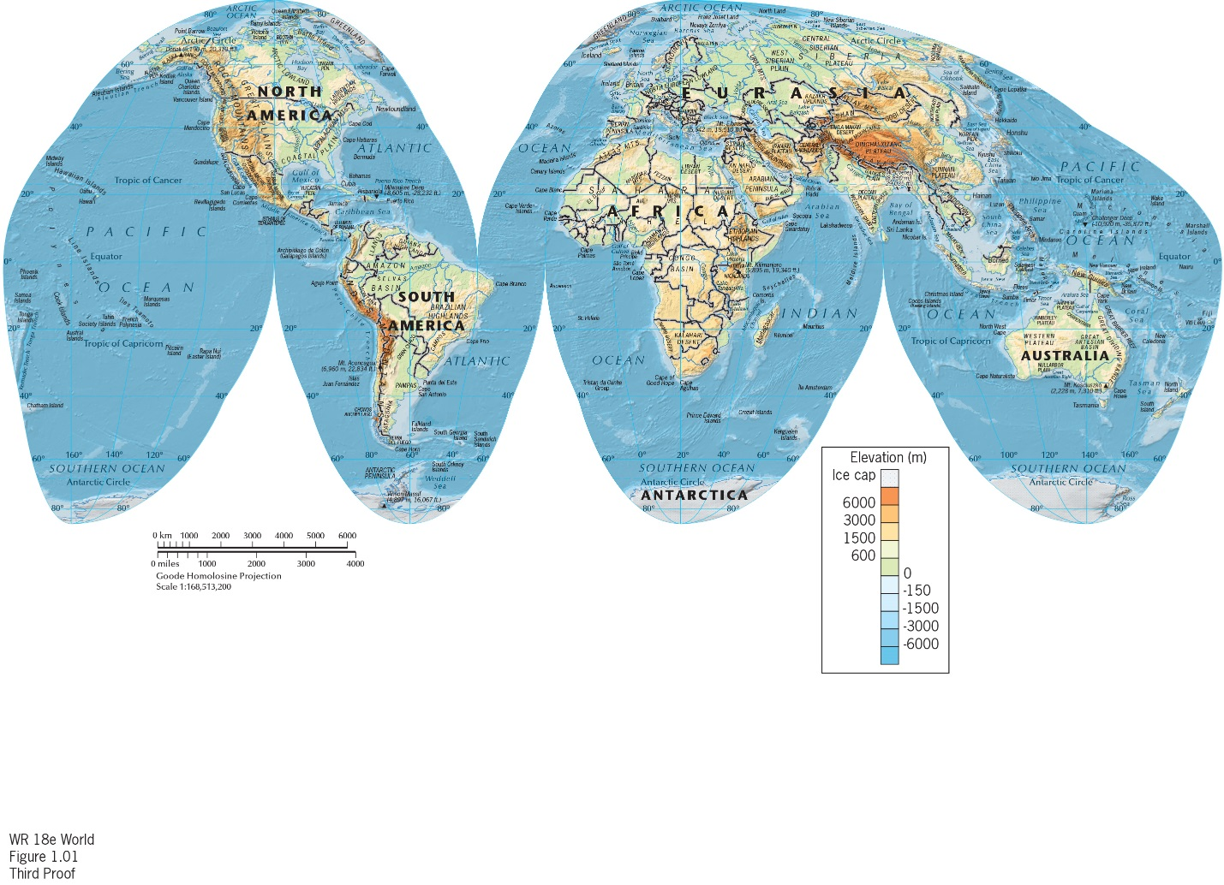

1. Asia
2. North America
3. South America
4. Africa
5. Europe

Answer: d

Difficulty: Easy

Learning Objective: Identify the major elements of the natural environment and their

general geographic characteristics.

Standard 1: Bloom's || Application

Section Reference: The Physical Setting

24) Global climate never stops changing.

Answer: True

Difficulty: Easy

Learning Objective: Identify the major elements of the natural environment and their

general geographic characteristics.

Standard 1: Bloom's || Comprehension

Section Reference: The Physical Setting

25) Which of the following major rivers is NOT associated with one of the world's great population clusters?

a) Mississippi

b) Huang (Yellow)

c) Rhine

d) Ganges

e) Chang Jiang (Yangzi)

Answer: a

Difficulty: Medium

Learning Objective: Explain the concepts of population distribution, urbanization, and cultural landscapes.

Standard 1: Bloom's || Knowledge

Section Reference: Realms of Population

26) Which of the following statements is INCORRECT?

a) China now has more people living in cities than in rural areas.

b) East Asia's population is projected to remain larger than South Asia's for the rest of this century.

c) The eastern North American population cluster is only about one-fourth the size of Europe's.

d) The world's three largest population clusters are all located on the Eurasian landmass.

e) Europe's population is predominantly urban.

Answer: b

Difficulty: Medium

Learning Objective: Explain the concepts of population distribution, urbanization, and cultural landscapes.

Standard 1: Bloom's || Knowledge

Section Reference: Realms of Population

27) The large cluster of population in South Asia is focused on the ______ River Basin.

a) Yellow

b) Amazon

c) Nile

d) Ganges

e) Yangzi

Answer: d

Difficulty: Hard

Learning Objective: Explain the concepts of population distribution, urbanization, and cultural landscapes.

Standard 1: Bloom's || Knowledge

Section Reference: Realms of Population

28) Which country is NOT located within one of the world's three largest population clusters:

a) South Korea

b) the United States

c) Pakistan

d) France

e) China

Answer: b

Difficulty: Hard

Learning Objective: Explain the concepts of population distribution, urbanization, and cultural landscapes.

Standard 1: Bloom's || Knowledge

Section Reference: Realms of Population

29) Figure 1-8 shows that the English language, predominant in North America, belongs to the language family.

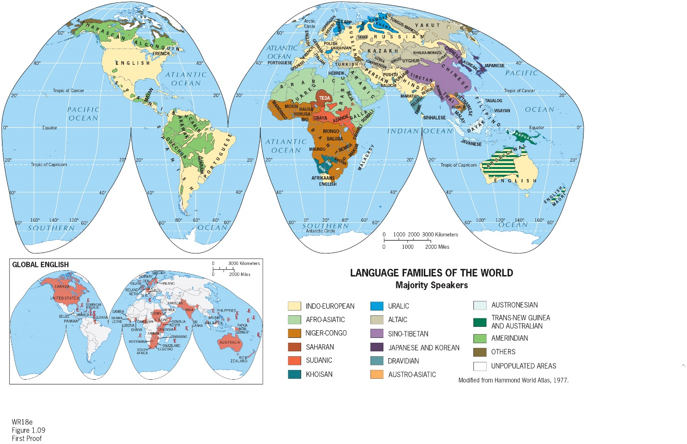

a) Indo-European

b) Altaic

c) Dravidian

d) Amerindian

e) Uralic

Answer: a

Difficulty: Easy

Learning Objective: Describe the notion of cultural landscape and discuss the roles of language and religion in cultural geographies.

Standard 1: Bloom's || Application

Section Reference: Realms of Culture

30) Figure 1-9 shows that _________ is the most dominant religion in the northern part of Africa:



a) Shia Islam

b) Sunni Islam

c) Traditional and Shamanist faiths

d) Roman Catholicism

e) Hinduism

Answer: b

Difficulty: Easy

Learning Objective: Describe the notion of cultural landscape and discuss the roles of language and religion in cultural geographies.

Standard 1: Bloom's || Application

Section Reference: Realms of Culture

31) States first began to develop _____________________.

a) because agricultural surpluses were accompanied by a more sophisticated and centralized exercise of power and political organization

b) in open areas between empires

c) in nineteenth-century Europe

d) in areas where boundaries had already been drawn by royal decree

e) They have always existed.

Answer: a

Difficulty: Hard

Learning Objective: Discuss the global state boundary framework and the notion of geopolitics.

Standard 1: Bloom's || Comprehension

Section Reference: A World of States

32) The European state model includes all of the following except ______________.

a) a population governed from a capital city

b) a clearly and legally defined territory

c) a representative government

d) a high level of urbanization

e) a concept developed during the seventeenth century in Europe.

Answer: d

Difficulty: Medium

Learning Objective: Discuss the global state boundary framework and the notion of geopolitics.

Standard 1: Bloom's || Knowledge

Section Reference: A World of States

33) The World Bank ranks countries within four groups. Which of the following is NOT one of those groups?

a) high-income countries

b) upper-middle-income countries

c) lower-middle-income countries

d) middle-income countries

e) low-income countries

Answer: d

Difficulty: Easy

Learning Objective: Explain the sub‐discipline of economic geography and various definitions of development.

Standard 1: Bloom's || Knowledge

Section Reference: Geographies of Development

34) Which of the following statements about the Global Core is INCORRECT?

a) It was formed before the 20th century

b) It is a good example of a functional region

c) It now contains Canada, Germany, Japan, and China

d) It is a component of an international spatial-economic system

e) It is subservient to the Global Periphery

Answer: e

Difficulty: Hard

Learning Objective: Explain the sub‐discipline of economic geography and various definitions of development.

Standard 1: Bloom's || Comprehension

Section Reference: Geographies of Development

35) An index of regional disparity would be useful for examining _________________.

a) economic differences between different regions of a country

b) political differences between functional and formal regions

c) climatic differences between core and periphery

d) similarities among African and Asian countries

e) differences between the Western and Eastern Hemispheres

Answer: a

Difficulty: Medium

Learning Objective: Explain the sub‐discipline of economic geography and various definitions of development.

Standard 1: Bloom's || Comprehension

Section Reference: Geographies of Development

36) Which of these countries is NOT considered a high-income economy, as classified by the World Bank in Figure 1-10?

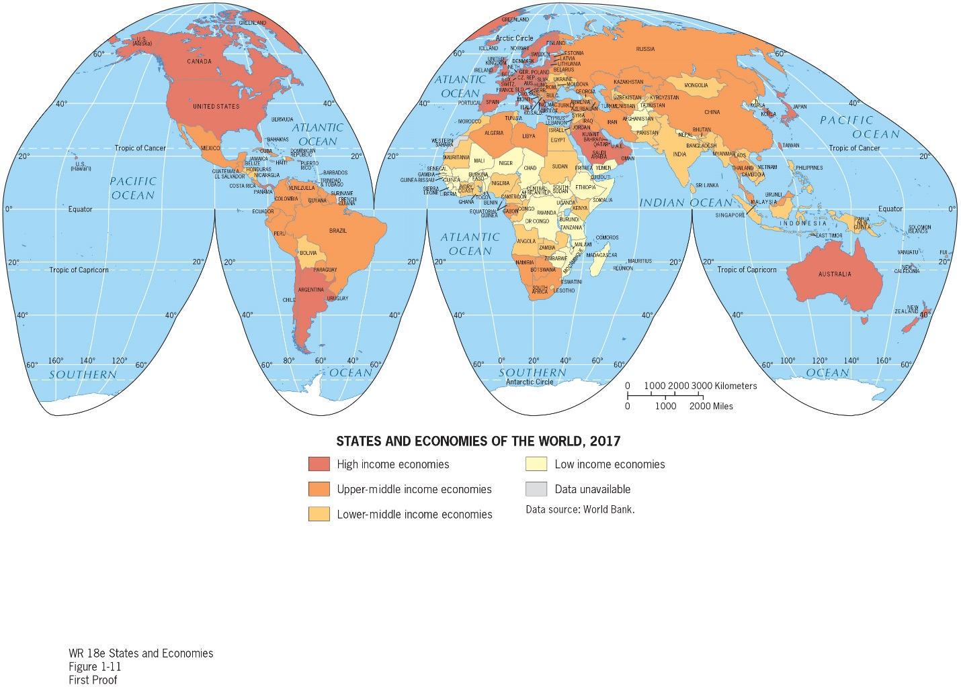

a) the United States

b) Canada

c) China

d) Japan

e) Australia

Answer: c

Difficulty: Easy

Learning Objective: Explain the sub‐discipline of economic geography and various definitions of development.

Standard 1: Bloom's || Application

Section Reference: Geographies of Development

37) Which of the following realms contains one of the top three population clusters but lies entirely outside of the Global Core, according to Figure 1-11?

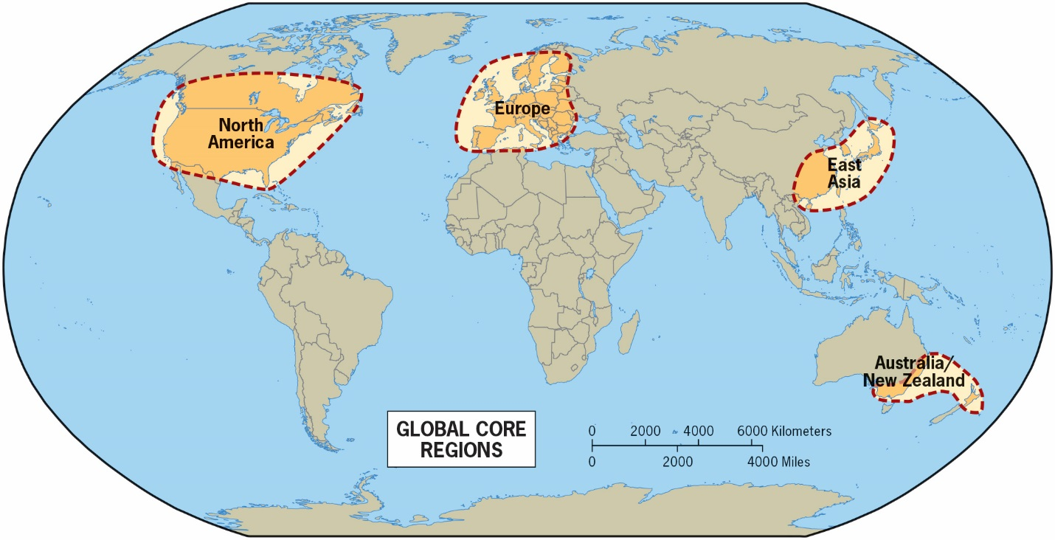

a) Europe

b) North America

c) East Asia

d) South Asia

e) Austral Realm

Answer: d

Difficulty: Hard

Learning Objective: Explain the sub‐discipline of economic geography and various definitions of development .

Standard 1: Bloom's || Synthesis

Section Reference: Geographies of Development

38) Which of the following is NOT an example of globalization?

a) McDonald's expansion into China

b) FIFA (International Federation of Association Football)

c) the worldwide dominance of English

d) Japanese cars assembled in Thailand

e) tariffs imposed on foreign automobiles

Answer: e

Difficulty: Medium

Learning Objective: Explain the spatial dimensions of globalization and migration.

Standard 1: Bloom's || Analysis

Section Reference: Globalization

39) The gradual reduction of regional contrasts resulting from increasing cultural, economic, political and other types of exchanges is known as ______________.

a) regional disparity

b) regional equalization

c) world flattening

d) the European trade model

e) globalization

Answer: e

Difficulty: Easy

Learning Objective: Explain the spatial dimensions of globalization and migration.

Standard 1: Bloom's || Knowledge

Section Reference: Globalization

40) Which of the following is a systematic subfield of geography?

a) regional geography

b) cartography

c) Geographic Information Science (GIS)

d) cultural geography

e) geology

Answer: d

Difficulty: Easy

Learning Objective: Explain the connections between regional and thematic foci in geography.

Standard 1: Bloom's || Knowledge

Section Reference: Regional and Thematic Geographies

41) A majority of earthquakes occur in and around the Pacific Ocean because:

a) Wave activity in the enormous Pacific Ocean can cause earthquakes.

b) God has chosen to punish people around this waterbody.

c) A majority of land closest to the Pacific Ocean is relatively flat making tsunami waves cause more damage when earthquakes do occur.

d) The Pacific Ocean is the biggest ocean. Therefore, it is logical that it has the most earthquakes.

e) Plate tectonic boundaries are the most common in this area.

Answer: e

Difficulty: Medium

Learning Objective: Identify the major elements of the natural environment and their general geographic characteristics.

Standard 1: Bloom's || Application

Section Reference: The Physical Setting

42) States can see their relative geopolitical status change as a result of______________.

a) new technologies

b) new leaders

c) growing populations

d) declining populations

e) natural disasters

Answer: a

Difficulty: Medium

Learning Objective: Discuss the global state boundary framework and the notion of geopolitics.

Standard 1: Bloom's || Knowledge

Section Reference: A World of States

43) This tool helps to summarize the circumstances when political and cultural boundaries are at odds.

a) border guard

b) border wall

c) map

d) camera

e) compass

Answer: c

Difficulty: Medium

Learning Objective: Explain the importance of maps, cartography, and the mapping revolution.

Standard 1: Bloom's || Knowledge

Section Reference: A World on Maps

44) A geospatial scientist does not utilize information collected through this medium.

a) smartphones

b) satellites

c) airplanes

d) radar

e) GIS

Answer: e

Difficulty: Medium

Learning Objective: Explain the importance of maps, cartography, and the mapping revolution.

Standard 1: Bloom's || Knowledge

Section Reference: A World on Maps

45) This instrument aids in identifying Sunni and Shi’ite Muslim adherents on maps.

a) satellite

b) field reporter

c) GIS

d) camera

e) aerial photography

Answer: b

Difficulty: Medium

Learning Objective: Explain the importance of maps, cartography, and the mapping revolution.

Standard 1: Bloom's || Knowledge

Section Reference: A World on Maps

46) This helps identify a geographical realm.

a) environmental factors

b) historical factors

c) cultural factors

d) organizational factors

e) All of the answer choices are correct.

Answer: e

Difficulty: Medium

Learning Objective: Explain the defining criteria for realms and regions.

Standard 1: Bloom's || Knowledge

Section Reference: World Geographic Realms

47) This is not a monocentric realm.

a) North America

b) Middle America

c) Europe

d) South Asia

e) East Asia

Answer: c

Difficulty: Medium

Learning Objective: Explain the defining criteria for realms and regions.

Standard 1: Bloom's || Application

Section Reference: World Geographic Realms

48) This country is the most influential power in the polycentric realm of Southeast Asia.

a) Philippines

b) Singapore

c) Thailand

d) Indonesia

e) Malaysia

Answer: d

Difficulty: Medium

Learning Objective: Explain the defining criteria for realms and regions.

Standard 1: Bloom's || Application

Section Reference: World Geographic Realms

49) This is not a thematic field of geography.

a) geomorphology

b) None of the choices are correct.

c) marine geography

d) climatology

e) biogeography

Answer: b

Learning Objective: Explain the connections between regional and thematic foci in geography

Standard 1: Bloom's || Knowledge

Section Reference: Regional and Thematic Geographies

50) Review Figure 1-15. This definition best describes geography.

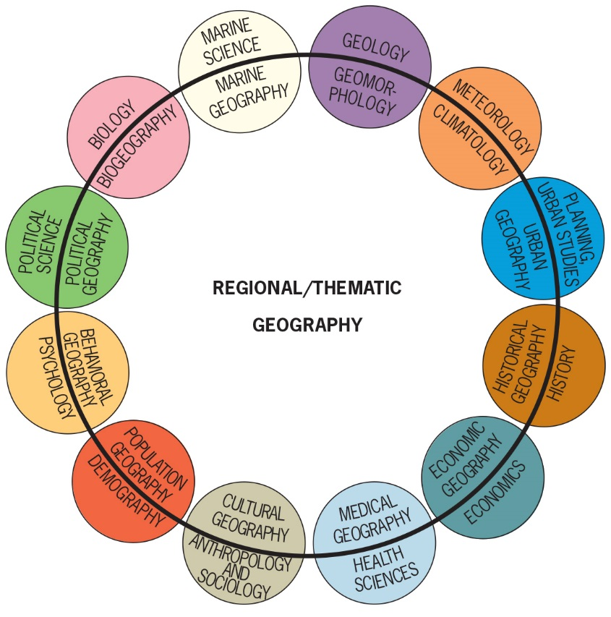

a) Geography is a physical science.

b) All of the choices are correct.

c) Geography is a social science.

d) Geography overlaps a great deal with other disciplines.

e) Geography is the study of the uneven distribution of things in time and space.

Answer: e

Learning Objective: Explain the connections between regional and thematic foci in geography

Standard 1: Bloom's || Knowledge

Section Reference: Regional and Thematic Geographies

Question Type: True/False

51) Geography is concerned with providing a spatial perspective on the world.

Answer: True

Difficulty: Easy

Learning Objective: Explain spatial perspectives, spatial patterns, and the importance of scale.

Standard 1: Bloom's || Knowledge

Section Reference: Geography’s Perspective

52) A world map is a small-scale map.

Answer: True

Difficulty: Medium

Learning Objective: Explain spatial perspectives, spatial patterns, and the importance of scale.

Standard 1: Bloom's || Comprehension

Section Reference: Geography’s Perspective

53) Map scale is the ratio of the distance between two places on a map and the actual distance between those two places on the Earth's surface.

Answer: True

Difficulty: Medium

Learning Objective: Explain spatial perspectives, spatial patterns, and the importance of scale.

Standard 1: Bloom's || Comprehension

Section Reference: Geography’s Perspective

54) A mental map shows an area committed to a person's memory.

Answer: True

Difficulty: Easy

Learning Objective: Explain the importance of maps, cartography, and the mapping revolution.

Standard 1: Bloom's || Knowledge

Section Reference: A World on Maps

55) Cartography is the new science of making maps with computers.

Answer: False

Difficulty: Easy

Learning Objective: Explain the importance of maps, cartography, and the mapping revolution.

Standard 1: Bloom's || Knowledge

Section Reference: A World on Maps

56) To find a city street, a small-scale map should be used.

Answer: False

Difficulty: Medium

Learning Objective: Explain spatial perspectives, spatial patterns, and the importance of scale.

Standard 1: Bloom's || Application

Section Reference: Geography’s Perspective

57) In land area, Russia is the largest nation on earth.

Answer: True

Difficulty: Easy

Learning Objective: Explain the defining criteria for realms and regions.

Standard 1: Bloom's || Knowledge

Section Reference: World Geographic Realms

58) Transition zones often mark the places where geographic realms meet.

Answer: True

Difficulty: Easy

Learning Objective: Explain the defining criteria for realms and regions.

Standard 1: Bloom's || Knowledge

Section Reference: World Geographic Realms

59) A region marked by homogeneity is known as a functional region.

Answer: False

Difficulty: Medium

Learning Objective: Discuss regions and how they relate to realms and explain the difference between formal and functional regions.

Standard 1: Bloom's || Knowledge

Section Reference: Regions within Realms

60) Besides location, a region must also possess areal extent.

Answer: True

Difficulty: Easy

Learning Objective: Discuss regions and how they relate to realms and explain the difference between formal and functional regions.

Standard 1: Bloom's || Knowledge

Section Reference: Regions within Realms

61) A region does not need to possess the geographic property of relative location.

Answer: False

Difficulty: Medium

Learning Objective: Discuss regions and how they relate to realms and explain the difference between formal and functional regions.

Standard 1: Bloom's || Knowledge

Section Reference: Regions within Realms

62) Relative location has far less relevance in human geography than absolute location.

Answer: False

Difficulty: Easy

Learning Objective: Discuss regions and how they relate to realms and explain the difference between formal and functional regions.

Standard 1: Bloom's || Knowledge

Section Reference: Regions within Realms

63) A region organized around a central urban core is known as a functional region.

Answer: True

Difficulty: Easy

Learning Objective: Discuss regions and how they relate to realms and explain the difference between formal and functional regions.

Standard 1: Bloom's || Knowledge

Section Reference: Regions within Realms

64) Wladimir Köppen developed the hypothesis of continental drift.

Answer: False

Difficulty: Easy

Learning Objective: Identify the major elements of the natural environment and their general geographic characteristics.

Standard 1: Bloom's || Knowledge

Section Reference: The Physical Setting

65) Pangaea is the name of Wegener's supercontinent.

Answer: True

Difficulty: Easy

Learning Objective: Identify the major elements of the natural environment and their general geographic characteristics.

Standard 1: Bloom's || Knowledge

Section Reference: The Physical Setting

66) The Holocene is the name of the most recent glaciation.

Answer: False

Difficulty: Medium

Learning Objective: Identify the major elements of the natural environment and their general geographic characteristics.

Standard 1: Bloom's || Knowledge

Section Reference: The Physical Setting

67) The *D* climates are humid cold climates.

Answer: True

Difficulty: Easy

Learning Objective: Identify the major elements of the natural environment and their general geographic characteristics.

Standard 1: Bloom's || Knowledge

Section Reference: The Physical Setting

68) In the Köppen-Geiger scheme, the world's drier climates are largely grouped under the letter *A*.

Answer: False

Difficulty: Easy

Learning Objective: Identify the major elements of the natural environment and their general geographic characteristics.

Standard 1: Bloom's || Knowledge

Section Reference: The Physical Setting

69) Weather is a momentary phenomenon, whereas climate refers to atmospheric conditions over the entire period for which records are available.

Answer: True

Difficulty: Easy

Learning Objective: Identify the major elements of the natural environment and their general geographic characteristics.

Standard 1: Bloom's || Knowledge

Section Reference: The Physical Setting

70) Population density refers to the number of persons per unit area.

Answer: True

Difficulty: Medium

Learning Objective: Explain the concepts of population distribution, urbanization, and cultural landscapes.

Standard 1: Bloom's || Knowledge

Section Reference: Realms of Population

71) The world’s population is currently estimated to recently have passed 10 billion in total size.

Answer: False

Difficulty: Easy

Learning Objective: Explain the concepts of population distribution, urbanization, and cultural landscapes.

Standard 1: Bloom's || Knowledge

Section Reference: Realms of Population

72) The Subsaharan African realm does not rank among the world's four largest population clusters.

Answer: True

Difficulty: Medium

Learning Objective: Explain the concepts of population distribution, urbanization, and cultural landscapes.

Standard 1: Bloom's || Knowledge

Section Reference: Realms of Population

73) China now has more people living in cities than in rural areas.

Answer: True

Difficulty: Medium

Learning Objective: Explain the concepts of population distribution, urbanization, and cultural landscapes.

Standard 1: Bloom's || Knowledge

Section Reference: Realms of Population

74) The world population growth rate has recently been slowing down.

Answer: True

Difficulty: Easy

Learning Objective: Explain the concepts of population distribution, urbanization, and cultural landscapes.

Standard 1: Bloom's || Knowledge

Section Reference: Realms of Population

75) The rate of urbanization increase is the same in every geographic realm.

Answer: False

Difficulty: Easy

Learning Objective: Explain the concepts of population distribution, urbanization, and cultural landscapes.

Standard 1: Bloom's || Knowledge

Section Reference: Realms of Population

76) Culture is predetermined by the natural environment.

Answer: False

Difficulty: Easy

Learning Objective: Describe the notion of cultural landscape and discuss the roles of language and religion in cultural geographies.

Standard 1: Bloom's || Application

Section Reference: Realms of Culture

77) According to Figure 1-7, all of the world’s major population clusters are located on a coast or major river.

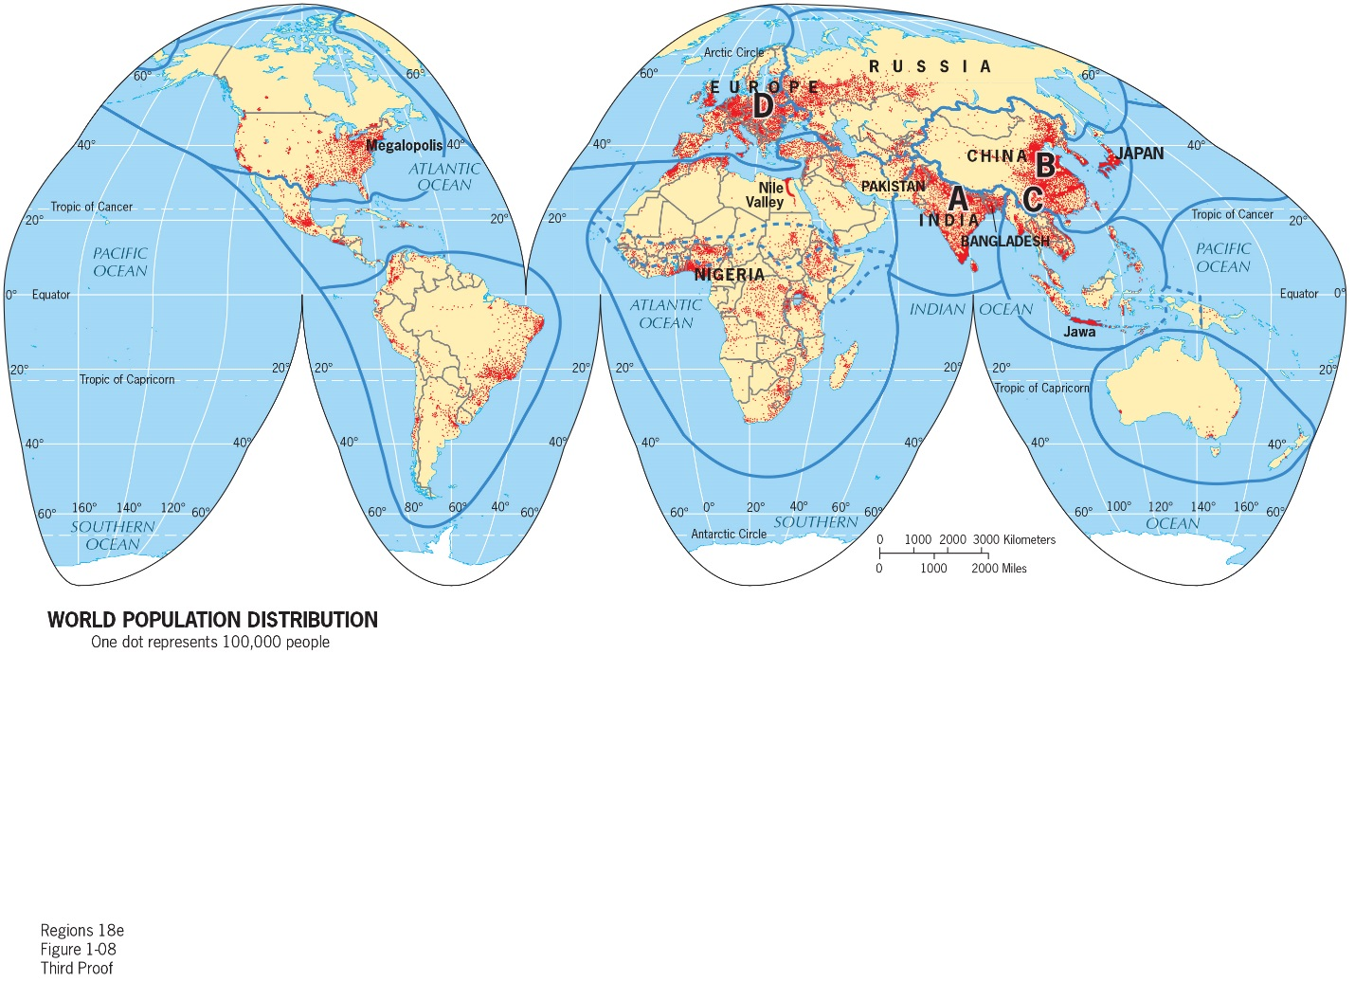

Answer: False

Difficulty: Medium

Learning Objective: Explain the concepts of population distribution, urbanization, and cultural landscapes.

Standard 1: Bloom's || Application

Section Reference: Realms of Population

78) A cultural landscape is created from a natural landscape by a cultural group.

Answer: True

Difficulty: Easy

Learning Objective: Describe the notion of cultural landscape and discuss the roles of language and religion in cultural geographies.

Standard 1: Bloom's || Application

Section Reference: Realms of Culture

79) Africa is the most *densely* populated continent.

Answer: False

Difficulty: Easy

Learning Objective: Explain the concepts of population distribution, urbanization and cultural landscapes.

Standard 1: Bloom's || Knowledge

Section Reference: Realms of Population.

80) From Figure 1-7 it appears that the eastern half of China is more densely populated than the western half.



Answer: True

Difficulty: Medium

Learning Objective: Explain the concepts of population distribution, urbanization, and cultural landscapes.

Standard 1: Bloom's || Application

Section Reference: Realms of Population

81) The modern state emerged during the height of Greek civilization.

Answer: False

Difficulty: Medium

Learning Objective: Discuss the global state boundary framework and the notion of geopolitics.

Standard 1: Bloom's || Knowledge

Section Reference: A World of States

82) Countries of large territorial size are usually more powerful than smaller countries.

Answer: True

Difficulty: Medium

Learning Objective: Discuss the global state boundary framework and the notion of geopolitics.

Standard 1: Bloom's || Comprehension

Section Reference: A World of States

83) Globalization impacts only those in the Global Periphery.

Answer: False

Difficulty: Easy

Learning Objective: Explain the spatial dimensions of globalization and migration.

Standard 1: Bloom's || Knowledge

Section Reference: Globalization

84) According to Figure 1-12, wealthy countries in the global economy positively impact the environment.

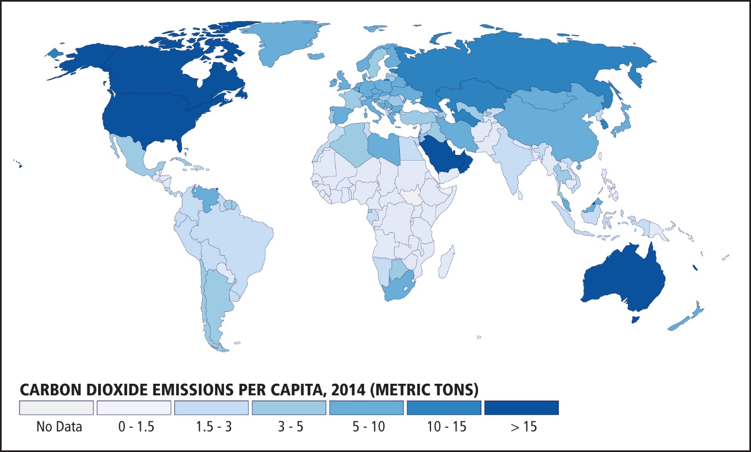

Answer: False

Difficulty: Medium

Learning Objective: Explain the spatial dimensions of globalization and migration.

Standard 1: Bloom's || Application

Section Reference: Globalization

85) Topical and thematic geography are synonymous.

Answer: True

Difficulty: Easy

Learning Objective: Explain the connections between regional and thematic foci in geography .

Standard 1: Bloom's || Knowledge

Section Reference: Regional and Thematic Geographies

Question Type: Fill-in-the-blank

86) The ratio of distance on a map to actual ground distance is known as that map's ___.

Answer: scale

Difficulty: Easy

Learning Objective: Explain spatial perspectives, spatial patterns, and the importance of scale.

Standard 1: Bloom's || Knowledge

Section Reference: Geography’s Perspective

87) A map of the entire world is a _______-scale map.

Answer: small

Difficulty: Easy

Learning Objective: Explain spatial perspectives, spatial patterns, and the importance of scale.

Standard 1: Bloom's || Knowledge

Section Reference: Geography’s Perspective

88) The ___ region, also known as a spatial system, is marked not by an internal sameness, but by its dynamic internal structuring.

Answer: functional

Difficulty: Easy

Learning Objective: Discuss regions and how they relate to realms and explain the difference between formal and functional regions.

Standard 1: Bloom's || Knowledge

Section Reference: Regions within Realms

89) Uniform cultural regions characterized by internal homogeneity are classified as ___ regions.

Answer: formal

Difficulty: Medium

Learning Objective: Discuss regions and how they relate to realms and explain the difference between formal and functional regions.

Standard 1: Bloom's || Knowledge

Section Reference: Regions within Realms

90) Desert and steppe climates belong to the Köppen-Geiger climate type identified by the letter ___.

Answer: B

Difficulty: Easy

Learning Objective: Identify the major elements of the natural environment and their general geographic characteristics.

Standard 1: Bloom's || Knowledge

Section Reference: The Physical Setting

91) The Southern Hemisphere contains no areas with ___ climates.

Answer: D

Difficulty: Medium

Learning Objective: Identify the major elements of the natural environment and their general geographic characteristics.

Standard 1: Bloom's || Application

Section Reference: The Physical Setting

92) The Intergovernmental Panel on Climate Change predicts an increase of 3.6°F or 2°C during the twenty-first century. Name at least one potential consequence if this is realized.

Answer: Flooding of low-lying areas, more intense hurricanes, species range changes by both plants and animals, melting of polar ice caps, etc.

Difficulty: Medium

Learning Objective: Identify the major elements of the natural environment and their general geographic characteristics.

Standard 1: Bloom's || Application

Section Reference: The Physical Setting

93) The world's population is approximately __ billion in size.

Answer: 7.7

Difficulty: Easy

Learning Objective: Explain the concepts of population distribution, urbanization, and cultural landscapes.

Standard 1: Bloom's || Knowledge

Section Reference: Realms of Population

94) The most widely spoken language family in the world is named the ___ language family.

Answer: Indo-European

Difficulty: Easy

Learning Objective: Describe the notion of cultural landscape and discuss the roles of language and religion in cultural geographies.

Standard 1: Bloom's || Application

Section Reference: Realms of Culture

95) What portable device most helps with globalized knowledge acquisition and navigation?

Answer: Smartphone

Difficulty: Medium

Learning Objective: Explain the spatial dimensions of globalization and migration.

Standard 1: Bloom's || Analysis

Section Reference: Globalization

96) ___ geography entails the discipline's topical fields of study.

Answer: Systematic

Difficulty: Easy

Learning Objective: Explain the connections between regional and thematic foci in geography

Standard 1: Bloom's || Knowledge

Section Reference: Regional and Thematic Geographies

© John Wiley & Sons, Inc. or the author, All rights reserved. Instructors who are authorized users of this course are permitted to download these materials and use them in connection with the course. Except as permitted herein or by law, no part of these materials should be reproduced, stored in a retrieval system, or transmitted, in any form or by any means, electronic, mechanical, photocopying, recording or otherwise.