Human Geography: Places and Regions in Global Context, Cdn. 5e (Knox et al.)
Chapter 1 Geography Matters

1.1 Minimal Choice

1) In a cartogram, ________ is distorted for effect.
A) space
B) location
Answer: A
Diff: 2
Bloom's: 1.5 Remembering/Understanding
Section Headings: The Basic Tools and Methods of Human Geographers

2) For data to be meaningful for GIS, it is critical that
A) the data's specific location in space can be identified.
B) the data can be seen in satellite images.
Answer: A
Diff: 1
Bloom's: 2 Understanding
Section Headings: The Basic Tools and Methods of Human Geographers

3) Isopleth maps rely heavily on
A) lines.
B) dots.
Answer: A
Diff: 3
Bloom's: 1.5 Remembering/Understanding
Section Headings: The Basic Tools and Methods of Human Geographers

4) GPS has drastically increased the accuracy and efficiency of collecting ________ data.
A) spatial
B) temporal
Answer: A
Diff: 2
Bloom's: 1.5 Remembering/Understanding
Section Headings: The Basic Tools and Methods of Human Geographers

5) Topographic maps are examples of
A) isopleth maps.
B) choropleth maps.
Answer: A
Diff: 3
Bloom's: 1 Remembering
Section Headings: The Basic Tools and Methods of Human Geographers

6) Small-scale maps cover a ________ portion of the Earth's surface on a page.
A) large
B) small
Answer: A
Diff: 2
Bloom's: 2 Understanding
Section Headings: The Basic Tools and Methods of Human Geographers
7) Representative fractions are ________ that indicate the ratio between linear distance on a map and actual distance on the Earth's surface.
A) map scales
B) proportional charts
Answer: A
Diff: 1
Bloom's: 1 Remembering
Section Headings: The Basic Tools and Methods of Human Geographers

8) As socially constructed representations of the world around us, all maps are
A) subjective.
B) objective
Answer: A
Diff: 2
Bloom's: 2 Understanding
Section Headings: The Basic Tools and Methods of Human Geographers

9) Geographers warn that GIS can be used to help create a surveillance society in which people are judged by
A) where they live.
B) lifestyle and beliefs.
Answer: A
Diff: 2
Bloom's: 1.5 Remembering/Understanding
Section Headings: The Basic Tools and Methods of Human Geographers

10) Say that one has a series of maps of the same place but that they vary by scale. They are arranged from the largest scale map on the left to the smallest scale on the right. Thus, going left to right, the features on the map are getting
A) farther apart.
B) closer together.
Answer: A
Diff: 3
Bloom's: 4 Analyzing
Section Headings: The Basic Tools and Methods of Human Geographers

11) Geographic information systems can be a powerful and controlling tool in a
A) surveillance society.
B) mundane society.
Answer: A
Diff: 1
Bloom's: 1 Remembering
Section Headings: The Basic Tools and Methods of Human Geographers

12) Physical geographers study things like weather, soil formation and animal ecology. Human geographers are more likely to study
A) landscapes.
B) landforms.
Answer: A
Diff: 1
Bloom's: 2 Understanding
Section Headings: Studying Human Geography
13) People's relationships with their environments are more likely to be studied by
A) physical geographers.
B) human geographers.
Answer: B
Diff: 3
Bloom's: 2 Understanding
Section Headings: Studying Human Geography

14) Agricultural production, food security, resource management, population change, ecology of human disease, environmental pollution and the symbolism of place and landscape are studied by
A) human geographers.
B) physical geographers.
Answer: A
Diff: 2
Bloom's: 2 Understanding
Section Headings: Studying Human Geography

15) Those who study climate, weather patterns, soil formation, plant and animal ecology and other such topics related to Earth's natural processes and outcomes are called
A) regional geographers.
B) physical geographers.
Answer: B
Diff: 2
Bloom's: 2 Understanding
Section Headings: Studying Human Geography

16) The shared meanings that come from the lived experiences of daily life—those common & routine interactions that allow us to become familiar with one another's vocabulary, humor, dress codes, gestures, etc.—are known as
A) intersubjectivity.
B) spatial interaction.
Answer: A
Diff: 1
Bloom's: 1.5 Remembering/Understanding
Section Headings: Regional Analysis

17) The scale of social interaction—of personal relationships and daily routine—for most people is the scale of the
A) community.
B) national state.
Answer: A
Diff: 2
Bloom's: 4 Analyzing
Section Headings: Why Places Matter

18) The prime meridian cuts through
A) Greenwich, England.
B) Quito, Ecuador.
Answer: A
Diff: 1
Bloom's: 1 Remembering
Section Headings: Spatial Analysis
19) The prime meridian is a line of
A) latitude.
B) longitude.
Answer: B
Diff: 1
Bloom's: 1 Remembering
Section Headings: Spatial Analysis

20) The Global Positioning System (GPS) used to help with location and navigation relies on information broadcast from
A) a series of U.S. satellites.
B) the Royal Observatory in London, England.
Answer: A
Diff: 1
Bloom's: 1 Remembering
Section Headings: Spatial Analysis

21) The Global Positioning System is based on the concept of
A) absolute location.
B) relative location.
Answer: A
Diff: 2
Bloom's: 4 Analyzing
Section Headings: Spatial Analysis

22) When we explain that New Orleans sits on a marshy delta, at and below sea level, and in a hurricane region, we are describing New Orleans' location in term of its
A) site.
B) situation.
Answer: A
Diff: 2
Bloom's: 3 Applying
Section Headings: Spatial Analysis

23) Windsor, Ontario's ________, on the Canadian border across the river from Detroit, Michigan, provides ideal access to the American automotive industry.
A) site
B) situation
Answer: B
Diff: 2
Bloom's: 3 Applying
Section Headings: Spatial Analysis

24) The diffusion of phenomena over space is very important in understanding geographical change and is one of the most important aspects of
A) spatial interaction.
B) relative location.
Answer: A
Diff: 2
Bloom's: 2 Understanding
Section Headings: Spatial Analysis
25) The spread of gossip among students seated in a classroom would best be characterized as ________ diffusion.
A) expansion
B) hierarchical
Answer: A
Diff: 2
Bloom's: 3 Applying
Section Headings: Spatial Analysis

26) The landscape(s) you pass every day on the way to school, the ones you do not give much thought to, are known as
A) vernacular landscapes.
B) symbolic landscapes.
Answer: A
Diff: 1
Bloom's: 1.5 Remembering/Understanding
Section Headings: Regional Analysis

27) Extreme devotion of people with different cultural backgrounds to regional interests and customs is known as
A) sectionalism.
B) irredentism.
Answer: A
Diff: 1
Bloom's: 2 Understanding
Section Headings: Regional Analysis

28) The transferability of coal is greater between places connected by
A) rail and navigable waterways.
B) interstate expressways and air routes.
Answer: A
Diff: 2
Bloom's: 3 Applying
Section Headings: Spatial Analysis

29) Which of the following two have higher transferability?
A) computer microchips
B) computer monitors
Answer: A
Diff: 2
Bloom's: 3 Applying
Section Headings: Spatial Analysis

30) The geographic concept of intervening opportunities refers to
A) alternative origins and destinations.
B) alternative spaces and scales.
Answer: A
Diff: 2
Bloom's: 2 Understanding
Section Headings: Spatial Analysis
31) The observation that the railroad contributed to time-space convergence is an example of a
A) general outcome.
B) unique outcome.
Answer: A
Diff: 2
Bloom's: 3 Applying
Section Headings: Developing a Geographical Imagination

32) ________ space is measured by the nature and degree of connectivity between locations, rather than in conventional measures of distance.
A) Cognitive
B) Topological
Answer: B
Diff: 2
Bloom's: 2 Understanding
Section Headings: Spatial Analysis

1.2 Multiple Choice

1) Mercator, Polyconic, Mollweide, Peters, and Azimuthal Equidistant are all examples of ________ projections.
A) equal-area
B) equivalent
C) map
D) area
E) distance
Answer: C
Diff: 2
Bloom's: 3 Applying
Section Headings: The Basic Tools and Methods of Human Geographers

2) Location, distance, space, accessibility, and spatial interaction are five concepts that are key to ________ analysis.
A) time
B) spatial
C) aerial
D) locational
E) regional
Answer: B
Diff: 2
Bloom's: 1.5 Remembering/Understanding
Section Headings: Spatial Analysis
3) By acting locally to ban genetically modified crops and food from the town, ________, Germany has established itself as a "GM-free" zone.
A) Berlin
B) Unkel
C) Cologne
D) Überlingen
E) Bavaria
Answer: D
Diff: 2
Bloom's: 1.5 Remembering/Understanding
Section Headings: Why Places Matter

4) Because of the difficulty of projecting a round, 3-dimensional earth on a 2-dimensional piece of paper, maps of the world typically vary according to
A) shapes of the landmasses.
B) relative sizes of the landmasses.
C) relative altitude of the landmasses.
D) shapes and relative sizes of landmasses.
E) shapes and relative altitudes of landmasses.
Answer: D
Diff: 3
Bloom's: 2 Understanding
Section Headings: The Basic Tools and Methods of Human Geographers

5) Choropleth maps represent data with
A) tonal shadings.
B) dots.
C) special symbols.
D) arrows of varying lengths.
E) symbols of varying sizes.
Answer: A
Diff: 1
Bloom's: 1 Remembering
Section Headings: The Basic Tools and Methods of Human Geographers

6) Which type of map projection is best for representing cultural, demographic, and economic data?
A) Peters projection
B) Robinson projection
C) Mollweide projection
D) Dymaxion projection
E) Mercator projection
Answer: C
Diff: 2
Bloom's: 1.5 Remembering/Understanding
Section Headings: The Basic Tools and Methods of Human Geographers
7) The ________ map projection deliberately emphasizes the true areas of countries.
A) Robinson
B) Peters
C) Notsram
D) Mollweide
E) Mercator
Answer: B
Diff: 2
Bloom's: 1 Remembering
Section Headings: The Basic Tools and Methods of Human Geographers

8) The ________ map projection presents the true shapes of landmasses but distorts their relative sizes.
A) Mercator
B) Xonk
C) Mollweide
D) Robinson
E) Peters
Answer: A
Diff: 2
Bloom's: 1 Remembering
Section Headings: The Basic Tools and Methods of Human Geographers

9) Though all of the following distort the shape of land masses and area, which of the following maps or map types does so most blatantly and intentionally?
A) cartograms
B) conformal projections.
C) polyconic
D) isoline
E) Peters
Answer: A
Diff: 2
Bloom's: 1 Remembering
Section Headings: The Basic Tools and Methods of Human Geographers

10) The Robinson projection, which is used by the National Geographic Society in many of its publications, is a compromise projection that distorts both ________ and directional relationships but provides a general-purpose world map.
A) oceans
B) distance
C) area
D) direction
E) landmasses
Answer: C
Diff: 2
Bloom's: 1.5 Remembering/Understanding
Section Headings: The Basic Tools and Methods of Human Geographers
11) The distribution of dairy farms across the United States would most effectively and precisely be represented using a(n)
A) dot map.
B) isoline map.
C) choropleth map.
D) cartogram.
E) linear map.
Answer: A
Diff: 1
Bloom's: 4 Analyzing
Section Headings: The Basic Tools and Methods of Human Geographers

12) Isolines, dots, and proportional symbols can appropriately and effectively be used in the creation of ________ maps.
A) choropleth
B) topographic
C) satellite
D) aerial
E) thematic
Answer: E
Diff: 2
Bloom's: 2 Understanding
Section Headings: The Basic Tools and Methods of Human Geographers

13) A rise in international oil prices associated with an outbreak of war in an oil producing country demonstrates the interdependence of geographic
A) scale.
B) situation.
C) site.
D) projection.
E) longitude.
Answer: A
Diff: 3
Bloom's: 4 Analyzing
Section Headings: Why Geography Matters

14) The declining fortunes of a potato farmer in Idaho due to a decline in North American cultural preferences for French fries demonstrates interdependence of
A) scale.
B) place.
C) situation.
D) site.
E) region.
Answer: A
Diff: 3
Bloom's: 4 Analyzing
Section Headings: Future Geographies
15) The study of natural events such as tornadoes, forest fires or landslides are explored within the ________ branch of geography.
A) physical
B) human
C) regional
D) spatial
E) natural
Answer: A
Diff: 1
Bloom's: 2 Understanding
Section Headings: Studying Human Geography

16) Human Geography is best described as the
A) study of how activity is organized in space.
B) relationship between people and their environment(s).
C) location of places (capitals, rivers, countries, etc.) around the earth.
D) description of the world's environments in terms of its landforms.
E) unique combinations of environmental and human factors which produce territories with distinctive landscapes and cultural attributes.
Answer: B
Diff: 2
Bloom's: 1 Remembering
Section Headings: Studying Human Geography

17) Reference to "Downtown Eastside" as a neighbourhood in Vancouver or the "Mink Mile" shopping district in Toronto identifies these places in terms of their ________ location.
A) absolute
B) cognitive
C) nominal
D) spatial
E) relative
Answer: C
Diff: 3
Bloom's: 3 Applying
Section Headings: Spatial Analysis

18) Global Positioning Systems (GPS) rely upon satellites orbiting the Earth to help us accurately identify the ________ location of a place on earth.
A) absolute
B) cognitive
C) nominal
D) spatial
E) relative
Answer: A
Diff: 3
Bloom's: 3 Applying
Section Headings: Spatial Analysis
19) In the grid of coordinates that cover the earth, lines of ________ intersect at the North and South Poles.
A) latitude
B) longitude
C) prime meridians
D) parallel
E) location
Answer: B
Diff: 2
Bloom's: 2 Understanding
Section Headings: Spatial Analysis

20) When driving from Ottawa to Winnipeg, the absolute distance between them is measured in terms of the number of
A) cups of coffee one might drink between them.
B) music compact disks one will listen to.
C) hours and minutes it takes to make the drive.
D) potty stops the children will require.
E) kilometres between them.
Answer: E
Diff: 2
Bloom's: 2 Understanding
Section Headings: Spatial Analysis

21) When one expresses the distance between home and her favorite restaurant as "a $6.00 cab ride," she is referring to the ________ distance between them.
A) absolute
B) cognitive
C) relative
D) spatial
E) situational
Answer: C
Diff: 3
Bloom's: 3 Applying
Section Headings: Spatial Analysis

22) Hawaii's tropical location, sandy beaches, volcanoes, volcanic soils, and plentiful moisture play an important role in its economic activities. In terms of its relative location, these characteristics refer to Hawaii's
A) site.
B) situation.
C) place.
D) space.
E) distance.
Answer: A
Diff: 3
Bloom's: 3 Applying
Section Headings: Spatial Analysis
23) The statement, "Mexico's location next to the United States has had a great impact on its economic development," suggests that Mexico's economic development is related to its
A) site.
B) situation.
C) spatial interaction.
D) cognitive distance.
E) sense of place.
Answer: B
Diff: 3
Bloom's: 3 Applying
Section Headings: Spatial Analysis

24) For each person who makes the 1050 kilometre-mile trip from Calgary to Vancouver, which of the following varies the least from person to person?
A) absolute distance
B) relative distance
C) cognitive distance
D) aerial distance
E) topological distance
Answer: A
Diff: 3
Bloom's: 4 Analyzing
Section Headings: Spatial Analysis

25) In contrast to the suburbs on the far outskirts of a city, the location of a neighbourhood next to a downtown university has high ________ to the students.
A) utility
B) intersubjectivity
C) ubiquity
D) cognitive distance
E) time-space convergence
Answer: A
Diff: 3
Bloom's: 3 Applying
Section Headings: Spatial Analysis

26) The utility of a specific place to live is generally measured in terms of
A) access to things like work, school and leisure.
B) housing costs.
C) quality of life.
D) cost of living.
E) all of the above
Answer: E
Diff: 2
Bloom's: 2 Understanding
Section Headings: Spatial Analysis
27) To a business manager, the utility of a potential supermarket location will most likely be based on
A) prestige, convenience and feelings of community happiness.
B) projected costs and revenues.
C) environmental characteristics.
D) distance from sources of food and household goods.
E) its population characteristics.
Answer: B
Diff: 2
Bloom's: 3 Applying
Section Headings: Spatial Analysis

28) The concept of ________ suggests that the farther a person has to travel to Toronto, the less likely he or she is to attend a Toronto Maple Leafs hockey game.
A) friction of distance
B) distance decay
C) cognitive distance
D) absolute distance
E) friction of utility
Answer: A
Diff: 3
Bloom's: 3 Applying
Section Headings: Spatial Analysis

29) "Everything is related to everything else, but near things are more related than distant things." This statement was once described as the ________ of geography.
A) goal
B) first law
C) main law
D) core
E) outcome
Answer: B
Diff: 2
Bloom's: 1.5 Remembering/Understanding
Section Headings: Spatial Analysis

30) The PRIZM C2 ® segmentation system, which identifies geodemographic classifications is increasingly being used by ________ and fundraisers to focus their efforts on the most promising neighbourhoods.
A) demographers
B) political campaigners
C) human geographers
D) religious leaders
E) epidemiologists
Answer: B
Diff: 2
Bloom's: 2 Understanding
Section Headings: Spatial Analysis
31) Urban Young, Suburban Elite, and Rural Downscales are three examples of
A) popular Ottawa magazines.
B) the major sociogeographic groups outlined in the PRIZM C2 ® segmentation system.
C) restaurant types in Ottawa.
D) a comprehensive household classification system used in the U.S.
E) polling firms used in downtown Toronto.
Answer: B
Diff: 2
Bloom's: 2 Understanding
Section Headings: Spatial Analysis

32) A transportation map, such as a bus or subway map showing the routes and connections between places, is a representation of
A) relative space.
B) cognitive space.
C) topological space.
D) inner space.
E) contested space.
Answer: C
Diff: 3
Bloom's: 1 Remembering
Section Headings: Spatial Analysis

33) Topological space is best exemplified by a
A) topographic map.
B) metro (subway) system map.
C) page from a road atlas.
D) weather map.
E) map of the trails and features in a provincial park.
Answer: B
Diff: 2
Bloom's: 1 Remembering
Section Headings: Spatial Analysis

34) Geographers characterize accessibility in terms of
A) absolute location.
B) relative location.
C) cognitive location.
D) friction of distance.
E) spatial interaction.
Answer: B
Diff: 2
Bloom's: 1 Remembering
Section Headings: Spatial Analysis
35) ________ is the result of several factors, including physical environments, specialization and economies of scale, resource endowments, and the division of labour.
A) Infrastructure
B) Intervening opportunities
C) Diffusion
D) Complementarity
E) Accessibility
Answer: D
Diff: 3
Bloom's: 2 Understanding
Section Headings: Spatial Analysis

36) Despite great demand for fresh water in Saudi Arabia and the great availability of fresh water in Canada, spatial interdependence between the two countries is limited due to
A) high complementarity.
B) low complementarity.
C) high transferability.
D) low transferability.
E) medium transferability.
Answer: D
Diff: 3
Bloom's: 4 Analyzing
Section Headings: Spatial Analysis

37) The transferability of a good is most likely to change over time with changes in
A) technology.
B) cultural preferences.
C) demand.
D) supply.
E) nation states.
Answer: A
Diff: 3
Bloom's: 2 Understanding
Section Headings: Spatial Analysis

38) The best example of cascade (or hierarchical) diffusion is the spread of
A) fashion across the world's major urban centers.
B) an agricultural innovation across a farming region.
C) a disease from one side of a country to the other.
D) a rumour across a university campus.
E) a cold from one person to another.
Answer: A
Diff: 2
Bloom's: 3 Applying
Section Headings: Spatial Analysis
39) Landscapes that represent the aspirations and/or values of the people that created them (such as Parliament Hill and other federal buildings in the centre of Ottawa) are referred to as ________ landscapes.
A) ordinary
B) vernacular
C) symbolic
D) patriotic
E) contested
Answer: C
Diff: 2
Bloom's: 1.5 Remembering/Understanding
Section Headings: Regional Analysis

40) The way that things spread through space and over time is known to geographers as
A) time-space convergence.
B) spatial diffusion.
C) globalization.
D) irredentism.
E) transferability.
Answer: B
Diff: 1
Bloom's: 2 Understanding
Section Headings: Spatial Analysis

41) Based on all the songs and stories written about them, the Great Lakes carry a strong ________ for both those who have lived near them and those who have not.
A) sense of place
B) geographical imagination
C) mental map
D) social construction
E) regionalism
Answer: A
Diff: 2
Bloom's: 3 Applying
Section Headings: Regional Analysis

42) The prime meridian is also known as (the)
A) international date line.
B) 0 (zero) degrees longitude.
C) 0 (zero) degrees latitude.
D) equator.
E) North Pole.
Answer: B
Diff: 2
Bloom's: 1 Remembering
Section Headings: Spatial Analysis
43) Places are "social products," and are socially constructed. This refers to the
A) buildings & monuments humans have built in places.
B) meanings different groups give to different places.
C) relationships between the different social groups of a place.
D) interrelationships between places.
E) way cartographers organize places when making maps.
Answer: B
Diff: 2
Bloom's: 1 Remembering
Section Headings: Why Places Matter

44) The hierarchical (also known as cascade) diffusion pattern by which HIV/AIDS spread across the world is characterized by moving across the world's
A) lowest income countries.
B) major urban areas.
C) most popular tourist areas.
D) island countries.
E) tropical regions.
Answer: B
Diff: 2
Bloom's: 3 Applying
Section Headings: Spatial Analysis

45) Remote sensing is one of today's geographer's numerous tools. Fundamental to remote sensing are
A) aerial photographs and satellite imagery.
B) binoculars.
C) mental maps.
D) computerized library archives.
E) Global Positioning Systems.
Answer: A
Diff: 1
Bloom's: 2 Understanding
Section Headings: The Basic Tools and Methods of Human Geographers

46) Regional geography is
A) the theoretical side of cartography.
B) the part of human geography that emphasizes landscapes.
C) a combination of elements from both human and physical geography.
D) a sub-category of physical geography.
E) what separates human from physical geography.
Answer: C
Diff: 1
Bloom's: 1 Remembering
Section Headings: Studying Human Geography
47) Of the following, which would probably be the most useful source of information for evaluating the loss of farmland to urban growth around the edges of the Greater Golden Horseshoe over a 20-year period?
A) geodemographic research
B) global positioning systems
C) remote sensing
D) mental maps
E) spatial diffusion
Answer: C
Diff: 3
Bloom's: 3 Applying
Section Headings: The Basic Tools and Methods of Human Geographers

48) Which of the following helps describe Niagara Falls' (Ontario) situation?
A) It lies at or below sea level.
B) It is in hurricane alley.
C) It is on the coast.
D) It has a subtropical climate.
E) It is located in close proximity to New York State.
Answer: E
Diff: 3
Bloom's: 1 Remembering
Section Headings: Spatial Analysis

49) Which of the following is most likely to be found around the outer parts of a culture region as modeled by geographer Donald Meinig?
A) core
B) sphere
C) domain
D) cultural hearth
E) symbolic landscapes
Answer: B
Diff: 2
Bloom's: 1 Remembering
Section Headings: Regional Analysis

50) Places, regions, spaces, and people are largely
A) isolated from one another.
B) in competition with one another.
C) in conflict with one another.
D) not connected to one another.
E) interdependent.
Answer: E
Diff: 1
Bloom's: 2 Understanding
Section Headings: Why Geography Matters
51) In the context of human geography, places
A) are dynamic.
B) have fixed boundaries.
C) are static.
D) are evolving.
E) are in competition.
Answer: A
Diff: 1
Bloom's: 2 Understanding
Section Headings: Why Places Matter

52) Places can best be thought of as
A) independent.
B) interdependent.
C) co-dependent.
D) dependent.
E) competitive.
Answer: B
Diff: 1
Bloom's: 1.5 Remembering/Understanding
Section Headings: Why Geography Matters

53) The success of Geographic Information Systems is primarily due to the use of
A) shipping.
B) the world wide web.
C) computers.
D) global satellites.
E) data storage capabilities.
Answer: C
Diff: 1
Bloom's: 1.5 Remembering/Understanding
Section Headings: The Basic Tools and Methods of Human Geographers

54) At the heart of geographic research is
A) getting published in National Geographic.
B) analysis of data.
C) collection of facts.
D) getting government grants.
E) learning place names.
Answer: B
Diff: 1
Bloom's: 1.5 Remembering/Understanding
Section Headings: The Basic Tools and Methods of Human Geographers
55) Of the following tools of the geographer, which is most commonly used?
A) computer simulations
B) surveys
C) lab experiments
D) maps
E) interviews
Answer: D
Diff: 1
Bloom's: 1.5 Remembering/Understanding
Section Headings: The Basic Tools and Methods of Human Geographers

56) The prime meridian
A) is essentially a latitude line.
B) passes through Greenwich, England.
C) forms an angle of 0 degrees with the earth's equator.
D) was established by the Greeks.
E) is a tourist destination in England.
Answer: B
Diff: 1
Bloom's: 1 Remembering
Section Headings: Spatial Analysis

57) Denver is now one of the world's most important centres of cable television in large part because
A) its location is ideal for satellite transmission around the world.
B) it has a well-educated workforce.
C) the Federal Communications Commission is headquartered there.
D) it offers tax incentives to cable television corporations.
E) of its lax personal income tax laws.
Answer: A
Diff: 2
Bloom's: 1 Remembering
Section Headings: Spatial Analysis

58) Friction of distance
A) is usually negligible over distances of less than 15 kilometres.
B) is dependent in part upon an individual's cognitive distance.
C) is now considered an outdated concept with little current utility.
D) is another term for the distance-decay function.
E) is when a car experiences friction from the road it is travelling on.
Answer: B
Diff: 2
Bloom's: 2 Understanding
Section Headings: Spatial Analysis
59) The utility of a specific place
A) varies directly with its distance from a person's primary place of residence.
B) is unaffected by the friction of distance.
C) is the same for all people.
D) is a measure of the value and importance of that place to a certain person or group.
E) is known as it spatiality.
Answer: D
Diff: 2
Bloom's: 2 Understanding
Section Headings: Spatial Analysis

60) Absolute space is
A) socioeconomic space.
B) behavioural space.
C) mathematical space.
D) experiential/cultural space.
E) ordinary space.
Answer: C
Diff: 2
Bloom's: 1.5 Remembering/Understanding
Section Headings: Spatial Analysis

61) A point in mathematical space corresponds to ________ in behavioural space.
A) a landmark
B) distribution
C) a territory
D) a pathway
E) a node
Answer: A
Diff: 2
Bloom's: 2 Understanding
Section Headings: Spatial Analysis

62) Human geographers, like most social scientists, begin with
A) model formation.
B) observation.
C) statistical analysis.
D) data visualization.
E) literature reviews.
Answer: B
Diff: 1
Bloom's: 1.5 Remembering/Understanding
Section Headings: The Basic Tools and Methods of Human Geographers
63) The prime meridian
A) always crosses the equator at an angle of less than 90 degrees.
B) goes through Paris and New York.
C) is the main reference point for determining latitude.
D) runs through both poles.
E) was introduced by the British monarchy hundreds of years ago.
Answer: D
Diff: 2
Bloom's: 1 Remembering
Section Headings: Spatial Analysis

64) Critical to the development of a shared sense of place is what takes place daily in "third places," meaning such places as
A) pubs, cafes, and corner stores.
B) workplaces.
C) people's homes and apartments.
D) government offices.
E) financial institutions.
Answer: A
Diff: 2
Bloom's: 1 Remembering
Section Headings: Regional Analysis

65) A(n) ________ is the ratio between linear distance on a map and linear distance on the earth's surface.
A) map scale
B) economy of scale
C) map projection
D) isoline
E) contour line
Answer: A
Diff: 2
Bloom's: 1 Remembering
Section Headings: The Basic Tools and Methods of Human Geographers

66) An S-curve showing the growth in the percentage of adopters is useful in helping to explain
A) the spatial diffusion of an innovation.
B) connectivity in topological space.
C) the transferability of energy resources.
D) the relationship between relative and absolute distance.
E) the impact of sense of place on outsiders.
Answer: A
Diff: 2
Bloom's: 1.5 Remembering/Understanding
Section Headings: Spatial Analysis
67) Which of the following geographic phenomena is most effectively understood through spatial analysis?
A) the distance people are willing to travel for groceries
B) the strong feelings people have toward their ethnic home region
C) regionalization and the classification of a continent into sub-regions
D) place-making and the production of cultural landscapes
E) natural processes creating unique landforms in humid environments
Answer: A
Diff: 3
Bloom's: 1.5 Remembering/Understanding
Section Headings: Spatial Analysis

68) Sense of place is experienced
A) only by insiders.
B) only by outsiders.
C) by both insiders and outsiders.
D) by animals, not humans.
E) by people on vacation.
Answer: C
Diff: 2
Bloom's: 1.5 Remembering/Understanding
Section Headings: Regional Analysis

69) Most central to developing our appreciation for the importance of geography is for us to develop our
A) geographical imagination.
B) sense of place.
C) intersubjectivity.
D) cognitive space.
E) neoliberal policies.
Answer: A
Diff: 2
Bloom's: 1.5 Remembering/Understanding
Section Headings: Developing a Geographical Imagination

70) Understanding the first law of geography, that "Everything is related to everything else, but near things are more related than are distant things," is to recognize the concept of
A) friction of distance.
B) time-space convergence.
C) cognitive distance.
D) situation.
E) regionalism.
Answer: A
Diff: 2
Bloom's: 1.5 Remembering/Understanding
Section Headings: Spatial Analysis
71) Human geography can best be defined as
A) the study of the spatial organization of human activity and relationships with their environment.
B) the mapping of distinct human settlements and cultural landscapes.
C) the study of human groups and the spatial diffusion of their cultures.
D) the study of the spatial relationships between human and social structures.
E) the study of the spatial forms of environmental development.
Answer: A
Diff: 2
Bloom's: 1.5 Remembering/Understanding
Section Headings: Why Geography Matters

72) According to a 2005 Royal Canadian Geographic survey, what percent of Canadians are considered geographically illiterate?
A) 33 percent
B) 10 percent
C) 50 percent
D) 25 percent
E) 40 percent
Answer: A
Diff: 2
Bloom's: 1.5 Remembering/Understanding
Section Headings: Why Geography Matters

73) The primary requirement for data to be used in Geographic Information Systems is associated to the following question:
A) where.
B) when.
C) why.
D) how.
E) what.
Answer: A
Diff: 2
Bloom's: 3 Applying
Section Headings: The Basic Tools and Methods of Human Geographers

74) What is the time-consuming component of GIS work?
A) data processing
B) data capture
C) putting the software in place
D) producing synthesis maps
E) sorting out the different layers of information
Answer: B
Diff: 3
Bloom's: 3 Applying
Section Headings: The Basic Tools and Methods of Human Geographers
75) Which among the following statements best describes the basis on which regions can be defined?
A) Regions can be defined on the basis of any attribute.
B) Regions can be defined only on the basis of one set-and-defined attribute.
C) Regions can be defined only on the basis of combinations of attributes.
D) Regions can be defined on the basis of any attribute or combination of attributes.
E) Regions can be defined only after a boundary has been established.
Answer: D
Diff: 3
Bloom's: 4 Analyzing
Section Headings: Why Geography Matters

76) Contour lines on topographic maps
A) cannot be used to make an isoline map.
B) connect points of equal elevation.
C) were common on maps made before the nineteenth century, but are rarely used now.
D) are required to make sense of a three-dimensional map.
E) cannot illustrate negative values.
Answer: B
Diff: 1
Bloom's: 1.5 Remembering/Understanding
Section Headings: The Basic Tools and Methods of Human Geographers

77) This kind of map projection is used in small-scale thematic maps.
A) Dymaxion projection
B) proportional projection
C) equivalent projection
D) Mercator projection
E) cartogram
Answer: E
Diff: 2
Bloom's: 1.5 Remembering/Understanding
Section Headings: The Basic Tools and Methods of Human Geographers

78) This component of geographical position is a measure of angular distance north and south of the equator.
A) the standard meridian
B) longitude
C) latitude
D) the equator
E) polar bearing
Answer: C
Diff: 1
Bloom's: 1.5 Remembering/Understanding
Section Headings: Spatial Analysis
79) Mental maps are associated to which of the following types of distance?
A) absolute distance
B) cognitive distance
C) socioeconomic distance
D) topological distance
E) relative distance
Answer: B
Diff: 2
Bloom's: 1.5 Remembering/Understanding
Section Headings: Spatial Analysis

80) Which type of space refers specifically to connections between points in space?
A) topological space
B) dynamic space
C) topographic space
D) isostatic space
E) interactive space
Answer: A
Diff: 2
Bloom's: 2 Understanding
Section Headings: Spatial Analysis

81) Topological space refers to which specific principle of spatial interaction?
A) connectivity
B) complementarity
C) intervening opportunity
D) spatial diffusion
E) contagious expansion
Answer: A
Diff: 3
Bloom's: 1.5 Remembering/Understanding
Section Headings: Spatial Analysis

82) This concept draws its meaning from human activity and experience. It makes reference to a location that has meaning to individuals or groups.
A) space
B) relative location
C) place
D) scale
E) grid coordinate
Answer: C
Diff: 2
Bloom's: 1.5 Remembering/Understanding
Section Headings: Why Places Matter
83) The spatial diffusion of phenomena typically tends to follow which type of curve?
A) inverse
B) power function
C) S-shaped
D) exponential
E) straight line
Answer: C
Diff: 3
Bloom's: 4 Analyzing
Section Headings: Spatial Analysis

84) The initial spread of the HIV-1 virus from a hearth area in Central Africa would be an example of
A) relocation diffusion.
B) expansion diffusion.
C) hierarchical diffusion.
D) contact diffusion.
E) random diffusion.
Answer: C
Diff: 2
Bloom's: 3 Applying
Section Headings: Spatial Analysis

1.3 True or False

1) The most detailed scale with which geographers work is the body and the self.
Answer: TRUE
Diff: 2
Bloom's: 4 Analyzing
Section Headings: The Basic Tools and Methods of Human Geographers

2) The first law of geography is that "Everything is related to everything else, but near things are more
related than are distant things."
Answer: TRUE
Diff: 2
Bloom's: 1.5 Remembering/Understanding
Section Headings: Spatial Analysis

3) Canadian Geography magazine focuses on many geographical issues that affect Canada.
Answer: FALSE
Diff: 1
Bloom's: 1 Remembering
Section Headings: Why Geography Matters

4) Isoline maps connect data points that have equal value.
Answer: TRUE
Diff: 1
Bloom's: 1.5 Remembering/Understanding
Section Headings: The Basic Tools and Methods of Human Geographers
5) Geography provides knowledge of Earth's physical and human systems and of the interdependency of living things and physical environments.
Answer: TRUE
Diff: 1
Bloom's: 1.5 Remembering/Understanding
Section Headings: Why Geography Matters

6) Used in thematic mapping, the proportional symbol includes circles, squares, spheres, cubes, or some other shape, which can be drawn in proportion to the frequency of occurrence of some particular phenomenon or event at a given location.
Answer: TRUE
Diff: 2
Bloom's: 1.5 Remembering/Understanding
Section Headings: The Basic Tools and Methods of Human Geographers

7) The most controversial of the various types of map projections discussed in the text is the Mercator projection.
Answer: FALSE
Diff: 3
Bloom's: 1 Remembering
Section Headings: The Basic Tools and Methods of Human Geographers

8) Latitude measures angular distance, while longitude measures linear distance.
Answer: FALSE
Diff: 2
Bloom's: 2 Understanding
Section Headings: Spatial Analysis

9) Topographic maps contain isolines.
Answer: TRUE
Diff: 1
Bloom's: 1.5 Remembering/Understanding
Section Headings: The Basic Tools and Methods of Human Geographers

10) Map projections do not have to deal with nor consider scale.
Answer: FALSE
Diff: 2
Bloom's: 2 Understanding
Section Headings: The Basic Tools and Methods of Human Geographers

11) The best maps are the most objective maps.
Answer: FALSE
Diff: 2
Bloom's: 4 Analyzing
Section Headings: The Basic Tools and Methods of Human Geographers

12) According to your text, globalization will eventually make geography obsolete through destruction and homogenization.
Answer: FALSE
Diff: 1
Bloom's: 4 Analyzing
Section Headings: Future Geographies
13) All the world's people and places benefit equally from globalization.
Answer: FALSE
Diff: 1
Bloom's: 2 Understanding
Section Headings: Future Geographies

14) The prime meridian and the equator are both lines of latitude.
Answer: FALSE
Diff: 1
Bloom's: 1.5 Remembering/Understanding
Section Headings: Spatial Analysis

15) One cannot have a cognitive image (nor draw a mental map) of a place to which he or she has not been.
Answer: FALSE
Diff: 3
Bloom's: 2 Understanding
Section Headings: Spatial Analysis

16) Complementarity emerges from the ability of two places to understand and appreciate each other.
Answer: FALSE
Diff: 2
Bloom's: 1.5 Remembering/Understanding
Section Headings: Spatial Analysis

17) Cost savings from high volumes of production are known as economies of space.
Answer: FALSE
Diff: 2
Bloom's: 1 Remembering
Section Headings: Spatial Analysis

18) Small family farms are unable to compete with large factory farms because they are unable to operate at similar economies of scale.
Answer: TRUE
Diff: 1
Bloom's: 3 Applying
Section Headings: Spatial Analysis

19) Geographers understand that just because a place is near by does not mean that it is accessible.
Answer: TRUE
Diff: 2
Bloom's: 2 Understanding
Section Headings: Spatial Analysis

20) Climatic complementarity helps explain why a retiree spends summers in the north and winters in the south.
Answer: TRUE
Diff: 2
Bloom's: 3 Applying
Section Headings: Spatial Analysis
21) Complementarity is sufficient to explain the interdependence between places.
Answer: FALSE
Diff: 2
Bloom's: 1.5 Remembering/Understanding
Section Headings: Spatial Analysis

22) Car tires have higher transferability than Swiss watches.
Answer: FALSE
Diff: 2
Bloom's: 3 Applying
Section Headings: Spatial Analysis

23) Time-space convergence refers to the shrinking relative distances between places.
Answer: TRUE
Diff: 1
Bloom's: 2 Understanding
Section Headings: Spatial Analysis

24) The mental maps of people from the same home town will be identical.
Answer: FALSE
Diff: 1
Bloom's: 2 Understanding
Section Headings: Spatial Analysis

25) Regions come in many scales.
Answer: TRUE
Diff: 1
Bloom's: 4 Analyzing
Section Headings: Regional Analysis

26) Geographic Information Systems (GIS) are used mostly by physical geographers, rarely by human geographers.
Answer: FALSE
Diff: 1
Bloom's: 2 Understanding
Section Headings: The Basic Tools and Methods of Human Geographers

27) Insiders and outsiders tend to construct a given place differently.
Answer: TRUE
Diff: 1
Bloom's: 2 Understanding
Section Headings: Regional Analysis

28) The pattern by which communicable diseases (including HIV/AIDS) spread is usually by a combination of expansion and hierarchical diffusion.
Answer: TRUE
Diff: 1
Bloom's: 4 Analyzing
Section Headings: Regional Analysis
29) People's relationships with their environments is a central theme of human geography.
Answer: TRUE
Diff: 1
Bloom's: 1 Remembering
Section Headings: Studying Human Geography

30) Generally, as connectivity increases, accessibility falls.
Answer: TRUE
Diff: 1
Bloom's: 2 Understanding
Section Headings: Spatial Analysis

31) The term "geography" means the study of maps and place names.
Answer: FALSE
Diff: 1
Bloom's: 1.5 Remembering/Understanding
Section Headings: Studying Human Geography

32) Human geography is only about cartography, map-making, and clearly portraying where things are.
Answer: FALSE
Diff: 2
Bloom's: 1.5 Remembering/Understanding
Section Headings: Studying Human Geography

33) Geography is a theoretical science with few practical applications to real world problems and issues.
Answer: FALSE
Diff: 1
Bloom's: 2 Understanding
Section Headings: The Basic Tools and Methods of Human Geographers

34) The scientific classification of places and areas is called regionalization.
Answer: TRUE
Diff: 1
Bloom's: 1 Remembering
Section Headings: Regional Analysis

35) Geographical research attempts to formulate hypotheses and create models.
Answer: TRUE
Diff: 2
Bloom's: 1 Remembering
Section Headings: The Basic Tools and Methods of Human Geographers

36) GIS is the one analytical tool used by all geographers.
Answer: FALSE
Diff: 2
Bloom's: 2 Understanding
Section Headings: The Basic Tools and Methods of Human Geographers
37) The geographical term "situation" refers to a place's location relative to other places and human activities.
Answer: TRUE
Diff: 1
Bloom's: 1.5 Remembering/Understanding
Section Headings: Spatial Analysis

38) Generally, the greater the absolute distance, the lesser the cognitive distance.
Answer: FALSE
Diff: 2
Bloom's: 4 Analyzing
Section Headings: Spatial Analysis

39) Advances in telecommunications and transportation technologies have reduced cognitive distances.
Answer: TRUE
Diff: 2
Bloom's: 4 Analyzing
Section Headings: Spatial Analysis

40) Generally, people try to maximize the overall utility of a location.
Answer: TRUE
Diff: 2
Bloom's: 4 Analyzing
Section Headings: Spatial Analysis

41) For two places to be interdependent, there must be a demand for something in one place and an accessible supply of it in the other place.
Answer: TRUE
Diff: 2
Bloom's: 2 Understanding
Section Headings: Spatial Analysis

42) Economic specialization is an obstacle to achieving economies of scale.
Answer: FALSE
Diff: 2
Bloom's: 2 Understanding
Section Headings: Spatial Analysis

43) The international division of labour is a factor contributing to complementarity.
Answer: TRUE
Diff: 1
Bloom's: 4 Analyzing
Section Headings: Spatial Analysis

44) Cognitive images are mental maps that precisely portray real life.
Answer: FALSE
Diff: 2
Bloom's: 2 Understanding
Section Headings: Spatial Analysis
45) The friction of distance means that the further away a place is, the less likely the interaction with it.
Answer: TRUE
Diff: 2
Bloom's: 2 Understanding
Section Headings: Spatial Analysis

46) People create and modify places at the same time that they are influenced by them.
Answer: TRUE
Diff: 2
Bloom's: 1.5 Remembering/Understanding
Section Headings: Why Places Matter

47) Geography is more interested in unique outcomes than general outcomes.
Answer: FALSE
Diff: 2
Bloom's: 2 Understanding
Section Headings: Developing a Geographical Imagination

48) An insider's sense of place develops in the context of their lifeworld, intersubjectivity, and experiences in "third places."
Answer: TRUE
Diff: 2
Bloom's: 2 Understanding
Section Headings: Regional Analysis

49) Most places are independent.
Answer: FALSE
Diff: 2
Bloom's: 1.5 Remembering/Understanding
Section Headings: Why Places Matter

50) The primary requirement for data to be used in GIS is that the locations for the variables are known.
Answer: FALSE
Diff: 3
Bloom's: 2 Understanding
Section Headings: The Basic Tools and Methods of Human Geographers

51) Isopleth maps connect data points that have equal value.
Answer: TRUE
Diff: 1
Bloom's: 1 Remembering
Section Headings: The Basic Tools and Methods of Human Geographers

52) A map with a representative fraction of 1/ 1 000 000 is a large-scale map.
Answer: FALSE
Diff: 3
Bloom's: 3 Applying
Section Headings: The Basic Tools and Methods of Human Geographers
53) Hierarchical diffusion, even though it can be faster, is not always as thorough in reaching all locations as contagious diffusion.
Answer: TRUE
Diff: 2
Bloom's: 3 Applying
Section Headings: Spatial Analysis

54) At a very local scale, the expansion diffusion process is more important than the hierarchical process.
Answer: TRUE
Diff: 3
Bloom's: 3 Applying
Section Headings: Spatial Analysis

1.4 Matching

SPACE: Match the example to the type of space.

A) coastal regions
B) Canadian cities as scary, crowded places
C) sacred spaces of holy cities
D) 100 square mile area

1) Absolute space
Diff: 2
Bloom's: 3 Applying
Section Headings: Spatial Analysis

2) Relative space (socioeconomic)
Diff: 2
Bloom's: 3 Applying
Section Headings: Spatial Analysis

3) Relative space (experiential/cultural)
Diff: 2
Bloom's: 3 Applying
Section Headings: Spatial Analysis

4) Cognitive space
Diff: 2
Bloom's: 3 Applying
Section Headings: Spatial Analysis

Answers: 1) D 2) A 3) C 4) B
LATITUDE & LONGITUDE: Match the line to its correct name.
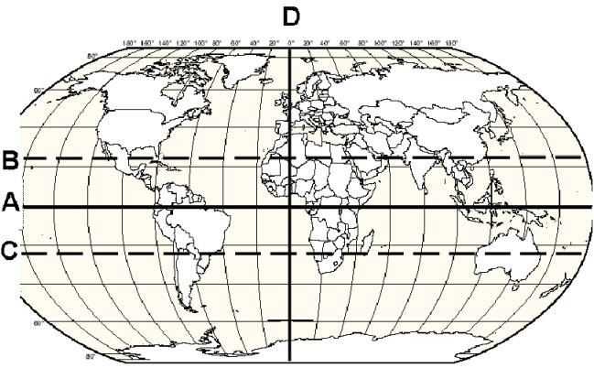
5) Which line indicates the prime meridian?
Answer: D
Diff: 1
Bloom's: 1 Remembering
Section Headings: The Basic Tools and Methods of Human Geographers

6) Which line indicates the equator?
Answer: A
Diff: 1
Bloom's: 1 Remembering
Section Headings: The Basic Tools and Methods of Human Geographers

7) Which line is a line of longitude?
Answer: D
Diff: 1
Bloom's: 1.5 Remembering/Understanding
Section Headings: The Basic Tools and Methods of Human Geographers

8) Which line indicates the Tropic of Capricorn?
Answer: C
Diff: 1
Bloom's: 1.5 Remembering/Understanding
Section Headings: The Basic Tools and Methods of Human Geographers
9) Which line indicates the Tropic of Cancer?
Answer: B
Diff: 1
Bloom's: 1.5 Remembering/Understanding
Section Headings: The Basic Tools and Methods of Human Geographers

MAPS AND PROJECTIONS: Match the characteristic to the map or projection it best describes.

A) Map most likely to be centered on the North Pole
B) preserves compass bearing—used in navigation for centuries
C) represents Earth's form horizontally and vertically
D) varying colors or patterns to show variations in number, frequencies or densities
E) Equal-area map to emphasize the global South
F) Distorts everything, yet used by National Geographic for its appearance and suitability as a reference map
G) intentional distortion of space and area in proportion to magnitude of a characteristic

10) Azimuthal Projection
Diff: 2
Bloom's: 1.5 Remembering/Understanding
Section Headings: The Basic Tools and Methods of Human Geographers

11) Peters projection
Diff: 1
Bloom's: 1.5 Remembering/Understanding
Section Headings: The Basic Tools and Methods of Human Geographers

12) Robinson projection
Diff: 1
Bloom's: 1.5 Remembering/Understanding
Section Headings: The Basic Tools and Methods of Human Geographers

13) Mercator projection
Diff: 1
Bloom's: 1.5 Remembering/Understanding
Section Headings: The Basic Tools and Methods of Human Geographers
14) topographic maps
Diff: 1
Bloom's: 1.5 Remembering/Understanding
Section Headings: The Basic Tools and Methods of Human Geographers

15) choropleth maps
Diff: 1
Bloom's: 1.5 Remembering/Understanding
Section Headings: The Basic Tools and Methods of Human Geographers

16) cartogram
Diff: 2
Bloom's: 1.5 Remembering/Understanding
Section Headings: The Basic Tools and Methods of Human Geographers

Answers: 10) A 11) E 12) F 13) B 14) C 15) D 16) G

SPATIAL INTERACTION: Match the term or concept to the explanation.

A) spatial diffusion
B) transferability
C) intervening opportunity
D) complementarity

17) important in determining the volume and pattern of movements and flows
Diff: 2
Bloom's: 2 Understanding
Section Headings: Spatial Analysis

18) the cost of moving an item relative to the value of the item
Diff: 2
Bloom's: 2 Understanding
Section Headings: Spatial Analysis

19) precondition for spatial interaction — matching supply in one place with demand in another
Diff: 2
Bloom's: 2 Understanding
Section Headings: Spatial Analysis

20) the way that things spread through space and time
Diff: 2
Bloom's: 2 Understanding
Section Headings: Spatial Analysis

Answers: 17) C 18) B 19) D 20) A
1.5 Map Identification

World Map

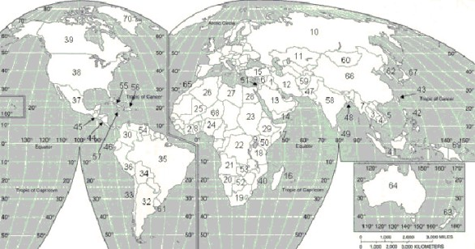

1) China shares a border with which of the following countries?
A) Russia
B) India
C) France
D) Canada
E) Both Russia and India
Answer: E
Diff: 1
Bloom's: 1 Remembering

2) The country of Ethiopia is identified by the number
A) 25.
B) 29.
C) 34.
D) 59.
E) 60.
Answer: B
Diff: 1
Bloom's: 1 Remembering
3) Ankara is the capital of
A) Turkey.
B) Iran.
C) Jamaica.
D) Botswana.
E) Kazakhstan.
Answer: A
Diff: 1
Bloom's: 1 Remembering

4) Ottawa is the capital of
A) Canada.
B) France.
C) Iran.
D) Mexico.
E) India.
Answer: A
Diff: 1
Bloom's: 1 Remembering

5) The capital of country #10 is
A) Moscow.
B) Ottawa.
C) Beijing.
D) Cairo.
E) Addis Ababa.
Answer: A
Diff: 1
Bloom's: 1 Remembering

6) The capital of country #11 is
A) Moscow.
B) Ottawa.
C) Paris.
D) Astana.
E) Addis Ababa.
Answer: D
Diff: 1
Bloom's: 1 Remembering

7) The country situated between countries 37 and 39 is
A) Canada.
B) China.
C) Mexico.
D) Russia.
E) the United States of America.
Answer: E
Diff: 1
Bloom's: 1 Remembering
8) Mexico City is the capital of which country?
A) 34
B) 35
C) 36
D) 37
E) 38
Answer: D
Diff: 1
Bloom's: 1 Remembering

9) Countries 20, 21 and 22 are all part of
A) North Africa.
B) Sub-Saharan Africa.
C) Southeast Asia.
D) the Middle East.
E) North America.
Answer: B
Diff: 1
Bloom's: 1 Remembering

10) Which pair of countries share a border?
A) Russia & Kazakhstan
B) Canada & Mexico
C) Ethiopia & Kazakhstan
D) Canada & France
E) India & Mexico
Answer: A
Diff: 1
Bloom's: 1 Remembering

11) Of the following, which is farthest from the prime meridian?
A) 5
B) 15
C) 20
D) 25
E) 50
Answer: A
Diff: 1
Bloom's: 1 Remembering

12) Of the following, which is closest to the prime meridian?
A) 5
B) 15
C) 20
D) 25
E) 50
Answer: D
Diff: 1
Bloom's: 1 Remembering
1.6 Questions with Images

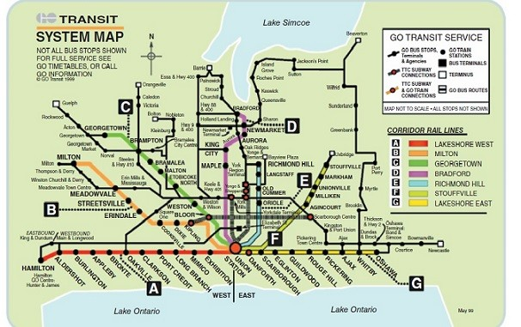

1) The map of Toronto's GO Transit system in the figure above is an example of a
A) mental map.
B) topological map.
C) cognitive image.
D) geographic information system.
E) culture region.
Answer: B
Diff: 2
Bloom's: 1 Remembering
Section Headings: Spatial Analysis
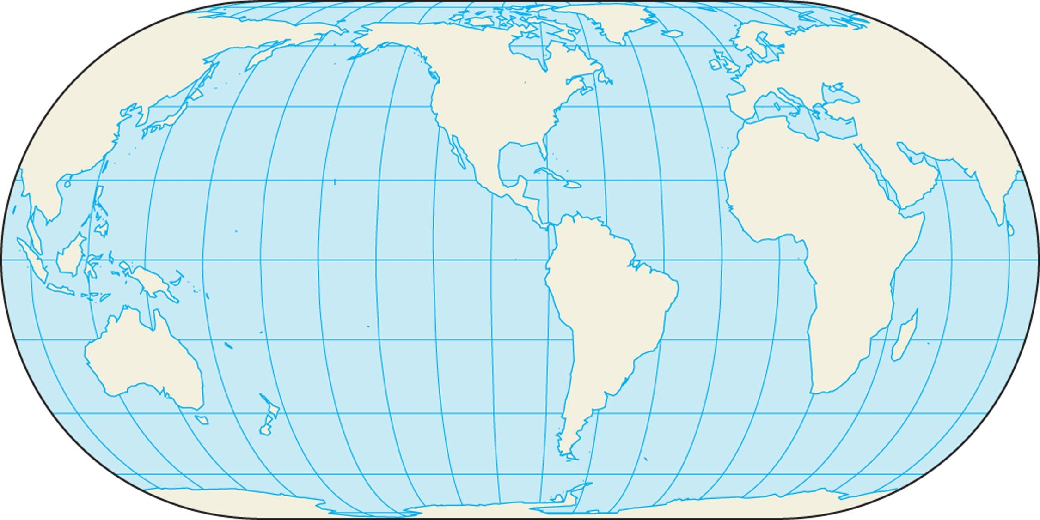

2) The above map is an example of a
A) Robinson Projection map.
B) Peters projection map.
C) Mercator projection map.
D) cartogram.
E) choropleth map.
Answer: A
Diff: 2
Bloom's: 1 Remembering
Section Headings: The Basic Tools and Methods of Human Geographers
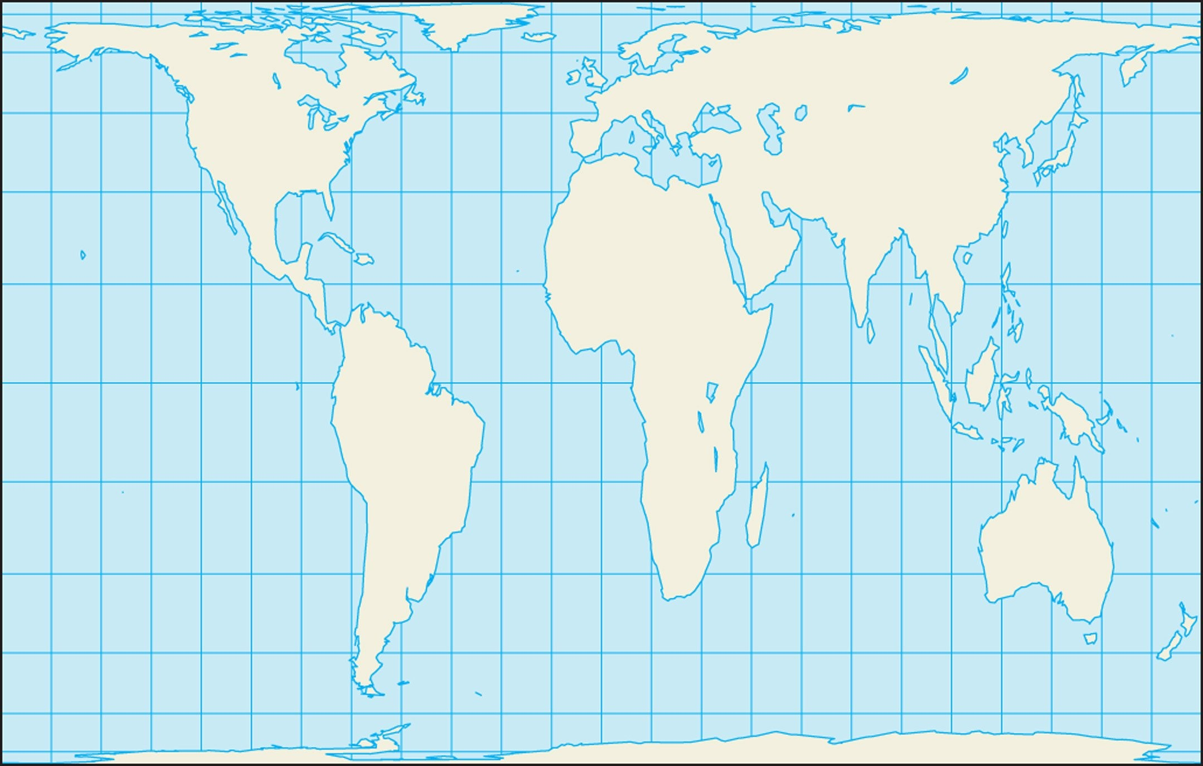

3) The above map is an example of a
A) Robinson projection map.
B) Peters projection map.
C) Mercator projection map.
D) cartogram.
E) choropleth map.
Answer: B
Diff: 2
Bloom's: 1 Remembering
Section Headings: The Basic Tools and Methods of Human Geographers
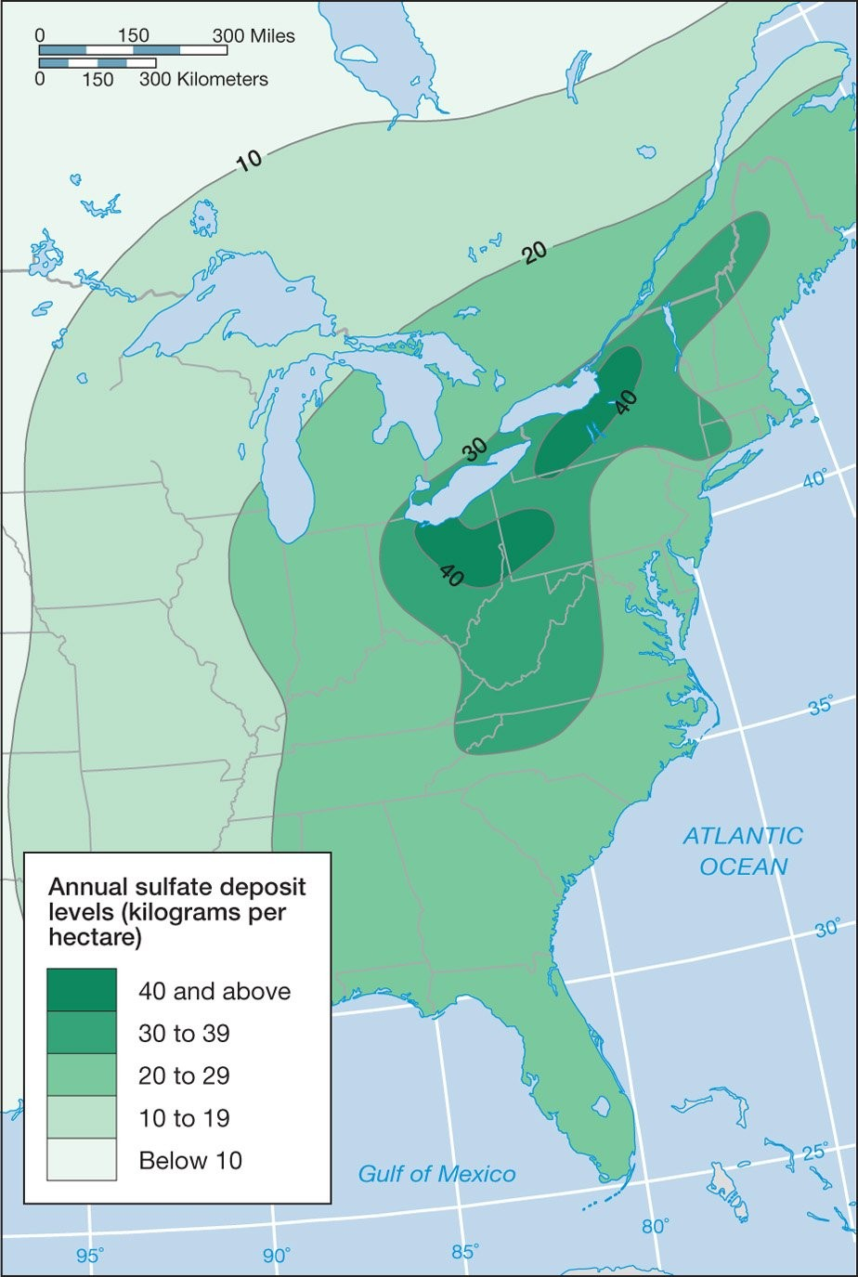

4) The above map is an example of a(n)
A) isoline map.
B) topographic map.
C) located chart map.
D) azimuthal equidistant projection.
E) choropleth map.
Answer: A
Diff: 2
Bloom's: 4 Analyzing
Section Headings: The Basic Tools and Methods of Human Geographers

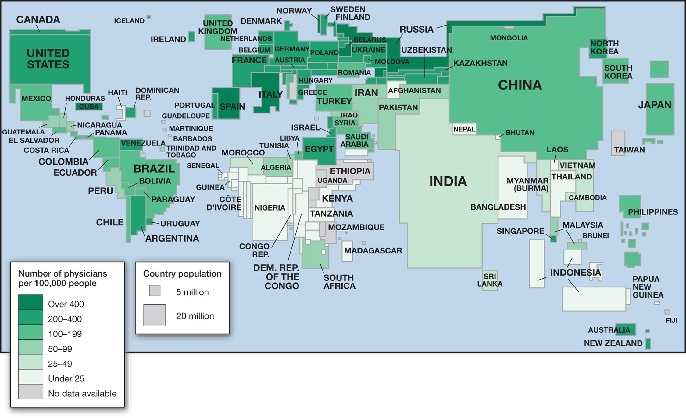

5) The above map is an example of a(n)
A) isopleth map.
B) topographic map.
C) cartogram.
D) Peters projection map.
E) located chart map.
Answer: C
Diff: 2
Bloom's: 1.5 Remembering/Understanding
Section Headings: The Basic Tools and Methods of Human Geographers
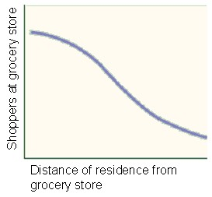

6) The above graph shows that the farther people have to travel, the less likely they are to do so. The inhibiting effect of distance is ascribed to
A) the friction of distance.
B) the problem of space.
C) time-space convergence.
D) cognitive distance.
E) irredentism.
Answer: A
Diff: 3
Bloom's: 2 Understanding
Section Headings: Spatial Analysis

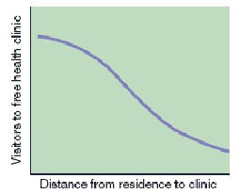

7) As conceptualized in the above graph, the farther people have to travel, the less likely they are to do so. This is best captured in the geographic concept of
A) distance decay.
B) friction of distance.
C) spatial analysis.
D) complementarity.
E) transferability.
Answer: B
Diff: 3
Bloom's: 3 Applying
Section Headings: Spatial Analysis
1.7 Short Answer

1) Define the term "human geography" and briefly expand on its interest to the Canadian public.
Diff: 3
Bloom's: 2 Understanding
Section Headings: Why Places Matter

2) Discuss how places serve as the settings for social interaction.
Diff: 2
Bloom's: 2 Understanding
Section Headings: Why Places Matter

3) Discuss the geographic notion that interdependence is a two-way process.
Diff: 2
Bloom's: 3 Applying
Section Headings: Why Places Matter

4) List and briefly describe five applications of geography, i.e., the various types of work that geographers can do.
Diff: 1
Bloom's: 1.5 Remembering/Understanding
Section Headings: Why Places Matter

5) While providing a specific example for each, explain three different patterns of spatial diffusion.
Diff: 2
Bloom's: 1.5 Remembering/Understanding
Section Headings: Spatial Analysis

6) What are some key differences between your mental map (in your mind) versus a sketch map (what you sketch)?
Diff: 2
Bloom's: 2 Understanding
Section Headings: Spatial Analysis

7) Describe what you think is meant by the power of place.
Diff: 3
Bloom's: 3 Applying
Section Headings: Why Places Matter

8) Provide definitions for latitude, longitude, the prime meridian, and the equator.
Diff: 2
Bloom's: 1.5 Remembering/Understanding
Section Headings: Spatial Analysis

9) Define the distance-decay function using an example.
Diff: 2
Bloom's: 2 Understanding
Section Headings: Spatial Analysis
10) Describe the relative location of the nearest major shopping mall in relation to your current location.
Diff: 2
Bloom's: 1.5 Remembering/Understanding
Section Headings: Spatial Analysis

11) Use an example to describe the concept of an intervening opportunity.
Diff: 2
Bloom's: 2 Understanding
Section Headings: Spatial Analysis

1.8 Essay

1) Write an essay that supports this assertion: "Canada's large cities offer more diverse opportunities for employment, entertainment, and the pursuit of non-conformist lifestyles. On the other hand, large cities are often perceived as anonymous."
Diff: 2
Bloom's: 3 Applying
Section Headings: Why Places Matter

2) Choose two geographic career options to research. Provide as much relevant information as possible about the careers and the requisite skills needed for qualification (imagine you are creating a job posting for each career option).
Diff: 2
Bloom's: 2 Understanding
Section Headings: Why Places Matter

3) Write a short essay describing both the site and situation of your university campus. What is the relationship between the site and situation?
Diff: 2
Bloom's: 3 Applying
Section Headings: Spatial Analysis

4) While providing a relevant example for each, write an essay that explains the four basic concepts of spatial interaction.
Diff: 3
Bloom's: 3 Applying
Section Headings: Spatial Analysis

5) Identify and describe your identity, which is the sense that you make of yourself through your subjective feelings based on your everyday experiences and social relations.
Diff: 2
Bloom's: 3 Applying
Section Headings: Why Places Matter

6) Discuss the nature and uses of Geographic Information Systems.
Diff: 2
Bloom's: 3 Applying
Section Headings: The Basic Tools and Methods of Human Geographers
7) In an essay, discuss some of the more common basic tools and methods used by human geographers.
Diff: 3
Bloom's: 3 Applying
Section Headings: The Basic Tools and Methods of Human Geographers

8) Present and explain three commonly used types of map projections.
Diff: 2
Bloom's: 2 Understanding
Section Headings: The Basic Tools and Methods of Human Geographers

9) Discuss what is meant by the first law of geography: "Everything is related to everything else, but near things are more related than distant things."
Diff: 2
Bloom's: 3 Applying
Section Headings: Spatial Analysis

10) Discuss the fundamental principles of spatial interaction using real-world examples.
Diff: 3
Bloom's: 3 Applying
Section Headings: Spatial Analysis

11) Describe possible strengths and weaknesses of geodemographic research, such as that done by Environics Analytics.
Diff: 3
Bloom's: 3 Applying
Section Headings: Spatial Analysis

12) Discuss the importance of connectivity and accessibility.
Diff: 3
Bloom's: 3 Applying
Section Headings: Spatial Analysis

13) Discuss how space can be measured in absolute, relative, and cognitive terms.
Diff: 2
Bloom's: 3 Applying
Section Headings: Spatial Analysis

14) Define expansion, hierarchical, and relocation diffusion and provide an example of each.
Diff: 3
Bloom's: 1.5 Remembering/Understanding
Section Headings: Spatial Analysis

