1. In which way can art be categorized?
 | a. | geographically
 | b. | historically
 | c. | chronologically
 | d. | thematically
 | e. | all of the above

ANSWER: | e

2. What's missing in this definition of art? Art is primarily a ____ medium that is used to express our ideas about our human experience and the world around us.
 | a. | human
 | b. | visual
 | c. | spiritual
 | d. | historical

ANSWER: | b

3. Art is a ____ phenomenon.
 | a. | natural
 | b. | scientific
 | c. | geographical
 | d. | human

ANSWER: | d

4. Art has several functions, including (choose the best answer):
 | a. | serving as a profession in society
 | b. | providing economic benefits to the artist
 | c. | protesting social injustice
 | d. | decorating museum walls
 | e. | all of the above

ANSWER: | e

5. Aesthetics is:
 | a. | a branch of philosophy
 | b. | a study of creativity
 | c. | a study of art and its effects
 | d. | none of the above
 | e. | all of the above

ANSWER: | a

6. Popular art includes:
 | a. | gallery displays
 | b. | calendars
 | c. | museum works
 | d. | art history slides

ANSWER: | b

7. Craft refers to which of the following?
 | a. | painting
 | b. | sculpture
 | c. | pottery
 | d. | architecture

ANSWER: | c

8. The components of an artwork include perception, response, creativity, and ____.
 | a. | expression
 | b. | beauty
 | c. | energy
 | d. | quality

ANSWER: | a

9. Content and form are interchangeable in a work of art.
 | a. | True
 | b. | False

ANSWER: | b

10. Van Gogh was not a member of another stylistic group.
 | a. | True
 | b. | False

ANSWER: | b

11. Ancient Egypt had an ever-changing artistic style.
 | a. | True
 | b. | False

ANSWER: | b

12. The content of a work of art refers to ____.
 | a. | its size
 | b. | its media
 | c. | its meaning
 | d. | its form

ANSWER: | c

13. An equestrian sculpture is one that includes a ____.
 | a. | caryatid
 | b. | ceremonial mask
 | c. | horse
 | d. | elements of nature

ANSWER: | c

14. In ancient Rome, ____ sculptures were seen as the ultimate symbol of imperial dignity and power.
 | a. | caryatid
 | b. | keystone
 | c. | equestrian
 | d. | kitsch

ANSWER: | c

15. In a work of art, the word “composition” refers to ____.
 | a. | the physical material used by the artist
 | b. | the arrangement of the formal elements of art
 | c. | the technical style used by the artist
 | d. | the physical texture of the work

ANSWER: | b

16. 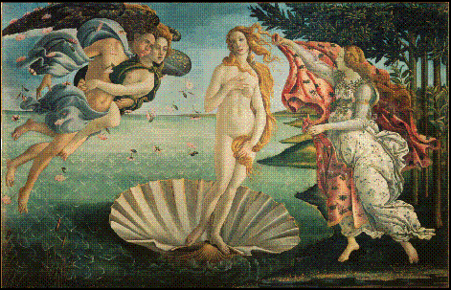
This artwork would be classified as ____.
 | a. | fine art
 | b. | applied art
 | c. | naive art
 | d. | classical art

ANSWER: | a

17. 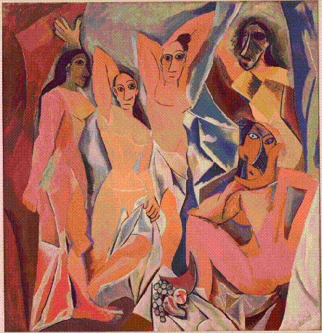
This painting was a catalyst for the ____ movement in art.
 | a. | Futurist
 | b. | Dadaist
 | c. | Surrealist
 | d. | Cubist

ANSWER: | d

18. 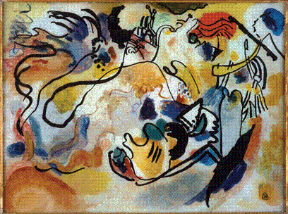
Stylistically this painting would be categorized as ____ art.
 | a. | naturalistic
 | b. | expressionist
 | c. | representational
 | d. | classical

ANSWER: | b

19. In a paragraph, discuss the idea that artwork must have two ingredients (innovation and artistic self-expression). Is this a valid idea? How and why? Give an example from the book. Can art be considered art without these ingredients? How and why? Give an example from the book.
ANSWER: | Answers will vary, but any answer that the student can support with evidence can be accepted.

20. Discuss the difference between "high" and "low" art. How can you tell which is which? What does the setting have to do with the different classifications?
ANSWER: | Students should mention expectations and definitions by the various media, as well as displays on museum walls.

21. Write a paragraph on the meaning of "kitsch" in art.
ANSWER: | Students should discuss the dictionary meaning and intention of the artist, as well as advertising and consumer pressure.

22. Discuss the difference between nonobjective and abstract art.
ANSWER: | Students should mention the former has no recognizable imagery that comes from nature or the outside world.

23. Is it acceptable for artists to copy others' styles? Explain.
ANSWER: | Answers will vary, but students should mention cultural traditions of copying, such as those of ancient Egypt and the Pacific Northwest.

24. Discuss the various meanings the term “classical” has in reference to style.
ANSWER: | Classical can refer to art that is composed in an orderly, balanced, and clear manner.  It can also refer to an evolution in the development of a particular style — classical works represent mature work of a particular style.  When written with a capital C, “Classical” refers to art made in ancient Greece.

25. Discuss how art can function as “cultural documents.” Reference a specific culture and works of art.
ANSWER: | Students should mention how art can inform us about existing and past cultures — what was valued, considered ideal, gender roles, etc. References to any Western or Eastern cultures are acceptable as long as students cite specific works to support their argument.

26. Traditional Chinese paintings were not made from life, but from memory.
 | a. | True
 | b. | False

ANSWER: | True

27. Art is always a serious endeavor and never functions as entertainment.
 | a. | True
 | b. | False

ANSWER: | False

28. Regardless of culture, content is always readily apparent in a work of art.
 | a. | True
 | b. | False

ANSWER: | False

29.
When this image was painted, its idealized concept of human beauty was at odds with medieval notions of the body as sinful.
 | a. | True
 | b. | False

ANSWER: | True

30. Art is whatever a society or a culture determines is art.
 | a. | True
 | b. | False

ANSWER: | True

31. Every culture, both past and present, has a word that corresponds to ours for art.
 | a. | True
 | b. | False

ANSWER: | False

32. Contemporary art and popular culture often share the same images.
 | a. | True
 | b. | False

ANSWER: | True

33. ____________________ styles of art convey intense emotions.
a. | Naturalistic
b. | Idealized
c. | Abstract
d. | Expressive

ANSWER: | Expressive

34. Ceramics, glass, jewelry, weaving, and woodworking are categorized as ____________________.
a. | kitsch
b. | ethnic art
c. | crafts
d. | fine art

ANSWER: | crafts

35. Art is primarily a ____________________ medium used to express ideas about our human experience and the world around us.
a. | visual
b. | tactile
c. | literal
d. | visceral

ANSWER: | visual

36. The visual form of a work of art is the ____________________ embodiment of an idea.
a. | literal
b. | psychological
c. | historical
d. | physical

ANSWER: | physical

37. Art has ____________________ form, which includes the materials used to make the artwork, its formal elements, and its overall composition.
a. | visual
b. | conceptual
c. | iconographic
d. | contextual

ANSWER: | visual

38. ____________________ is the mass of ideas associated with a work of art.
a. | Function
b. | Content
c. | Aesthetics
d. | Context

ANSWER: | Content

39. When artists challenge existing conventions of art, they are considered to be ________________.
a. | expressive
b. | academic
c. | kitsch
d. | avant-garde

ANSWER: | avant-garde

40. Objects or images are categorized as ____________________ if they have an emotional appeal that is generalized, superficial, or sentimental.
a. | naturalistic
b. | surreal
c. | kitsch
d. | abstract

ANSWER: | kitsch

41. ____________________ is the manner of expression that is characteristic of art made by an individual artist, from a historic period or from an entire civilization.
a. | Context
b. | Content
c. | Iconography
d. | Style

ANSWER: | Style

