Package Title: Test Bank

Course Title: Jenkins 3e

Chapter Number: 1

Question type: Multiple Choice

1) When the examiner uses a stethoscope to amplify the sound of breathing into the lungs, this is called ___.

a) inspection.

b) percussion.

c) auscultation.

d) palpation.

e) ultrasonography.

Answer: c

Difficulty: Easy

Learning Objective 1: LO 1.1 Describe the six levels of structural organization and the eleven systems of the human body.

Section Reference 1: Section 1.1 The human body is composed of six levels of structural organization and contains eleven body systems.

2) When an examiner feels the body surfaces with hands, for example to detect enlarged or tender organs, this is called ___.

a) inspection.

b) percussion.

c) auscultation.

d) palpation.

e) ultrasonography.

Answer: d

Difficulty: Easy

Learning Objective 1: LO 1.1 Describe the six levels of structural organization and the eleven systems of the human body.

Section Reference 1: Section 1.1 The human body is composed of six levels of structural organization and contains eleven body systems.

3) The spleen, thymus, and tonsils are all organs that function within the ___.

a) urinary system

b) digestive system

c) endocrine system

d) lymphatic system

e) cardiovascular system

Answer: d

Difficulty Easy

Learning Objective 1: LO 1.1 Describe the six levels of organization and the eleven systems of the human body.

Section Reference 1: Section 1.1 The human body is composed of six levels of structural organization and contains eleven body systems.

4) Which of the following statements best describes the location of the radius bone anatomically?

a) It is proximal to the carpal region and inferior to the manual region.

b) It is the lateral bone of the antebrachium.

c) It is located in the crural region.

d) It is inferior to the femoral region and superior to the tarsal region.

e) It is distal to the antecubital region, and is the medial bone of the crural region.

Answer: b

Difficulty: Medium

Learning Objective 1: LO 1.4 Describe the human body using the anatomical position and specific terms.

Section Reference 1: Directional Terms.

5) Two organs on the same side of the body, such as the spleen and the descending colon, are ___.

a) distal

b) ipsilateral

c) proximal

d) contralateral

e) intermediate

Answer: b

Difficulty: Easy

Learning Objective 1: LO 1.4 Describe the human body using the anatomical position and specific terms.

Section Reference 1: Directional Terms.

6) Two organs on the opposite side of the body, such as the spleen and the gallbladder, are ___.

a) distal

b) ipsilateral

c) proximal

d) contralateral

e) intermediate

Answer: d

Difficulty: Easy

Learning Objective 1: LO 1.4 Describe the human body using the anatomical position and specific terms.

Section Reference 1: Directional Terms.

7) The heart is ___ to the lungs.

a) distal

b) proximal

c) ipsilateral

d) medial

e) contralateral

Answer: d

Difficulty: Easy

Learning Objective 1: LO 1.4 Describe the human body using the anatomical position and specific terms.

Section Reference 1: Directional Terms.

8) A good example of a positive feedback mechanism would be:

a) enhancement of labor contraction by oxytocin

b) blood calcium regulation

c) blood pressure regulation

d) blood glucose regulation

e) body temperature regulation

Answer: a

Difficulty: Medium

Learning Objective 1: LO 1.3 Explain how homeostasis is maintained through negative and positive feedback systems, and how it can be disrupted by diseases and disorders.

Section Reference 1: Positive Feedback Systems.

9) Along which of the following body planes has this section been made?  
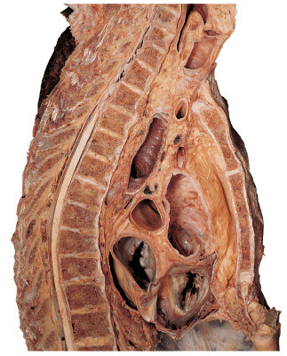

a) oblique

b) frontal

c) sagittal

d) coronal

e) transverse

Answer: c

Difficulty: Medium

Learning Objective 1: LO 1.4 Describe the human body using the anatomical position and specific terms.

Section Reference 1: Planes and Sections.

10) Which of the following anatomical terms best describes the indicated region?  
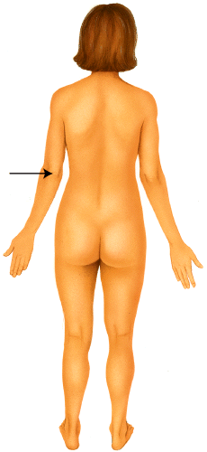

a) popliteal

b) mental

c) crural

d) olecranal

e) occipital

Answer: d

Difficulty: Medium

Learning Objective 1: LO 1.4 Describe the human body using the anatomical position and specific terms.

Section Reference 1: Regional Names.

11) This component of a feedback system provides input directly to the control center.

a) effector

b) receptor

c) brain

d) stimulus

e) efferent

Answer: b

Difficulty: Easy

Learning Objective 1: LO 1.3 Explain how homeostasis is maintained through negative and positive feedback systems, and how it can be disrupted by diseases and disorders.

Section Reference 1: Feedback Systems.

12) A 24 year old female presents to the emergency room complaining of the following symptoms:  
• Acute lower right quadrant abdominal pain rated at an 9 out of 10 on the pain scale (10 being the worst pain ever!), that she characterizes as “burning and stabbing” in quality  
• Feelings of nausea, dizziness and weakness.  
• No difficulty breathing  
As her physician, you notice that she exhibits the following signs:  
• A very high fever (104ºF)  
• High blood pressure (146/90)  
• A rapid heart rate (110 beats per minute)  
• Clear lung sounds- although her respiratory rate is rapid.  
Which of the following choices is the most likely the correct diagnosis?

a) hypoglycemia (low blood sugar)

b) pulmonary embolus (blood clot in the lungs)

c) acute appendicitis

d) meningitis

e) pneumonia

Answer: c

Difficulty: Hard

Learning Objective 1: LO 1.7 Distinguish between the regions and quadrants of the abdominopelvic cavity.

Section Reference 1: 1.7 The abdominopelvic cavity is divided into regions or quadrants.

13) This component of a feedback system receives output from the control center.

a) effector

b) stimulus

c) receptor

d) central Nervous System

e) afferent

Answer: a

Difficulty: Easy

Learning Objective 1: LO 1.3 Explain how homeostasis is maintained through negative and positive feedback systems, and how it can be disrupted by diseases and disorders.

Section Reference 1: Feedback Systems.

14) The study of body structures and relationships among structures is called ___.

a) physiology

b) histology

c) embryology

d) biology

e) anatomy

Answer: e

Difficulty: Easy

Learning Objective 1: LO 1.1 Describe the six levels of structural organization and the eleven systems of the human body.

Section Reference 1: Section 1.1 The human body is composed of six levels of structural organization and contains eleven body systems.

15) The study of body function, how the body parts work, is called ___.

a) physiology

b) histology

c) embryology

d) biology

e) anatomy

Answer: a

Difficulty: Easy

Learning Objective 1: LO 1.1 Describe the six levels of structural organization and the eleven systems of the human body.

Section Reference 1: Section 1.1 The human body is composed of six levels of structural organization and contains eleven body systems.

16) Which term best describes the view shown in this image of the human skull?  
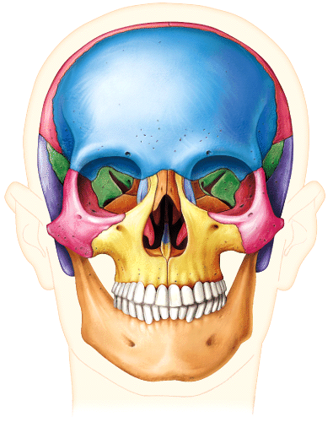

a) anterior

b) medial

c) posterior

d) ipsilateral

e) lateral

Answer: a

Difficulty: Medium

Learning Objective 1: LO 1.4 Describe the human body using the anatomical position and specific terms.

Section Reference 1: Directional Terms.

17) The body is in the ___ position when laying face down.

a) sagittal

b) proximal

c) supine

d) prone

e) oblique

Answer: d

Difficulty: Easy

Learning Objective 1: LO 1.4 Describe the human body using the anatomical position and specific terms.

Section Reference 1: Body Positions.

18) When anatomists use directional terms, which of these is NOT a consideration?

a) The position of a body part is described relative to another body part.

b) Structures such as blood vessels can be described relative to an origin, the heart, using the terms proximal or distal.

c) Humans stand upright, so terms such as anterior and ventral (or posterior and dorsal, or superior and cephalic) are interchangeable; this is not true for four-legged animals.

d) Structures on the limbs are usually described as proximal or distal.

e) The directional terms are used with the assumption that the body is in a supine position with the hands facing palm upward.

Answer: e

Difficulty: Hard

Learning Objective 1: LO 1.4 Describe the human body using the anatomical position and specific terms.

Section Reference 1: Body Positions.

19) The body is in the ___ position when laying face up.

a) prone

b) proximal

c) supine

d) intermediate

e) oblique

Answer: c

Difficulty: Easy

Learning Objective 1: LO 1.4 Describe the human body using the anatomical position and specific terms.

Section Reference 1: Body Positions.

20) Which of the following choices is NOT considered to be a basic life process?

a) reproduction

b) metabolism

c) growth

d) responsiveness

e) pathology

Answer: e

Difficulty: Easy

Learning Objective 1: LO 1.2 Outline the six most important life processes that distinguish living organisms from nonliving objects.

Section Reference 1: Basic Life Processes.

21) Which of these are the smallest living units of an organism?

a) molecules

b) cells

c) tissues

d) protons

e) organs

Answer: b

Difficulty: Easy

Learning Objective 1: LO 1.1 Describe the six levels of organization and the eleven systems of the human body.

Section Reference 1: 1.1 The human body is composed of six levels of structural organization and contains eleven systems.

22) The organs in the human body ___.

a) function entirely independently from one another

b) are made of a single tissue type

c) are the smallest living units in the human body

d) include examples such as the bones, the skin, the heart and the lungs

e) can only contribute to the function of a single organ system, such as the gonads contributing to the function of the reproductive system

Answer: d

Difficulty: Medium

Learning Objective 1: LO 1.1 Describe the six levels of organization and the eleven systems of the human body.

Section Reference 1: Section 1.1 The human body is composed of six levels of structural organization and contains eleven systems.

23) The pancreas is an organ that plays a role in the ___.

a) digestive and urinary systems

b) respiratory and digestive systems

c) endocrine and lymphatic systems

d) respiratory and lymphatic systems

e) endocrine and digestive systems

Answer: e

Difficulty: Medium

Learning Objective 1: LO 1.1 Describe the six levels of organization and the eleven systems of the human body.

Section Reference 1: Section 1.1 The human body is composed of six levels of structural organization and contains eleven systems.

24) A group of cells with similar emergent functional properties is defined as a(n):

a) organism

b) compound

c) tissue

d) organ

e) molecule

Answer: c

Difficulty: Easy

Learning Objective 1: LO 1.1 Describe the six levels of organization and the eleven systems of the human body.

Section Reference 1: Section 1.1 The human body is composed of six levels of structural organization and contains eleven systems.

25) Which of these answers describes the sum of all chemical reactions that occur in the body?

a) metabolism

b) catalyst

c) anabolism

d) catabolism

e) homeostasis

Answer: a

Difficulty: Medium

Learning Objective 1: LO 1.2 Outline the six most important life processes that distinguish living organisms from nonliving objects.

Section Reference 1: Feedback Systems.

26) The term brachial refers to the ___.

a) chin

b) fingers

c) arm

d) forearm

e) top of the head

Answer: c

Difficulty: Easy

Learning Objective 1: LO 1.4 Describe the human body using the anatomical position and specific terms.

Section Reference 1: Regional Names.

27) The term sacral refers to the ___.

a) chin

b) area between the shoulder blades

c) area at the base of the skull

d) area inferior to the lumbar region and medial to the coxae

e) calf of the leg

Answer: d

Difficulty: Medium

Learning Objective 1: L0 1.4 Describe the human body using the anatomical position and specific terms.

Section Reference 1: Regional Names.

28) The term otic refers to the:

a) eye

b) leg

c) shoulder

d) ear

e) elbow

Answer: d

Difficulty: Medium

Learning Objective 1: LO 1.4 Describe the human body using the anatomical position and specific terms.

Section Reference 1: Regional Names.

29) The mental region is ___ to the orbital region.

a) inferior

b) deep

c) superficial

d) lateral

e) contralateral

Answer: a

Difficulty: Easy

Learning Objective 1: LO 1.4 Describe the human body using the anatomical position and specific terms.

Section Reference 1: Directional Terms.

30) The carpal region is ___ to the antebrachium.

a) proximal

b) superior

c) deep

d) distal

e) medial

Answer: d

Difficulty: Medium

Learning Objective 1: LO 1.4 Describe the human body using the anatomical position and specific terms.

Section Reference 1: Directional Terms.

31) The pancreas and liver are organs in the ___ system.

a) integumentary

b) lymphatic

c) digestive

d) reproductive

e) skeletal

Answer: c

Difficulty: Medium

Learning Objective 1: LO 1.1 Describe the six levels of organization and the eleven systems of the human body.

Section Reference 1: Section 1.1 The human body is composed of six levels of structural organization and contains eleven systems.

32) Which of the following organs would NOT be visible if the body was sectioned along a mid-sagittal plane?

a) heart

b) adrenal gland

c) small intestine

d) liver

e) uterus

Answer: b

Difficulty: Medium

Learning Objective 1: LO 1.4 Describe the human body using the anatomical position and specific terms.

Section Reference 1: Planes and Sections.

33) Which one of the following terms describes the body's ability to detect and respond to changes in the internal or external environment?

a) responsiveness

b) reproduction

c) differentiation

d) metabolism

e) catabolism

Answer: a

Difficulty: Easy

Learning Objective 1: LO 1.2 Outline the six most important life processes that distinguish living organisms from nonliving objects.

Section Reference 1: Basic Life Processes.

34) The term sural refers to the ___.

a) skin

b) ear

c) forehead

d) shoulder

e) calf

Answer: e

Difficulty: Medium

Learning Objective 1: LO 1.4 Describe the human body using the anatomical position and specific terms.

Section Reference 1: Regional Terms.

35) Which of the following is a TRUE statement concerning the selected feedback mechanism in a healthy individual?

a) Positive feedback mechanisms are stable, and the most common means to maintain homeostasis in the body.

b) Blood glucose levels are regulated by positive feedback mechanisms.

c) Elevated blood sugar levels (hyperglycemia) result in the release of glucagon from the pancreas, which stimulates the breakdown of glycogen into glucose—resulting in more glucose in the bloodstream.

d) Blood pressure regulation is a good example of positive feedback, because the response to the initial stimulus increases the stimulus.

e) Stretch receptors in the cervix, stimulated by the fetus during labor and delivery, result in the release of a hormone that stimulates more forceful uterine contractions and additional “stretch” or dilation of the cervix. This is a good example of a positive feedback mechanism.

Answer: e

Difficulty: Hard

Learning Objective 1: LO 1.3 Explain how homeostasis is maintained through negative and positive feedback systems, and how it can be disrupted by diseases and disorders.

Section Reference 1: Positive Feedback Systems.

36) The thoracic region is ___ to the inguinal region.

a) superior

b) deep

c) distal

d) ipsilateral

e) supine

Answer: a

Difficulty: Medium

Learning Objective 1: LO 1.4 Describe the human body using the anatomical position and specific terms.

Section Reference 1: Directional Terms.

37) Which of the following anatomical terms best describes the indicated region?  


a) mental

b) popliteal

c) antecubital

d) olecranal

e) coxal

Answer: e

Difficulty: Medium

Learning Objective 1: LO 1.4 Describe the human body using the anatomical position and specific terms.

Section Reference 1: Regional Names.

38) Which of the following anatomical terms best describes the indicated region?  
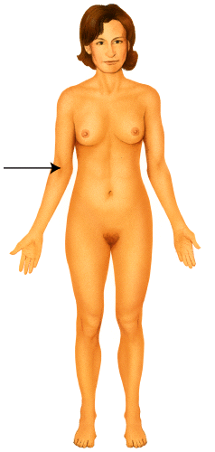

a) otic

b) popliteal

c) antecubital

d) olecranal

e) occipital

Answer: c

Difficulty: Medium

Learning Objective 1: LO 1.4 Describe the human body using the anatomical position and specific terms.

Section Reference 1: Regional Names.

39) Which of the following terms best describes the location of the stomach relative to the pancreas?

a) deep

b) serous

c) distal

d) transverse

e) anterior

Answer: e

Difficulty: Medium

Learning Objective 1: LO 1.4 Describe the human body using the anatomical position and specific terms.

Section Reference 1: Directional Terms.

40) Which of the following statements is TRUE?

a) The cranial cavity houses the brain and is lined by the pleural membranes.

b) The pericardial cavity lies within the superior portion of the mediastinum.

c) The pleural cavities are lined by a membrane called the parietal peritoneum.

d) The visceral layer of a serous membrane covers the organ it protects.

e) The superior border of the pelvic cavity is the diaphragm.

Answer: d

Difficulty: Medium

Learning Objective 1: LO 1.6 Identify the locations of the various serous membranes.

Section Reference 1: Section 1.6 Serous membranes line the walls of body cavities and cover the organs within them.

41) Which term describes the serous membrane lining the cavity that houses the lungs?

a) parietal pericardium

b) parietal peritoneum

c) visceral peritoneum

d) parietal pleura

e) visceral pleura

Answer: d

Difficulty: Medium

Learning Objective 1: LO 1.6 Identify the locations of the various serous membranes.

Section Reference 1: Section 1.6 Serous membranes line the walls of body cavities and cover the organs within them.

42) Which term describes the serous membrane lining the cavity that houses the liver?

a) parietal pericardium

b) parietal peritoneum

c) dura mater

d) parietal pleura

e) parietal mediastinum

Answer: b

Difficulty: Medium

Learning Objective 1: LO 1.6 Identify the locations of the various serous membranes.

Section Reference 1: Section 1.6 Serous membranes line the walls of body cavities and cover the organs within them.

43) Which of these answers is the best example of a retroperitoneal organ?

a) pancreas

b) liver

c) heart

d) stomach

e) jejunum of small intestine

Answer: a

Difficulty: Medium

Learning Objective 1: LO 1.6 Identify the locations of the various serous membranes.

Section Reference 1: Section 1.6 Serous membranes line the walls of body cavities and cover the organs within them.

44) In which cavity is the brain located?

a) cranial cavity

b) mediastinal cavity

c) pleural cavity

d) pelvic cavity

e) vertebral cavity

Answer: a

Difficulty: Easy

Learning Objective 1: LO 1.5 Distinguish among the major cavities of the body and their subdivisions.

Section Reference 1: Section 1.5 Body cavities are spaces within the body that help protect, separate, and support internal organs.

45) In which cavity is the spleen located?

a) cranial cavity

b) mediastinal cavity

c) pleural cavity

d) pelvic cavity

e) abdominal cavity

Answer: e

Difficulty: Easy

Learning Objective 1: LO 1.5 Distinguish among the major cavities of the body and their subdivisions.

Section Reference 1: Section 1.5 Body cavities are spaces within the body that help protect, separate, and support internal organs.

46) Which of the following is NOT retroperitoneal?

a) pancreas

b) adrenal gland

c) stomach

d) duodenum of small intestine

e) kidney

Answer: c

Difficulty: Medium

Learning Objective 1: LO 1.5 Distinguish among the major cavities of the body and their subdivisions.

Section Reference 1: Section 1.5 Body cavities are spaces within the body that help protect, separate, and support internal organs.

47) An individual has been in a traumatic motor vehicle accident and has been ejected from the vehicle because they were not wearing their seatbelt. The person is conscious, and complaining of left upper quadrant pain. When you visualize the area, it has significant swelling and is painful to palpation. Which one of the following organs is located in that area and might be of concern?

a) appendix

b) urinary bladder

c) brain

d) spleen

e) gall bladder

Answer: d

Difficulty: Medium

Learning Objective 1: LO 1.7 Distinguish between the regions and quadrants of the abdominopelvic cavity.

Section Reference 1: Section 1.7 The abdominopelvic cavity is divided into regions or quadrants.

48) An individual has been in a traumatic motor vehicle accident and has been ejected from the vehicle because they were not wearing their seatbelt. The person is unconscious, has no pulse, and is apneic (not breathing). You notice some clear fluid leaking from the otic region. You also see some significant lacerations in the cranial region, and the bleeding is profuse. Where is the leakage of clear fluid located?

a) ear

b) base of the skull

c) eye

d) nose

e) mouth

Answer: a

Difficulty: Medium

Learning Objective 1: LO 1.4 Describe the human body using the anatomical position and specific terms.

Section Reference 1: Regional Names.

49) This is a change in body function that can be measured objectively.

a) symptom

b) disorder

c) disease

d) X-ray

e) sign

Answer: e

Difficulty: Easy

Learning Objective 1: LO 1.3 Explain how homeostasis is maintained through negative and positive feedback systems, and how it can be disrupted by diseases and disorders.

Section Reference 1: Homeostatic Imbalances.

50) Which of the following statements best defines a disorder?

a) an illness accompanied by signs and symptoms

b) subjective changes experienced by the patient

c) an abnormality of structure or function

d) measurable changes that can be observed clinically

e) both subjective changes experienced by the patient and measurable changes that can be observed clinically.

Answer: c

Difficulty: Easy

Learning Objective 1: LO 1.3 Explain how homeostasis is maintained through negative and positive feedback systems, and how it can be disrupted by diseases and disorders.

Section Reference 1: Homeostatic Imbalances.

51) This plane divides the body into anterior and posterior portions.

a) oblique

b) frontal

c) horizontal

d) transverse

e) midsagittal

Answer: b

Difficulty: Easy

Learning Objective 1: LO 1.4 Describe the human body using the anatomical position and specific terms.

Section Reference 1: Planes and Sections.

52) Which cavity would enclose the heart?

a) cranial cavity

b) pericardial cavity

c) vertebral cavity

d) abdominal cavity

e) pleural cavity

Answer: b

Difficulty: Easy

Learning Objective 1: LO 1.5 Distinguish among the major cavities of the body and their subdivisions.

Section Reference 1: Section 1.5 Body cavities are spaces within the body that help protect, separate, and support internal organs.

53) A female is having pain in her hypogastric region. Which organ is NOT located in this region?

a) uterus

b) spleen

c) urinary bladder

d) large intestines

e) small intestines

Answer: b

Difficulty: Medium

Learning Objective 1: LO 1.7 Distinguish between the regions and quadrants of the abdominopelvic cavity.

Section Reference 1: Section 1.7 The abdominopelvic cavity is divided into regions or quadrants.

54) Which of these is the function of serous fluid?

a) protect the central nervous system

b) separate the abdominal and pelvic cavities

c) reduce friction between organs

d) circulate respiratory gases

e) carry nervous impulses

Answer: c

Difficulty: Medium

Learning Objective 1: LO 1.6 Identify the locations of the various serous membranes.

Section Reference 1: Section 1.6 Serous membranes line the walls of body cavities and cover the organs within them.

55) The sternum is ___ to the heart.

a) deep

b) anterior

c) inferior

d) distal

e) transverse

Answer: b

Difficulty: Medium

Learning Objective 1: LO 1.4 Describe the human body using the anatomical position and specific terms.

Section Reference 1: Directional Terms.

56) What is the name of this region?  
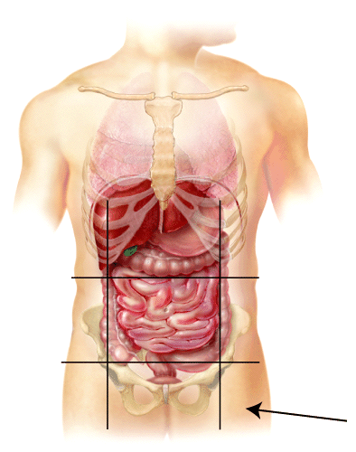

a) left hypochondriac

b) right Lumbar

c) left inguinal

d) hypogastric

e) mental

Answer: c

Difficulty: Medium

Learning Objective 1: LO 1.7 Distinguish between the regions and quadrants of the abdominopelvic cavity.

Section Reference 1: Section 1.7 The abdominopelvic cavity is divided into regions or quadrants.

57) A transverse plane will section a body or organ into ___.

a) anterior and posterior

b) left and right

c) superior and inferior

d) unequal left and right sides

e) proximal and distal

Answer: c

Difficulty: Medium

Learning Objective 1: LO 1.4 Describe the human body using the anatomical position and specific terms.

Section Reference 1: Planes and Sections.

58) This is the skill and science of distinguishing one disorder or disease from another.

a) anatomy

b) physiology

c) dissection

d) diagnosis

e) immunology

Answer: d

Difficulty: Medium

Learning Objective 1: LO 1.3 Explain how homeostasis is maintained through negative and positive feedback systems, and how it can be disrupted by diseases and disorders.

Section Reference 1: Homeostatic Imbalances.

59) Which of these is defined as a group of cells with similar structure and function?

a) tissue

b) organ

c) molecules

d) compounds

e) organism

Answer: a

Difficulty: Easy

Learning Objective 1: LO 1.1 Describe the six levels of organization and the eleven systems of the human body.

Section Reference 1: Section 1.1 The human body is composed of six levels of structural organization and contains eleven systems.

60) Which of these answers is defined as the process of breaking down larger substances into simpler ones?

a) metabolism

b) anabolism

c) catabolism

d) auscultation

e) palpation

Answer: c

Difficulty: Easy

Learning Objective 1: LO 1.2 Outline the six most important life processes that distinguish living organisms from nonliving objects.

Section Reference 1: Homeostasis.

61) Which of these answers is defined as the regulation of body conditions within normal limits?

a) palpation

b) percussion

c) homeostasis

d) autopsy

e) histology

Answer: c

Difficulty: Easy

Learning Objective 1: LO 1.3 Explain how homeostasis is maintained through negative and positive feedback systems, and how it can be disrupted by diseases and disorders.

Section Reference 1: Feedback Systems.

62) Which of these body fluids most directly affects the proper functioning of cells?

a) lymph

b) blood

c) interstitial fluid

d) aqueous humor

e) vitreous body

Answer: c

Difficulty: Medium

Learning Objective 1: LO 1.2 Outline the six most important life processes that distinguish living organisms from nonliving objects.

Section Reference 1: Body Fluids.

63) This is the structure of a feedback system that receives output from the control center.

a) receptor

B) body fluids

C) brain

D) effector

E) afferent

Answer: d

Difficulty: Medium

Learning Objective 1: LO 1.3 Explain how homeostasis is maintained through negative and positive feedback systems, and how it can be disrupted by diseases and disorders.

Section Reference 1: Feedback Systems.

64) A condition that is NOT regulated by a negative feedback loop would be ___.

a) childbirth

b) body temperature

c) blood pressure

d) heart rate

e) blood sugar levels

Answer: a

Difficulty: Medium

Learning Objective 1: LO 1.3 Explain how homeostasis is maintained through negative and positive feedback systems, and how it can be disrupted by diseases and disorders.

Section Reference 1: Positive Feedback Systems.

65) This is a change in body function that is subjective and is described by the patient to the clinician.

a) symptom

B) disorder

C) disturbance

D) disease

E) sign

Answer: a

Difficulty: Medium

Learning Objective 1: LO 1.3 Explain how homeostasis is maintained through negative and positive feedback systems, and how it can be disrupted by diseases and disorders.

Section Reference 1: Homeostatic Imbalances.

66) In which cavity are the lungs located?

a) cranial cavity

b) vertebral cavity

c) abdominal cavity

d) pericardial cavity

e) pleural cavity

Answer: e

Difficulty: Easy

Learning Objective 1: LO 1.5 Distinguish among the major cavities of the body and their subdivisions.

Section Reference 1: Section 1.5 Body cavities are spaces within the body that help protect, separate, and support internal organs.

67) In which cavity is the stomach located?

a) cranial cavity

b) vertebral cavity

c) abdominal cavity

d) pericardial cavity

e) pleural cavity

Answer: c

Difficulty: Easy

Learning Objective 1: LO 1.5 Distinguish among the major cavities of the body and their subdivisions.

Section Reference 1: Section 1.5 Body cavities are spaces within the body that help protect, separate, and support internal organs.

68) This cavity is inferior to the abdominal cavity.

a) vertebral cavity

b) cranial cavity

c) abdominal cavity

d) pericardial cavity

e) pelvic cavity

Answer: e

Difficulty: Medium

Learning Objective 1: LO 1.4 Describe the human body using the anatomical position and specific terms.

Section Reference 1: Directional Terms.

69) Which cavity would include a lung?

a) cranial cavity

b) vertebral cavity

c) abdominal cavity

d) pericardial cavity

e) pleural cavity

Answer: e

Difficulty: Easy

Learning Objective 1: LO 1.5 Distinguish among the major cavities of the body and their subdivisions.

Section Reference 1: Section 1.5 Body cavities are spaces within the body that help protect, separate, and support internal organs.

70) This plane divides the body into unequal left and right sides.

a) frontal

b) midsagittal

c) transverse

d) oblique

e) parasagittal

Answer: e

Difficulty: Medium

Learning Objective 1: LO 1.4 Describe the human body using the anatomical position and specific terms.

Section Reference 1: Planes and Sections.

71) An oblique plane will cut a body or organ into ___.

a) anterior and posterior

b) left and right

c) superior and inferior

d) sections along an angle

e) unequal left and right sides

Answer: d

Difficulty: Medium

Learning Objective 1: LO 1.4 Describe the human body using the anatomical position and specific terms.

Section Reference 1: Planes and Sections.

72) Which of these directional terms means farthest from the midline?

a) medial

B) anterior

C) proximal

D) deep

E) lateral

Answer: e

Difficulty: Medium

Learning Objective 1: LO 1.4 Describe the human body using the anatomical position and specific terms.

Section Reference 1: Directional Terms.

73) Membranes that cover lung tissue are called ___.

a) meninges

b) visceral pleura

c) parietal mesenteries

d) parietal serosa

e) dura mater

Answer: b

Difficulty: Medium

Learning Objective 1: LO 1.6 Identify the locations of the various serous membranes.

Section Reference 1: Section 1.6 Serous membranes line the walls of body cavities and cover the organs within them.

74) Which of these directional terms means farther from the attachment of a limb to the trunk or farther from the origination of a structure?

a) deep

b) contralateral

c) lateral

d) cephalic

e) distal

Answer: e

Difficulty: Medium

Learning Objective 1: LO 1.4 Describe the human body using the anatomical position and specific terms.

Section Reference 1: Directional Terms.

75) This directional term is the opposite of deep.

a) superficial

b) superior

c) inferior

d) distal

e) proximal

Answer: a

Difficulty: Easy

Learning Objective 1: LO 1.4 Describe the human body using the anatomical position and specific terms.

Section Reference 1: Directional Terms.

76) The heart is ___ to the liver.

a) inferior

b) anterior

c) contralateral

d) superior

e) superficial

Answer: d

Difficulty: Medium

Learning Objective 1: LO 1.4 Describe the human body using the anatomical position and specific terms.

Section Reference 1: Directional Terms.

77) Which of the following organs is NOT found in the abdominal cavity?

a) stomach

b) spleen

c) liver

d) gallbladder

e) diaphragm

Answer: e

Difficulty: Medium

Learning Objective 1: LO 1.5 Distinguish among the major cavities of the body and their subdivisions.

Section Reference 1: Section 1.5 Body cavities are spaces within the body that help protect, separate, and support internal organs.

78) This covers the viscera within the thoracic and abdominal cavities and lines the walls of the thorax and abdomen.

a) pericardium

b) pleura

c) mediastinum

d) diaphragm

e) serous membrane

Answer: e

Difficulty: Medium

Learning Objective 1: LO 1.6 Identify the locations of the various serous membranes.

Section Reference 1: Section 1.6 Serous membranes line the walls of body cavities and cover the organs within them.

79) Where on the diagram is the femoral area?  
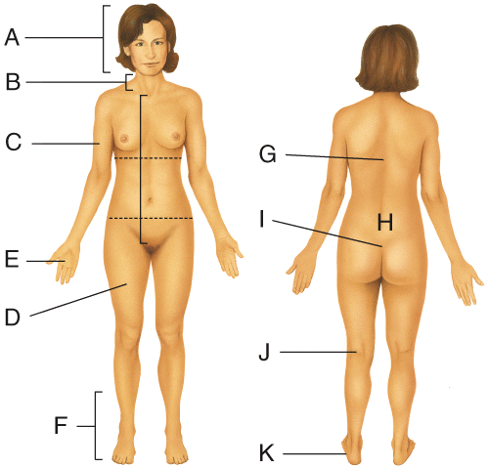

a) D

b) E

c) F

d) J

e) K

Answer: a

Difficulty: Medium

Learning Objective 1: LO 1.4 Describe the human body using the anatomical position and specific terms.

Section Reference 1: Regional Names.

80) Where on the diagram is the sacral area?  


a) C

b) D

c) E

d) I

e) J

Answer: d

Difficulty: Medium

Learning Objective 1: LO 1.4 Describe the human body using the anatomical position and specific terms.

Section Reference 1: Regional Names.

81) Where on the diagram is the cervical area?  


a) C

b) E

c) J

d) K

e) B

Answer: e

Difficulty: Medium

Learning Objective 1: LO 1.4 Describe the human body using the anatomical position and specific terms.

Section Reference 1: Regional Names.

82) Where on the diagram is the brachial area?  


a) C

b) E

c) I

d) K

e) D

Answer: a

Difficulty: Medium

Learning Objective 1: LO 1.4 Describe the human body using the anatomical position and specific terms.

Section Reference 1: Regional Names.

83) Where on the diagram is the popliteal area?  


a) H

b) I

c) J

d) D

e) E

Answer: c

Difficulty: Medium

Learning Objective 1: LO 1.4 Describe the human body using the anatomical position and specific terms.

Section Reference 1: Regional Names.

84) The gallbladder is ___ to the sternum.  
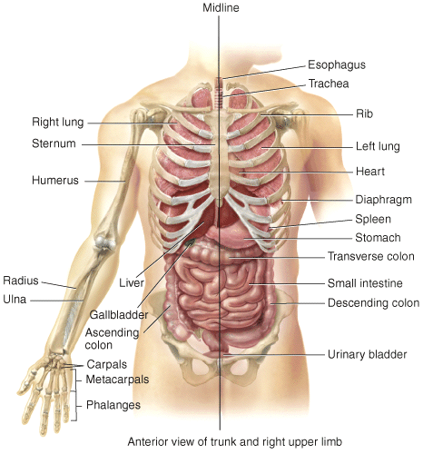

a) superficial

b) medial

c) proximal

d) distal

e) inferior

Answer: e

Difficulty: Medium

Learning Objective 1: LO 1.4 Describe the human body using the anatomical position and specific terms.

Section Reference 1: Directional Terms.

85) The stomach is ____ to the bladder.  


a) lateral

b) medial

c) distal

d) inferior

e) superior

Answer: e

Difficulty: Medium

Learning Objective 1: LO 1.4 Describe the human body using the anatomical position and specific terms.

Section Reference 1: Directional Terms.

86) The humerus is ___ to the radius.  


a) proximal

b) distal

c) medial

d) superior

e) anterior

Answer: a

Difficulty: Medium

Learning Objective 1: LO 1.4 Describe the human body using the anatomical position and specific terms.

Section Reference 1: Directional Terms.

87) Which plane is parasagittal?  
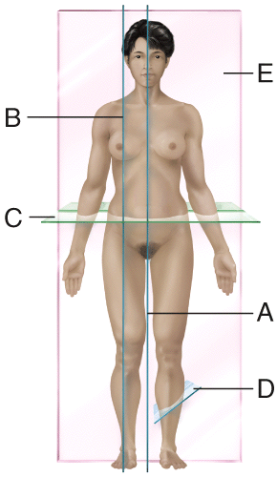

a) A

b) B

c) C

d) D

e) E

Answer: b

Difficulty: Medium

Learning Objective 1: LO 1.4 Describe the human body using the anatomical position and specific terms.

Section Reference 1: Planes and Sections.

88) Which plane is frontal?  


a) A

b) B

c) C

d) D

e) E

Answer: e

Difficulty: Medium

Learning Objective 1: LO 1.4 Describe the human body using the anatomical position and specific terms.

Section Reference 1: Planes and Sections.

89) Which plane is transverse?  


a) A

b) B

c) C

d) D

e) E

Answer: c

Difficulty: Medium

Learning Objective 1: LO 1.4 Describe the human body using the anatomical position and specific terms.

Section Reference 1: Planes and Sections.

90) Which plane is oblique?  


a) A

b) B

c) C

d) D

e) E

Answer: d

Difficulty: Medium

Learning Objective 1: LO 1.4 Describe the human body using the anatomical position and specific terms.

Section Reference 1: Planes and Sections.

Question type: Essay

91) Name the cavities of the trunk and the serous membranes that line these cavities.

Answer:

Difficulty: Medium

Learning Objective 1: LO 1.5 Distinguish among the major cavities of the body and their subdivisions.

Section Reference 1: 1.5 Body cavities are spaces within the body that help protect, separate, and support internal organs.

Solution: The cavities are the thoracic, abdominal, pelvic, and vertebral. The thoracic is subdivided into the pleural and pericardial cavities. The heart is enclosed within the pericardial cavity, a smaller subdivision of the mediastinum. The pericardial cavity is lined by the pericardium. The pleurae line the pleural cavity. The abdominal and pelvic cavities are lined by the peritoneum. The vertebral cavity is lined by the meninges.

92) List the eleven systems of the human body.

Answer:

Difficulty: Medium

Learning Objective 1: LO 1.1 Describe the six levels of organization and the eleven systems of the human body.

Section Reference 1: 1.1 The human body is composed of six levels of structural organization and contains eleven systems.

Solution: The eleven system of the human body include the integumentary, skeletal, muscular, nervous, digestive, urinary, respiratory, immune/lymphatic, cardiovascular, endocrine, and reproductive systems.

93) Describe the anatomical position.

Answer:

Difficulty: Medium

Learning Objective 1: LO 1.4 Describe the human body using the anatomical position and specific terms.

Section Reference 1: Body Positions.

Solution: In the anatomical position the subject stands erect facing the observer with the head level and the eyes facing forward. The feet are flat on the floor and directed forward and the arms are at the sides with the palms turned forward.

94) List the basic processes of life.

Answer:

Difficulty: Medium

Learning Objective 1: LO 1.2 Outline the six most important life processes that distinguish living organisms from nonliving objects.

Section Reference 1: Basic Life Processes.

Solution: The basic processes of life include metabolism, responsiveness, movement, growth, differentiation and reproduction.

95) Name the structural levels of the body, and describe each level.

Answer:

Difficulty: Hard

Learning Objective 1: LO 1.1 Describe the six levels of organization and the eleven systems of the human body.

Section Reference 1: Section 1.1 The human body is composed of six levels of structural organization and contains eleven systems.

Solution: The chemical level consists of atoms and the molecules that are formed from atoms. The cellular level consists of cells, the smallest structural and functional units of the body. The tissue level consists of groups of cells that work to provide an emergent function or functions. The organ level consists of organs, constructed of different types of tissue, which can provide different specific functions. The systems level consists of many organs that are interlinked in general functions. The organism is made up of all of the systems that work to provide homeostasis.

96) List and briefly describe the six basic life processes.

Answer:

Difficulty: Hard

Learning Objective 1: LO 1.2 Outline the six most important life processes that distinguish living organisms from nonliving objects.

Section Reference 1: Basic Life Processes.

Solution: The six basic life processes include metabolism, which is the sum of all chemical processes in the body. Responsiveness is the body's ability to detect and respond to internal and external stimuli. Movement includes motion of an individual cell to the entire body. Growth means an increase in body size or an increase in the number of cells. Differentiation is the process as dividing cells become more specialized. Reproduction refers to formation of new cells for growth and repair or production of a new individual.

97) Describe a feedback system and list the components.

Answer:

Difficulty: Medium

Learning Objective 1: LO 1.3 Explain how homeostasis is maintained through negative and positive feedback systems, and how it can be disrupted by diseases and disorders.

Section Reference 1: Feedback Systems.

Solution: A feedback loop is a cycle of events in which the status of the body condition is monitored, evaluated and changed to maintain homeostasis. A feedback system will include a receptor that detects the stimuli, a control center that receives the input from the receptor and generates an output and an effector that produces a response.

98) Compare and contrast a positive and a negative feedback system.

Answer:

Difficulty: Hard

Learning Objective 1: LO 1.3 Explain how homeostasis is maintained through negative and positive feedback systems, and how it can be disrupted by diseases and disorders.

Section Reference 1: 1.3 Homeostasis is controlled through feedback systems.

Solution: A positive feedback system will enhance the original stimulus while a negative feedback system negates the initial stimulus. Negative feedback systems are more stable, and more common in terms of the maintaining overall body homeostasis. Positive feedback systems are inherently unstable but are sometimes necessary to maintain life. An example of positive feedback mechanism would be the clotting of blood.

99) Describe why maintaining the volume and composition of bodily fluids is important to homeostasis.

Answer:

Difficulty: Hard

Learning Objective 1: LO 1.2 Outline the six most important life processes that distinguish living organisms from nonliving objects.

Section Reference 1: 1.2 The human body carries on basic life processes that distinguish it from nonliving objects.

Solution: Dissolved in the water of intracellular and extracellular fluid are solutes necessary to maintain life, such as oxygen, glucose, proteins, electrolytes and ions. The fluid volumes must be maintained in order to maintain proper hydrostatic pressures. The composition of the fluids must be maintained in order to maintain proper osmotic gradients. If fluid balance is not maintained, the body cells, tissues, and organs cannot sustain life.

100) Describe the positive feedback mechanism that regulates labor contractions during the birth of a baby.

Answer:

Difficulty: Hard

Learning Objective 1: LO 1.3 Explain how homeostasis is maintained through negative and positive feedback systems, and how it can be disrupted by diseases and disorders.

Section Reference 1: Positive Feedback Systems.

Solution: Uterine contractions force the baby's head against the cervix, causing stretching. Stretch receptors in the cervix send a signal along afferent pathways to the control center (the brain). The brain releases oxytocin, a hormone that targets the uterus to produce more forceful contractions. The baby's head is thus pushed again against the cervix, causing more stretching. The cycle repeats until the birth of the baby breaks the positive feedback loop.

101) Explain the difference between signs and symptoms and provide examples.

Answer:

Difficulty: Hard

Learning Objective 1: LO 1.3 Explain how homeostasis is maintained through negative and positive feedback systems, and how it can be disrupted by diseases and disorders.

Section Reference 1: Homeostatic Imbalances.

Solution: Symptoms are subjective changes in body functions that are not apparent to an observer, for example a sore throat, a headache, or nausea. Signs are objective, measurable changes that a clinician can observe, such as redness and swelling in the throat, a fever, or high blood pressure.

102) Compare and contrast the disciplines of anatomy and physiology, and explain why they are studied together in courses such as the one you are now taking.

Answer:

Difficulty: Medium

Learning Objective 1: LO 1.1 Describe the six levels of structural organization and the eleven systems of the human body.

Section Reference 1: Section 1.1 The human body is composed of six levels of structural organization and contains eleven body systems.

Solution: Anatomy is the study of structure, the parts of the body and how they fit together. Physiology is the study of how those parts work. Structure and function are often reflections of each other. For example a red blood cell’s structural features (anucleate, flexible, anaerobic) reflect its function (carry hemoglobin proteins without using the bound oxygen through the smallest of the blood vessels). You would never take your vehicle to a mechanic who only knew the names of all the car parts and had no idea of how they worked. The study of form and function are both required for an effective understanding of the human body.