Business Data Networks And Security, 11th Edition

Panko and Panko

INSTRUCTORS’ MANUAL

# Contents

## *Ⅰ Broad Matters*

Why Networking and Security?

Concepts and Principles; then Applications to Technology

Teaching Individual Chapters

Pedagogy

PowerPoint Presentations

Study Figures

Hands-On Chapters

Online Resources for Teachers

Student Pedagogy of the Book

## *Ⅱ and Ⅲ Chapter Support*

| Chapter | Ⅱ Link to Teaching Suggestions | Ⅲ Link to Test-Your-Understanding Question Answers and Multiple-Choice Questions |
| --- | --- | --- |
| Chapter 1: Core Network Concepts and Terminology | Link | Link |
| Chapter 2: Network Standards | Link | Link |
| Chapter 3: Network Management | Link | Link |
| Chapter 4: Network Security | Link | Link |
| Chapter 5: Ethernet (802.3) Wired Switched LANs | Link | Link |
| Chapter 6: Wireless LANs I | Link | Link |
| Chapter 7: Wireless LANs II | Link | Link |
| Chapter 8: T C P/ I P Internetworking I | Link | Link |
| Chapter 9: T C P/ I P Internetworking II | Link | Link |
| Chapter 10: Carrier Wide Area Networks (WANs) | Link | Link |
| Chapter 11: Networked Applications | Link | Link |
| Appendix Managing the Security Process | Link | Link |
| Online Modules | Link |  |

# Part Ⅰ: Broad Matters

This instructor’s manual has three parts.

* **Broad Matters** has key information about the book and using it in your course.
* **Chapter Information** gives information for teaching individual chapters.
* **Answer Keys and Multiple-Choice Questions** are tied to individual Test-Your-Understanding (T Y U) questions in each chapter.

## Why Networking and Security?

The preface for adopters has more detail on why the book is right for courses. Here’s the short version:

* It’s right for a pure business data networking course because security is a huge part of today’s networking profession. General security courses do not cover many relevant network security concepts. Cover the 11 chapters plus some hands-on “a” chapters.
* Its also right for the growing number of schools that combine introductory networking and security courses. The Appendix adds additional information on planning and response that balance the protection information in other chapters. It is good to cover the Appendix after Chapter 4, which is the security overview. It is also a fun way to end the term.

## Concepts and Principles; Then Applications to Technologies

As noted in the Preface for Instructors, businesses want graduates who can approach technologies like Wi-Fi, Ethernet, and applications holistically—how standards, management, and technology apply to each because that is how networking and security are done in organizations. This learn-and-apply approach to networking and security concepts and principles also helps burn them into students’ mental ROM by applying them to different situations.

* **First Concepts and Principles**. The first four chapters discuss general concepts, standards, network management, and security. (Security, as you might expect, also weaves through the first three.) In a combined introductory networking and security course, I teach the Appendix right after Chapter 4.
* **Then Applying Concepts and Principles Holistically**. The rest of the book applies these concepts and principles to a series of technologies: Ethernet (Chapter 5), Wi-Fi (Chapters 6 and 7), the Internet of Things devices (Chapter 7), the Internet (Chapters 8 and 9), WANs (Chapter 10), and applications, including cloud computing (Chapter 11). Figure P-1 shows how this works for 802.11 Wi-Fi.

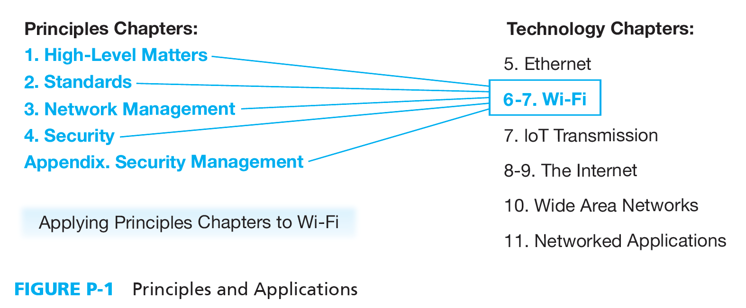

## Teaching Individual Chapters

### Coverage

Each chapter takes about 2.5 hours of class time. In semester courses, that is a week. If Chapter 4 (security) is taught interactively, it will take a little longer. I also like to schedule extra time for Chapter 1 to cover the hands-on experiences in Chapter 1a in class. The Appendix and Chapter 5 may also merit an extra class day.

I suggest *not* covering More Information sections with deeper background information the first time through the book. I usually don’t cover them even later.

### Pedagogy

In class, I normally use the PowerPoint presentations. More on them later.

* **Class Discussions**. Some chapters, especially Chapter 4 on security, lend themselves to discussions in class. For that chapter, I go to the board and have them come up with lists of attackers and attacks. They know a lot, and they feel good showing it. In most chapters, however, there are too many new and complex concepts for this. Even then, however, you can go over something and ask a few questions about it to reinforce learning.
* **Chapter-Opening Caselets**. Several chapters begin with opening caselets. I usually assign these for study before the class. To warm up the class, I begin with a few minutes going over Test-Your-Understanding questions from the caselet, then launch into the PowerPoint presentation.
* **Test Your Understanding Questions**. The book is built around Test-Your-Understanding questions. Individual multiple-choice questions are keyed to individual T Y U questions. If you tell students to skip a section in the book, it is easy to avoid including multiple choice questions that on that section.
* **Homework**. Each subsection (Level 2 heading) ends with Test-Your-Understanding questions. The best students read a subsection and then immediately go over the T Y U questions to see if they understand it well enough. There are too many T Y U questions to assign for homework, so I assign selected ones that are important or tend to cause problems. I then spend about 20 minutes of the next class going over the ones students want to go over.

### PowerPoint Presentations

* **Full Lectures**. The PowerPoint presentations are full lectures, not just “a few chosen examples.”
* **Larger Figures**. Some figures are too large to show on a PowerPoint slide, and just breaking them down into pieces can cause confusion. Most chapters have “Larger Figure” files that students can download. These show the larger figures for the chapter. It helps them follow the PowerPoint presentations for these figures.
* **Calculations and Examples**. When there are calculations to be done, take time to work through the example in the presentation, and have them do another couple of examples in the presentation. Also, ask questions a lot to see if they have gotten various points. Yes, this is just Teaching 101.
* **Multistep Processes**. Many students have a hard time with multistep processes. They must simultaneously learn both individual steps and the overall flow. It’s like learning to play a violin while giving a performance. Go through each step closely, recapping where they are in the process frequently. Give them confidence that they can learn these things. It is a critical academic skill that is too often not achieved in school or in life. It is, of course, crucial in business.
* **Choosing Alternatives**. Another common problem is that networking is usually about choosing among alternatives. Some students myopically understand individual alternatives, but this is not enough. Students must learn to compare them, contrast them, and choose among them. The PPT presentations emphasize this.
* **Notes**. Versions of the PowerPoint presentations for authors will have slide notes about how to teach a particular slide.
* **Notes 2**. Sometimes slide notes have additional information you can use to inject background into your presentation.
* **Skipping Stuff**. If you trust your students to read the book, cut out some straightforward sections and tell them to read it. This lets you move more slowly through the hard stuff.
* **Illustrations**. Slides with illustrations are best covered in a particular way.
  + First, discuss the problem that must be solved. In Figure 1-1, this is how distributed denial-of-service attacks are conducted.
  + Then, “set the scene.” Note the individual parts and discuss briefly the role of each. In Figure 1-1, these are the botmaster, the KrebsOnSecurity website, the I o T devices and bots.
  + Then go through the process that is depicted. What the botmaster does, what the individual I o T bots do, and what happens on the website.

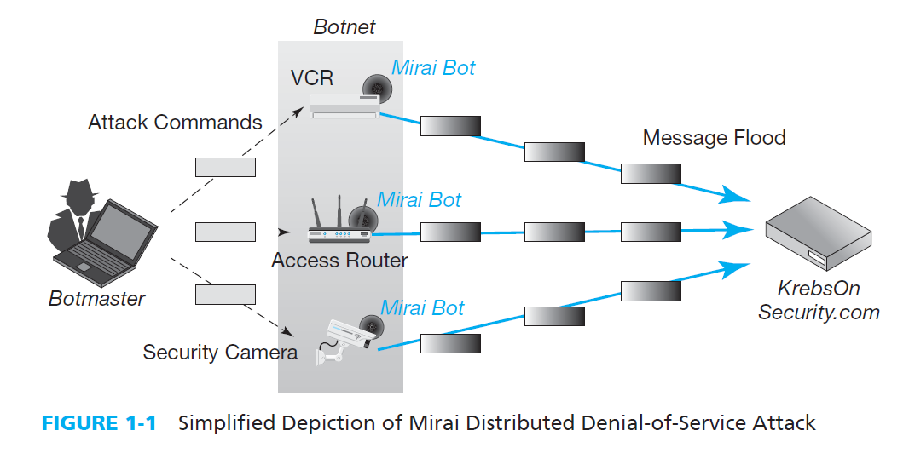

* For more complex illustrations, there are sequence numbers to guide your explanation after you give the problem and set the scene. In the PowerPoint deck, slide builds help you walk through them systematically (and make each part more understandable). This also reduces student panic when they see a complex slide (and sometimes teacher panic).

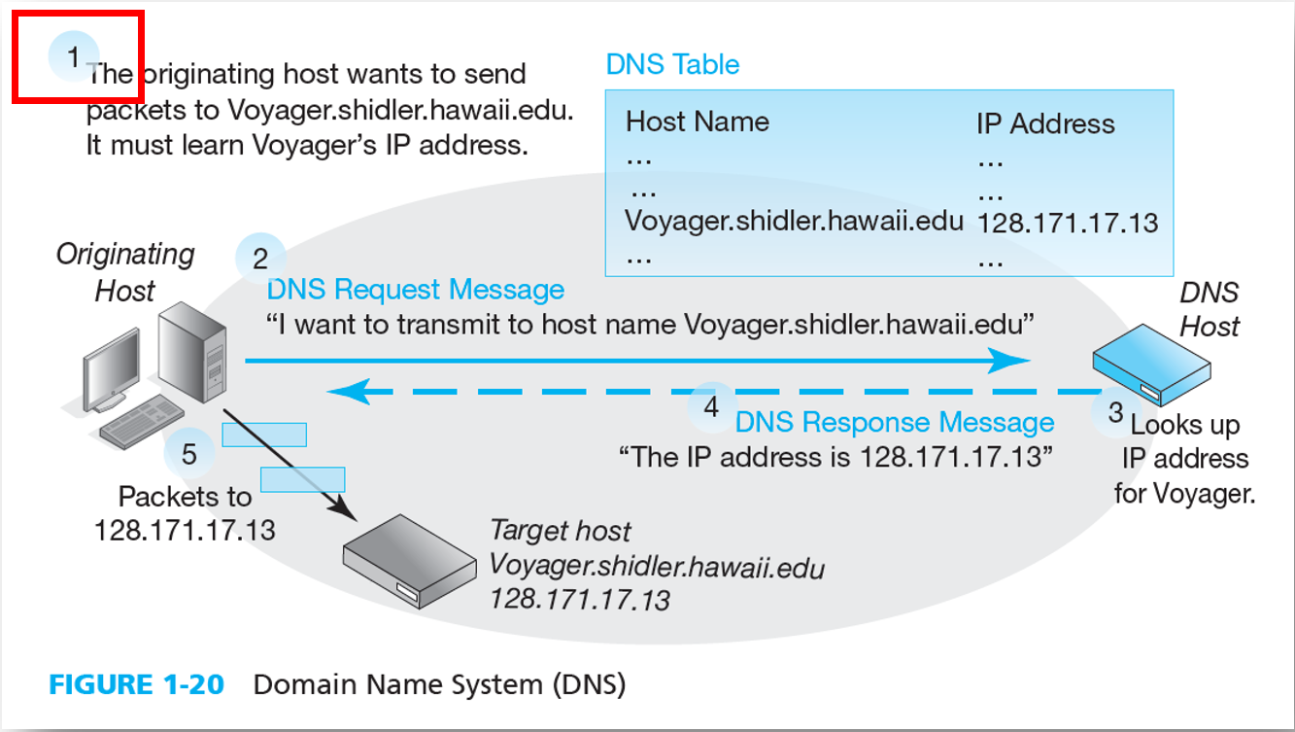

* **Study Figures**. Some figures are text figures that simply recap basic information in the text. Essentially, we take notes for the students. Thanks to text figures, nearly every important point is covered in the figures. This makes them great for exam study.

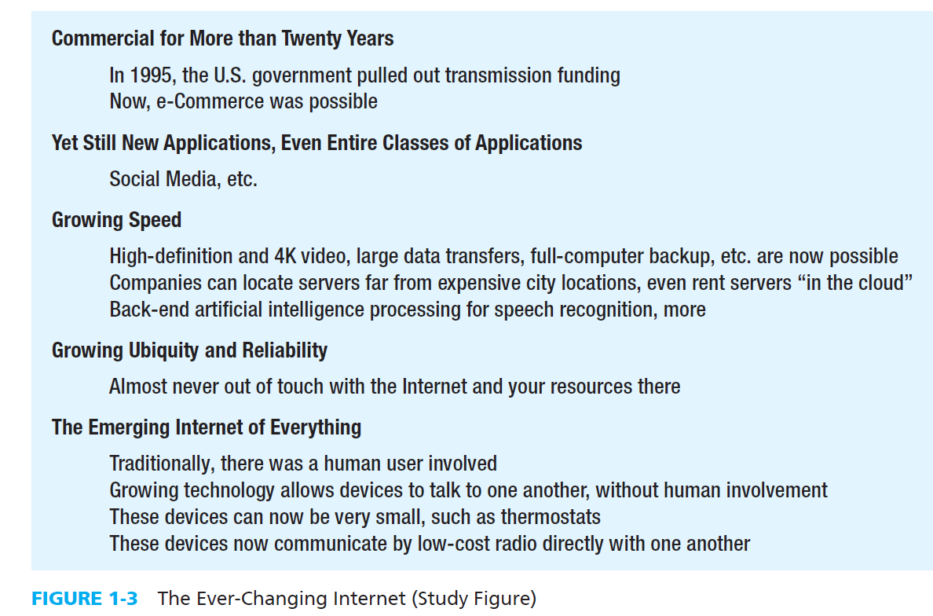

## Hands-On Chapters

Several chapters are followed by brief hands-on chapters to give students some concrete experience to help them understand what they have just learned. I usually assign them as homework, but I do a “warm up” demo in class to see what they will experience. I go over what they actually learned briefly in the next class. In my class forum, I have students post questions to help them get around any glitches.

For Chapter 1a, I (the older author) actually go through some of it when I teach Chapter 1. Traceroute is a great way to show them how many routers their packets travel through to reach the destination host, and it burns the idea of routers, data links, and destination hosts into their mental ROM.

Networking and security are brain games, so working examples on network capacity calculations is more fundamental than cutting and connectorizing 4-pair solid-wire U T P. However, students really crave more hands-on work. I wish classes could cover all of the hands-on ability needed for Cisco certifications, but there is not enough time without tacking on additional credits.

## Online Resources for Teachers

Beyond this Instructor’s manual, there are online resources for courses.

### For Teachers

This instructor’s manual is only available to teachers.

So are annotated PowerPoint presentations for teachers.

### For Students

Students can download the student versions of the PowerPoint presentations to follow along in class.

Students can also download homework files so that you can see their answers in the context of the specific questions asked. These are in Word for Windows file format.

In addition to PowerPoint presentations, you and students can download “Larger Figures.” This is a word file that contains one or more large figures. PowerPoint slide builds are great for presentation, so we use them a lot. However, students also need to see whole figures.

## Student Pedagogy in the Book

**Sections**. Each chapter’s flow is broken into a lot of sections, subsections, and sub-subsections. Each has a header giving the gist of what is covered. Students have a difficult time reading through multipage blocks of text without their eyes glazing over and losing the flow. Some teachers hate all the subsections, but they make the book look less intimidating to students and help them focus on what each block of text is about.

**Test-Your-Understanding Questions**. Again, PowerPoint presentations help, but students need to work by themselves to learn the material. Networking is both complex and unfamiliar. Security is more familiar but similarly nuanced. Test-Your-Understanding questions are central to learning the material. It is best to study a section, then do the T Y U questions, and then go back over the section to learn what they aren’t sure about. Honestly, only the best students do it, but it’s a powerful tool.

T Y U questions are also important because multiple-choice questions are taken directly from them. Of course, they can’t just memorize questions and answers because the wording on multiple-choice questions will be different, but the content will be the same.

**Process for Exam Study**. To study for exams, I recommend that students first read through material that is broken out with solid lines above it and below it. These are key concepts. I then ask them to go over each figure and give a lecture snippet to explain it. Finally, there is going over the T Y U questions and going back to restudy if they do not have high confidence in their answers.

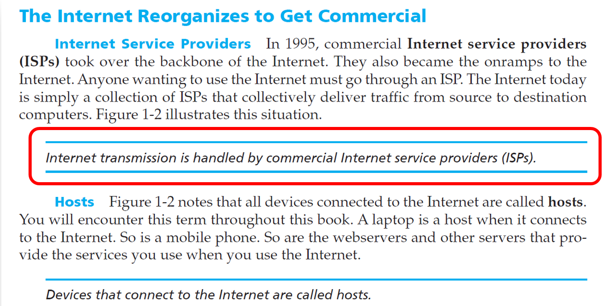

**Fun Footnotes**. No, that is not an oxymoron. We limit chapter content to what all students should be able to master in an introduction to networking course. Sometimes, it is useful for some students if a bit more information is available to satisfy their curiosity. We put them in footnotes. They are not required reading, so they are not deadly detailed. Sometimes, footnotes are used for illustrative (and occasionally a bit snarky) comments.

## Changes Since the Last Edition

Based on experience teaching the last edition and listening to others who have taught it, this new edition contains a lot of new writing. Much of this involves presenting sections of material in improved ways. Changes are listed in the sections for individual chapters. However, we should note several general changes here.

* As much as possible, we have streamlined the chapters by removing material that is not absolutely essential. Gone are several technologies and concepts that now sleep with the fishes. Other information, which is nice to know, has been moved to footnotes for students who are interested. In general, chapters are about 10% to 20% lighter.
* Some of this streamlining has been used to add more examples of things that students have a difficult time with. These sections need a little more class time and student exercises. In addition, when a figure has multiple steps, callouts are sometimes added to show the order in which things should be understood. These become builds in PowerPoint presentations.
* In the last edition, Chapter 3 dealt with network security while Chapter 4 covered network and security management.
  + In this edition, the third chapter is now on network management. All S D N material has been placed in this chapter.
  + Security is now introduced in depth in Chapter 4 because it is important to cover all possible network principles to be able to talk about network security as opposed to security in general.
  + The Appendix has security information that is important but that the teacher may not wish to cover in a networking course. It covers security planning from Chapter 3 in the last edition and expands on this topic. It also covers responses to incidents in considerably more detail.

# Part Ⅱ: Chapter Teaching Suggestions

## Chapter 1: Core Network Concepts and Terminology

### Role in the Book

This is the first of four core chapters (five if you cover the Appendix) that present the principles and concepts students will see through the rest of the book. The role of this chapter is to introduce the Internet and single networks like Ethernet and Wi-Fi that create the data links between Internet routers. Following chapters focus on standards, network management, and security.

### Content Flow

An opening caselet introduces the Mirai botnet. This introduces security in the context of the first IoT-based denial-of-service attack, which had unprecedented volume. (There is more detail on D o S attacks in Chapter 4.) The attack also involves the Domain Name System, which is described toward the end of the chapter. Since the book was written, new information has come to light that you can talk about in class. See the chapter’s section on New Information.

* Chapter 1 then looks at the Internet broadly to give overall concepts and perspective.
* The next section treats the Internet as a cloud and looks at what happens outside the Internet, on the hosts that create packets, submit them, and receive them. It looks at what happens at what we will see in Chapter 2 are the application, transport, and Internet layers.
* The next section looks inside the Internet, to see how routers and data links work to forward packets through the Internet’s mesh.
* Beyond packet routing, the chapter looks at two Internet supervisory standards, DNS and DHCP. They introduce supervisory protocols and cover key I P concepts we will need throughout the course.
* The chapter ends by comparing and contrasting three devices that tend to get confused: home access routers, Internet core routers, and corporate access points. Nearly all students have experience with home access routers, and they need to overcome that experience to understand Internet core routers and corporate Wi-Fi access points.
* Chapter 1a presents hands-on exercises so that students can test their Internet connectivity, look up a host’s I P address using DNS, and use Ping and traceroute to understand the paths of packets between the source and destination host.

### Opportunities to Enrich the PowerPoint Presentation

I like to begin by asking the class about their use of the Internet and ask if there are things that they would like to know more about it. They are all experienced, so it is a good ice breaker.

Before the class, I assign them the State of Siege caselet and ask them to be ready to go over its Test-Your-Understanding questions in class. This is another good ice breaker. By the way, there is newer information about Mirai in the More Information section for this chapter.

As I go through Chapter 1, I go through a few things in the hands-on “a” chapter, Chapter 1a.

* The concepts of I P addresses and packets traveling across multiple routers can be abstract. I use Ping and Traceroute exercises in Chapter 1a to make them more concrete.
* Similarly, for host names and I P addresses, I demonstrate how they work with hands-on exercises from 1a.

If possible, bring in a nonworking home access router, Internet core router, and corporate access point to show them. It makes them less abstract. IT departments in local companies are good sources of devices like this.

### The Hard Parts

Since layered network architectures were created in the 1960s, students have been daunted by all the different messages they must learn at different layers. Students need to distinguish among application messages, T C P segments, U D P datagrams, I P packets of both types, frames of several types, physical links, data links, and routes. Layers 2 and 3 are particularly difficult because they introduce very similar but different terminology for single networks and internets. The chapter tries to help them by introducing a lot of repetition and doing direct comparing and contrasting.

Students need to learn both standards architectures and standards layers. In other words, they have to learn the framework and individual pieces constantly. Learning is a bit like a spiral. This is hard to learn, and concepts are slippery in memory.

The best way to help students learn this sort of thing to work the examples in the PowerPoint presentation during class and frequently quiz them. (What layer are we talking about here? Is this a data link or a route?) It is smart to do this frequently in later chapters as well.

Dotted decimal notation is a bit of work, but once they do one or two examples, they get it.

### More Information

The three perpetrators of the Mirai botnet attack were identified and pled guilty in December 2017. They were 20 and 21 years old at the time of their guilty pleas.

About two months before, more detail about Mirai became available. It basically was a dumb password guesser. Many devices such as security cameras and VCRs come with well-known default usernames and passwords that should be changed before ever connecting to the Internet. Some, in fact, cannot be changed. Mirai tried only 68 username-password combinations. It tried them on many devices around the Internet, downloading bot software when it succeeded. Many components and devices came from a single Chinese parts supplier and a single Chinese surveillance camera supplier. Often, I o T devices such as surveillance cameras are installed by third parties who do not change defaults or set up security properly. Due to the shoddy nature of I o T device security, Mirai’s creators were able to infect hundreds of thousands of devices very quickly with this older-than-dirt attack method.

Mirai used Telnet and SSH to probe potential victims. Many devices allow remote access via Telnet and SSH. A window on the attacker’s screen allows the attacker to type keystrokes on the victim device as if was his or her own device.

### Significant Changes Since the Last Edition

This chapter is pretty much a total rewrite. The last edition introduced single networks and then showed how the Internet links them together. This is historically correct, but it proved cleaner to jump into the Internet right away and introduce single networks in the context of data links to connect routers.

In Edition 10, Chapter 1 introduced network architectures. To lighten Chapter 1 in this edition, network architectures are moved to Chapter 2. However, the new first chapter uses terms such as “physical processes” and “transport processes” to make it easier to cover layered standards architectures in the next chapter.

The chapter introduces the Point-to-Point Protocol.

The section on residential access routers, Internet core routers, and Wi-Fi access points is new. I have also been careful to depict corporate access routers and residential access routers differently.

Network speeds are moved to Chapter 3 to lighten and focus Chapter 1. Students already know basic bits per second speed notation enough to put off the details to a later chapter.

Cloud computing is moved to Chapter 11. It fits better with the application architectures section of that chapter.

In general, this edition replaces semi-realistic icons for routers, switches, and other devices, with basic Cisco Systems symbols. It has proven surprisingly helpful in reducing distractions because it reduces the visual complexity of figures.

# Part Ⅲ: Answer Keys

1

Core Network Concepts and Terminology

## A State of Siege

1. What is a D D o S attack?

A distributed denial-of-service attack tries to reduce or eliminate a resource’s ability to serve its users. The attacker overwhelms the resource by sending a flood of messages from many compromised computers.

1a.) Flooding a host with traffic so that it cannot serve its legitimate users is a Fill in the blank attack.

1. hacking
2. virus
3. malware
4. D o S

Answer: D

Diff: Basic

Question: 1a

Objective: Discuss how the Internet is changing and the security challenges these changes are creating.

A A C S B: Applying Information Technology

1. In what two ways was the KrebsOnSecurity.com D D o S attack unusual?

The Krebs on security attack was unusual for its very high attack traffic volume and the fact that the compromised devices were Internet of Things devices instead of the usual suspects: laptops, mobile phones, desktops, or server computers.

1b.) The KrebsOnSecurity.com attack Fill in the blank.

* 1. was a denial of service attack
  2. used I o T devices to attack the site
  3. Both A and B
  4. Neither A nor B

Answer: C

Diff: Basic

Question: 1b

Objective: Discuss how the Internet is changing and the security challenges these changes are creating.

A A C S B: Applying Information Technology, Analytical Thinking

1. What do we mean by the “Internet of Things”?

IoT devices are usually small devices such as surveillance cameras that communicate directly with one another without human involvement. There will soon be more I o T device using the Internet than humans surfing the Web, sending e-mail, sending Excel and Word files, and doing other “humanish” things.

1c.) Internet communication that does not involve a human is referred to with the term Fill in the blank.

1. World Wide Web
2. impersonal
3. anonymous
4. IoT

Answer: D

Diff: Deeper

Question: 1c

Objective: Discuss how the Internet is changing and the security challenges these changes are creating.

A A C S B: Applying Information Technology, Analytical Thinking

1. What happens when a host cannot reach a Domain Name System server?

If your device cannot reach a DNS server, knowing a site’s host name will not allow you to learn its I P address so that you can send it packets.

1d.) If a host cannot reach a DNS server, it Fill in the blank.

1. cannot have a host name
2. will have to rely on host names
3. will need to use a DHCP server
4. is unlikely to be able to communicate with most server hosts

Answer: D

Diff: Deeper

Question: 1d

Objective: Discuss how the Internet is changing and the security challenges these changes are creating.

A A C S B: Applying Information Technology, Analytical Thinking

1. What specific security weakness did the Mirai malware use to propagate from machine to machine?

Default passwords on devices that were not or could not be changed. These default passwords are common knowledge, so logging into a device with an unchanged default password is easy.

Since the book was written, the Mirai botnet creators were identified and pled guilty. At the time of their guilty pleas, which came about a year after their main attack, they were 20 and 21 years old.

Most of the compromised devices, by the way, had equipment produced by Hangzhou Xiongmai. It had a default password that was not required to be changed.

1e.) The Mirai bots in the KrebsOnSecurity.com attack were Fill in the blank.

1. client hosts
2. server hosts
3. IoT devices
4. All of the above

Answer: C

Diff: Basic

Question: 1e

Objective: Discuss how the Internet is changing and the security challenges these changes are creating.

A A C S B: Applying Information Technology

## Anything, Anytime, Anywhere

1. When was commercial activity on the Internet first allowed?

1995

1. What services do Internet service providers provide?

Giving access to the Internet and carrying traffic in the Internet.

3a.) ISPs Fill in the blank.

* 1. carry traffic in the Internet
  2. connect users to the Internet
  3. Both A and B
  4. Neither A nor B

Answer: C

Diff: Basic

Question: 3a

Objective: Discuss how the Internet is changing and the security challenges these changes are creating.

A A C S B: Applying Information Technology, Analytical Thinking,

1. In Figure 1-2, through which ISP(s) will traffic pass if a packet from Hawaii.edu goes to Panko.com? (Answer: ISP 1, ISP 2, and ISP 3.)

ISP 1, ISP 2, and ISP 3.

1. Through which ISP(s) will traffic pass if a packet from Microsoft.com goes to the mobile phone in the lower right of Figure 1-2?

ISP 5 only. It could take a less direct route, but it probably will not.

3c.) A packet sent from one host to another over the Internet will ALWAYS pass through Fill in the blank.

1. a single ISP
2. at least 2 ISPs
3. multiple ISPs
4. None of the above

Answer: D

Diff: Deeper

Question: 3c

Objective: Discuss how the Internet is changing and the security challenges these changes are creating.

A A C S B: Applying Information Technology, Analytical Thinking, Application of Knowledge.

1. In Figure 1-2, through which ISP(s) may traffic pass if a packet from Microsoft.com goes to Panko.com? (Hint. There are multiple possible answers.)

5, 1, 2, 3.

5, 4, 2, 3 will also work.

1. What do we call any device connected to the Internet?

A host.

4a.) We call any device connected to the Internet a(n) Fill in the blank.

* 1. I P
  2. client
  3. router
  4. host

Answer: D

Diff: Basic

Question: 4a

Objective: Discuss how the Internet is changing and the security challenges these changes are creating.

A A C S B: Applying Information Technology.

1. When you use a laptop to connect to the Internet, is it a host? Explain in terms of the definition of *host*.

Yes. It is a device, and it is connected to the Internet.

4b.) Which of the following is a host when it is on a network?

1. a client PC
2. a server
3. a mobile phone
4. All of the above

Answer: D

Diff: Basic

Question: 4b

Objective: Discuss how the Internet is changing and the security challenges these changes are creating.

A A C S B: Applying Information Technology.

1. When you use the Internet, are *you* a host? Explain in terms of the definition.

No, you are not a device. This is a serious question. It emphasizes that It is important to turn to definitions to answer questions about concepts. In this case it is silly, but it is important in general. Just dashing off an answer from the top of your head based on gut intuition will not get you very far in business no matter which profession you end up in.

1. What continuing changes in the Internet are contributing to its ability to support new applications constantly?

Growing speed, growing ubiquity, and growing reliability.

5a.) Which of the following is leading to new applications constantly?

* 1. increasing speed
  2. increasing reliability
  3. increasing availability wherever you are
  4. All of the above

Answer: D

Diff: Basic

Question: 5a

Objective: Discuss how the Internet is changing and the security challenges these changes are creating.

A A C S B: Applying Information Technology, Analytical Thinking.

1. What are the characteristics of the Internet of Things?

Devices, usually small ones, that communicate directly with one another, without human involvement.

1. Who owns the Internet?

Nobody owns the entire Internet. Different companies own different ISPs, which carry one another’s packets between the source and destination hosts.

BTW, this is exactly how the worldwide telephone network works.

6a.) Who owns the Internet?

* 1. The U.S. government
  2. The United Nations
  3. The I E T F
  4. No one

Answer: D

Diff: Basic

Question: 6a

Objective: Discuss how the Internet is changing and the security challenges these changes are creating.

A A C S B: Applying Information Technology.

1. Who is in charge of the Internet?

Nobody is really in charge of the Internet. The ISPs simply work with one another.

BTW, they may be subject to national regulation, but this is a very weak form of “in charge.”

6b.) Who is in charge of the Internet?

1. the U.S. government
2. the United Nations
3. the I E T F
4. No one

Answer: D

Diff: Basic

Question: 6b

Objective: Discuss how the Internet is changing and the security challenges these changes are creating.

A A C S B: Applying Information Technology.

1. What is the role of the I E T F?

The Internet Engineering Task Force creates technical standards for the Internet.

BTW, adopting these standards is not mandatory for ISPs to use.

6c.) The I E T F primarily Fill in the blank.

1. manages the Internet
2. creates Internet standards
3. coordinates the work of ISPs
4. All of the above.

Answer: B

Diff: Deeper

Question: 6c

Objective: Discuss how the Internet is changing and the security challenges these changes are creating.

A A C S B: Applying Information Technology, Analytical Thinking.

1. Why is the Internet’s ability to give broad access a good thing?

It allows individuals to get broad access to resources on the Internet, regardless of their location.

1. What danger does it bring?

It also allows criminals to gain wide access to resources and customers in order to exploit them.

7b.) From the point of view of security, the Internet’s ability to give access to nearly everyone is a Fill in the blank.

1. good thing
2. bad thing
3. Both A and B
4. Neither A nor B

Answer: B

Diff: Deeper

Question: 7b

Objective: Discuss how the Internet is changing and the security challenges these changes are creating.

A A C S B: Applying Information Technology, Analytical Thinking.

1. What does “Inter” in Internet mean.

It means *between*. It was originally created to connect various single networks together. Single networks came before the Internet.

8a.) In the name Internet, “inter” means Fill in the blank.

1. between
2. interior
3. international
4. interplanetary

Answer: A

Diff: Basic

Question: 8a

Objective: Discuss how the Internet is changing and the security challenges these changes are creating.

A A C S B: Applying Information Technology.

1. Why is this significant?

It emphasizes that the Internet was created to network many smaller single networks together.

## Outside the Internet

1. Why is the Internet often depicted as a cloud?

The cloud symbolism emphasizes that devices and people who use the Internet do not have to understand how it works. It simply accepts and delivers their packets.

9a.) Depicting the Internet as a cloud symbolizes that Fill in the blank.

1. the Internet is amorphous
2. the Internet today is too complex to be understandable by humans
3. the Internet is too complex for anyone to depict
4. users do not have to know how the Internet operates

Answer: D

Diff: Basic

Question: 9a

Objective: Explain basic concepts and terminology for the hosts (devices) that connect to the Internet.

A A C S B: Applying Information Technology, Analytical Thinking.

1. Why is the Internet not about sending messages between hosts?

It is about sending messages between applications. Applications are the only things that users care about.

1. Distinguish between client and server hosts.

In client/server processing, there are two hosts. The one that provides service is the server host. The one that receives service is the client host.

10a.) When you use your tablet to access the Internet, the tablet is a Fill in the blank.

1. client host
2. server host
3. Both A and B
4. Neither A nor B

Answer: A

Diff: Basic

Question: 10a

Objective: Explain basic concepts and terminology for the hosts (devices) that connect to the Internet.

A A C S B: Applying Information Technology, Application of Knowledge.

1. What type of devices are most servers?

Most servers are rack servers.

10b.) Most servers are Fill in the blank.

1. mainframes
2. Windows PCs
3. rack servers
4. routers

Answer: C

Diff: Basic

Question: 10b

Objective: Explain basic concepts and terminology for the hosts (devices) that connect to the Internet.

A A C S B: Applying Information Technology.

1. What are networked applications?

Networked applications are those that require a network to communicate with one another. Early computer programs ran on stand-alone devices and did not interact with other programs on other machines.

1. Is the client always a browser?

No. It is important to distinguish between examples in the text and the general situation.

11b.) The client program is nearly always a browser.

1. True
2. False

Answer: B

Diff: Basic

Question: 11b

Objective: Explain basic concepts and terminology for the hosts (devices) that connect to the Internet.

A A C S B: Applying Information Technology, Analytical Thinking, Application of Knowledge

1. Is the server always a webserver?

No. It is important to distinguish between examples in the text and the general situation.

11c.) The server program is always a webserver program.

1. True
2. False

Answer: B

Diff: Basic

Question: 11c

Objective: Explain basic concepts and terminology for the hosts (devices) that connect to the Internet.

A A C S B: Applying Information Technology, Analytical Thinking, Application of Knowledge

1. What two processes does the network stack provide?

The internet and transport processes.

12a.) The network stack implements the Fill in the blank layer process(es).

1. application
2. transport
3. physical
4. data link

Answer: B

Diff: Deeper

Question: 12a

Objective: Explain basic concepts and terminology for the hosts (devices) that connect to the Internet.

A A C S B: Applying Information Technology, Application of Knowledge

1. What is the maximum size of an I P packet?

The maximum size of an I P packet is 65,536 bytes.

Not discussed in the book is the fact that many frames cannot carry that much data. In 802.3 Ethernet (excluding Jumbo Frames), the data field is limited to 1,500 bytes. For 802.11 Wi-Fi it is 2,304 bytes. The source data link process therefore needs to fragment packets across multiple frames, and the destination data link process has to put them back together. Nice to know, but with so much else to go over, including this in the text would have been a matter of serious overload, confusing them with the transport process’s fragmentation of application messages, which is more important to understand.

1. What does the transport process do to the application message if it is short enough to fit in a single packet If the application message is too long?

It simply puts the application message in its data field. There is no fragmentation of the application message.

12c.) The transport process always fragments the application message.

1. True
2. False

Answer: B

Diff: Deeper

Question: 12c

Objective: Explain basic concepts and terminology for the hosts (devices) that connect to the Internet.

A A C S B: Applying Information Technology, Application of Knowledge.

1. What does the transport process add to the application message or fragment?

It adds a transport layer header—either a T C P or U D P header.

12d.) What process adds a header in front of an application message or fragment?

1. Application
2. Transport
3. Internet
4. Data Link

Answer: B

Diff: Basic

Question: 12d

Objective: Explain basic concepts and terminology for the hosts (devices) that connect to the Internet.

A A C S B: Applying Information Technology, Analytical Thinking, Application of Knowledge

1. What is the resulting message called?

The encapsulated application message or fragment plus the T C P or U D P header form a T C P segment or a U D P datagram.

12e.) A T C P message is called a Fill in the blank.

1. datagram
2. packet
3. frame
4. None of the above

Answer: D

Diff: Basic

Question: 12e

Objective: Explain basic concepts and terminology for the hosts (devices) that connect to the Internet.

A A C S B: Applying Information Technology.

1. What does the internet process do with each T C P segment?

It places it in the data field of an I P packet.

12f.) What process adds a header in front of a T C P segment?

1. Application
2. Transport
3. Internet
4. Data Link

Answer: C

Diff: Basic

Question: 12f

Objective: Explain basic concepts and terminology for the hosts (devices) that connect to the Internet.

A A C S B: Applying Information Technology, Analytical Thinking, Application of Knowledge

1. What are the three parts of an I P packet?

The I P header, the T C P header, and the application message or message fragment.

13.) An I P packet may include a(n) Fill in the blank.

1. application message or fragment
2. T C P segment or U D P datagram
3. Both A and B
4. Neither A nor B

Answer: C

Diff: Deeper

Question: 13

Objective: Explain basic concepts and terminology for the hosts (devices) that connect to the Internet.

A A C S B: Applying Information Technology, Application of Knowledge

1. What does the Internet process on the destination host do when a packet arrives for it?

It checks for errors. Then it removes the I P header and passes the T C P segment or U D P datagram up to the transport process.

14a.) When a frame arrives, the data link process on the destination host Fill in the blank.

1. adds a header
2. removes a header
3. Both A and B
4. Neither A nor B

Answer: B

Diff: Basic

Question: 14a

Objective: Explain basic concepts and terminology for the hosts (devices) that connect to the Internet.

A A C S B: Applying Information Technology, Application of Knowledge

1. What does the transport process on the destination host do with multiple T C P segments from a single application message? (This answer is not short.)

It first checks the T C P segment for errors. If it finds an error, it silently discards the packet.

If the packet is free of error, the transport process on the destination host collects all the T C P segments for an application layer message. Using the T C P sequence number field, it puts the application message fragments back in order. It combines them into the original application message. Finally, it passes the application message up to the application process.

14b.) The transport layer on the destination host Fill in the blank.

1. reassembles the application message if it has been fragmented
2. removes the transport header
3. Both A and B
4. Neither A nor B

Answer: C

Diff: Deeper

Question: 14b

Objective: Explain basic concepts and terminology for the hosts (devices) that connect to the Internet.

A A C S B: Applying Information Technology, Application of Knowledge

## Inside the Internet

1. How many bits long are I P v 4 addresses?

32 bits.

15a.) I P v 4 addresses are Fill in the blank bits long.

1. 32
2. 64
3. 128
4. None of the above

Answer: A

Diff: Basic

Question: 15a

Objective: Explain basic concepts and terminology for the Internet itself.

A A C S B: Applying Information Technology.

15a.) Fill in the blank addresses are 32 bits long.

1. I P v 4
2. I P v 6
3. EUI-48
4. None of the above

Answer: A

Diff: Basic

Question: 15a

Objective: Explain basic concepts and terminology for the Internet itself.

A A C S B: Applying Information Technology.

1. Convert 00000001 00000010 00000000 11111111 to dotted decimal notation (spaces have been added). (Note: 00000001 is 1).

1.2.0.255

1. Convert 5.6.0.255 to a 32-bit I P address (add spaces between groups of 8 bits). (Note: 5 is 0000101, not 101.)

00000101 00000110 00000000 11111111

Not: 101 110 0 11111111.

1. What are the three parts of an I P packet? (Yes, this is a repeat of an earlier question.)

The I P header, the T C P or U D P header, and the application message or fragment.

16a.) Which is NOT in an I P packet?

1. Internet header
2. Transport header
3. Data link header
4. All of the above ARE part of the I P packet

Answer: C

Diff: Deeper

Question: 16a

Objective: Explain basic concepts and terminology for the Internet itself.

A A C S B: Applying Information Technology, Analytical Thinking.

1. In which part will you find the source and destination I P addresses?

The I P header.

1. Which of these addresses will routers use to deliver the I P packet?

Routers use I P addresses to deliver I P packets.

16c.) To deliver I P v 4 packets, routers look at the Fill in the blank addresses.

1. dotted decimal notation
2. EUI-48
3. I P v 4
4. All of the above

Answer: C

Diff: Basic

Question: 16c

Objective: Explain basic concepts and terminology for the Internet itself.

A A C S B: Applying Information Technology, Application of Knowledge

1. What does a router do when an I P packet arrives?

It passes the packet on to the next-hop router or, in the final router, to the destination host.

17a.) Routing is based on a(n) Fill in the blank.

1. I P address
2. single-network address
3. either A or B
4. Neither A nor B

Answer: A

Diff: A

Question: 17a

Objective: Explain basic concepts and terminology for the Internet itself.

A A C S B: Applying Information Technology, Application of Knowledge.

1. What is router forwarding called?

Routing.

17b.) Router forwarding is called Fill in the blank.

1. routing
2. switching
3. forwarding
4. None of the above

Answer: A

Diff: Deeper

Question: 17b

Objective: Explain basic concepts and terminology for the Internet itself.

A A C S B: Applying Information Technology.

1. In Figure 1-17, suppose that 60.3.27.47 transmits a packet to 128.171.17.13. When Router C receives the packet, what will be its routing choices?

There is only one choice that makes sense. Router C sends the packet to the destination host.

1. Distinguish between data links and routes.

A data link is the path a frame takes across a single network. A route is the path a packet takes across the Internet.

18a.) paths across a single network are called Fill in the blank.

1. routes
2. data links
3. physical links
4. None of the above

Answer: B

Diff: Basic

Question: 18a

Objective: Explain basic concepts and terminology for the Internet itself.

A A C S B: Applying Information Technology.

1. In Figure 1-15, how many data links are there when the packet travels to Host 5.6.7.8?

7.

1. How many routes will there be?

1.

1. In general, when a source host sends a packet to a destination host, will there probably be more data links or routes along the way? Explain. (The answer is not in the text.)

More data links normally. This is because the packet will usually travel across multiple single networks to get to the destination host. There is never more than one route.

18d.) When a source host sends a packet to a destination host, there will probably be Fill in the blank along the way.

1. more routes
2. more data links
3. about the same number of routes and data links
4. All of the above

Answer: B

Diff: Deeper

Question: 18d

Objective: Explain basic concepts and terminology for the Internet itself.

A A C S B: Applying Information Technology, Analytical Thinking, Application of Knowledge.

1. There are six routers between the source and destination host. How many transport processes will be involved? Explain.

Just two—the ones on the source and destination hosts. Routers do not need transport processes to route packets.

19a.) There are 10 routers between the source and destination hosts. How many transport processes will be involved on all devices?

1. 1
2. 2
3. 10
4. 12

Answer: B

Diff: Deeper

Question: 19a

Objective: Explain basic concepts and terminology for the Internet itself.

A A C S B: Applying Information Technology, Analytical Thinking, Application of Knowledge.

1. How many internet processes will be involved? Explain.

Eight. There will be an internet process on each of the six routers, plus one each on the source and destination hosts.

19b.) There are 10 routers between the source and destination hosts. How many internet processes will be involved on all devices?

1. 1
2. 2
3. 10
4. 12

Answer: D

Diff: Deeper

Question: 19b

Objective: Explain basic concepts and terminology for the Internet itself.

A A C S B: Applying Information Technology, Analytical Thinking, Application of Knowledge

1. Why does the Internet need supervisory protocols?

I P, T C P, and U D P deliver packets. However, there are many other Internet standards. Most deal with the management of the Internet beyond packet delivery. These beyond-routing standards are called supervisory protocols.

20.) Which of the following is an Internet supervisory protocol?

1. DNS
2. I P
3. Both A and B
4. Neither A nor B

Answer: A

Diff: Deeper

Question: 20

Objective: Explain basic concepts and terminology for the Internet itself.

A A C S B: Applying Information Technology, Analytical Thinking, Application of Knowledge

1. What type of host gets a dynamic I P address?

Clients get dynamic I P addresses. Servers get static I P addresses.

21a.) On the Internet, a Fill in the blank host usually gets a dynamic I P address.

1. client
2. server
3. Both A and B
4. Neither A nor B

Answer: A

Diff: Basic

Question: 21a

Objective: Explain basic concepts and terminology for the Internet itself.

A A C S B: Applying Information Technology.

1. What type of host gets a static I P address?

Clients get dynamic I P addresses. Servers get static I P addresses.

21b.) On the Internet, a Fill in the blank host usually gets a static I P address.

1. client
2. server
3. Both A and B
4. Neither A nor B

Answer: B

Diff: Basic

Question: 21b

Objective: Explain basic concepts and terminology for the Internet itself.

A A C S B: Applying Information Technology.

1. Why is a static I P address needed for this type of host?

Static I P addresses allow a client to address packets to servers easily. If server I P addresses changed constantly, there would be no way for clients to address packets to them because the clients would have to find some way to learn the target host’s current dynamic I P address. DNS servers only store static I P addresses associated with host names, although there are extensions for dynamic I P addresses. However, Dynamic DNS is not the norm.

21c.) A host with a Fill in the blank I P address is easier to find than a host with a Fill in the blank I P address.

1. dynamic, static
2. static, dynamic
3. Neither A nor B is easier to find

Answer: B

Diff: Basic

Question: 21c

Objective: Explain basic concepts and terminology for the Internet itself.

A A C S B: Applying Information Technology, Analytical Thinking, Application of Knowledge

1. Does a DHCP server give a host the same I P address each time?

No they do not. Although they may try, there is no guarantee.

21d.) You can expect a DHCP server to give the client host the same I P address each time.

1. True
2. False

Answer: B

Diff: Basic

Question: 21d

Objective: Explain basic concepts and terminology for the Internet itself.

A A C S B: Applying Information Technology.

1. Distinguish between the originating host, the DNS server, and the target host.

When an originating host wishes to send packets to another host (the target host), it needs to know the target host’s I P address. If it knows the target host’s host name, it can get the target host’s I P address from a DNS server. Afterward, the originating host may send packets freely to the target host’s I P address.

1. What is the purpose of a DNS lookup?

To determine the I P address of a host with a particular host name.

22b.) When Host A wishes to communicate with Host B, a DNS server provides the I P address of Fill in the blank.

1. Host A
2. the DNS server
3. Host B
4. None of the above

Answer: C

Diff: Basic

Question: 22b

Objective: Explain basic concepts and terminology for the Internet itself.

A A C S B: Applying Information Technology, Analytical Thinking, Application of Knowledge.

22b.) When Host A wishes to talk with Host B, the DHCP server provides the I P address of Fill in the blank.

1. Host A
2. DNS server
3. Host B
4. All of the above

Answer: A

Diff: Deeper

Question: 22b

Objective: Explain basic concepts and terminology for the Internet itself.

A A C S B: Applying Information Technology, Analytical Thinking, Application of Knowledge.

1. Does the originating host need to contact the DNS host each time it sends a packet to the target host? Explain.

No. Once it contacts the DNS server, it stores the host name-I P address data pair in a DNS cache. If the host name is used again, its I P address will be read from the DNS cache entry for that particular host name.

22c.) The originating host needs to contact the DNS server each time it sends a packet to the target host.

1. True
2. False

Answer: B

Diff: Basic

Question: 22c

Objective: Explain basic concepts and terminology for the Internet itself.

A A C S B: Applying Information Technology.

## Single Networks, Data Links, and Physical Links

1. Distinguish between physical links and data links.

In a single network, physical links are connections between adjacent devices, such as hosts, switches, and access points. The data link is the path that a packet takes across one or more (usually more) physical links in a single network.

23a.) In a single switched network, a Fill in the blank connects consecutive switches.

1. physical link
2. data link
3. route
4. None of the above

Answer: A

Diff: Basic

Question: 23a

Objective: Explain basic concepts and terminology for single networks and their role on the Internet.

A A C S B: Applying Information Technology, Application of Knowledge

1. In a point-to-point single network, how many physical links will there be when a packet is transmitted?

A point-to-point network has both a single physical link and a single data link.

23b.) In a point-to-point single network, how many physical links will there be when a packet is transmitted?

1. 0
2. 1
3. 2
4. It cannot be determined from the information given.

Answer: B

Diff: Basic

Question: 23b

Objective: Explain basic concepts and terminology for single networks and their role on the Internet.

A A C S B: Applying Information Technology, Analytical Thinking, Application of Knowledge.

1. How many data links?

A point-to-point network has both a single physical link and a single data link.

23c.) When a packet is transmitted, there is a single data link in each Fill in the blank.

1. point-to-point single network
2. switched network
3. Both A and B
4. Neither A nor B

Answer: C

Diff: Basic

Question: 23c

Objective: Explain basic concepts and terminology for single networks and their role on the Internet.

A A C S B: Applying Information Technology, Analytical Thinking, Application of Knowledge

23c.) In a point-to-point single network, there is always the same number of physical and data links.

1. True
2. False

Answer: A

Diff: Deeper

Question: 23c

Objective: Explain basic concepts and terminology for single networks and their role on the Internet.

A A C S B: Applying Information Technology, Analytical Thinking, Application of Knowledge

* + - 1. In Figure 1-22, how many physical links will there be when Router A sends a Packet to Router B. (Answer: 4.)

4.

* + - 1. How many data links will there be? (Answer: 1).

1.

* + - 1. When Client Host Y sends a packet to Router B, how many physical links will there be?

2.

* + - 1. Data links?

1.

* + - 1. When Client Host Y sends a packet to Server Host X, how many physical links will there be?

4.

* + - 1. Data links?

1.

* + - 1. Are packets carried inside frames, or are frames carried inside packets?

Packets are carried in the data fields of frames.

25a.) Which of the following is true?

1. Frames are carried inside packets.
2. Packets are carried inside frames
3. Both A and B
4. Neither A nor B

Answer: B

Diff: Basic

Question: 25a

Objective: Explain basic concepts and terminology for single networks and their role on the Internet.

A A C S B: Applying Information Technology.

* + - 1. A host sends a packet to another host. There are ten single networks along the way. How many hosts will there be?

Two: the source host and the destination host.

25b.) A host sends a packet to another host. There are seven single networks along the way. How many other hosts will there be along the route when Host A transmits?

1. 1
2. 2
3. 7
4. 9

Answer: A

Diff: Deeper

Question: 25b

Objective: Explain basic concepts and terminology for single networks and their role on the Internet.

A A C S B: Applying Information Technology, Analytical Thinking, Application of Knowledge

* + - 1. How many data links?

There will be ten data links. (Draw the picture.)

25c.) A host sends a packet to another host. There are six single networks along the way. How many data links will there be along the way?

1. 1
2. 6
3. 7
4. 8

Answer: B

Diff: Deeper

Question: 25c

Objective: Explain basic concepts and terminology for single networks and their role on the Internet.

A A C S B: Applying Information Technology, Analytical Thinking, Application of Knowledge

* + - 1. How many routes?

There is always a single route because this is the name we give to the path a packet takes across an internet.

25d.) A host sends a packet to another host. There are six single networks along the way. How many routes will there be along the way?

1. 1
2. 6
3. 7
4. 8

Answer: A

Diff: Basic

Question: 25d

Objective: Explain basic concepts and terminology for single networks and their role on the Internet.

A A C S B: Applying Information Technology, Application of Knowledge

* + - 1. How many frames?

10. One per single network.

25e.) A host sends a packet to another host. There are six single networks along the way. How many frames will there be along the way?

1. 1
2. 6
3. 7
4. 8

Answer: B

Diff: Basic

Question: 25e

Objective: Explain basic concepts and terminology for single networks and their role on the Internet.

A A C S B: Applying Information Technology, Application of Knowledge

* + - 1. How many packets?

One. Always.

25f.) A host sends a packet to another host. There are six single networks along the way. How many packets will there be along the way?

1. 1
2. 6
3. 7
4. 8

Answer: A

Diff: Basic

Question: 25f

Objective: Explain basic concepts and terminology for single networks and their role on the Internet.

A A C S B: Applying Information Technology, Application of Knowledge

* + - 1. To what device will the first host transmit a frame containing a packet?

To the first router.

25g.) In a single switched network with seven switches between a source and destination host, to which device will the source host *address* the frame?

1. To the first switch
2. To the destination host
3. To the first router
4. To the final switch

Answer: B

Diff: Deeper

Question: 25g

Objective: Explain basic concepts and terminology for single networks and their role on the Internet.

A A C S B: Applying Information Technology, Analytical Thinking, Application of Knowledge

* + - 1. To what device will the final router address a frame?

The destination host.

25h.) The final router in a route sends the packet being routed in a frame addressed to the Fill in the blank.

1. next-hop router
2. destination host
3. local router
4. default router

Answer: B

Diff: Deeper

Question: 25h

Objective: Explain basic concepts and terminology for single networks and their role on the Internet.

A A C S B: Applying Information Technology, Analytical Thinking, Application of Knowledge

* + - 1. Are all data link addresses EUI-48 addresses?

No. EUI-48 is the most common type of data link address but not the only type.

26a.) All data link addresses are EUI-48 addresses.

1. True
2. False

Answer: B

Diff: Basic

Question: 26a

Objective: Explain basic concepts and terminology for single networks and their role on the Internet.

A A C S B: Applying Information Technology.

* + - 1. In which header are source and destination I P addresses found?

In the I P header of the packet.

26b.) Source and destination I P addresses found in the Fill in the blank header.

1. I P
2. Frame
3. T C P
4. All of the above

Answer: A

Diff: Basic

Question: 26b

Objective: Explain basic concepts and terminology for single networks and their role on the Internet.

A A C S B: Applying Information Technology, Application of Knowledge

* + - 1. In which header are source and destination data link addresses found?

In the header fields of frames.

26c.) Source and destination EUI-48 addresses are found in Fill in the blank headers.

1. I P
2. frame
3. T C P
4. U D P

Answer: B

Diff: Basic

Question: 26c

Objective: Explain basic concepts and terminology for single networks and their role on the Internet.

A A C S B: Applying Information Technology, Application of Knowledge

* + - 1. What kind of data link address do Ethernet networks use?

EUI-48 addresses, formerly known as MAC addresses.

26d.) Ethernet uses Fill in the blank addresses.

1. I P v 4
2. I P v 6
3. MAC
4. EUI-48

Answer: D

Diff: Basic

Question: 26d

Objective: Explain basic concepts and terminology for single networks and their role on the Internet.

A A C S B: Applying Information Technology.

* + - 1. What kind of data link address do Wi-Fi networks use.

EUI-48 as well.

26e.) Wi-Fi uses Fill in the blank addresses.

1. I P v 4
2. I P v 6
3. MAC
4. EUI-48

Answer: D

Diff: Basic

Question: 26e

Objective: Explain basic concepts and terminology for single networks and their role on the Internet.

A A C S B: Applying Information Technology.

26e.) Which of the following uses EUI-48 addresses?

1. Ethernet
2. Wi-Fi
3. Both A and B
4. Neither A nor B

Answer: C

Diff: Basic

Question: 26e

Objective: Explain basic concepts and terminology for single networks and their role on the Internet.

A A C S B: Applying Information Technology, Analytical Thinking, Application of Knowledge

* + - 1. Why do hosts need two addresses?

One to receive frames addressed to it. One to receive packets addressed to it.

26f.) Hosts on the Internet have Fill in the blank addresses.

1. I P
2. data link
3. Both A and B
4. Neither A nor B

Answer: C

Diff: Deeper

Question: 26f

Objective: Explain basic concepts and terminology for single networks and their role on the Internet.

A A C S B: Applying Information Technology, Analytical Thinking, Application of Knowledge

## Internet Routers and Personal Access Routers

* + - 1. Compare Internet core routers with home access routers in terms of functionality.

Internet core routers are pure routers. Home access routers also do DHCP and have at least a simple firewall, have consumer-grade Wi-Fi access points, and have a multiport Ethernet switch.

<Actually, to be precise some Internet cores have simple firewall filtering capabilities>

27a.) Fill in the blank have access points.

1. Home access routers
2. Internet core routers
3. Both A and B
4. Neither A nor B

Answer: A

Diff: Basic

Question: 27a

Objective: Explain the distinctions between Internet routers and personal access routers; explain the differences between personal access routers and wireless access points.

A A C S B: Applying Information Technology, Application of Knowledge

27a.) Fill in the blank have DHCP servers.

1. Home access routers
2. Internet core routers
3. Both A and B
4. Neither A nor B

Answer: A

Diff: Basic

Question: 27a

Objective: Explain the distinctions between Internet routers and personal access routers; explain the differences between personal access routers and wireless access points.

A A C S B: Applying Information Technology, Application of Knowledge

* + - 1. Compare them in terms of routing complexity.

Internet core routers have multiple input and output ports and can do sophisticated routing. Access routers have one port from the Internet and one port to the internal network. Packets coming in one way automatically go out the other way, so routing is trivial.

* + - 1. Compare corporate access points and Internet access routers with wireless access point capabilities.

Home access routers have rudimentary access points. Corporate access points can be remotely managed, have adjustable power, and usually can be remotely manageable.

27c.) Which of the following has better access point capabilities?

1. Home access routers
2. Corporate access points
3. Both have about the same access point capabilities.

Answer: B

Diff: Basic

Question: 27c

Objective: Explain the distinctions between Internet routers and personal access routers; explain the differences between personal access routers and wireless access points.

A A C S B: Applying Information Technology, Application of Knowledge

## End of Chapter Questions

### Thought Questions

* 1. In Figure 1-28, when Host A transmits a packet to Host B, how many physical links, data links, and routes will there be along the way? How many packets and frames? How many switches and routers? (Hint: the answers are in the figure, but work it out yourself.)

Physical links: 7

Data links: 3

Routes: 1

Packets: 1

Frames: 3

Switches: 4

Routers: 2

* 1. Repeat for Host C sending a packet to Host E.

Physical links: 10

Data links: 3

Routes: 1

Packets: 1

Frames: 3

Switches: 7

Routers: 2

* 1. Repeat for Host A to Host C.

Physical links: 4

Data links: 1

Routes: 1

Packets: 1

Frames: 1

Switches: 3

Routers: 0

* 1. Repeat for Host E and Router 3.

Physical links: 2

Data links: 1

Routes: 1

Packets: 1

Frames: 1

Switches: 1

Routers: 0

* 1. Repeat for Router 1 and Router 3.

Physical links: 5

Data links: 2

Routes: 1

Packets: 1

Frames: 2

Switches: 3

Routers: 1

* 1. Repeat for Router 1 and Router 2.

Physical links: 1

Data links: 1

Routes: 1

Packets: 1

Frames: 1

Switches: 0

Routers: 0

### Perspective Questions

* 1. What was the most surprising thing you learned in this chapter?

Student answers will vary.

* 1. What was the most difficult thing in this chapter for you? Why was it difficult?

Student answers will vary.

1

Core Network Concepts and Terminology

Last Name: _____________________________________

First Name: _____________________________________

Due Date: ___________________

## Instructions

Homework files are in Word for Windows format.

You download them from the book’s website.

In a chapter, your teacher may assign you questions to complete.

To begin typing your answer, click after the right angle brackets.

### A State of Siege

1. a) What is a DDoS attack?

>>>

b) In what two ways was the KrebsOnSecurity.com DDoS attack unusual?

>>>

c) What do we mean by the “Internet of Things”?

>>>

d) What happens when a host cannot reach a Domain Name System server?

>>>

e) What specific security weakness did the Mirai malware use to propagate from machine to machine?

>>>

### Anything, Anytime, Anywhere

2. When was commercial activity on the Internet first allowed?

>>>

3. a) What services do Internet service providers provide?

>>>

b) In Figure 1-2, through which ISP(s) will traffic pass if a packet from Hawaii.edu goes to Panko.com?

>>>

c) Through which ISP(s) will traffic pass if a packet from Microsoft.com goes to the mobile phone in the lower right of Figure 1-2?

>>>

d) In Figure 1-2, through which ISP(s) may traffic pass if a packet from Microsoft.com goes to Panko.com? (Hint. There are multiple possible answers.)

>>>

4. a) What do we call any device connected to the Internet?

>>>

b) When you use a laptop to connect to the Internet, is it a host? Explain in terms of the definition of *host*.

>>>

c) When you use the Internet, are *you* a host? Explain in terms of the definition.

>>>

5. a) What continuing changes in the Internet are contributing to its ability to support new applications constantly?

>>>

b) What are the characteristics of the Internet of Things?

>>>

6. a) Who owns the Internet?

>>>

b) Who is in charge of the Internet?

>>>

c) What is the role of the IETF?

>>>

7. a) Why is the Internet’s ability to give broad access a good thing?

>>>

b) What danger does it bring?

>>>

8. a) What does “Inter” in Internet mean.

>>>

b) Why is this significant?

>>>

### Outside the Internet

9. a) Why is the Internet often depicted as a cloud?

>>>

b) Why is the Internet not about sending messages between hosts?

>>>

10. a) Distinguish between client and server hosts.

>>>

b) What type of devices are most servers?

>>>

11. a) What are networked applications?

>>>

b) Is the client always a browser?

>>>

c) Is the server always a webserver?

>>>

12. a) What two processes does the network stack provide?

>>>

b) What is the maximum size of an IP packet?

>>>

c) What does the transport process do to the application message if it is short enough to fit in a single packet If the application message is too long?

>>>

d) What does the transport process add to the application message or fragment?

>>>

e) What is the resulting message called?

>>>

f) What does the internet process do with each TCP segment?

>>>

13. What are the three parts of an IP packet?

>>>

14. a) What does the internet process on the destination host do when a packet arrives for it?

>>>

b) What does the transport process on the destination host do with multiple TCP segments from a single application message? (This answer is not short.)

>>>

### Inside the Internet

15. a) How many bits long are IPv4 addresses?

>>>

b) Convert 00000001 00000010 00000000 11111111 to dotted decimal notation (spaces have been added). (Note: 00000001 is 1).

>>>

c) Convert 5.6.0.255 to a 32-bit IP address (add spaces between groups of 8 bits). (Note: 5 is 0000101, not 101.)

>>>

16. a) What are the three parts of an IP packet? (Yes, this is a repeat of an earlier question.)

>>>

b) In which part will you find the source and destination IP addresses?

>>>

c) Which of these addresses will routers use to deliver the IP packet?

>>>

17. a) What does a router do when an IP packet arrives?

>>>

b) What is router forwarding called?

>>>

c) In Figure 1-17, suppose that 60.3.27.47 transmits a packet to 128.171.17.13. When Router C receives the packet, what will be its routing choices?

>>>

18. a) Distinguish between data links and routes.

>>>

b) In Figure 1-15, how many data links are there when the packet travels to Host 5.6.7.8?

>>>

c) How many routes will there be?

>>>

d) In general, when a source host sends a packet to a destination host, will there probably be more data links or routes along the way? Explain. (The answer is not in the text.)

>>>

19. a) There are six routers between the source and destination host. How many transport processes will be involved? Explain.

>>>

b) How many internet processes will be involved? Explain.

>>>

20. Why does the Internet need supervisory protocols?

>>>

21 a) What type of host gets a dynamic IP address?

>>>

b) What type of host gets a static IP address?

>>>

c) Why is a static IP address needed for this type of host?

>>>

d) Does a DHCP server give a host the same IP address each time?

>>>

22. a) Distinguish between the originating host, the DNS server, and the target host.

>>>

b) What is the purpose of a DNS lookup?

>>>

c) Does the originating host need to contact the DNS host each time it sends a packet to the target host? Explain.

>>>

### Single Networks, Data Links, and Physical Links

23. a) Distinguish between physical links and data links.

>>>

b) In a point-to-point single network, how many physical links will there be when a packet is transmitted?

>>>

c) How many data links?

>>>

24. a) In Figure 1-22, how many physical links will there be when Router A sends a Packet to Router B.

>>>

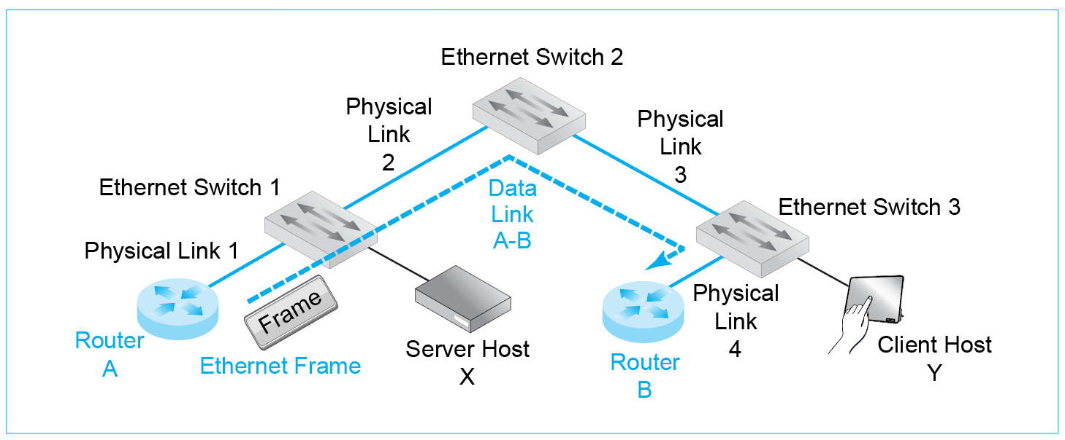

b) How many data links will there be?

>>>

c) When Client Host Y sends a packet to Router B, how many physical links will there be?

>>>

d) Data links?

>>>

e) When Client Host Y sends a packet to Server Host X, how many physical links will there be?

>>>

f) Data links?

>>>

25. a) Are packets carried inside frames, or are frames carried inside packets?

>>>

b) A host sends a packet to another host. There are ten single networks along the way. How many hosts will there be?

>>>

c) How many data links?

>>>

d) How many routes?

>>>

e) How many frames?

>>>

f) How many packets?

>>>

g) To what device will the first host transmit a frame containing a packet?

>>>

h) To what device will the final router address a frame?

>>>

26. a) Are all data link addresses EUI-48 addresses?

>>>

b) In which header are source and destination IP addresses found?

>>>

c) In which header are source and destination data link addresses found?

>>>

d) What kind of data link address do Ethernet networks use?

>>>

e) What kind of data link address do Wi-Fi networks use.

>>>

f) Why do hosts need two addresses?

>>>

### Internet Routers and Personal Access Routers

27. a) Compare Internet core routers with home access routers in terms of functionality.

>>>

b) Compare them in terms of routing complexity.

>>>

c) Compare corporate access points and Internet access routers with wireless access point capabilities.

>>>

### End of Chapter Questions

Thought Questions

1-1. In Figure 1-28, when Host A transmits a packet to Host B, how many physical links, data links, and routes will there be along the way? How many packets and frames? How many switches and routers? (Hint: the answers are in the figure, but work it out yourself.)

>>>

1-2 Repeat for Host C sending a packet to Host E.

>>>

1-3. Repeat for Host A to Host C.

>>>

1-4. Repeat for Host E and Router 3.

>>>

1.5. Repeat for Router 1 and Router 3.

>>>

1-6. Repeat for Router 1 and Router 2.

>>>

Perspective Questions

**1-7.** What was the most surprising thing you learned in this chapter?

>>>

**1-8.** What was the most difficult thing in this chapter for you? Why was it difficult?