**Koeppen: Berne and Levy Physiology, 6th Edition**

**Chapter 1: Principles of Cell Function**

**Test Bank**

**Multiple Choice**

1. The subcellular structure that degrades proteins is called the:

A. tight junction

B. mitochondria

C. lysosome

D. plasma membrane

E. ribosome

ANS: C

2. An experiment is done to measure the uptake of an amino acid into a cell. The following data are obtained.

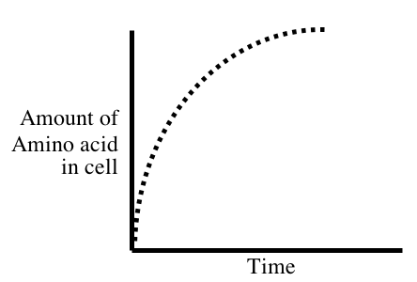

If Na+ is removed from the extracellular bathing solution, or a drug is added that prevents the cell from making ATP, the uptake of amino acid into the cell is markedly reduced. Based on this information which of the following mechanisms is likely responsible for the transport of the amino acid into the cell?

A. passive diffusion through the lipid bilayer

B. uniporter

C. transport ATPase

D. Na+ symporter

E. Na+ antiporter

ANS: D

3. A membrane permeable only to Na+ separates two compartments containing Na2SO4 as shown below.

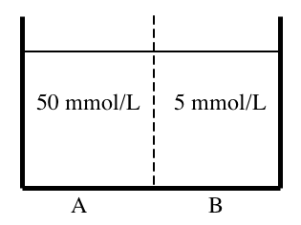

Electrodes are placed in both compartments and a voltage applied (compartment A is held at 0 mV). What voltage applied to compartment B would result in NO net movement of Na+ across the membrane separating the compartments?

A. –60 mV

B. –30 mV

C. 0 mV

D. +30 mV

E. +60 mV

ANS: E

4. The resting membrane potential of a cell is –85 mV. The intracellular and extracellular concentrations of several ions are indicated below, as is the calculated Nernst equilibrium potentials (E) for these ions.

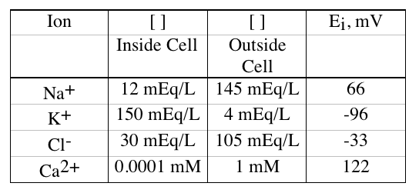

The membrane has channels for Na+, K+, Cl- and Ca++. The conductance of the membrane is the greatest for which ion?

A. Na+

B. K+

C. Cl-

D. Ca++

ANS: B

5. A cell contains the following membrane transporters:

Na+ channel

K+ channel

Na+,K+-ATPase

The resting membrane voltage of the cell is –80 mV and the intracellular and extracellular ion concentrations are:

|  |  |  |
| --- | --- | --- |
|  | Intracellular (mEq/L) | Extracellular (mEq/L) |
| Na+ | 10 | 145 |
| K+ | 120 | 4 |

The cell is treated with a drug to inhibit the Na+,K+-ATPase. What would be the effect of this drug on the following parameters?

|  |  |  |  |  |
| --- | --- | --- | --- | --- |
|  | Intracellular [Na+] | Intracellular [K+] | Cell volume | Membrane voltage |
| A. | decrease | decrease | decrease | depolarize |
| B. | increase | decrease | increase | depolarize |
| C. | increase | increase | increase | no change |
| D. | decrease | increase | decrease | hyperpolarize |
| E. | increase | increase | decrease | hyperpolarize |

ANS: B

6. Which of the labeled proteins (shaded) is attached to the membrane by a glycosylphosphatidylinositol (GPI) anchor?

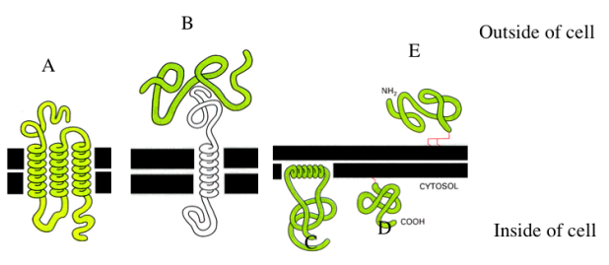

ANS: E

7. A cell has channels for Na+, K+, and Cl- in its plasma membrane. The resting membrane potential is –60 mV (cell interior negative). The intracellular and extracellular concentrations for these ions are given below, as is the calculated Nernst potential.

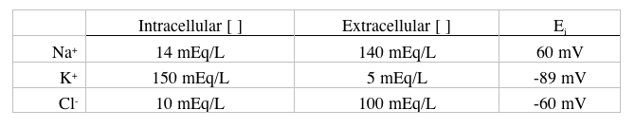

A drug is applied to the cell that increases the permeability of the cell to Cl- (i.e., it opens Cl- channels). What effect will this drug have on the net movement of Cl- across the plasma membrane?

A. Net Cl- movement out of the cell will be increased.

B. Net Cl- movement into the cell will be increased.

C. There will be no change in the net movement of Cl-.

ANS: C

8. Reducing the extracellular [K+] would be expected to have which of the following effects on the resting membrane potential, and excitability of ventricular myocytes?

|  |  |  |
| --- | --- | --- |
|  | Membrane potential | Excitability |
| A. | unchanged | unchanged |
| B. | hyperpolarized | decreased |
| C. | hyperpolarized | increased |
| D. | depolarized | decreased |
| E. | depolarized | increased |

ANS: B

9. A cell is bathed in a solution that contains 5 mmol/L of glucose. The intracellular concentration of glucose is 10 mmol/L. What is the most likely mechanism for the transport of glucose across the plasma membrane of this cell?

A. glucose uniporter

B. Na+-glucose symporter

C. Na+-glucose antiporter

D. diffusion of glucose through the lipid bilayer of the membrane

ANS: A

10. A blood sample is taken from an individual whose blood osmolality is 295 mOsm/kg H2O. Red blood cells from this sample are then placed in the following solutions.

|  |  |  |
| --- | --- | --- |
|  | Osmolality (mOsm/kg H2O) | ⬧ of solute |
| 1. NaCl | 300 | 1 |
| 2. fructose | 300 | 0.5 |
| 3. urea | 300 | 0 |
| 4. CaCl2 | 100 | 1 |
| 5. KCl | 150 | 1 |

The red blood cells in which of these solutions will swell to the greatest degree?

A. 1

B. 2

C. 3

D. 4

E. 5

ANS: C

11. A solution that causes a cell to shrink is:

A. isotonic

B. hypotonic

C. hypertonic

ANS: C

12. Osmosis is the:

A. active transport of water

B. number of solute particles in 1 kg of water

C. diffusion of water across cell membranes

D. defined as the weight of a volume of a solution divided by the weight of an equivalent volume of distilled water

E. amount of a substance relative to its molecular weight

ANS: C