Test Bank
Biology Now
Anne Houtman
Megan Scudellari
Cindy Malone
Anu Singh-Cundy
Test Bank by
Elizabeth Collins
iowa central community college
Tiffany Randall
john tyler community college
Lori Rose
sam houston state university
Suzanne Wakim
butte college

 W • W • Norton & Company • New York • London
Contents
Chapter 1  The Nature of Science 1
Chapter 2  Chemistry of Life 18
Chapter 3  Life Is Cellular 32
Chapter 4  How Cells Work 51
Chapter 5  Cell Division 65
Chapter 6  Patterns of Inheritance 79
Chapter 7  Chromosomes and Human Genetics 94
Chapter 8  What Genes Are 109
Chapter 9  How Genes Work 122
Chapter 10  Evidence for Evolution 137
Chapter 11  Mechanisms of Evolution 151
Chapter 12  Adaptation and Species 164
Chapter 13  The History of Life 178
Chapter 14  Human Evolution 196
Chapter 15  General Principles of Ecology 214
Chapter 16  Growth of Populations 227
Chapter 17  Communities of Organisms 243
Chapter 18  Ecosystems 258
Chapter 19  Homeostasis, Reproduction, and Development 273
Chapter 20  Digestive, Muscular, and Skeletal Systems 289
Chapter 21  Circulatory, Respiratory, Urinary, and Nervous Systems 303
Chapter 22  Endocrine and Immune Systems 318
Chapter 23  Plant Physiology 334
Chapter 24  Applying the Science 347

Chapter 1 The Nature of Science
Learning Objectives
1.1 Determine whether something is living or nonliving based on the characteristics of living things.
1.2 Caption a diagram of the scientific method, identifying each step in the process.
1.3 Given an observation, develop a hypothesis and suggest one or more predictions based on that hypothesis.
1.4 Design an experiment using appropriate variables, treatments, and controls.
1.5 Distinguish between correlation and causation, and give a clear example of each.
1.6 Give specific examples of a scientific fact and a scientific theory.
1.7 Create a graphic showing the levels of biological organization.

MULTIPLE CHOICE

1. What characteristic is NOT shared by all living organisms?
a. | They make their own energy. | c. | They evolve through time.
b. | They grow and develop. | d. | They are composed of one or more cells.

ANS: A DIF: Easy REF: BatCrazy OBJ: 1.1
MSC: Remembering

2. Living organisms maintain a constant internal environment by sensing and responding to their internal conditions. This stable maintenance of internal conditions is known as
a. | homeostasis. | c. | reproduction.
b. | evolution. | d. | sensation.

ANS: A DIF: Easy REF: BatCrazy OBJ: 1.1
MSC: Understanding

3. DNA is one of the features common to all known forms of life;
a. | it forms the protective outer membrane of cells.
b. | it is produced expressly for reproduction and is found only in egg and sperm.
c. | it is the blueprint that guides the growth, development, behavior, and reproduction of all organisms.
d. | its absence in viruses is the basis for classifying them as nonliving.

ANS: C DIF: Medium REF: BatCrazy OBJ: 1.1
MSC: Understanding

4. The roots of a sunflower plant growing downwards while the shoot grows upwards and the flower turns towards the sun are examples of what characteristic of all living organisms?
a. | They reproduce using DNA.
b. | They evolve through time.
c. | They make their own energy.
d. | They sense the environment and respond to it.

ANS: D DIF: Medium REF: BatCrazy OBJ: 1.1
MSC: Understanding

5. A species of butterflies gradually becomes darker in color over many generations; this is an example of which characteristic of living organisms?
a. | They reproduce using DNA.
b. | They obtain energy from the environment to support metabolism.
c. | They can evolve as groups.
d. | They sense the environment and respond to it.

ANS: C DIF: Medium REF: BatCrazy OBJ: 1.1
MSC: Analyzing

6. Which of these characteristics of living organisms are present in viruses?
a. | composed of one or more cells; obtain energy from their environment; reproduce using DNA (or RNA)
b. | reproduce using DNA (or RNA); sense their environment and respond to it; can evolve as groups
c. | maintain a constant internal environment; obtain energy from their environment; composed of one or more cells
d. | obtain energy from their environment; composed of one or more cells; maintain a constant internal environment

ANS: B DIF: Medium REF: BatCrazy OBJ: 1.1
MSC: Understanding

7. When scientists generate a single informed, logical, and plausible explanation for a question and observations of the natural world, they are proposing a scientific
a. | hypothesis. | c. | theory.
b. | observation. | d. | correlation.

ANS: A DIF: Easy REF: ProveMeWrong
OBJ: 1.2 MSC: Remembering

8. A scientific hypothesis must be constructed with which of the following characteristics?
a. | It is always provable and clearly states what is already known to be fact.
b. | It provides a reasonable explanation to a question and is consistent with current observations; it must also be testable and falsifiable.
c. | It provides an explanation consistent with accepted theological ideas and does not need to be tested.
d. | It does not require testing by experimentation or additional observations. It is not falsifiable.

ANS: B DIF: Easy REF: ProveMeWrong
OBJ: 1.2 MSC: Remembering

9. Is it important for scientists to communicate their results to fellow scientists?
a. | Yes. Scientists want to receive recognition and monetary reward for their work.
b. | No. There is no reason for scientists to communicate their results to fellow scientists.
c. | Yes. The quality and accuracy of the scientific work can be enhanced by input, further review, and possibly even repetition by other scientists working in the same field.
d. | No. Communication between scientists is discouraged because it can confuse the details of the experiments.

ANS: C DIF: Easy REF: ProveMeWrong
OBJ: 1.2 MSC: Remembering

10. A scientific hypothesis must be ________; if not, science cannot evaluate it.
a. | provable | c. | accepted
b. | testable | d. | rejected

ANS: B DIF: Easy REF: ProveMeWrong
OBJ: 1.2 MSC: Remembering

11. Whenever we ________, we are proceeding scientifically.
a. | invoke a supernatural power as an explanation for how a natural phenomenon occurred
b. | stop questioning our observations
c. | try to solve a problem by systematically evaluating the plausibility of various solutions
d. | develop an unchangeable and definitive explanation

ANS: C DIF: Medium REF: ProveMeWrong
OBJ: 1.2 MSC: Applying

12. Is it possible for scientists to study events that happened or animals/plants that lived millions of years ago?
a. | Yes. Apply the laws of physics and nature that we know exist today to evaluate the evidence of past events. For example, observe modern animal behavior, structure, and function, and compare them to the structures of fossilized animals to deduce the function of the fossilized structures.
b. | No. The laws of physics that exist today are not the same laws of physics that existed in the past, so there is no way to compare plant or animal fossils to those of modern organisms and deduce the function of fossilized structures.
c. | Yes. Genetic manipulation of fossils allows scientists to directly test metabolic and behavioral characteristics of plants and animals from the past.
d. | No. There is no way to analyze plant or animal fossils that lived millions of years ago because the laws of nature that exist today have changed dramatically from the past.

ANS: A DIF: Difficult REF: ProveMeWrong
OBJ: 1.2 MSC: Applying

13. Victoria, who is 10 years old, wants to be a zoologist when she grows up because she loves animals. So, she decided to begin her training by “doing something scientific.” Specifically, she weighed and measured the lengths of all the earthworms she could find in her yard and recorded the data in a notebook. She then made a graph showing the maximum, minimum, and average weights and heights of the earthworms. Was she doing something scientific?
a. | No, because she is too young to think like a scientist.
b. | No, because she had no hypothesis to direct her data collection or interpretation.
c. | Yes, because scientists always make measurements.
d. | Yes, because scientists always construct graphs with the data they collect.

ANS: B DIF: Difficult REF: ProveMeWrong
OBJ: 1.2 MSC: Understanding

14. Recently, beekeepers have noticed an alarming and sudden disappearance of honeybees from their hives. Some beekeepers and environmentalists worry that crops genetically engineered to contain the gene for the Bt insecticidal toxin may be killing the bees. Without data from a scientific experiment, is it reasonable to state that Bt-containing crops are responsible for the loss of honeybees?
a. | Yes, because it is obviously the Bt crops killing the bees.
b. | Yes, because there cannot possibly be any other explanation for the loss of the honeybees.
c. | No, because there could be some other unknown or unmentioned factor affecting the survival of honeybees.
d. | No, because there is no reason to suspect that an insecticide would kill honeybees.

ANS: C DIF: Medium REF: ProveMeWrong
OBJ: 1.3 MSC: Understanding

15. The hypothesis that a common ancestor gave rise to all living organisms is strengthened by what observation?
a. | Almost all cells in all living organisms use DNA to direct their structure, function, and behavior.
b. | All living organisms use energy acquired directly from the environment or from other organisms.
c. | All living organisms reproduce.
d. | Each type of living organism adheres to the general principles of the biological hierarchy.

ANS: A DIF: Medium REF: ProveMeWrong
OBJ: 1.3 MSC: Applying

16. Which of the following statements is true?
a. | Once a hypothesis has been proposed, it can never be challenged.
b. | A valid scientific hypothesis is self-evident and does not need to be tested by experimentation.
c. | The scientific method or process can help people make informed medical and environmental decisions.
d. | If properly designed, experiments always prove hypotheses to be wrong.

ANS: C DIF: Medium REF: ProveMeWrong
OBJ: 1.3 MSC: Applying

17. Which of the following questions could NOT be used to develop a testable hypothesis?
a. | Does exposure to secondhand smoke affect the probability of developing lung cancer?
b. | Do organic vegetables contain harmful substances?
c. | Should everyone drink bottled water only?
d. | Does a can of vegetable juice contain more salt than the same size can of iced tea?

ANS: C DIF: Medium REF: ProveMeWrong
OBJ: 1.3 MSC: Applying

18. Recently, beekeepers have noticed an alarming and sudden disappearance of honeybees from their hives. Some beekeepers and environmentalists worry that crops genetically engineered to contain the gene for the Bt insecticidal toxin may be killing the bees. Which of these experiments tests the hypothesis that Bt is killing the bees?
a. | Spraying Bt toxin on a field and counting the number of bees present before and after spraying.
b. | Collecting hundreds of bees. Half of the bees would be kept in a facility with plants genetically engineered to contain the gene for Bt toxin while the other half would be kept in a facility with plants not genetically engineered to contain the gene for Bt toxin. The survival rate for both sets of bees would be calculated and compared.
c. | Collecting hundreds of bees and spraying half of them with Bt toxin while the other half is not sprayed with Bt toxin. The survival rate for both sets of bees would be calculated and compared.
d. | The number of bees in two adjacent fields would be counted before and after spraying one of the fields with Bt toxin. The survival rate of bees in both fields would be calculated and compared.

ANS: B DIF: Difficult REF: ProveMeWrong
OBJ: 1.3 MSC: Applying

19. Some questions fall outside the realm of science. Which of the following questions could NOT be answered using the scientific method?
a. | What is the function of the appendix in human beings?
b. | Why is it unethical to test newly developed drugs in animals?
c. | Why do smokers develop lung cancer more frequently than nonsmokers?
d. | Why is it so difficult to quit smoking?

ANS: B DIF: Difficult REF: ProveMeWrong
OBJ: 1.3 MSC: Applying

20. Observational studies typically point out correlations between aspects of the natural world, but they do not establish solid ________ relationships.
a. | controlled | c. | correlative
b. | cause-effect | d. | casual

ANS: B DIF: Medium REF: ProveMeWrong
OBJ: 1.5 MSC: Understanding

21. Experimental studies are an effective way of establishing a ________ relationship between two or more aspects of the natural world because they provide a way of testing predicted interaction(s).
a. | controlled | c. | correlative
b. | cause-effect | d. | casual

ANS: B DIF: Medium REF: ProveMeWrong
OBJ: 1.5 MSC: Understanding

22. A researcher wanted to determine if consuming diet sodas causes diabetes. He conducted a study in which subjects were asked to recall how many diet sodas they drank each day, on average; the subjects’ blood sugar levels were then measured. The average blood sugar levels were determined in the test subjects. Each group included an equal number of male and female participants and the groups were standardized for average weight and age. Which of these statements most accurately describes what is seen in the graph?
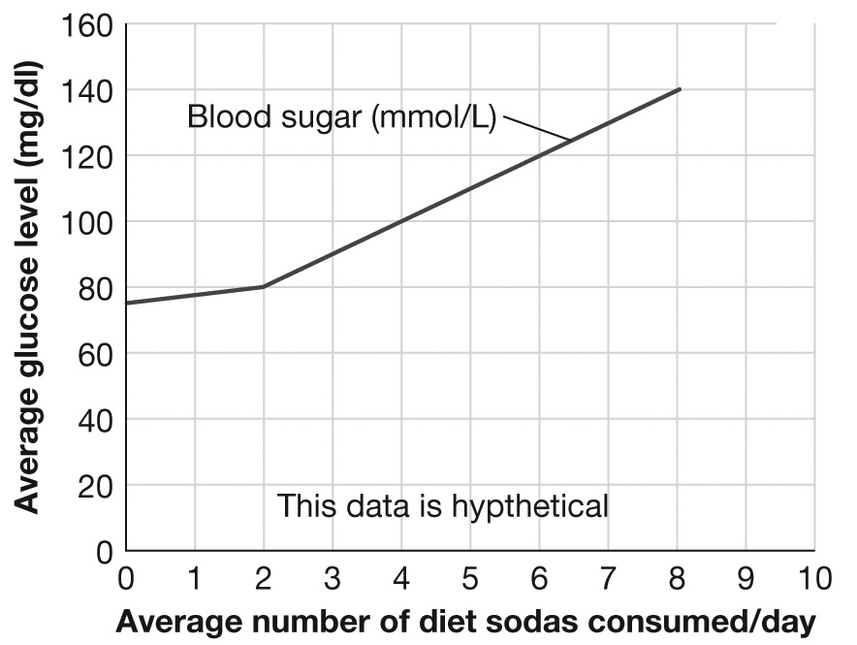
a. | There appears to be a positive correlation between the number of diet sodas consumed each day and the average blood sugar levels measured in mmol/L. However, no definite cause-effect relationship has been established.
b. | There appears to be a negative correlation between the number of diet sodas consumed each day and the average blood sugar levels measure in mmol/L. However, no definite cause-effect relationship has been established.
c. | Drinking four or more diet sodas each day causes diabetes; a definite cause-effect relationship has been established.
d. | Drinking six or more diet sodas each day causes diabetes; a definite cause-effect relationship has been established.

ANS: A DIF: Difficult REF: ProveMeWrong
OBJ: 1.5 MSC: Analyzing

23. New medications undergo extensive human testing before receiving FDA approval. These tests represent an experiment and variations in the dosage given to participants represents the
a. | dependent variable. | c. | correlation coefficient.
b. | independent variable. | d. | invariable.

ANS: B DIF: Easy REF: CatchingtheCulprit
OBJ: 1.4 MSC: Applying

24. Experimentation is the primary, but not only, means used to verify or refute the ________ made by a hypothesis.
a. | variables | c. | predictions
b. | theories | d. | laws

ANS: C DIF: Medium REF: CatchingtheCulprit
OBJ: 1.4 MSC: Understanding

25. Once supported by a predictable experimental outcome, a scientific hypothesis
a. | is never reexamined.
b. | still cannot be considered to have been proven true.
c. | can be used to predict the outcome of all future similar events.
d. | is elevated to the status of theory.

ANS: B DIF: Medium REF: CatchingtheCulprit
OBJ: 1.4 MSC: Understanding

26. David Blehert and his research team captured 117 healthy bats to study in the laboratory and divided them into four groups. Group 1 was housed in an area free from Geomyces destructans. Group 2 was housed in an area that shared the same air as bats infected with WNS, but they did not have direct contact with the infected bats. Group 3 was housed in direct contact with other bats infected with WNS. Group 4 was directly exposed to Geomyces destructans when it was applied to their wings. During the study period the bats were monitored for signs of WNS. Which group is the control group?
a. | group 1 | c. | group 3
b. | group 2 | d. | group 4

ANS: A DIF: Medium REF: CatchingtheCulprit
OBJ: 1.4 MSC: Applying

27. Which of the following represents conducting an experiment?
a. | dialing a telephone number
b. | comparing prices of computers
c. | checking your midterm grades online
d. | predicting the outcome of a basketball game

ANS: A DIF: Difficult REF: CatchingtheCulprit
OBJ: 1.4 MSC: Analyzing

28. David Blehert and his research team captured 117 healthy bats to study in the laboratory and divided them into 4 groups. Group 1 was housed in an area free from Geomyces destructans. Group 2 was housed in an area that shared the same air as bats infected with WNS, but they did not have direct contact with the infected bats. Group 3 was housed in direct contact with other bats infected with WNS. Group 4 was directly exposed to Geomyces destructans when it was applied to their wings. During the study period the bats were monitored for signs of WNS. What is the specific hypothesis being tested by the inclusion of group 4 in this experiment?
a. | Geomyces destructans causes WNS, and it can be transmitted through the air.
b. | Geomyces destructans causes WNS, and it is only transmitted by direct contact with other infected bats.
c. | Geomyces destructans causes WNS, and it can be transmitted by direct contact with the fungus; no contact with infected bats is needed for transmission of the fungus.
d. | Group 4 is the control.

ANS: C DIF: Difficult REF: CatchingtheCulprit
OBJ: 1.4 MSC: Analyzing

29. David Blehert and his research team captured 117 healthy bats to study in the laboratory and divided them into 4 groups. Group 1 was housed in an area free from Geomyces destructans. Group 2 was housed in an area that shared the same air as bats infected with WNS, but they did not have direct contact with the infected bats. Group 3 was housed in direct contact with other bats infected with WNS. Group 4 was directly exposed to Geomyces destructans when it was applied to their wings. During the study period the bats were monitored for signs of WNS. What were the independent and dependent variables in this experiment?
a. | The independent variable was the type of exposure to Geomyces destructans. The dependent variable was whether or not the bats became sick with WNS.
b. | The independent variable was whether or not the bats became sick with WNS. The dependent variable was the type of exposure to Geomyces destructans.
c. | The independent variable was whether or not the bats became sick with WNS. The dependent variable was the number of bats included in the study.
d. | The independent variable was the number of bats included in the study. The dependent variable was the type of exposure to Geomyces destructans.

ANS: A DIF: Difficult REF: CatchingtheCulprit
OBJ: 1.4 MSC: Analyzing

30. A group of researchers conducted an experiment and collected the data presented in this graph. Which of the following statements are supported by the information in this graph?
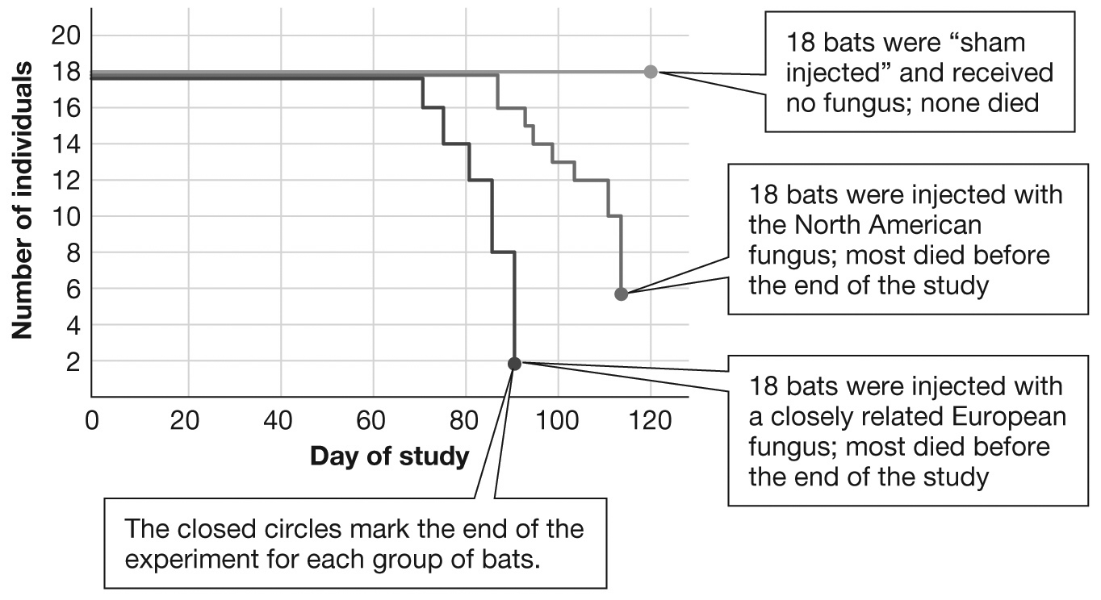
a. | The hypothesis was proven beyond a doubt because all members of the control group survived while most of the members of both treatment groups died by the end of the study.
b. | The hypothesis was proven because all members of the control group survived while most of the members of both treatment groups died by the end of the study.
c. | The hypothesis was not supported because all members of the control group died while most of the members of both treatment groups survived through the end of the study.
d. | The hypothesis was supported because all members of the control group survived while most of the members of both treatment groups died by the end of the study.

ANS: D DIF: Difficult REF: CatchingtheCulprit
OBJ: 1.5 MSC: Analyzing

31. Scientists are human beings and are, like all human beings, susceptible to personal and group biases that may influence how they interpret evidence. Before original research work is accepted and added to a growing body of scientific understanding, perhaps even contributing to our understanding of an important scientific theory, it must be scrutinized by experts in the field who have no direct connection to the research under review. The main mechanism for doing this is
a. | popular magazines. | c. | peer-reviewed publications.
b. | the Discovery Channel. | d. | Wikipedia.

ANS: C DIF: Easy REF: CatchingtheCulprit
OBJ: 1.6 MSC: Understanding

32. You are coughing and producing a wheezing sound as you breathe; you also have a fever. You go to the doctor who listens to your chest, takes X-rays of your chest, and determines that you probably have something called croup. Which of the following are the facts in this scenario?
a. | You are coughing, wheezing, and have a fever.
b. | You probably have croup.
c. | You probably have whooping cough.
d. | You probably need antibiotics.

ANS: A DIF: Easy REF: CatchingtheCulprit
OBJ: 1.6 MSC: Applying

33. In science, when a hypothesis or group of hypotheses supported by repeated experimental evidence holds true through time, it can be developed into a ________. It is not a guess. It is not static. It is tentative and dynamic and can be adjusted when new, compelling evidence is discovered. It is typically an overarching explanation that best fits all of the available information or evidence.
a. | law | c. | hypothesis
b. | mathematical theorem | d. | theory

ANS: D DIF: Easy REF: CatchingtheCulprit
OBJ: 1.6 MSC: Understanding

34. The human heart pumps blood throughout the blood vessels in the body. This is a scientific
a. | theory. | c. | fact.
b. | hypothesis. | d. | experiment.

ANS: C DIF: Medium REF: CatchingtheCulprit
OBJ: 1.6 MSC: Applying

35. You often experience numbness and pain in the thumb and first two fingers on your right hand. You go to the doctor who suspects that carpal tunnel syndrome is the reason for the numbness and pain. The doctor then orders a simple test to see how fast nerve impulses are moving up and down your arm. The doctor’s preliminary diagnosis of carpal tunnel syndrome is a(n)
a. | theory. | c. | experiment.
b. | fact. | d. | hypothesis.

ANS: D DIF: Medium REF: CatchingtheCulprit
OBJ: 1.6 MSC: Analyzing

36. Which of the following would be a theory?
a. | Specific pathogens are directly responsible for specific diseases and conditions.
b. | A fungal infection is responsible for the spread of white noses and associated higher mortality across bat populations and species.
c. | Bats with white noses have been observed in the wild.
d. | A fungal infection causes bats to wake up repeatedly during the winter and use up their fat reserves.

ANS: A DIF: Medium REF: CatchingtheCulprit
OBJ: 1.6 MSC: Understanding

37. In 1890, Robert Koch developed a hypothesis regarding the cause of communicable diseases. He designed an experiment and collected data that supported his hypothesis. Later, his experiment was repeated by many other scientists who used other pathogens and documented similar results that not only supported their hypotheses but also supported Koch’s original hypothesis. These many experiments that supported multiple hypotheses regarding the cause of communicable diseases contributed to the development of the
a. | theory of evolution. | c. | theory of relativity.
b. | germ theory of disease. | d. | law of gravity.

ANS: B DIF: Medium REF: CatchingtheCulprit
OBJ: 1.6 MSC: Understanding

38. Scientific understanding can always be challenged, and even changed, with new ways of observing and with different interpretations. For example, new tools and techniques have resulted in new observations and the discovery of additional information. This has resulted in revised ways of understanding how molecules are moved across the plasma membrane of cells. Hence, there is no certainty in science, only degrees of probability (likelihood) and potential for change. In light of this understanding, which of the following statements is most meaningful?
a. | Scientific knowledge is absolute knowledge.
b. | Scientific knowledge is necessarily contingent knowledge.
c. | Scientific knowledge is a static and unchanging collection of facts.
d. | Scientific knowledge is rigid collection of invariable facts.

ANS: B DIF: Difficult REF: CatchingtheCulprit
OBJ: 1.6 MSC: Applying

39. Which of the following would be a fact?
a. | Specific pathogens are directly responsible for specific diseases and conditions.
b. | A fungal infection is solely responsible for the spread of white noses and associated higher mortality across bat populations and species.
c. | Bats with white noses have been observed in the wild.
d. | A fungal infection causes bats to wake up repeatedly during the winter and use up their fat reserves.

ANS: C DIF: Medium REF: NoEndinSight
OBJ: 1.6 MSC: Understanding

40. Which of the following sequences correctly represents the biological hierarchy of a multicellular organism?
a. | cells → tissues → organs → individual
b. | tissues → organs → cells → individual
c. | individual → cells → organ systems → tissues
d. | organ systems → organs → tissues → individual

ANS: A DIF: Easy REF: NoEndinSight
OBJ: 1.7 MSC: Applying

41. A tissue is defined as
a. | a group of cells that performs a unique set of tasks in the body.
b. | two or more atoms held together by strong chemical bonds.
c. | the basic unit of life.
d. | a network of organs which perform a wide range of functions.

ANS: A DIF: Easy REF: NoEndinSight
OBJ: 1.7 MSC: Remembering

42. Bats use echolocation to orient themselves and locate objects. Doing this requires special adaptations in their inner ear, midbrain, and auditory cortex of their cerebrum. The echolocation system of bats is an example of
a. | a cell. | c. | an organ.
b. | a tissue. | d. | an organ system.

ANS: D DIF: Easy REF: NoEndinSight
OBJ: 1.7 MSC: Understanding

43. The caves in upstate New York, where Alan Hicks’ team first noticed the deaths of thousands of bats, represent the
a. | biosphere where the bats lived. | c. | ecosystem where the bats lived.
b. | biome where the bats lived. | d. | community where the bats lived.

ANS: C DIF: Medium REF: NoEndinSight
OBJ: 1.7 MSC: Applying

44. Which term best describes the temperate deciduous forests that cover the northeastern United States, including the Adirondack Mountains?
a. | biosphere | c. | ecosystem
b. | biome | d. | community

ANS: B DIF: Medium REF: NoEndinSight
OBJ: 1.7 MSC: Analyzing

45. Land biomes are most commonly defined by
a. | their climate, physical characteristics, and dominant animal life.
b. | only the dominant plant life in them.
c. | the dominant plant life that influences the dominant animal life in them.
d. | their climate and physical characteristics which influence the dominant plant life and, subsequently, animal life in them.

ANS: D DIF: Difficult REF: NoEndinSight
OBJ: 1.7 MSC: Applying

COMPLETION

1. The genetic material used for reproduction by those organisms conventionally considered to be living is ________.

ANS: DNA

DIF: Medium REF: BatCrazy OBJ: 1.1 MSC: Applying

2. The first two steps of the scientific process typically include making ________ and forming a ________.

ANS: observations; hypothesis

DIF: Easy REF: BatCrazy OBJ: 1.2 MSC: Remembering

3. After observing that students who regularly attend class appear to be making good grades, I propose the hypothesis that regular class attendance increases the probability that students earn higher grades. If I attend classes regularly this semester, I should make higher grades than I did last semester when I often missed class. This is a ________.

ANS: prediction

DIF: Medium REF: ProveMeWrong OBJ: 1.3
MSC: Applying

4. When Dr. Blehert and his team set out to determine the cause of death for thousands of bats, they determined that the sick and dead bats had a strange white fuzz on their noses and wings along with depleted fat reserves and damaged wing tissue. Predicting that the white fungus was associated with the illness would be acknowledging a possible ________ between the illness and the fungus.

ANS: correlation

DIF: Difficult REF: ProveMeWrong OBJ: 1.5
MSC: Applying

5. During an experimental study, a control group is maintained under a standard set of conditions with no change in the independent variable. The ________ group is maintained under the same standard set of conditions as the control group, but the independent variable is adjusted.

ANS: treatment | experimental

DIF: Easy REF: CatchingtheCulprit OBJ: 1.4
MSC: Remembering

6. A direct and repeatable observation of any aspect of the natural world can be considered a scientific ________.

ANS: fact

DIF: Easy REF: CatchingtheCulprit OBJ: 1.6
MSC: Remembering

7. A way to visualize the breadth and scope of life, from the smallest structures of atoms and cells to the broadest interactions between living and nonliving systems that we can comprehend, is typically referred to as the ________.

ANS: biological hierarchy

DIF: Easy REF: NoEndinSight OBJ: 1.7
MSC: Remembering

SHORT ANSWER

1. Describe how DNA makes it possible for organisms to make new individuals like themselves.

ANS:
No matter how simple or complex the life form, the genetic code found in DNA provides the instructions to build new cellular components, carry out cellular metabolism, and dictate cellular behavior, including the initiation of cell reproduction and the transfer of information from one generation to the next. The DNA is read to produce proteins that direct cellular reproduction, produce new cellular components, and initiate cellular reproduction.

DIF: Medium REF: BatCrazy OBJ: 1.1 MSC: Applying

2. Explain the self-correcting nature of science.

ANS:
The process of science is based on evidence that can be demonstrated through observations and/or experiments. Scientific findings are subject to peer review and independent validation and can, therefore, be challenged by anyone on the basis of evidence. When new evidence demonstrates that current scientific thinking is incorrect, hypotheses are adjusted or discarded and investigation continues.

DIF: Medium REF: BatCrazy | ProveMeWrong OBJ: 1.2
MSC: Applying

3. People who exercise regularly have a lower average resting heart rate and blood pressure than people who do not exercise. Given this observation, develop a hypothesis and provide one prediction relating to that hypothesis.

ANS:
Hypothesis: Daily exercise reduces average resting heart rate and blood pressure.
Prediction: If one group of people exercises for thirty minutes every day and another group does not exercise, the first group will experience a reduction in their average resting heart rate and blood pressure. The second group will not experience a change in their average resting heart rate and blood pressure.

DIF: Difficult REF: ProveMeWrong OBJ: 1.3
MSC: Applying

4. A parent heard some celebrities on television stating there was a study published in 1998 that asserted a connection between the measles-mumps-rubella (MMR) vaccine and the onset of autism in children. The celebrities went on to say that after the MMR vaccine replaced the old simple measles vaccine in 1988 there was a 273 percent increase in autism rates during the next 11 years. The celebrities, however, did not reveal that the study published in 1998 included a sample size of 12 children who were already known to have some form of autism or similar developmental difficulties. They also did not present the evidence from hundreds of studies conducted since 1998 that show no connection between vaccines and the onset of autism. What was the hypothesis, regarding vaccines and autism, implied by the celebrities? Did the evidence they presented show a correlation or cause-and-effect relationship between vaccines and autism? State at least two obvious problems with the structure of the 1998 study.

ANS:
The celebrities’ implied hypothesis was, “Vaccines cause autism.” The evidence they presented showed only a weak possible correlation. Two obvious problems with the structure of the 1998 study include the extremely small sample size of 12 children and the bias introduced because all of the children had already been diagnosed with some form of autism or developmental difficulties. It was hardly a random sample.

DIF: Difficult REF: ProveMeWrong OBJ: 1.5
MSC: Applying

5. The claim has been made that women may be able to achieve significant improvements in memory by taking Gingko biloba supplements. To determine if the claim is fraudulent and prior to accepting this claim, what type of evidence would you like to see? Provide brief details of an investigative design.

ANS:
The hypothesis to be examined is, “Taking Gingko biloba supplements significantly improves the memory of women.” The prediction is that if women take Gingko biloba supplements their memory function will improve. This can be tested by setting up an experiment that includes a control group of randomly selected women who receive a placebo and an experimental group of women who will actually receive Gingko biloba supplements. Consuming the Gingko biloba supplement would be the independent variable. The experiment should attempt to control for other possible factors such as age, amount of daily exercise, and other dietary considerations when selecting participants. Both groups of women would be tested before the study begins to determine their average memory capabilities (dependent variable) prior to the experiment. Both groups of women would be retested at the end of the experiment. Statistical analyses should be conducted to determine if any differences in memory function between the two groups are significant and if the data supports the hypothesis.

DIF: Difficult REF: CatchingtheCulprit OBJ: 1.4
MSC: Creating

6. Your friend says to you, “You do not need to understand evolution to understand biology because evolution is just a theory.” How would you explain to your friend that a “theory” in science is not “just a theory”?

ANS:
In science, a theory usually consists of a group of very well-researched and supported hypotheses that are interrelated. There are so many diverse and independent lines of investigation supporting these related hypotheses that form the theory that we can rely on the theory to help guide our understanding of all related topics. In the nonscience vernacular, the word theory usually refers to an untested explanation.

DIF: Medium REF: CathchingtheCuplrit OBJ: 1.6
MSC: Understanding

7. Organize the following concepts in order of most exclusive to most inclusive and give a brief explanation of the concepts: biome, biosphere, community, ecosystem, organism, and population.

ANS:
Organism (an individual), population (a group of individuals of the same species living and interacting in a shared environment), community (the populations of different species that live and interact with one another in a particular place), ecosystem (a particular physical environment and all the communities found there), biome (a large region of the world defined by its physical characteristics, especially climate, and a distinctive community of organisms), biosphere (all the world’s living organisms and the places where they live).

DIF: Medium REF: NoEndinSight OBJ: 1.7
MSC: Understanding

MATCHING

Match the correct term(s) with the sentence.
a. | tests
b. | communicate
c. | accept, reject, or modify
d. | observe
e. | analyze
f. | hypothesis
g. | predictions

1. ________ and ask questions about the natural world.

2. Suggest a ________ to explain your observations and questions.

3. Generate ________ to test your hypothesis.

4. Design ________ of the predictions of your hypothesis.

5. ________ your results to fellow scientists for their review and input.

6. ________ your hypothesis, predictions, or test according to the results.

7. ________ the results.

1. ANS: D DIF: Medium REF: BatCrazy | ProveMeWrong
OBJ: 1.2 MSC: Understanding

2. ANS: F DIF: Medium REF: BatCrazy | ProveMeWrong
OBJ: 1.2 MSC: Understanding

3. ANS: G DIF: Medium REF: BatCrazy | ProveMeWrong
OBJ: 1.2 MSC: Understanding

4. ANS: A DIF: Medium REF: BatCrazy | ProveMeWrong
OBJ: 1.2 MSC: Understanding

5. ANS: B DIF: Medium REF: BatCrazy | ProveMeWrong
OBJ: 1.2 MSC: Understanding

6. ANS: C DIF: Medium REF: BatCrazy | ProveMeWrong
OBJ: 1.2 MSC: Understanding

7. ANS: E DIF: Medium REF: BatCrazy | ProveMeWrong
OBJ: 1.2 MSC: Understanding

