CHAPTER 1 | Matter and Energy: The Origin of the Universe

1.1. Collect and Organize
In Figure P1.1(a) we are shown “molecules” each consisting of one red sphere and one blue sphere and in Figure P1.1(b) we have separate blue spheres and red spheres. In each figure we are to identify whether the substance(s) depicted is a solid, liquid, or gas and if the figures show pure elements or compounds.

Analyze
A pure substance is composed of all the same type of element or compound, not a mixture of two kinds. An element is composed of all the same type of atom and a compound is composed of two or more types of atoms. Solids have a definite volume and a highly ordered arrangement where the particles are close together, liquids also have a definite volume but have a disordered arrangement of particles that are close together, and gases have disordered particles that fill the volume of the container and are far apart from each other.

Solve
(a) Because the particles each consist of one red sphere and one blue sphere, all the particles are the same—this is a pure compound. The particles fill the container and are disordered, so these particles are in the gas phase.
(b) Because Figure P1.1(b) shows a mixture of red and blue spheres, this is depicting a mixture of blue element atoms and red element atoms. The blue spheres fill the container and are disordered, so these particles are in the gas phase. The red spheres have a definite volume and are slightly disordered, so these particles are in the liquid phase.

Think About It
Remember that both elements and compounds may be either pure or present in a mixture.

1.2. Collect and Organize
In Figure P1.2(a) we are shown “atoms” of only red spheres and in Figure P1.2(b) we have “molecules” consisting of two red spheres or two blue spheres. In each figure we are to identify whether the substance(s) depicted is a solid, liquid, or gas and if the figures show pure elements or compounds.

Analyze
A pure substance (whether element or compound) is composed of all the same type of molecule or atom, not a mixture of two kinds. An element is composed of all the same type of atom and a compound is composed of two or more types of atoms. Solids have a definite volume and a highly ordered arrangement where the particles are close together, liquids also have a definite volume but have a disordered arrangement of particles that are close together, and gases have disordered particles that fill the volume of the container and are far apart from each other.

Solve
(a) Because all the atoms are of the same type, Figure P1.2(a) depicts a pure element. The particles take up a definite volume and are ordered, so this element is in the solid phase.
(b) Because there is a mixture of blue diatomic molecules and red diatomic molecules, Figure P1.2(b) depicts a mixture of two elements. Both the blue and red diatomic particles fill the container’s volume and are highly disordered; the mixture depicted is in the gas phase.

Think About It
Elements do not need to be present as single atoms. They may be diatomic, as in H₂ or Br₂, or even more highly associated, as in S₈ or P₄.

1.3. Collect and Organize
In this question we are to consider whether the reactants as depicted undergo a chemical reaction and/or phase change.

Analyze
Chemical reactions involve the breaking and making of bonds in which atoms are combined differently in the products compared to that of the reactants. In considering a possible phase change, solids have a definite volume and a highly ordered arrangement where the particles are close together, liquids also have a definite volume but have a disordered arrangement of particles that are close together, and gases have disordered particles that fill the volume of the container and are far apart from each other. It may help to visualize each scenario, as shown below
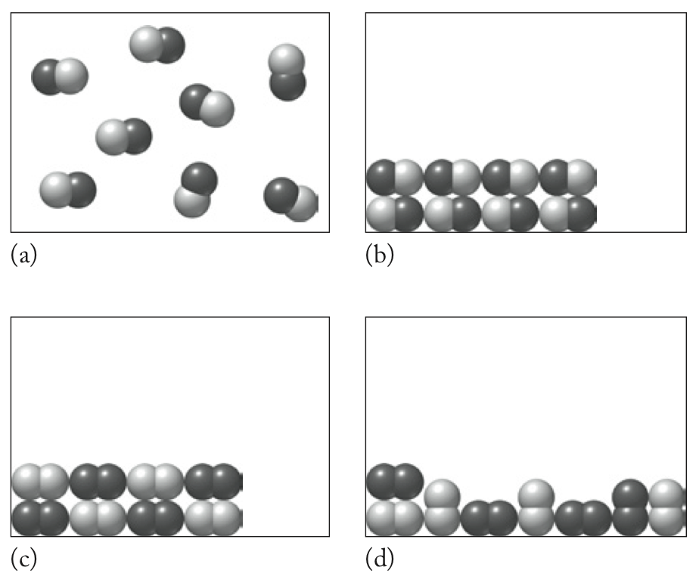

Solve
In Figure P1.3 two pure elements (red–red and blue–blue) in the gas phase recombine to form a compound (red–blue) in the solid phase (ordered array of molecules). Therefore, answer (b) describes the reaction shown.

Think About It
A phase change does not necessarily accompany a chemical reaction. We will learn later that the polarity of the product will determine whether or not a substance will be in the solid, liquid, or gaseous state at a given temperature.

1.4. Collect and Organize
In this question we are to consider whether the reactants as depicted undergo a chemical reaction (either recombination or decomposition) and/or a phase change.

Analyze
Chemical reactions involve the breaking and making of bonds in which atoms are combined differently in the products compared to that of the reactants. In considering a possible phase change, solids have a definite volume and a highly ordered arrangement where the particles are close together, liquids also have a definite volume but have a disordered arrangement of particles that are close together, and gases have disordered particles that fill the volume of the container and are far apart from each other.

Solve
In Figure P1.4 we see that no recombination of the diatomic molecules occurs. The pure element (red–red) condenses to a slightly disordered phase while the other element (blue–blue) remains in the gas phase. Therefore, answer (a) describes the reaction pictured.

Think About It
Cooling of air in this fashion to different temperatures separates the components of air.
1.5. Collect and Organize
From the space-filling model shown, we are to write the formula for the chemical represented.

Analyze
Based on the Atomic Color Palette (see the inside back cover of the textbook) we see that this model contains three hydrogen atoms bonded to a carbon atom that is bonded to an O–H unit.

Solve
H₃COH or CH₄O

Think About It
This model represents methanol, and the presence of the O–H unit classifies it as an alcohol. Sometimes methanol is called “wood alcohol.”

1.6. Collect and Organize
From the ball and stick model of acetone shown, we are to write the chemical formula.

Analyze
Based on the Atomic Color Palette on the inside back cover of the textbook, we see that this model contains two CH₃ units bonded to a CO unit.

Solve
H₃C(CO)CH₃ or C₃H₆O

Think About It
Acetone is classified as a ketone and is a useful solvent. It is the main component in some nail-polish removers.

1.7. Collect and Organize
This question considers if and how matter and energy are related. In particular, we consider whether the sun is all mass or all energy.

Analyze
Einstein showed that matter and energy are interconvertible through E = mc².

Solve
The sun is an example where matter is being changed into energy through nuclear fusion reactions. Therefore, both students are correct.

Think About It
Through Einstein’s equation we see that a little bit of mass contains a great deal of energy locked in the nuclei of the atoms.

1.8. Collect and Organize
In this question, we consider how elements and compounds compare.

Analyze
Compounds are made from elements and have different types of atoms in them. Elements are composed of atoms that are all the same.

Solve
Compounds are different from elements in that they are made up of two or more elements, these elements can be separated from each other (but elements cannot be separated further), and compounds have different chemical and physical properties from the elements that compose them. Compounds are commonly found in nature, but elements rarely are. Compounds are similar to elements in that they are composed of atoms, have definite physical and chemical properties, and can be isolated in pure form.

Think About It
By combining the different elements with each other, we can arrive at many, many compounds which are used as fuels, medicines, plastics, etc.

1.9. Collect and Organize
For this question we are to list some chemical and physical properties of gold.

Analyze
A chemical property is seen when a substance undergoes a chemical reaction thereby becoming a different substance. A physical property can occur without any transformation of one substance into another.

Solve
One chemical property of gold is its resistance to corrosion (oxidation). Gold’s physical properties include its density, color, melting point, metallic luster, malleability, ductility, and electrical and thermal conductivity.

Think About It
Another metal that does not corrode (or rust) is platinum. Platinum and gold, along with palladium, are often called “noble metals.”

1.10. Collect and Organize
For this question we are to compare the physical properties of gold and silver.

Analyze
Physical properties include density, color, melting point, metallic luster, malleability, ductility, and electrical and thermal conductivity.

Solve
Both gold and silver have metallic luster, are malleable, and conduct electricity. However, gold and silver have different densities, different melting points, and different colors.

Think About It
The yellow color of pure gold compared to most metals, which are silvery, is due to relativistic effects in the atom.

1.11. Collect and Organize
This question asks us to use differences in physical or chemical properties to separate a mixture of substances. Using filtration, we are to propose a method to separate salt (NaCl) from sand in a mixture.

Analyze
The difference between sand and salt is salt’s solubility in water versus sand’s insolubility in water.

Solve
Adding water to the salt–sand mixture will dissolve the salt. After putting the sand–salt-solution mixture through a filter, the sand will remain on the filter. The salt can be recovered by evaporating the water from the solution that passed through the filter.
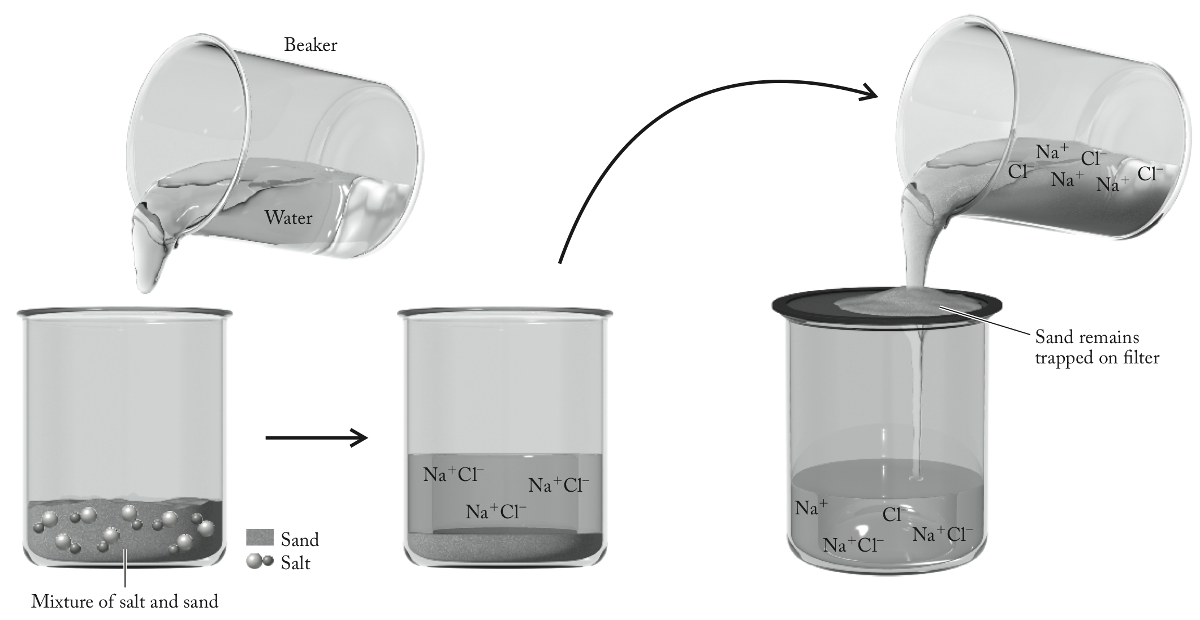

Think About It
The filtration method works very well for a mixture of two substances when one is soluble and the other is insoluble in a particular solvent. It is used often to separate and purify the desired product of a chemical reaction.

1.12. Collect and Organize
We are to describe how we can use distillation to remove the salt from seawater.

Analyze
Distillation involves the boiling of an impure liquid until the vaporization of the pure liquid occurs. The pure liquid, now a pure compound, is isolated by cooling the vapor through a condenser.

Solve
When seawater is boiled, only the water enters the vapor phase, leaving the salts and other impurities behind. Condensing the water vapor gives pure liquid water.

Think About It
By distilling seawater, we can convert undrinkable water to drinkable water.

1.13. Collect and Organize
For the four processes named, we are to determine which involve a chemical change.

Analyze
Chemical changes involve transforming one substance into another to give that substance different physical and chemical properties.

Solve
(a) Distillation purifies a substance—not a chemical change.
(b) Combustion transforms the fuel (such as wood) into carbon dioxide and water—a chemical change.
(c) Filtration separates substances from each other—not a chemical change.
(d) Condensation changes a vapor into a liquid—not a chemical change.

Think About It
Distillation, filtration, and condensation all involve physical changes, not chemical changes.
1.14. Collect and Organize
We are to determine whether gasohol (mixture of gasoline and ethanol) is a heterogeneous or a homogeneous mixture.

Analyze
In a homogeneous mixture the components are evenly distributed throughout the mixture, giving a uniform appearance to the eye. A heterogeneous mixture contains distinct, observable, individual components.

Solve
Because the ethanol is dissolved in the gasoline, we do not see regions of ethanol distinct from regions of gasoline. Gasohol, therefore, is a homogeneous mixture.

Think About It
Most cars on the road today can run well on a 10% ethanol to 90% gasoline fuel mixture. There is widespread interest in using ethanol as a fuel, despite its expense, because of lower CO and NO_{x} emissions and as a means to replace reliance on petroleum, a fossil fuel.

1.15. Collect and Organize
For the foods listed, we are to determine which are heterogeneous.

Analyze
A heterogeneous mixture has visible regions of different compositions.

Solve
A Snickers bar and an uncooked hamburger (b, d) are heterogeneous—they have clear regions of differing composition, but solid butter and grape juice (a, c) are homogeneous.

Think About It
When butter is melted, you notice that there are milk solids and clear regions that are definitely discernible. Therefore, homogeneous solid butter becomes heterogeneous when heated.

1.16. Collect and Organize
For the foods listed, we are to determine which are homogeneous.

Analyze
Homogeneous mixtures have the same composition throughout.

Solve
Freshly brewed coffee and vinegar (a, b) are homogeneous mixtures. A slice of white bread and a slice of ham (c, d) are heterogeneous mixtures.

Think About It
A slice of white bread is considered to be heterogeneous because its crust is different from the interior bread, and the bread contains gas bubbles that are clearly seen as tiny holes in the bread.

1.17. Collect and Organize
For the foods listed, we are to determine which are heterogeneous.

Analyze
A heterogeneous mixture has visible regions of different compositions.

Solve
Orange juice (with pulp; d) is heterogeneous—there are clear regions of differing composition. Apple juice, cooking oil, solid butter, and tomato juice (a–c, e) are homogeneous.

Think About It
When butter is melted, you notice that there are milk solids and clear regions that are definitely discernible. Therefore, homogeneous solid butter becomes heterogeneous when heated.

1.18. Collect and Organize
For the substances listed, we are to determine which are homogeneous.

Analyze
Homogeneous mixtures have the same composition throughout.

Solve
The wedding ring shown, sweat, and compressed air in a scuba tank (a, b, e) are homogeneous. Nile River water and human blood (c, d) are heterogeneous.

Think About It
A gold wedding ring is made up of an alloy (a solid solution of one metal dissolved in another) of gold with another metal such as palladium or copper to give the soft gold metal strength and make it less expensive than 100% gold.

1.19. Collect and Organize
We are asked to name three properties to distinguish between table sugar, water, and oxygen.

Analyze
We can distinguish between substances using either physical properties (color, melting point, density, etc.) or chemical properties (chemical reactions, corrosion, flammability, etc.).

Solve
We can distinguish between table sugar, water, and oxygen by examining their physical states (at room temperature and standard pressure, sugar is a solid, water is a liquid, and oxygen is a gas), densities, melting points, and boiling points.

Think About It
These three substances are also very different at the atomic level. Oxygen is a pure element made up of diatomic molecules, water is a liquid compound made up of discrete molecules of hydrogen and oxygen (H₂O), and table sugar is a solid compound made up of carbon, hydrogen, and oxygen atoms (C₁₂H₂₂O₁₁).

1.20. Collect and Organize
We are asked to name three properties to distinguish between table salt, sand, and copper.

Analyze
We can distinguish between substances using either physical properties (color, melting point, density, etc.) or chemical properties (chemical reactions, corrosion, flammability, etc.).

Solve
We can distinguish between table salt, sand, and copper by examining their color (salt is composed of small cubic white crystals, sand is irregularly shaped and many-colored, and copper is reddish). Salt will dissolve in water, whereas sand and copper will not. Copper conducts electricity, solid table salt and sand do not. The densities of these substances will also differ.

Think About It
These three substances are also very different at the atomic level. Table salt is a crystalline ionic compound composed of sodium cations and chloride anions. Sand is a compound most commonly composed of silica, a compound of silicon and oxygen. Copper is a pure element and a metal.

1.21. Collect and Organize
From the list of properties of sodium, we are to determine which are physical and which are chemical properties.

Analyze
Physical properties are those that can be observed without transforming the substance into another substance. Chemical properties are only observed when one substance reacts with another and therefore is transformed into another substance.

Solve
Density, melting point, thermal and electrical conductivity, and softness (a–d) are all physical properties, whereas tarnishing and reaction with water (e, f) are both chemical properties.

Think About It
Because the density of sodium is less than that of water, a piece of sodium will float on water as it reacts.

1.22. Collect and Organize
From the list of properties of hydrogen gas, we are to determine which are physical and which are chemical properties.

Analyze
Physical properties are those that can be observed without transforming the substance into another substance. Chemical properties are only observed when one substance reacts with another and therefore is transformed into another substance.

Solve
Density, boiling point, and electrical conductivity (a, c, d) are all physical properties, whereas the reaction of hydrogen with oxygen (b) is a chemical property.

Think About It
Because the density of hydrogen gas is lower than that of any other gas, a lightweight balloon filled with hydrogen will float in air like the more familiar helium balloon.

1.23. Collect and Organize
We are asked to determine which of the given species is not a pure substance.

Analyze
All matter may be classified as either a pure substance or a mixture. If a substance may be separated by physical means, it is not a pure substance. In addition to sodium chloride, table salt includes anti-caking agents and sodium iodide.

Solve
Both air and table salt may be separated into simpler components, so they cannot be pure substances. Nitrogen gas, oxygen gas, and argon gas are all pure elements.

Think About It
Air is a mixture of nitrogen gas, oxygen gas, argon gas, and other pure substances.

1.24. Collect and Organize
We are asked to determine which of the given forms of matter is a pure substance.

Analyze
Pure substances cannot be separated by a physical process.

Solve
Mineral water, blood, brass, and beer are mixtures of more than one substance. Only sucrose (table sugar) is a pure compound that cannot be physically separated into simpler components.

Think About It
Mineral water, blood, and beer all contain mostly water; the other components are what make them different from one another. Brass is an alloy, meaning it is a mixture of two solids. Sucrose (table sugar) can only be separated into other components by chemical means, such as respiration and combustion.

1.25. Collect and Organize
From the given list, we are asked to identify the elements.

Analyze
An element is a pure substance that cannot be broken down into simpler components by any process.

Solve
Only Cl₂ is a pure element. The other species listed are compounds of more than one type of element.

Think About It
The elements are listed in the periodic table of the elements. Some elements, such as chlorine, form diatomic molecules (i.e., Cl₂) in their pure form.

1.26. Collect and Organize
From the given list, we are asked to identify the species that are not elements.

Analyze
An element is a pure substance that cannot be broken down into simpler components by any process. Any pure substance that is composed of multiple elements is a compound.

Solve
Iodine (I₂), cerium (Ce), and sulfur (S) are all pure elements. ClF is the only substance that is composed of more than one type of element; it is classified as a compound, not an element.

Think About It
Despite containing multiple atoms in their pure elemental state, I₂ and S₈ are still elements because they consist of only one type of atom.

1.27. Collect and Organize
We are asked to determine which of the given mixtures is homogeneous.

Analyze
A homogeneous mixture has no visible boundaries and contains a uniform distribution of components. We should picture each of these items, and decide if their components are uniformly distributed.

Solve
Only filtered water is uniformly distributed, and so it is the only homogeneous mixture.

Think About It
All of the other species listed are heterogeneous mixtures, since they have components that are visually different, or are not uniformly distributed. Clouds may take many shapes and densities, so they do not exhibit a uniform distribution.

1.28. Collect and Organize
From the list below, we are asked to identify the species that are heterogeneous mixtures.

Analyze
In a heterogeneous mixture, visible boundaries may be observed, and components are not uniformly distributed. We should first decide if these items are mixtures or pure substances, then classify the mixtures as homogeneous or heterogeneous.

Solve
Muddy river water is the only heterogeneous mixture from this list. While the mixture may appear uniform, suspended mud particles stick together in an irregular fashion.

Think About It
Table salt, air, sugar dissolved in water, and brass are homogeneous mixtures because all components are spread uniformly throughout the samples. Suspended mud particles will settle from a sample of muddy water if the sample is allowed to sit undisturbed for long enough.

1.29. Collect and Organize
We are to determine which mixtures can be separated into their components by filtering.

Analyze
Filtration is used to separate suspended solids from a liquid or gas; this technique will only work if our sample is a heterogeneous mixture containing a solid suspended in a liquid or a gas.

Solve
Sand and water may be separated using filtration. The sand will be trapped on the filter, and the water will pass through.

Think About It
The other mixtures listed in the question are homogeneous and cannot be separated by filtration.

1.30. Collect and Organize
In this question we consider whether distillation or filtration would be a suitable method to separate a protein (enzyme) in egg whites from water in a solution.

Analyze
Distillation vaporizes a liquid in a mixture and then condenses it in pure form. Filtration separates suspended solids from a liquid.

Solve
Distillation will separate the water and the dissolved proteins that have formed a homogeneous solution with the water. This would have to be accomplished, however, at low temperature, because heating the solution of the enzyme might cause a chemical change.

Think About It
Filtration is not appropriate because the enzyme in water forms a homogeneous solution.

1.31. Collect and Organize
From the list of properties of formaldehyde, we are asked to determine which one is a chemical property.

Analyze
Chemical properties are observed when a chemical reaction takes place. We should identify which property relates to a chemical reaction between formaldehyde and another substance.

Solve
Formaldehyde must react with the air in order to burn. Flammability (c) is a chemical property.

Think About It
Smell, solubility, phase of matter, and color are all physical properties. We can observe these properties without destroying (reacting) the formaldehyde.

1.32. Collect and Organize
From the list of properties of silver, we are asked to determine which one is a physical property.

Analyze
Physical properties can be observed without transforming one substance into another.

Solve
We may observe that silver will sink in water without converting it into another substance, making this (d) a physical property.

Think About It
Tarnish forms on silver when it reacts with compounds in the air around it. Tarnishing, or other reactions of silver are chemical events.

1.33. Collect and Organize
We are to explain if an extensive property can be used to identify a substance.

Analyze
An extensive property is one that, like mass, length, and volume, is determined by size or amount.

Solve
Extensive properties will change with the size of the sample and therefore cannot be used to identify a substance.

Think About It
We could, for example, have the same mass of feathers and lead, but their mass alone will not tell us which mass measurement belongs to which—the feathers or the lead.

1.34. Collect and Organize
Of the properties listed, we are to choose which are intensive properties, and which are extensive properties.

Analyze
An intensive property is not dependent on the size or amount of the sample, while an extensive property does depend on the size or amount of a sample.

Solve
Of the properties listed, density, conductivity, solubility, and the temperature at which a phase change will occur (a–e) are all intensive properties. Mass (f) is an extensive property.

Think About It
Intensive properties may be used to identify a substance, as they will not change based on the size or quantity of the sample used. Intensive properties are related to chemical interactions between atoms and molecules in the substance that will not change from sample to sample.

1.35. Collect and Organize
In this question we think about the information needed to formulate a hypothesis.

Analyze
A hypothesis is a tentative explanation for an observation.

Solve
To form a hypothesis we need at least one observation, experiment, or idea (from examining nature).

Think About It
A hypothesis that is tested and shown to be valid can become a theory.

1.36. Collect and Organize / Analyze
In this question we consider how a hypothesis becomes a theory.

Solve
A theory is formed from a hypothesis when the hypothesis has been extensively tested by many observations and experiments. A theory is the best (current) possible explanation that is extensively supported by experimentation.

Think About It
A theory, tested over time, may be elevated further to become a scientific law.

1.37. Collect and Organize
We are to consider whether we can disprove a hypothesis.

Analyze
A hypothesis is a tentative explanation for an observation.

Solve
It is possible to disprove a scientific hypothesis. In fact, many experiments are designed to do just that as the best test of the hypothesis’s validity.

Think About It
It is even possible to disprove a theory (albeit harder to do so) or cause a theory to be modified when new evidence, a new experimental technique, or new data from a new instrument give observations that are counter to the explanation stated by the theory.

1.38. Collect and Organize
In this question we consider why the atomic theory is universally accepted.

Analyze
Atomic theory states that all matter is composed of atoms. This theory is accepted despite the fact that scientists have not seen atoms directly.

Solve
The atomic theory is universally accepted because of the sheer volume of evidence from various experiments and observations that support the hypothesis that matter is composed of atoms.

Think About It
In the 1980s, the techniques of scanning tunneling microscopy and atomic force microscopy were developed to give us indirect “pictures” of atoms and molecules.

1.39. Collect and Organize
We are to define theory as used in conversation.

Analyze
Theory in everyday conversation has a different meaning than it does in science.

Solve
Theory in normal conversation is someone’s idea or opinion or speculation that can easily be changed and may not have much evidence or many arguments to support it.

Think About It
A theory in science is a generally accepted and highly tested explanation of observed facts.
1.40. Collect and Organize
We consider whether a theory can be proven.

Analyze
Theory in science is the best (current) possible explanation that is extensively supported by experimentation and observations.

Solve
Theory is nearly equivalent to fact in science, without being the absolute truth. A theory is hard to prove absolutely, but has many, many supporting experiments whose observations strongly support the theory.

Think About It
The results of one experiment that counter the explanation for a phenomenon explained by a theory could disprove a theory, so theories may be toppled and replaced with new explanations and theories.

1.41. Collect and Organize
We are to compare SI units to English units.

Analyze
SI units are based on a decimal system to describe basic units of mass, length, temperature, energy, etc. whereas English units vary.

Solve
SI units, which were based on the original metric system, can be easily converted into a larger or smaller unit by multiplying or dividing by multiples of 10. English units are more complicated to manipulate. For example, to convert miles to feet you have to know that there are 5280 feet in 1 mile and to convert gallons to quarts you have to know that 4 quarts are in 1 gallon.

Think About It
Once you can visualize a meter, a gram, and a liter, using the SI system is quite convenient.

1.42. Collect and Organize / Analyze
In this question we are to suggest two reasons why SI units are not more widely used in the United States.

Solve
English units instead of SI units are used everywhere in the United States because many of our manufacturing facilities have been built to make parts in inches or to bottle liquids in gallons. It has also been difficult for people used to buying and measuring in the English units to convert their thinking so as to visualize a kilometer instead of a mile or a liter instead of a quart.

Think About It
The only widespread everyday use of an SI unit in the United States is the 2 L soda bottle.

1.43. Collect and Organize
This problem asks which value from the given set contains the fewest number of significant figures.

Analyze
The listed values are a mix of standard and scientific notation. For values expressed using scientific notation, only the values prior to the exponent are counted as significant. By expressing all the quantities using scientific notation, we can better compare the number of significant figures.
(a) 5.45 × 10²
(b) 6.4 × 10^{–3}
(c) 6.50 × 10⁰
(d) 1.346 × 10²

Solve
(b) 6.4 × 10^{–3} contains two significant figures, which is the smallest number of significant figures for this set.

Think About It
The value 6.50 has three significant figures, as the zero trailing the decimal is significant.

1.44. Collect and Organize
This problem asks which value from the given set contains the greatest number of significant figures.

Analyze
The listed values are a mix of standard and scientific notation. For values expressed using scientific notation, only the values prior to the exponent are counted as significant. By expressing all the quantities using scientific notation, we can better compare the number of significant figures.
(a) 5.45 × 10²
(b) 6.4 × 10^{–3}
(c) 6.50 × 10⁰
(d) 1.346 × 10²

Solve
The greatest number of significant figures present is four. The quantity with four significant figures is (d) 1.346 × 10².

Think About It
Significant figures express our confidence in a number.

1.45. Collect and Organize
This problem asks which value from the given set contains the fewest number of significant figures.

Analyze
These values are all fractions. We should evaluate each fraction, and express it using scientific notation to help determine the number of significant figures.
(a) 1/545 = 0.00183 = 1.83 × 10^{–3}
(b) 1/6.4 × 10^{–3} = 156.25 = 1.6 × 10²
(c) 1/6.50 = 0.1538 = 1.54 × 10^{–1}
(d) 1/1.346 × 10² = 0.007429 = 7.429 × 10^{–3}

Solve
The smallest number of significant figures present is two. The quantity with two significant figures is (b) 1/6.4 × 10^{–3}.

Think About It
The number of significant figures is derived from the denominator of the fraction. Despite the fact that 1/6.4 × 10^{–3} gives us a number that appears to contain at least three digits before the decimal, we cannot be more confident than we would be in 6.4 × 10^{–3}, which contains two significant figures.

1.46. Collect and Organize
This problem asks which value from the given set contains the greatest number of significant figures.

Analyze
These values are all fractions. We should evaluate each fraction, and express it using scientific notation to help determine the number of significant figures.
(a) 1/545 = 0.00183 = 1.83 × 10^{–3}
(b) 1/6.4 × 10^{–3} = 156.25 = 1.6 × 10²
(c) 1/6.50 = 0.1538 = 1.54 × 10^{–1}
(d) 1/1.346 × 10² = 0.007429 = 7.429 × 10^{–3}

Solve
The greatest number of significant figures present is four. The quantity with four significant figures is (d) 1/1.346 × 10².

Think About It
Despite the large number of digits after the decimal that a calculator can generate, the number of significant figures is determined using the denominator of these fractions.

1.47. Collect and Organize
From the values given, we must identify those that contain four significant figures.

Analyze
Writing all the quantities in scientific notation will help determine the number of significant figures in each.
(a) 0.0592 = 5.92 × 10^{–2}
(b) 0.08206 = 8.206 × 10^{–2}
(c) 8.314
(d) 5420 = 5.42 × 10³ or 5.420 × 10³ (if the 0 is significant)
(e) 5.4 × 10³

Solve
The quantities that have four significant figures are (b) 0.08206, (c) 8.314, and maybe (d) 5420, if the 0 is significant.

Think About It
Remember that zeros at the end of the number may be significant or they may simply be acting as placeholders.

1.48. Collect and Organize
From the values given, we must identify those that contain three significant figures.

Analyze
Writing all the quantities in scientific notation will help determine the number of significant figures in each.
(a) 7.02
(b) 6.452
(c) 6.02 × 10²³
(d) 302 = 3.02 × 10²
(e) 12.77 = 1.277 × 10¹

Solve
The quantities that have three significant figures are (a) 7.02, (c) 6.02 × 10²³, and (d) 302.

Think About It
Remember that a zero between two other digits is always significant.

1.49. Collect and Organize
We are to express the result of each calculation to the correct number of significant figures.

Analyze
The rules regarding the significant figures that carry over in calculations are given in Section 1.8 in the textbook. Remember to operate on the weak-link principle.

Solve
(a) The least well-known value has three significant figures so the calculator result of 17.363 is reported as 17.4 with rounding up the tenths place.
(b) The least well-known value has only one significant figure so the calculator result of 1.044 × 10^{–13} is reported as 1 × 10^{–13}.
(c) The least well-known value has three significant figures so the calculator result of 5.701 × 10^{–23} is reported as 5.70 × 10^{–23}.
(d) The least well-known value has three significant figures so the calculator result of 3.5837 × 10^{–3} is reported as 3.58 × 10^{–3}.

Think About It
Indicating the correct number of significant figures for a calculated value indicates the level of confidence we have in our calculated value. Reporting too many significant figures would indicate a higher level of precision in our number than we actually have.

1.50. Collect and Organize
We are to express the result of each calculation to the correct number of significant figures.

Analyze
The rules regarding the significant figures that carry over in calculations are given in Section 1.8 in the textbook. Remember to operate on the weak-link principle.

Solve
(a) The least well-known value has two significant figures so the calculator result of 1.5506 × 10^{–1} is reported as 1.6 × 10^{–1}.
(b) The least well-known value has three significant figures so the calculator result of 146.3988 is reported as 146.
(c) The least well-known value has three significant figures so the calculator result of 2.25857 × 10^{–2} is reported as 2.26 × 10^{–2}.
(d) The least well-known value has three significant figures so the calculator result of 3.5700 × 10³ is reported as 3.57 × 10³.

Think About It
Indicating the correct number of significant figures for a calculated value indicates the level of confidence we have in our calculated value. Reporting too many significant figures would indicate a higher level of precision in our number than we actually have.

1.51. Collect and Organize
To compute the runner’s speed we have to use the definition: speed = change in distance/change in time. In the marathon runner’s case we are given distance in miles and time in hours plus additional minutes. The first calculation of speed, therefore, in miles per hour will not require any unit conversion. That result will be used to compute the runner’s speed in meters per second using conversions for miles to meters and hours to seconds.

Analyze
The equation to compute speed is given by
Because the time is given as 3 hours 40 minutes, we will have to convert the 40 minutes into a part of an hour using the fact that 1 hour = 60 minutes. We can then divide the marathon distance by this time in hours to get the speed in miles per hour.

To convert this speed to meters per second, we can use the following conversions:

Solve
First, the number of hours for the runner to complete the marathon is
- The speed in miles per hour is
- Converting this speed to meters per second gives

Think About It
Both of these values seem reasonable. A walking pace is about 3 miles per hour, so running could be imagined to be twice that fast. Also, 3 meters per second can be run easily by a fast runner.

1.52. Collect and Organize
This problem asks us to convert a given number of revolutions per minute into the more familiar units of miles per hour. We must know the circumference of the disc in order to understand the distance traveled at the edge with each revolution of the DVD. Using this value, we can convert from revolutions per minute to centimeters per minute. From this point, we can simply convert units using known relationships. We may guess that the speed will be comparable to that traveled by a car (within an order of magnitude), since the tachometer in a car typically ends around 8,000 revolutions per minute.

Analyze
The circumference of a circle (C) is equal to the diameter of the circle (d) multiplied by π.
C = πd
(Use the π button on your calculator to avoid rounding errors.)

For converting the distance, we can make use of the following conversions:
For converting the time, we can make use of the conversion

Solve
C = π(11.95 cm) = 37.542 cm
(Keep one more significant figure than we need, for now.)

Think About It
Though 140 miles per hour may seem fast, it is not orders of magnitude faster than you would drive a car.

1.53. Collect and Organize
We are asked to compare the volume of an imperial gallon and a U.S. gallon. Though both of these are “gallons,” it may be helpful to consider the volume contained in each using another unit, like the liter. Since the U.S. gallon and the imperial gallon are similar in volume, the values should be approximately equal.

Analyze
We are told that one imperial gallon contains 4.546 L. From the text, we know that one U.S. gallon contains 3.7854 L. These may be expressed as fractions:
By canceling units common to both, we can determine the number of U.S. gallons in one imperial gallon.

Solve

Think About It
The imperial gallon is a slightly larger unit of volume. We could also calculate the number of imperial gallons contained in one U.S. gallon by flipping both conversion factors. This would give us a value of 0.8327 imperial gallons in one U.S. gallon. Each “gallon” is approximately, though not exactly, equal to the other.

1.54. Collect and Organize
For this problem we need to convert the distance of the Olympic mile (1500 m) from meters to miles and then to feet, compare that distance to a U.S. mile using a ratio, and then convert that into a percentage.

Analyze
For converting the distance we can make use of these conversions:
To determine the percentage the Olympic mile distance is compared to the U.S. mile, we will use

Solve

Think About It
This calculation shows that the Olympic mile is just a little bit shorter than the actual mile.

1.55. Collect and Organize
This question asks us to convert a mass in pounds to grams. There are approximately two pounds in a kilogram, so the mass should be just under 1000 grams.

Analyze
We may convert this mass using the following conversion

Solve

Think About It
A gram is a relatively small unit of mass, so it makes sense that 1.65 pounds would contain 748 grams (just under one kilogram).

1.56. Collect and Organize
This question asks us to convert a mass in grams to pounds. There are approximately two pounds in a kilogram, so the mass should be just under two pounds.

Analyze
We can convert this mass using the following conversion factor

Solve

Think About It
Since the gram is a relatively small unit of mass, a relatively large number of grams should only amount to a few (just under two) pounds.

1.57. Collect and Organize
This question asks us to convert a volume in gallons to milliliters. Remember that the prefix milli- can be read as 10^{–3}. There are approximately 4 liters in a gallon, so our value (just under 2.5 gallons) should be approximately 10 liters, or 10,000 milliliters.

Analyze
We can convert gallons to liters, then liters to milliliters, using the following conversions:

Solve

Think About It
Since the milliliter is a relatively small unit of volume, it makes sense that a large unit like a gallon would contain many milliliters. This volume is just under our estimate of 10 liters. You may also have arrived at the same answer using the conversion

1.58. Collect and Organize
This question asks us to convert a volume in milliliters to gallons. Remember that the prefix milli- can be read as 10^{–3}. There are approximately 4 liters in a gallon, so our value should be much less than 1 gallon.

Analyze
We can convert milliliters to liters, then liters to gallons, using the following conversions:

Solve

Think About It
108 mL is approximately four fluid ounces, which is significantly smaller than a gallon.

1.59. Collect and Organize
We are asked to compare two lengths, expressed using different units. We should express these values using the same units to find the larger number.

Analyze
We can convert feet to inches, and then add this value to the 11 remaining inches to determine Peter’s height in inches. We may then convert inches to centimeters and compare Peter and Paul’s heights on the same scale. The conversions we will use are

Solve
First, we will convert Peter’s height to inches
Peter’s height in centimeters is
Peter is slightly taller than Paul.

Think About It
Because their heights are so similar, we can only tell who is taller because of the number of significant figures in Paul’s height. If we had measured Paul’s height with only two significant figures, the two would not appear different. You might also convert Paul’s height into inches, and find that it is 69.3 in, which is also slightly smaller than Peter’s height.

1.60. Collect and Organize
We are asked to compare two depths, expressed in different units. After expressing these in the same units, the larger value will correspond to the deep end of the pool.

Analyze
We can convert inches to centimeters, then centimeters to meters using the following conversions

Solve
In meters, the depth of end B is
B is the deep end.

Think About It
You could also convert the depth at end A to inches and compare the two values. End A is 43 inches deep.

1.61. Collect and Organize
To find the Calories burned by the wheelchair marathoner in a race, we can first find the number of hours the race will be for the marathoner at the pace of 13.1 miles per hour. The Calories burned can then be calculated from that value and the rate at which the marathoner burns Calories.

Analyze
The time it takes for the marathoner to complete the race will be given by
The Calories burned will be computed by

Solve

Think About It
This problem could be solved without touching a calculator! Because it takes the marathoner 2.00 hr to complete the race, the Calories she burns is simply twice the number of Calories she burns in one hour.

1.62. Collect and Organize
To find how much gas is needed, we need only to convert the miles traveled (389 mi) into the gallons that would be used by using the known value of the gas mileage for the SUV (18 mi/gal).

Analyze
The number of gallons used in the trip can be computed by

Solve

Think About It
This is a reasonable value. As a quick estimate you can round the trip to 400 miles and the gas mileage to 20 miles per gallon. A quick mental computation gives this to be about 20 gallons. The above answer is, therefore, in the correct range.

1.63. Collect and Organize
This problem asks for a simple conversion of length from meters to miles.

Analyze
The conversions that we need include meters to kilometers and kilometers to miles.

Solve

Think About It
The answer is reasonable because 4000 meters would be a little over 2 miles when estimated. It is surprising, though, for a natural piece of silk to be that long.

1.64. Collect and Organize
This problem involves the conversion of one volume unit into another. We have to convert from cubic inches into liters via the cubic centimeter and cubic liter. We must remember to “cube” the units of length in the conversions to get the volume.

Analyze
The conversions needed are

Solve
Compared to the 2005 Thunderbird with a 3.9 L engine, the 1955 Thunderbird had a bigger engine.

Think About It
This might be a difficult conversion to visualize, but the value of 4.79 L is reasonable because the volume of an engine is on the liter scale, not a tenth of a liter or tens of liters.

1.65. Collect and Organize
In this problem we need to use the density of magnesium to find the mass of a specific size block of the metal.

Analyze
Density is defined as the mass of a substance per unit volume. The density of magnesium is given in Appendix 3 as 1.738 g/cm³. We have to find the volume of the block of magnesium by multiplying the length by the height by the depth (the value will be in cm³).
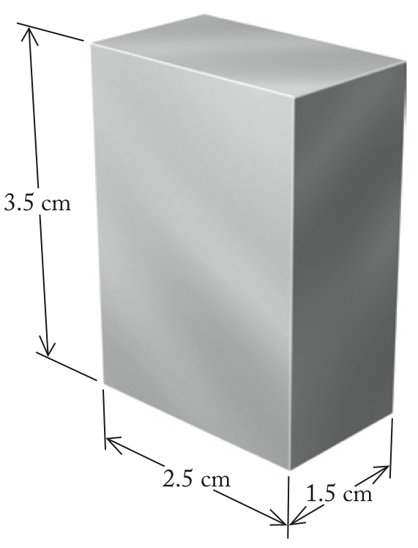
We can then find mass using the following formula:
Mass (g) = density (g/cm³) × volume (cm³)

Solve
The volume of the block of magnesium is
2.5 cm × 3.5 cm × 1.5 cm = 13 cm³
Therefore, the mass of the block is

Think About It
The mass of a sample depends on how much there is of a substance. In this case, we have about 23 grams. As a quick estimate, a block of magnesium of about 10 cm³ would weigh 10 times that of 1 cm³, or about 17 grams. Because we have more than 10 cm³ of this sample and the density is a little greater than 1.7 g/cm³, our answer of 23 grams is reasonable.

1.66. Collect and Organize
In this problem we need to use the density of osmium to find the mass of a specific size block of the metal. To find out whether we could lift it with one hand, we may also have to convert it into pounds, since that is the unit we are more closely familiar with in the United States.

Analyze
Density is defined as the mass of a substance per unit volume. In Appendix 3 the density of osmium is given as 22.57 g/cm³. We have to find the volume of the block of osmium by multiplying the length by the height by the depth (the value will be in cm³). We can then find mass through the following formula:
Mass (g) = density (g/cm³) × volume (cm³)
We can use the conversion of grams to pounds for the comparison:

Solve
The volume of the block of osmium is
6.5 cm × 9.0 cm × 3.25 cm = 190 cm³
Therefore, the mass of the block is
To convert this into the more familiar pounds:

Think About It
Nearly 10 pounds is fairly heavy, but it could be lifted with one hand. The block of osmium, though, will be surprisingly heavy because its volume is relatively small.

1.67. Collect and Organize
To answer this question we need to compute the mass of a copper sample that is 125 cm³ in volume using the density of copper. Next, we use that mass to find out what volume (in cm³) that mass of gold would occupy.

Analyze
We need the density both of copper and of gold from Appendix 3 to make the conversions from volume to mass (for copper) and then from mass to volume (for gold). These densities are 8.96 g/mL for copper and 19.3 g/mL for gold. One milliliter is equivalent to 1 cm³, so the densities are 8.96 g/cm³ and 19.3 g/cm³, respectively. The density formulas that we need are
and

Solve

Think About It
Because gold is more than twice as dense as copper, we would expect the volume of a gold sample to have about half the volume of that of the same mass of copper.

1.68. Collect and Organize
We have to consider how much air (in grams) the balloon holds when cool. Then, we can use that mass combined with the new larger volume of the heated balloon to find the new density.

Analyze
Density is mass per volume so we can obtain the mass of air in the cool balloon through
Mass = density of air × volume of cool balloon
Then, using this mass we can find the new density through

Solve

Think About It
Because the volume of the heated balloon is larger than that of the cooled balloon, we would expect that the density of the air has decreased upon expanding the balloon.

1.69. Collect and Organize
Using the density of mercury, we can find the volume of 1.00 kg of mercury.

Analyze
The density of mercury is given in Appendix 3 as 13.546 g /mL. Because this property is expressed in grams per milliliter, not kilograms per milliliter, we have to convert kilograms into grams using the conversion
Once we have the mass in grams, we can use the rearranged formula for density to find volume

Solve

Think About It
This is a fairly small amount that weighs one kilogram. This is due to the relatively high density of mercury.

1.70. Collect and Organize
For this problem we need to make a comparison of the student’s measurement of the density of her piece of jewelry to the known density of silver.

Analyze
The density of the piece of jewelry can be calculated by dividing the mass of the piece of jewelry by its volume according to the formula for density.

Solve
The density of silver is 10.50 g/mL. Because these densities match very closely, the jewelry could be made of pure silver.

Think About It
The difference in the densities between the piece of jewelry and pure silver is less than 5%. A better comparison of densities would require more significant digits for the measurements of mass and volume of the piece of jewelry.

1.71. Collect and Organize
To determine whether the HDPE will float on water we need to compare the density of the HDPE with that of water. If its density is less than water, then HDPE will float.

Analyze
To compare the densities we need to have the densities of the two substances (water and HDPE) in the same units. We can approach this in either of two ways—convert the seawater density to kg/m³ or convert the HDPE density to g/cm³. Let’s do the latter using the following conversions:
To calculate the density of the HDPE sample, we must divide the mass of the cube of HDPE in grams by the volume in cm³.

Solve
This density is less than the density of the seawater (1.03 g/cm³), so the cube of HDPE will float on water.

Think About It
Certainly boats are made out of materials (like iron) that are more dense than water. These boats float because the mass of the water they displace is greater than the mass of the boat.

1.72. Collect and Organize
In this problem we are asked to calculate the Sun’s density in grams per cubic centimeter given the mass in kilograms (we have to convert to grams) and the radius of the Sun in meters (from which we have to find volume in cubic centimeters).

Analyze
First, we can use the fact that 1000 g = 1 kg to convert the mass of the sun from kilograms to grams. Second, we have to determine the volume of the Sun through the formula
This volume can be computed in cubic centimeters if we first convert the radius in kilometers to centimeters using the equivalencies that 1 km = 1000 m and 1 m = 100 cm.

Solve

Think About It
The density of the Sun is much less than that of the Earth (5.5 g/cm³), which is not surprising because the Sun is mostly composed of gases.

1.73. Collect and Organize
In this problem we use the mass of a carat (the unit of weight for diamonds) to find the mass of a large diamond and then use the density to calculate the volume of that large diamond.

Analyze
We need the fact that 1 carat = 0.200 g and that the density is defined as mass per volume. To find the volume of the diamond we can rearrange the density equation to read

Solve
The mass of the 5.0 carat diamond is
The volume of the diamond is then

Think About It
For this relatively large diamond in terms of carats, the mass is fairly small (one gram is about a fifth of the mass of a nickel); in this case, even though the density is relatively low, the volume is also quite small.

1.74. Collect and Organize
There is a small amount of mercury in this lake per liter, but the volume of the lake will be quite large. In this problem we have to find the volume of the lake and use the concentration of mercury in one liter of the lake water to find the total amount of mercury in the lake.

Analyze
The volume of the lake can be calculated from the surface area and the average depth. However, we need this answer in liters since the concentration of mercury is expressed in micrograms per liter. We should first convert square kilometers to square meters. Then, we can calculate the volume of the lake by multiplying the surface area by the average depth. We need these conversions and the formula for volume from surface area and depth:
We then need to convert cubic meters into liters using
Next, we can use the mercury concentration to find the total mass of mercury in the lake (which will be in micrograms) and convert that to kilograms:

Solve
The amount of mercury in the lake then is computed as

Think About It
Although the concentration of the mercury is quite low, the entire lake contains a relatively large amount of mercury.

1.75. Collect and Organize
Given the data from three different manufacturers of circuit boards for copper line widths, we can determine which manufacturers were precise and which were accurate.

Analyze
By first calculating the range of values for the width of the copper lines from each manufacturer, we can see which manufacturer has the highest precision. By comparing measured line widths with the specified width of 0.500 µm, we can assess each manufacturer’s accuracy.

Solve
(a) Manufacturer 1 has a range of 0.516 – 0.504 = 0.012 µm; Manufacturer 2 has a range of 0.514 – 0.512 = 0.002 µm; and Manufacturer 3 has a range of 0.502 – 0.500 = 0.002 µm.
(b) Yes, Manufacturers 2 and 3 can claim “high precision.” They print the circuits with very little variability in the width of the copper lines.
(c) In the case of Manufacturer 2, the lines are printed at widths wider than the ones specified—a problem of accuracy. The claim of precision, without claiming accuracy, often misleads buyers.

Think About It
In electronic circuit boards, the specifications must be very strictly adhered to, and Manufacturer 3, who prints boards with the highest precision and accuracy, will win the contract.

1.76. Collect and Organize
Given the low and high measured temperatures for three thermometers, we can choose the best one to use.

Analyze
The best thermometer will be the one that is most accurate for the range of temperatures.

Solve
Thermometer A deviates from 0˚C by –0.8˚C and from 100˚C by +0.1˚C. Thermometer B deviates from 0˚C by +0.3˚C and from 100˚C by –0.2˚C. Thermometer C deviates from 0˚C by +0.3˚C and from 100˚C by +0.3˚C. Only for Thermometer C is the temperature scale linear, as it deviates from the melting and boiling points of water by the same amount (–0.3˚C), so it will be the “best” thermometer to use because it will be the most precise.

Think About It
To accurately use Thermometer C you must subtract 0.3˚C from each measured value.

1.77. Collect and Organize
This question asks if a temperature in Celsius would ever equal the temperature in Fahrenheit. We have to make use of the conversion equation between Celsius and Fahrenheit degrees.

Analyze
The equation converting between the temperatures is given as
To find the temperature at which these temperature scales meet (˚C = ˚F in the above equation) substitute ˚C for ˚F:

Solve
Rearranging this equation and solving for ˚C gives

Think About It
Because the intervals between degrees on the Celsius scale are larger than the degrees on the Fahrenheit scale, the two scales will eventually meet at one temperature. This solution shows that they meet at – 40˚.

1.78. Collect and Organize
In this question we define the absolute temperature scale.

Analyze
The Kelvin scale is the absolute temperature scale, and its lowest temperature is 0 K.

Solve
The absolute temperature scale (Kelvin scale) has no negative temperatures, and its 0 value is placed at the lowest possible temperature.

Think About It
Because the Kelvin scale has no negative temperatures, it will often be used in equations when using a negative temperature (in Celsius) would result in a nonsensical answer.

1.79. Collect and Organize
We are asked in this problem to convert from Kelvin to degrees Celsius.

Analyze
The relationship between the Kelvin temperature scale and the Celsius temperature scale is given by
Rearranging this gives the equation to convert Kelvin temperatures to Celsius:

Solve

Think About It
Because 4.2 K is very cold, we would expect that the Celsius temperature would be very negative. It should not, however, be lower than –273.15˚C, since that is the lowest temperature possible.

1.80. Collect and Organize
This question asks us to convert a Celsius temperature into Kelvin.

Analyze
Though temperatures on each scale have different values, the difference between temperatures on the Kelvin and Celsius scales is the same. We can easily convert between scales by adding or subtracting the difference between the two scales at absolute zero, as shown in the figure:
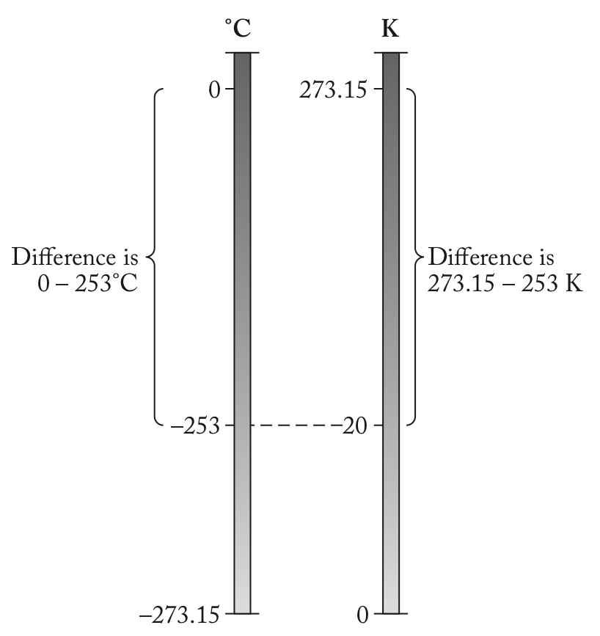
The relationship between the Kelvin temperature scale and the Celsius temperature scale is given by

Solve

Think About It
This is a low temperature for the Celsius temperature scale. It is still above the lowest possible temperature (0 K or –273.15˚C); it has to be!

1.81. Collect and Organize
This question asks us to convert a temperature in Fahrenheit degrees to a temperature in Celsius degrees.

Analyze
The relationship between the Celsius and Fahrenheit temperature scales is given by

Solve

Think About It
This temperature makes sense because it is higher than the normal body temperature, 37˚C.

1.82. Collect and Organize
This question asks us to convert a temperature in Celsius degrees to a temperature in Fahrenheit degrees.

Analyze
The relationship between the Celsius and Fahrenheit temperature scales is
This will have to be rearranged to find ˚F from ˚C:

Solve

Think About It
In humans, this temperature is considered normal body temperature.

1.83. Collect and Organize
This question asks us to convert the coldest temperature recorded on Earth from Fahrenheit to Celsius and Kelvin.

Analyze
Since the Celsius and Kelvin scales are similar (offset by 273.15 degrees), once we convert from Fahrenheit to Celsius, finding the Kelvin temperature will be straightforward. The equations we need are

Solve

Think About It
This temperature is cold on any scale!

1.84. Collect and Organize
This question asks us to convert the hottest temperature recorded on Earth from Fahrenheit to Celsius and Kelvin.

Analyze
Since the Celsius and Kelvin scales are similar (offset by 273.15 degrees), once we convert from Fahrenheit to Celsius, finding the Kelvin temperature will be straightforward. The equations we need are

Solve

Think About It
Remind yourself about the expected range for temperatures in the Celsius scale. While 56.7 ˚C is quite warm for a human, it is still below the boiling point of water; a cup of coffee at this temperature would seem tepid and unpalatable!

1.85. Collect and Organize
Given the freezing and boiling point of a radiator coolant, we are to convert these temperatures from the Celsius scale to the Fahrenheit scale.

Analyze
The relationship between Celsius and Fahrenheit temperature scales is given by
This will have to be rearranged to find ˚F from ˚C.

Solve
The freezing point of this coolant in degrees Fahrenheit is
The boiling point of this coolant in degrees Fahrenheit is

Think About It
In computing the freezing point of this coolant in degrees Fahrenheit, notice that the result is nearly the same as the freezing point in degrees Celsius. This is because the two temperature scales do share a temperature value (see P1.80).

1.86. Collect and Organize
This question asks for the conversion of two melting points from Celsius degrees to Kelvin.

Analyze
We need only adjust the values for the temperature according to the following equation

Solve
For the melting point of silver
For the melting point of gold

Think About It
The two melting temperatures should remain the same number of units apart (102) because the Kelvin is the same magnitude as the Celsius degree.

1.87. Collect and Organize
We are asked to compare the critical temperature (T_{c}) of three superconductors. The critical temperatures, however, are given in three different temperature scales, so for the comparison, we will need to convert them to a single scale.

Analyze
It does not matter which temperature scale we use as the common one, but since the critical temperatures are low, it might be easiest to express all of the temperatures in Kelvin. The equations we will need are
and

Solve
The T_{c} for YBa₂Cu₃O₇ is already expressed in Kelvin, T_{c} = 93.0 K.
The T_{c} of Nb₃Ge is expressed in ˚C and can be converted to K by
The T_{c} of HgBa₂CaCu₂O₆ is expressed in Fahrenheit degrees. To get this temperature in Kelvin, first convert to Celsius degrees, then to Kelvin:
The superconductor with the highest T_{c} is HgBa₂CaCu₂O₆ with a T_{c} of 127.0 K.

Think About It
The superconductor with the lowest T_{c} is Nb₃Ge with a T_{c} of 23.2 K, more than 100 K lower than the T_{c} of HgBa₂CaCu₂O₆.

1.88. Collect and Organize
Based on the boiling points for N₂, O₂, and Ar we can determine which gas condenses first as air is cooled.

Analyze
The boiling point of the liquids from Appendix 3, Table A3.2 are as follows:
b.p. N₂ = –195.8˚C
b.p. O₂ = –182.95˚C
b.p. Ar = –185.9˚C

Solve
As air is cooled, the gas with the highest (least negative) boiling point will condense first. Oxygen, therefore, will condense first.

Think About It
The second gas to condense is argon, followed by nitrogen.

1.89. Collect and Organize
This question considers the runoff of nitrogen every year into a stream resulting from a farmer’s application of fertilizer. We must consider that not all of the fertilizer contains nitrogen and not all of the fertilizer runs off into the stream. We must also account for the flow of the stream in taking up the nitrogen runoff.

Analyze
First, we have to determine the amount of nitrogen that is in the fertilizer (10% of 1500 kg). Then, we need to find how much of that nitrogen gets washed into the stream (15% of the mass of N in the fertilizer). Our final answer must be in milligrams of N, so we can convert the mass of N that gets washed into the stream from kilograms to milligrams.
Next, we need to know how much water flows through the farm each year via the stream. To find this, we must convert the rate of flow in cubic meters per minute to liters per year. We can convert this using dimensional analysis with the following conversions:

Solve
The amount of N washed into the stream each year is
The amount of stream water flowing through the field each year is
The additional concentration of N that is added to the stream by the fertilizer is

Think About It
The calculated amount of nitrogen that is added to the stream seems reasonable. The concentration is relatively low because the stream is moving fairly swiftly and the total amount of nitrogen that washes into the stream over the course of the year is not too great. This analysis, however, does not tell us if this amount would cause harm to the plant and animal life in the stream.

1.90. Collect and Organize
For this problem we try to identify which cylinder is made of aluminum and which is made of titanium by comparing experimentally determined densities with the actual known densities.

Analyze
It may help to picture what we are asked to determine in each part.
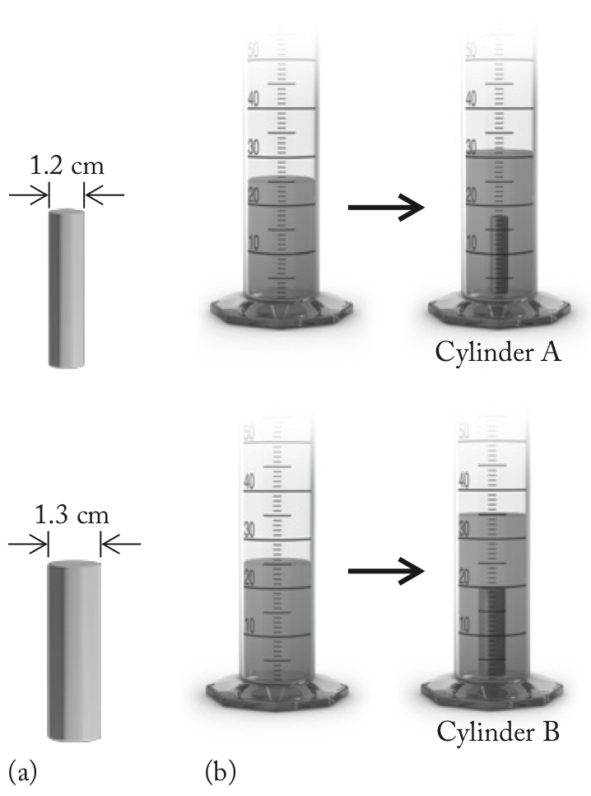
(a) To calculate the volume of each cylinder from its dimensions, we will have to use the equation for the volume of a cylinder:
(b) To calculate the volume from the water displacement method, we need only find the difference in water volume for each cylinder from the diagram in Figure P1.90.
(c) To determine the method with the most significant figures we will compare the answers in parts a and b.
(d) To compute the density for each cylinder we use the equation for density:

Solve
(a) Volumes of the cylinders from their measured dimensions:
(b) Volume of cylinders from water displacement measurements:
(c) Neither. As seen in the above calculations, both the volume measurement from the water displacement method and from the cylinders’ dimension have two significant figures for the volume calculation.
(d) From part a (and part b) we obtain answers with two significant figures for the density:

Think About It
How we make measurements is very important to the values we can report for those measurements. In this problem, neither method provided more significant figures for the calculation.

1.91. Collect and Organize
In this problem we need to express each mixture of chlorine and sodium as a ratio. The mixture that is closest to the ratio for chlorine to sodium will be the one with the desired product, leaving neither sodium nor chlorine left over.

Analyze
First, we must calculate the ratio of chlorine to sodium in sodium chloride. This is a simple ratio of the masses of these two substances:
We can compare the ratios of the other mixtures by making the same calculations.

Solve
In sodium chloride the mass ratio of chlorine to sodium is
Repeating this calculation for the four mixtures, we obtain each ratio of chlorine to sodium:
Both mixtures a and b react so that there is neither sodium nor chlorine left over.

Think About It
Mixture c has leftover chlorine and mixture d has leftover sodium after the reaction is complete.
1.92. Collect and Organize
From the given mass of fluoride per gram in toothpaste and given that NaF is 45% fluoride by mass, we are to calculate the mass of NaF in an 8.2-oz tube of toothpaste.

Analyze
First, we will convert the weight of the toothpaste in the tube from ounces to grams using 1 oz = 28.35 g. From that we can calculate the mg of F– in the toothpaste using 1.00 mg F–/g of toothpaste. Finally, because 45% of the mass of the active ingredient in toothpaste (NaF) is F–, we multiply the result by 100/45 to obtain the mass of sodium fluoride (NaF) in the toothpaste.

Solve

Think About It
Some toothpastes use sodium monofluorophosphate (Na₂PO₃F) as the active ingredient instead of sodium fluoride. Sodium monofluorophosphate has a much smaller percentage fluoride, so a larger mass is required to deliver the same quantity of fluoride in toothpaste.

1.93. Collect and Organize
Given the amounts of recognition molecule, capture molecule, and detector molecule along with the amounts of each needed for one HIV assay plate, we are to determine whether we have sufficient amounts for 96 assay plates.

Analyze
To calculate the amount of each molecule required for the 96 assay plates, we first multiply the required amounts of each molecule by 96. We then subtract this amount from the quantity of each molecule that is available to determine if there are sufficient amounts of each molecule.

Solve
(a) Amount of recognition molecule needed:
0.550 mg × 96 = 52.8 mg
This is less than the amount of recognition molecule available.
100.00 mg – 52.8 mg = 47.2 mg left over
Amount of capture molecule needed:
1.200 mg × 96 = 115.2 mg
This is more than the amount of recognition molecule available.
100.00 mg – 115.2 mg = –15.2 mg (deficit)
Amount of detector molecule needed:
0.450 mg × 96 = 43.2 mg
This is less than the amount of detector molecule available.
50.00 mg – 43.2 mg = 6.8 mg left over
(b) We can make only the number of plates that use up the amount of capture molecules.

Think About It
At most we could prepare 83 plates. Practically speaking, however, we might expect that we would be able to prepare slightly fewer than 83 plates because it is likely that some material would be lost during weighing and transfer of the capture molecule sample.

1.94. Collect and Organize
In this problem we have to calculate the number of tablets of vitamin C to take to reach a dosage level of 1.00 g given the amount of vitamin C in a 500.0 mg tablet.

Analyze
First, we have to calculate the amount (in grams) of vitamin C in each 500.0 mg tablet:
Next, we determine the number of tablets that would comprise 1.00 g of vitamin C

Solve

Think About It
This does not seem to be an extraordinary number of tablets to take. This is because the tablets themselves are fairly large (0.5 g) and contain a good portion of vitamin C (20%).

1.95. Collect and Organize
To make a complete bicycle we need all the parts. Here, we have to look for the maximum number of bicycles that can be built from the number of parts available.

Analyze
For each part, calculate the number of bicycles that can be built. This depends on the number of parts available and the number of those parts needed for each bicycle. For example, each bike needs two pedals so 112 pedals can build 56 bicycles. The part that is available in the lowest amount limits the number of bicycles that can be built. All the other parts will be left over.

Solve
For each bicycle part, the bikes that can be built are as follows:
111 frames will build 111 bicycles
81 front wheels will build 81 bicycles
95 rear wheels will build 95 bicycles
112 pedals will build 56 bicycles
47 sets of handlebars will build 47 bicycles
38 bike chains will build 38 bicycles
17 front brakes will build 17 bicycles
35 rear brakes will build 35 bicycles
We can build only as many bicycles as there are complete sets of parts. The part that is limiting the number of bicycles built in this problem is the front brakes. Therefore, only 17 complete bicycles can be built.

Think About It
After building 17 bicycles, we would have 94 frames, 64 front wheels, 78 rear wheels, 78 pedals, 30 handlebars, 21 bike chains, and 18 rear brakes left over.

1.96. Collect and Organize
To determine the amount of each treat the kindergartners will leave for the custodian, we have to subtract what the children consume from the amount of each treat the caterer has provided to the class.

Analyze
We have to account for each slice of pie, each cup of orange juice, the number of doughnut holes, and how much each child consumes of each treat. The pies are cut into 8 slices and each child has one slice. Each child drinks one cup of orange juice and eats two doughnut holes. It may help to sort each snack item by how many will be consumed by the students and how many are left.

Solve
Two pies cut into 8 slices yields 16 slices. If 11 children eat one slice, there will be 16 – 11 = 5 slices left. If each child drinks one cup of orange juice, there will be 18 – 11 = 7 cups of juice left. If the caterer delivered 2 dozen doughnut holes (24 doughnut holes) and each child eats 2 (11 × 2 = 22), there will be 24 – 22 = 2 doughnut holes left over.

Think About It
Because there are fewer children than slices of pie, there are several slices of pie left for the custodian. Also, the caterer provided 7 too many juice portions. Because each child eats two doughnut holes, however, only 2 are left over for the custodian.
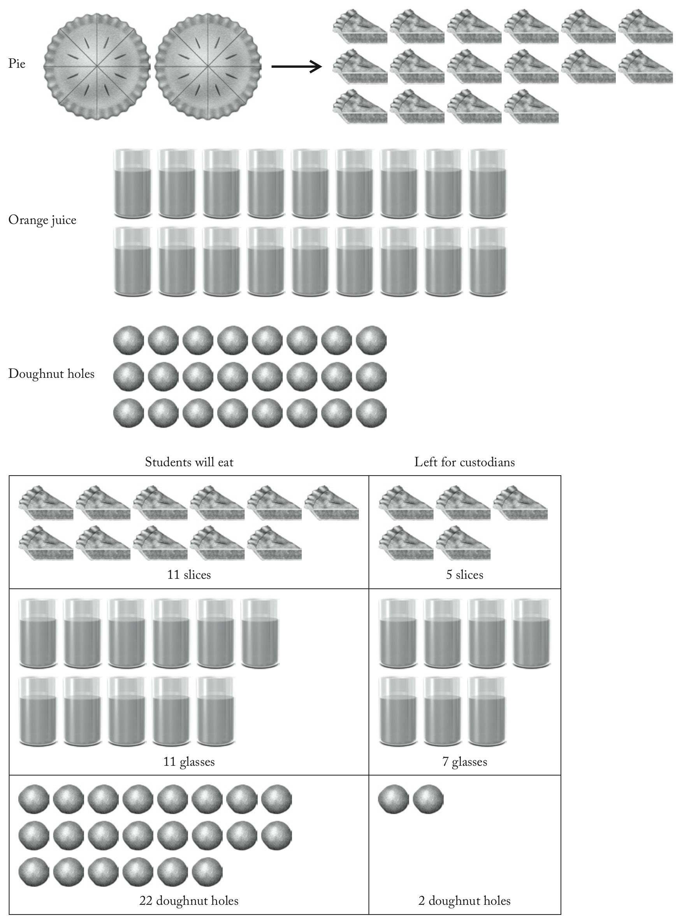

1.97. Collect and Organize
This problem asks us to compute the percentages of the two ingredients in trail mix as manufactured on different days.

Analyze
Because we compare each day’s percentage of peanuts in the trail mix bags to the ideal range of 65–69%, each day’s percentage of peanuts has to be computed from the data given.
Each day has a total of 82 (peanuts plus raisins), so the percentage of the mix in peanuts for each day is calculated by the equation

Solve
For each day, the percent peanuts is
The only day that met the specifications for the percentage of peanuts in the trail mix was Day 11.

Think About It
On Days 1, 21, and 31 too few peanuts were in the trail mix.

1.98. Collect and Organize
For this problem we have to calculate the volume that each liquid takes up from their known density values and add those volumes together. We then have to use that volume to determine the height of the liquid in the cylinder.

Analyze
To find the volume of each liquid from the given mass we can use the density equation.
The volume of each liquid should then be added together to find the total volume. Rearranging the equation describing the volume of a cylinder as shown, we can calculate the height of the two liquids in the cylinder:
We have to be careful to watch for consistent units. Knowing that 1 cm³ = 1 mL should help.

Solve
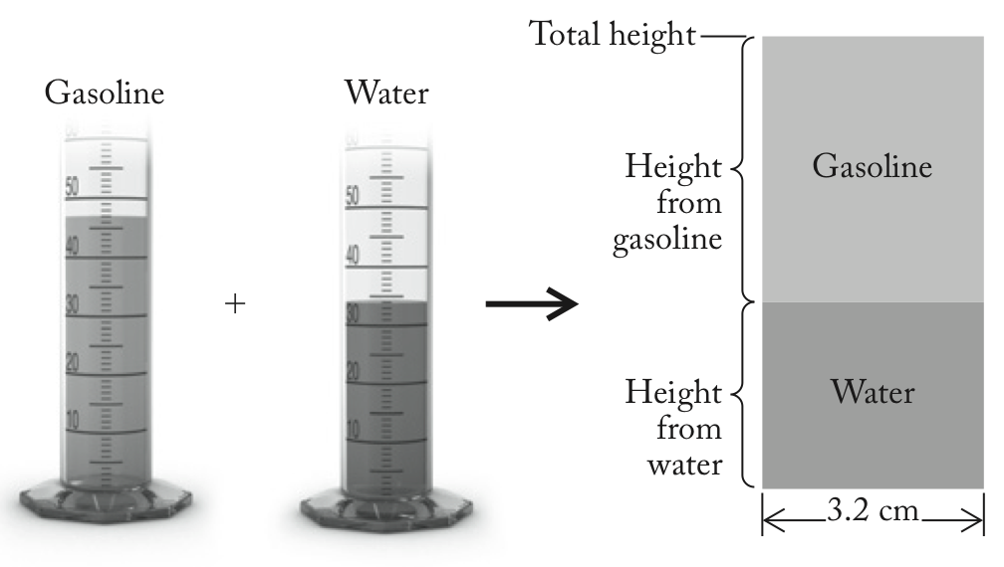
Using the above equation with V = 81 mL or 81 cm³ and the fact that the radius is half the diameter
(3.2 cm/2 = 1.6 cm) gives the height of the liquids in the cylinder.

Think About It
This is a reasonable value for the height of the liquids in the cylinder considering that their combined volume is about 81 mL.

1.99. Collect and Organize
We are told that the same force is used to stretch two springs. The stronger spring will stretch less than the weaker spring, so we are looking for which spring will experience a smaller percentage increase in length.

Analyze
We can find the percentage length increase in spring A by considering the length when stretched (l_{stretched}) and the natural length (l_{natural}). We can determine the percentage increase in length using

Solve
Spring A’s length increases by 35%, while spring B’s length only increases by 15%. Spring B is stronger.

Think About It
If we assume that spring B was also 4.0 cm in its natural state, a 15% increase in length corresponds to a final length of 4.6 cm. This is much shorter than spring A when stretched, supporting our answer above.

1.100. Collect and Organize
This question asks us about a total distance traveled, given a time and a series of speeds. A speed expressed as 1.6 mi/hr is equivalent to saying “travels 1.6 miles in one hour.”

Analyze
We can multiply each speed by the time the class traveled each day, eight hours, to determine the number of miles traveled each day. By adding these numbers, we can determine the total distance traveled on the field trip. The daily speeds we need are given in the question

Solve

Think About It
38 miles seems like a reasonable distance for a three-day hike. The class hikes nearly a half-marathon (13.1 miles) each day!

