1. The graphs of f(x) and g(x) are given. For what values of x is f(x) = g(x)?
​
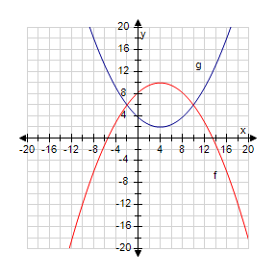
​
 | a. | 2, 3
 | b. | 0
 | c. | –1
 | d. | –2, 5
 | e. | –2, 10

ANSWER: | e

2. Which of the following functions is neither even nor odd?
​
 | a. | 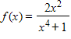
 | b.
 | c.

ANSWER: | b

3. If the point is on the graph of an even function, what other point must also be on the graph?
​
 | a.
 | b.
 | c. | (0, 0)
 | d.
 | e. | None of these

ANSWER: | d

4. If , evaluate the difference quotient 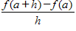.
​
 | a. | 2a + h – 8
 | b. | 2a – 8
 | c. | 2a – h – 8
 | d. | h
 | e. | none of these

ANSWER: | e

5. A box with an open top is to be constructed from a rectangular piece of card board with dimensions b = 6 in. by a = 25 in. by cutting out equal squares of side x at each corner and then folding up the sides as in the figure.
​
Express the volume V of the box as a function of x.
​
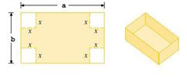
​
a.
b.
c.
d.
e.

ANSWER: | e

6. Find an expression for the function y = f(x) whose graph is the bottom half of the parabola
.
​
a.
b.
c.
d.
e.

ANSWER: | a

7. A rectangle has perimeter 14 m. Express the area of the rectangle as a function A(l) of the length l of one of its sides.
​
a.
b.
c.
d.
e.

ANSWER: | a

8. If , find and simplify 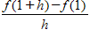, where h ≠ 0.
​
a.
b.
c.
d.

ANSWER: | d

9. Find the domain of the function.
​
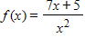
​
a.
b.
c.
d.

ANSWER: | d

10. Find the domain and sketch the graph of the function. What is its range?
​
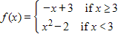
​
 | a. | D: (–∞, ∞); R: [–2, ∞) | b. | D: (–∞, ∞); R: (–∞, 0]
 | c. | D: (–∞, ∞); R: [0, ∞) | d. | D: (–∞, ∞); R: (–∞, ∞)

ANSWER: | d

11. Determine whether the function whose graph is given is even, odd, or neither.
​
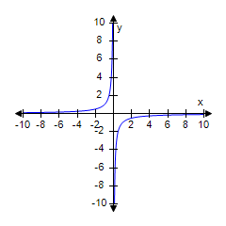
​
 | a. | Even
 | b. | Neither
 | c. | Odd

ANSWER: | c

12. Find the domain of the function 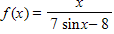
​
 | a. | (–∞, ∞)
 | b. | [, ∞)
 | c.
 | d.

ANSWER: | a

13. Sandy wishes to have a rectangular garden in her backyard. She has 50 ft of fencing with which to enclose her garden. Letting x denote the width of the garden, find a function f in the variable x that gives the area of the garden.
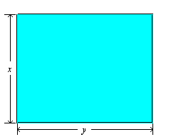
​
 | a. | f(x) = 50x – x², 0 < x < 25
 | b. | f(x) = 25x – x², 0 < x < 25
 | c. | f(x) = 50x – x², 0 < x < 50
 | d. | f(x) = 25x – x², 0 < x < 50

ANSWER: | b

14. The graph of the function f is given. State the value of f(2.7).
​
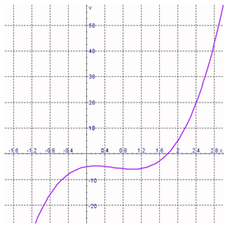
​
 | a. | f(2.7) = –40
 | b. | f(2.7) = –10
 | c. | f(2.7) = 40
 | d. | f(2.7) = 0
 | e. | f(2.7) = 10

ANSWER: | c

15. The graph shown gives the weight of a certain person as a function of age. Find the age at which the person stopped an exercise program.
​
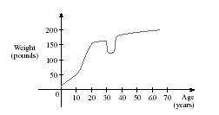
​
 | a. | 20
 | b. | 54
 | c. | 38
 | d. | 35
 | e. | 70

ANSWER: | d

16. In the function , what must be the value d, if f(3) = 1?
​
 | a. | d = 25
 | b. | d = 23
 | c. | d = –23
 | d. | d = –1
 | e. | d = –25

ANSWER: | c

17. An open rectangular box with volume 4 m³ has a square base. Express the surface area of the box as a function S(x) of the length x of a side of the base.
​
a.
b.
c.
d.
e.

ANSWER: | b

18. What is the equation of this graph?
​
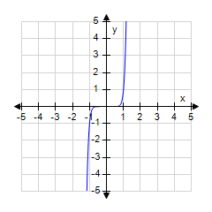
​
a.
b.
c.
d.
e.

ANSWER: | e

19. Find a, such that the function 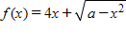 has the domain .
​
 | a. | a = –9
 | b. | a =
 | c. | a = –
 | d. | a = 9
 | e. | a = 3

ANSWER: | d

20. Determine whether f is even, odd, or neither.
​
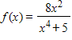
​
 | a. | neither
 | b. | odd
 | c. | even

ANSWER: | c

21. Find the domain.
​
​
 | a. | (0, 3)
 | b. | (–∞, 0]
 | c. | (–3, ∞]
 | d. | [0, 3]
 | e. | [0, ∞)

ANSWER: | d

22. Find the range of the function.
​
y = 4 + cos x
​
 | a. | (–∞, ∞)
 | b. | ​(2, ∞)
 | c. | ​[–1, 1]
 | d. | ​(–1, 3)
 | e. | ​[3, 5]

ANSWER: | e

23. Find the domain of the function.
​
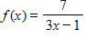

ANSWER: | ​  ​  ​

24. Determine whether f is even, odd, or neither.
​

ANSWER: | even

25. Find the domain of the function.
​
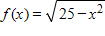

ANSWER: | [–5, 5]

26. Find the range of the function.
​
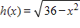

ANSWER: | 0 ≤ ​h​(​x​) ≤ 6

27. The graphs of f(x) and g(x) are given.
a) For what values of x is f(x) = g(x)?
b) Find the values of f(–1) and g(12).
​
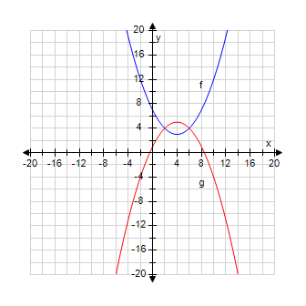
​

ANSWER: | a) 2, 6 b)  ​  ​  ​  ​

28. A spherical balloon with radius r inches has volume 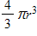.
Find a function that represents the amount of air required to inflate the balloon from a radius of r inches to a radius of r + 7 inches.
​
ANSWER: | ​  ​  ​  ​  ​  ​  ​

29. If 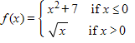
​
find f (–3), f (0), and f (4).

ANSWER: | f (–3) = 16, f (0) = 7, f (4) = 2.

30. Refer to the graph of the function f in the following figure.
​
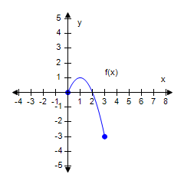
​
a. Find f (0).
b. Find the value of x for which (i) f(x) = 1 and (ii) f(x) = 0.
c. Find the domain and range of f.
​
​
​

ANSWER: | a. 0  b. (i) 1 (ii) 0, 2  c. D: [0, 3], R: [–3, 1]

31. Determine whether the function is even, odd, or neither.
​
​
ANSWER: | Neither

32. The following figure shows a portion of the graph of a function f defined on the interval [–1, 1]. Sketch the complete graph of f if it is known f is odd.
​
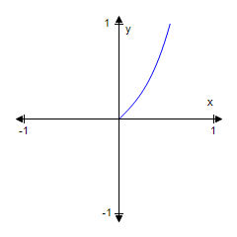
ANSWER:

33. By cutting away identical squares from each corner of a rectangular piece of cardboard and folding up the resulting flaps, an open box can be made. If the cardboard is 18 in. long and 9 in. wide and the square cutaways have dimensions of x in. by x in., find a function that gives the volume of the resulting box.
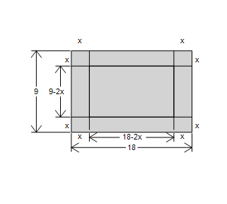
​

ANSWER:

34. Use the vertical line test to determine whether the curve is the graph of a function of x.
​
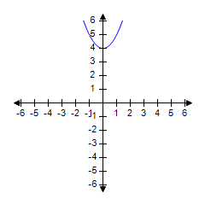
ANSWER: | Yes

35. Find the domain and sketch the graph of the function. What is its range?
​
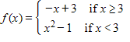
​
 | a. | D: (–∞, ∞); R: [–1, ∞) | b. | D: (–∞, ∞); R: (–∞, 0]
 | c. | D: (–∞, ∞); R: [0, ∞) | d. | D: (–∞, ∞); R: (–∞, ∞)

ANSWER: | d

36. Sketch the graph of the function.
​
ANSWER:

37. The graph of a function g is given. On what interval(s) is g increasing?

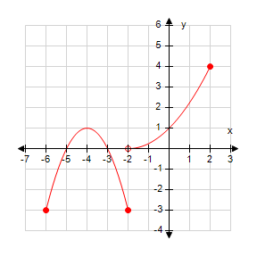
ANSWER:

38. Determine whether the statement is true or false.

If and f is a decreasing function, then .
 | a. | True
 | b. | False

ANSWER: | False

39. Let f be the function whose graph is given. Find the interval where the function is decreasing.

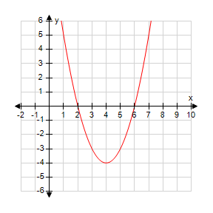

a.
b.
c.
d.

ANSWER: | a

