College Physics, 10e (Young)
Chapter 1 Models, Measurements and Vectors

1.1 Multiple Choice Questions

1) The following conversion equivalents are given:
1 gal = 231 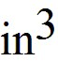 1 ft = 12 in 1 min = 60 s
A pipe delivers water at the rate of 95 gal/min. The rate in 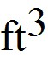/s, is closest to:
A) 0.21
B) 0.19
C) 0.17
D) 0.15
E) 0.14
Answer: A
Var: 50+

2) The following conversion equivalents are given:
1 m = 100 cm 1 in = 2.54 cm 1 ft = 12 in
A bin has a volume of 1.5 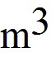. The volume of the bin, in , is closest to:
A) 35
B) 41
C) 47
D) 53
E) 59
Answer: D
Var: 1

3) The following conversion equivalents are given:
1 mile = 5280 ft 1 ft = 12 in 1 m = 39.37 in 1 hour = 60 min 1 min = 60 s
A particle has a velocity of 4.7 miles per hour. The velocity, in m/s, is closest to:
A) 2.1
B) 1.7
C) 1.9
D) 2.3
E) 2.5
Answer: A
Var: 50+
4) A speed of 65 miles per hour is the same as
A) 24 m/s
B) 29 m/s
C) 32 m/s
D) 37 m/s
E) 42 m/s
Answer: B
Var: 1

5) The following conversion equivalents are given:
1 kg = 1000g 1 l = 1000 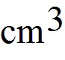 1 l = 0.0353
The density of a liquid is 0.83 g/. The density of the liquid, in kg/, is closest to:
A) 24
B) 19
C) 21
D) 26
E) 28
Answer: A
Var: 50+

6) A weight lifter can bench press 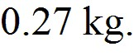 How many milligrams (mg) is this?
A) 2.7 × 108 mg
B) 2.7 × 109 mg
C) 2.7 × 107 mg
D) 2.7 × 106 mg
Answer: A
Var: 50+

7) Your car gets 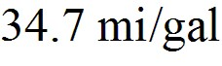 on a trip. How many 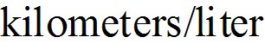 did it get? (3.79 = 1 gal; 1 mi = 1.61 km)
A) 14.7 km/l
B) 9.16 km/l
C) 55.9 km/l
D) 32.4 km/l
Answer: A
Var: 50+
8) The wavelength of a certain laser is 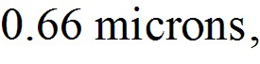 where 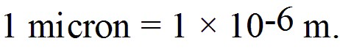 What is this wavelength in nanometers? (1 nm = 10-9m)
A) 6.6 × 102 nm
B) 6.6 × 103 nm
C) 6.6 × 101 nm
D) 6.6 × 104 nm
Answer: A
Var: 50+

9) Add 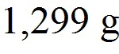 and 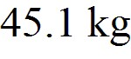 and express your answer in milligrams (mg).
A) 4.64 × 107 mg
B) 4.64 × 104 mg
C) 4.64 × 105 mg
D) 4.64 × 106 mg
Answer: A
Var: 50+

10) Express [2.2 × 106]-1/2 in scientific notation.
A) 6.7 × 10-4
B) 1.5 × 103
C) 1.5 × 10-5
D) 1.5 × 104
Answer: A
Var: 40

11) What is 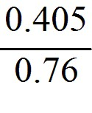 to the proper number of significant figures?
A) 0.53
B) 0.533
C) 0.5329
D) 0.5
Answer: A
Var: 50+

12) What is 0.3272/3, to the proper number of significant figures?
A) 0.475
B) 0.47
C) 0.5
D) 0.4746
Answer: A
Var: 50+
13) Which of the following is a reasonable estimate of the number of characters (typed letters or numbers) in a 609 page book? Assume an average of 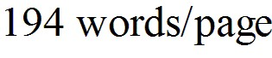 and a reasonable average number of 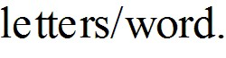
A) 5 × 105 char
B) 5 × 107 char
C) 5 × 106 char
D) 5 × 104 char
Answer: A
Var: 50+

14) A marathon is 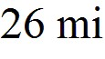 and 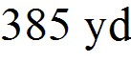 long. Estimate how many strides would be required to run a marathon. Assume a reasonable value for the average number of 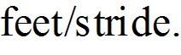
A) 4.5 × 104 strides
B) 4.5 × 103 strides
C) 4.5 × 105 strides
D) 4.5 × 106 strides
Answer: A
Var: 1

15) Estimate the number of times an average person's heart beats in a lifetime. Assume the average heart rate is 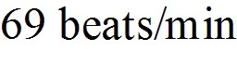 and a life span of 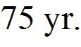
A) 3 × 109 beats
B) 3 × 108 beats
C) 3 × 1010 beats
D) 3 × 107 beats
Answer: A
Var: 50+

16) The components of vector 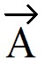 are given as follows:

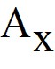 = +7.6
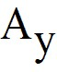 = -6.4

The magnitude of is closest to:
A) 9.9
B) 7.9
C) 8.9
D) 11
E) 12
Answer: A
Var: 50+
17) The components of vector are given as follows:

= +6.1
= -8.6

The angle measured counterclockwise from the x-axis to vector , in degrees, is closest to:
A) 305
B) 125
C) 215
D) 145
E) 55
Answer: A
Var: 50+

18) The components of vectors and 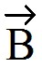 are given as follows:

= +7.6 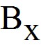 = -5.1
= -9.2 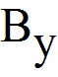 = -6.8

The magnitude of the vector difference - , is closest to:
A) 13
B) 3.5
C) 16
D) 170
E) 3.4
Answer: A
Var: 50+
19) The components of vectors and 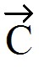 are given as follows:

= -9.2 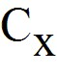 = -4.5
= -6.1 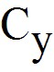 = +4.3

The angle (less than 180 degrees) between vectors and , in degrees, is closest to:
A) 77
B) 103
C) 10
D) 170
E) 84
Answer: A
Var: 50+

20) The magnitude of is 5.5. Vector lies in the second quadrant and forms an angle of 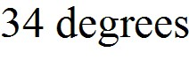 with the y-axis. The components, and , are closest to:
A) = -3.1, = +4.6
B) = +3.1, = -4.6
C) = +4.6, = -3.1
D) = -4.6, = +3.1
E) = -4.6, = -3.1
Answer: A
Var: 50+

21) Vector has length 2 units and directed to the north. Vector has length 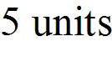 and is directed to the south. Calculate the magnitude and direction of 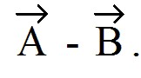
A) 7 units, north
B) 7 units, south
C) 3 units, north
D) 3 units, south
Answer: A
Var: 39
Figure 1.1

Vectors and are shown. Vector 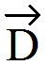 is given by = -
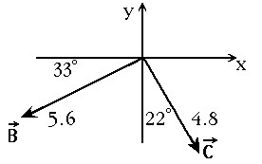

22) In Figure 1.1, the magnitude of is closest to:
A) 3.2
B) 5.3
C) 6.6
D) 8.0
E) 9.2
Answer: C
Var: 1

23) In Figure 1.1, the angle, measured counterclockwise from the x-axis to vector , in degrees, is closest to:
A) 12
B) 102
C) 168
D) 192
E) 258
Answer: C
Var: 1

24) You walk 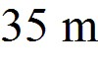 to the north, then turn 60° to your right and walk another 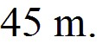 How far are you from where you originally started?
A) 69 m
B) 40 m
C) 76 m
D) 36 m
Answer: A
Var: 31
25) A rabbit trying to escape a fox runs north for 4.0 m, darts northwest for 8.0 m, then drops 1.0 m down a hole into its burrow. What is the magnitude of the net displacement of the rabbit?
A) 11 m
B) 8.9 m
C) 81 m
D) 13 m
Answer: A
Var: 50+

26) Which of the following is an accurate statement about vectors?
A) The magnitude of a vector can be zero even though one of its components is not zero.
B) It is possible to add a scalar quantity to a vector.
C) Even though two vectors have unequal magnitudes, it is possible that their vector sum is zero.
D) Rotating a vector about an axis passing through the tip of the vector does not change the vector.
E) The magnitude of a vector is positive even if all of its components are negative.
Answer: E
Var: 1

Figure 1.2

Three vectors are given as shown.
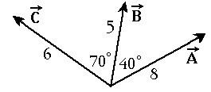

27) In Figure 1.2, the magnitude of the resultant of the three vectors is closest to:
A) 19
B) 16
C) 13
D) 10
E) 7
Answer: C
Var: 1
28) An airplane undergoes the following displacements: First, it flies 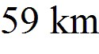 in a direction 30° east of north. Next, it flies 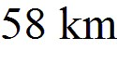 due south. Finally, it flies 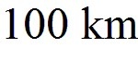 30° north of west. Using analytical methods, determine how far the airplane ends up from its starting point.
A) 71.5 km
B) 73 km
C) 74.4 km
D) 70.1 km
E) 68.7 km
Answer: A
Var: 50+

1.2 Short Answer Questions

1) Albert defines his own unit of length, the albert, to be the distance Albert can throw a small rock. One albert is 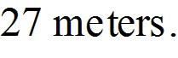 How many square alberts is one acre?
(1 acre = 43,560 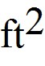 = 4050 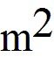)
Answer: 5.55555556 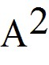
Var: 50+

Figure 1.3

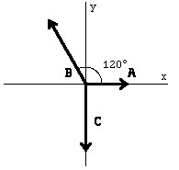

2) Find the magnitude and direction of the resultant 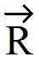 of the three vectors shown in Figure 1.3. The vectors have the following magnitudes: A = 5.0, B = 7.9, and C = 8.0. Express the direction of the vector sum by specifying the angle it makes with the positive x-axis, with the counterclockwise angles taken to be positive.
Answer: magnitude: R = 1.6, direction: Θ = 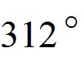
Var: 1
3) Two boys, Joe and Sam, who are searching for buried treasure start underneath the same tree. Joe walks 12 m east and then 12 m north, while Sam walks 15 m west and then 10 m south. Both boys then stop. Find the magnitude and direction of the vector from Sam to Joe. Express the direction of this vector by specifying the angle it makes with the west-to-east direction.
Answer: 35 m at 39°
Var: 1

4) A vector in the x-yplane has an x-component of –7.50 units. What must be the y-component of this vector so that its magnitude is 10.0 units. (Note: There are two possible answers.)
Answer: +6.61 units and –6.61 units
Var: 1

5) Three ropes are tied in a knot as indicated in Figure 1.4. One student pulls on rope A with 1 pound of force, and another student pulls on rope B with 7 pounds of force. How hard and in what direction must you pull on rope C to balance the first two pulls? Give the direction by specifying the angle of the pull with the direction of rope A and its direction (clockwise or counterclockwise).

Figure 1.4

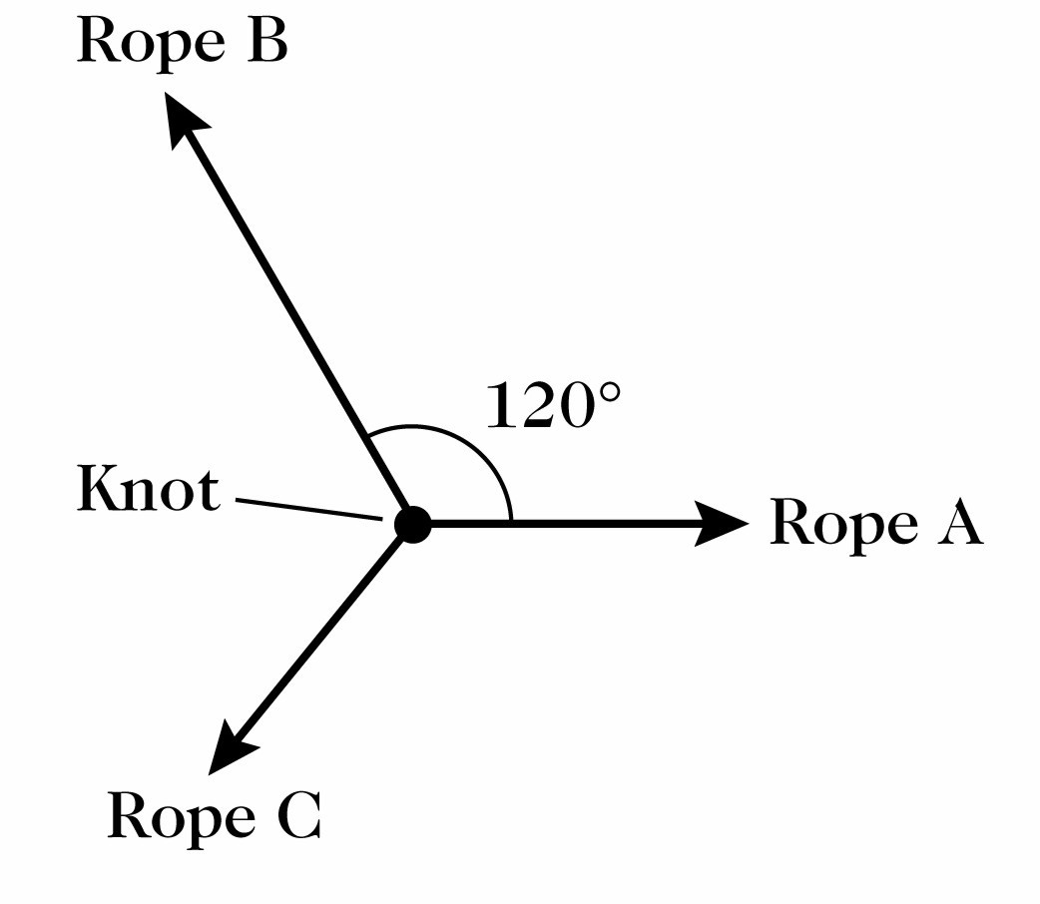

Answer: 6.6 pounds at 68° clockwise from rope A
Var: 1

