1. Decide whether the following problem can be solved using precalculus, or whether calculus is required. If the problem can be solved using precalculus, solve it. If the problem seems to require calculus, use a graphical or numerical approach to estimate the solution.
​
Find the distance traveled in 13 seconds by an object traveling at a constant velocity of 15 feet per second.
​
 | a. | calculus, 195 ft
 | b. | calculus, 215 ft
 | c. | precalculus, 195 ft
 | d. | calculus, 390 ft
 | e. | precalculus, 390 ft

ANSWER: | c
POINTS: | 1
DIFFICULTY: | Easy
REFERENCES: | Section 1.1
QUESTION TYPE: | Multi-Mode (Multiple choice)
HAS VARIABLES: | True
LEARNING OBJECTIVES: | LCalc11.1.1.2 - Understand that the tangent line problem is basic to calculus.
OTHER: | Skill
DATE CREATED: | 1/11/2017 9:56 AM
DATE MODIFIED: | 1/11/2017 9:56 AM

2. Decide whether the following problem can be solved using precalculus, or whether calculus is required. If the problem can be solved using precalculus, solve it. If the problem seems to require calculus, use a graphical or numerical approach to estimate the solution.
​
Find the distance traveled in 19 seconds by an object moving with a velocity of feet per second. Round your answer to four decimal places.
​
 | a. | calculus, 215.9209 ft
 | b. | precalculus, 217.2709 ft
 | c. | calculus, 210.0491 ft
 | d. | precalculus, 210.0491 ft
 | e. | precalculus, 215.9209 ft

ANSWER: | c
POINTS: | 1
DIFFICULTY: | Medium
REFERENCES: | Section 1.1
QUESTION TYPE: | Multi-Mode (Multiple choice)
HAS VARIABLES: | True
LEARNING OBJECTIVES: | CALC052 - Recognize problems requiring calculus and estimate solutions
OTHER: | Skill
DATE CREATED: | 1/11/2017 9:56 AM
DATE MODIFIED: | 1/11/2017 9:56 AM

3. Decide whether the following problem can be solved using precalculus, or whether calculus is required. If the problem can be solved using precalculus, solve it. If the problem seems to require calculus, use a graphical or numerical approach to estimate the solution.
​
A cyclist is riding on a path whose elevation is modeled by the function where x and are measured in miles. Find the rate of change of elevation when .
​
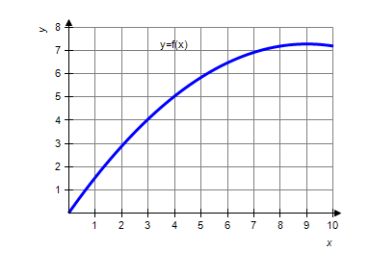
​
 | a. | precalculus, 0.09
 | b. | calculus, 0.21
 | c. | calculus, 0.81
 | d. | calculus, 0.09
 | e. | precalculus, 0.21

ANSWER: | c
POINTS: | 1
DIFFICULTY: | Medium
REFERENCES: | Section 1.1
QUESTION TYPE: | Multi-Mode (Multiple choice)
HAS VARIABLES: | True
LEARNING OBJECTIVES: | CALC052 - Recognize problems requiring calculus and estimate solutions
OTHER: | Skill
DATE CREATED: | 1/11/2017 9:56 AM
DATE MODIFIED: | 1/11/2017 9:56 AM

4. Decide whether the following problem can be solved using precalculus, or whether calculus is required. If the problem can be solved using precalculus, solve it. If the problem seems to require calculus, use a graphical or numerical approach to estimate the solution.
​
A cyclist is riding on a path whose elevation is modeled by the function where x and are measured in miles. Find the rate of change of elevation when . Round your answer to two decimal places, if necessary.
​
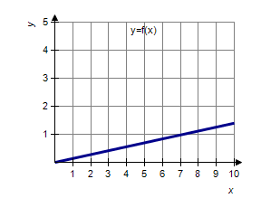
​
 | a. | calculus, 0.98
 | b. | precalculus, 0.14
 | c. | calculus, 0.14
 | d. | precalculus, 0.98
 | e. | precalculus, 0.39

ANSWER: | b
POINTS: | 1
DIFFICULTY: | Easy
REFERENCES: | Section 1.1
QUESTION TYPE: | Multi-Mode (Multiple choice)
HAS VARIABLES: | True
LEARNING OBJECTIVES: | LCalc11.1.1.2 - Understand that the tangent line problem is basic to calculus.
OTHER: | Skill
DATE CREATED: | 1/11/2017 9:56 AM
DATE MODIFIED: | 1/11/2017 9:56 AM

5. Decide whether the following problem can be solved using precalculus, or whether calculus is required. If the problem can be solved using precalculus, solve it. If the problem seems to require calculus, use a graphical or numerical approach to estimate the solution.
​
Find the area of the shaded region bounded by the triangle with vertices , , .
​​
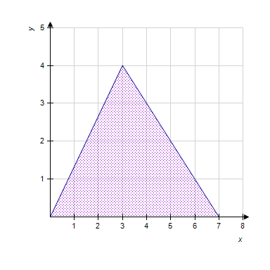
​
 | a. | precalculus, 28
 | b. | calculus, 42
 | c. | precalculus, 14
 | d. | precalculus, 42
 | e. | calculus, 28

ANSWER: | c
POINTS: | 1
DIFFICULTY: | Easy
REFERENCES: | Section 1.1
QUESTION TYPE: | Multi-Mode (Multiple choice)
HAS VARIABLES: | True
LEARNING OBJECTIVES: | LCalc11.1.1.2 - Understand that the tangent line problem is basic to calculus.
OTHER: | Skill
DATE CREATED: | 1/11/2017 9:56 AM
DATE MODIFIED: | 1/11/2017 9:56 AM

6. Decide whether the following problem can be solved using precalculus, or whether calculus is required. If the problem can be solved using precalculus, solve it. If the problem seems to require calculus, use a graphical or numerical approach to estimate the solution.
​
Find the area of the shaded region. Round your answer to the whole number.
​
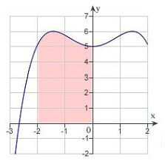
​
 | a. | calculus , 11
 | b. | precalculus , 11
 | c. | precalculus , 13
 | d. | calculus , 16
 | e. | precalculus , 16

ANSWER: | a
POINTS: | 1
DIFFICULTY: | Medium
REFERENCES: | Section 1.1
QUESTION TYPE: | Multi-Mode (Multiple choice)
HAS VARIABLES: | True
LEARNING OBJECTIVES: | CALC053 - Recognize problems requiring calculus and estimate solution
OTHER: | Skill
DATE CREATED: | 1/11/2017 9:56 AM
DATE MODIFIED: | 1/11/2017 9:56 AM

7. Consider the function and the point on the graph of f. Graph f and the secant line passing through and for .
​
 | a. | ​ | b. | ​
 | c. | ​ | d. | ​
 | e. | ​

ANSWER: | d
POINTS: | 1
DIFFICULTY: | Easy
REFERENCES: | Section 1.1
QUESTION TYPE: | Multi-Mode (Multiple choice)
HAS VARIABLES: | True
LEARNING OBJECTIVES: | LCalc11.1.1.0 - A Preview of Calculus
OTHER: | Skill
DATE CREATED: | 1/11/2017 9:56 AM
DATE MODIFIED: | 1/11/2017 9:56 AM

8. Consider the function and the point on the graph of f. Find the slope of the secant line passing through and for . Round your answer to four decimal places.
​
 | a.
 | b. | ​
 | c.
 | d.
 | e.

ANSWER: | a
POINTS: | 1
DIFFICULTY: | Easy
REFERENCES: | Section 1.1
QUESTION TYPE: | Multi-Mode (Multiple choice)
HAS VARIABLES: | True
LEARNING OBJECTIVES: | CALC055 - Calculate the slope of a secant line passing through given points
OTHER: | Skill
DATE CREATED: | 1/11/2017 9:56 AM
DATE MODIFIED: | 1/11/2017 9:56 AM

9. Consider the function and the point on the graph of f.
​
Consider the secant lines passing through and for x values of 97, 99, and 101. Find the slope of each secant line to four decimal places. Round your answers to four decimal places, if necessary.
​
(Think about how you could use your results to estimate the slope of the tangent line of f at , and how to improve your approximation of the slope.)
​
 | a. | 0.0504 , 0.0501 , 0.025
 | b. | 0.0504 , –0.0501 , 0.0499
 | c. | 0.0252 , 0.0251 , 0.025
 | d. | 0.0504 , 0.0501 , 0.0499
 | e. | –0.0252 , –0.0251 , –0.025

ANSWER: | d
POINTS: | 1
DIFFICULTY: | Medium
REFERENCES: | Section 1.1
QUESTION TYPE: | Multi-Mode (Multiple choice)
HAS VARIABLES: | True
LEARNING OBJECTIVES: | CALC056 - Calculate the slopes of secant lines
OTHER: | Skill
DATE CREATED: | 1/11/2017 9:56 AM
DATE MODIFIED: | 1/11/2017 9:56 AM

10. Consider the function and the point on the graph of f. Estimate the slope m of the tangent line of f at . Round your answer to four decimal places.
​
a.
b.
c.
d.
e.

ANSWER: | a
POINTS: | 1
DIFFICULTY: | Medium
REFERENCES: | Section 1.1
QUESTION TYPE: | Multi-Mode (Multiple choice)
HAS VARIABLES: | True
LEARNING OBJECTIVES: | CALC057 - Estimate the slope of a tangent line
OTHER: | Skill
DATE CREATED: | 1/11/2017 9:56 AM
DATE MODIFIED: | 1/11/2017 9:56 AM

11. Consider the function and the point on the graph of f. Graph f and the secant line passing through and for .
​
 | a. | ​ | b. | ​
 | c. | ​ | d. | ​
 | e. | ​

ANSWER: | d
POINTS: | 1
DIFFICULTY: | Easy
REFERENCES: | Section 1.1
QUESTION TYPE: | Multi-Mode (Multiple choice)
HAS VARIABLES: | True
LEARNING OBJECTIVES: | LCalc11.1.1.0 - A Preview of Calculus
OTHER: | Skill
DATE CREATED: | 1/11/2017 9:56 AM
DATE MODIFIED: | 1/11/2017 9:56 AM

12. Consider the function and the point on the graph of f. Find the slope of the secant line passing through and for . Round your answer to one decimal place.
​
 | a. | 7.5
 | b. | 6.0
 | c. | 4.0
 | d. | 5.5
 | e. | 4.0

ANSWER: | b
POINTS: | 1
DIFFICULTY: | Easy
REFERENCES: | Section 1.1
QUESTION TYPE: | Multi-Mode (Multiple choice)
HAS VARIABLES: | True
LEARNING OBJECTIVES: | CALC055 - Calculate the slope of a secant line passing through given points
OTHER: | Skill
DATE CREATED: | 1/11/2017 9:56 AM
DATE MODIFIED: | 1/11/2017 9:56 AM

13. Consider the function and the point on the graph of f. Estimate the slope of the tangent line of f at . Round your answer to the whole number.
​
 | a. | 15
 | b. | 6
 | c. | 13
 | d. | 5
 | e. | 14

ANSWER: | d
POINTS: | 1
DIFFICULTY: | Medium
REFERENCES: | Section 1.1
QUESTION TYPE: | Multi-Mode (Multiple choice)
HAS VARIABLES: | True
LEARNING OBJECTIVES: | CALC058 - Calculate the slope of secant line passing through the given points
OTHER: | Skill
DATE CREATED: | 1/11/2017 9:56 AM
DATE MODIFIED: | 1/11/2017 9:56 AM

14. Use the rectangles in the graph given below to approximate the area of the region bounded by 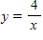, , , and . Round your answer to three decimal places.
​
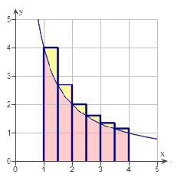
​
 | a. | 2.975 units²
 | b. | 6.871 units²
 | c. | 4.075 units²
 | d. | 6.372 units²
 | e. | 7.397 units²

ANSWER: | b
POINTS: | 1
DIFFICULTY: | Medium
REFERENCES: | Section 1.1
QUESTION TYPE: | Multi-Mode (Multiple choice)
HAS VARIABLES: | True
LEARNING OBJECTIVES: | LCalc11.1.1.3 - Understand that the area problem is also basic to calculus.
OTHER: | Skill
DATE CREATED: | 1/11/2017 9:56 AM
DATE MODIFIED: | 1/11/2017 9:56 AM

15. Consider the length of the graph of 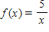 from to . Approximate the length of the curve by finding the sum of the lengths of four line segments, as shown in following figure. Round your answer to two decimal places.
​
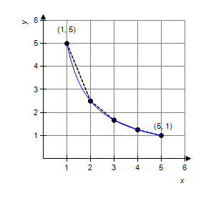
​
 | a. | 6.11
 | b. | 8.12
 | c. | 5.66
 | d. | 8.49
 | e. | 7.11

ANSWER: | a
POINTS: | 1
DIFFICULTY: | Medium
REFERENCES: | Section 1.1
QUESTION TYPE: | Multi-Mode (Multiple choice)
HAS VARIABLES: | True
LEARNING OBJECTIVES: | CALC060 - Estimate the length of the curve using a piecewise linear function
OTHER: | Skill
DATE CREATED: | 1/11/2017 9:56 AM
DATE MODIFIED: | 1/11/2017 9:56 AM

1. ​Complete the table and use the result to estimate the limit.
​
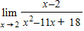
​
 | 1.9 | 1.99 | 1.999 | 2.001 | 2.01 | 2.1
​
 | a. | ​0.482143
 | b. | ​0.232143
 | c. | ​–0.142857
 | d. | ​0.357143
 | e. | ​–0.517857

ANSWER: | c
POINTS: | 1
QUESTION TYPE: | Multiple Choice
HAS VARIABLES: | True
DATE CREATED: | 1/11/2017 9:54 AM
DATE MODIFIED: | 1/11/2017 9:54 AM

2. ​Complete the table and use the result to estimate the limit.
​
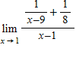
​
 | 0.9 | 0.99 | 0.999 | 1.001 | 1.01 | 1.1
​
 | a. | ​0.015625
 | b. | ​0.145625
 | c. | ​–0.114375
 | d. | ​0.125625
 | e. | ​–0.094375

ANSWER: | a
POINTS: | 1
QUESTION TYPE: | Multiple Choice
HAS VARIABLES: | True
DATE CREATED: | 1/11/2017 9:54 AM
DATE MODIFIED: | 1/11/2017 9:54 AM

3. Complete the table and use the result to estimate the limit.
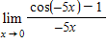
 | –0.1 | –0.01 | –0.001 | 0.001 | 0.01 | 0.1
​
 | a. | –1
 | b. | –0.5
 | c. | 0
 | d. | 0.5
 | e. | 1

ANSWER: | c
POINTS: | 1
DIFFICULTY: | Medium
REFERENCES: | Section 1.2
QUESTION TYPE: | Multi-Mode (Multiple choice)
HAS VARIABLES: | True
LEARNING OBJECTIVES: | CALC061 - Estimate a limit from a table of values
OTHER: | Skill
DATE CREATED: | 1/11/2017 9:54 AM
DATE MODIFIED: | 1/11/2017 9:54 AM

4. Determine the following limit. (Hint: Use the graph to calculate the limit.)
​
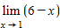
​
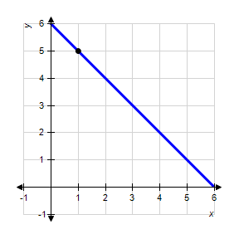
​
 | a. | 7
 | b. | 1
 | c. | 6
 | d. | 5
 | e. | does not exist

ANSWER: | d
POINTS: | 1
DIFFICULTY: | Easy
REFERENCES: | Section 1.2
QUESTION TYPE: | Multi-Mode (Multiple choice)
HAS VARIABLES: | True
LEARNING OBJECTIVES: | CALC062 - Estimate the limit of a function from its graph
OTHER: | Skill
DATE CREATED: | 1/11/2017 9:54 AM
DATE MODIFIED: | 1/11/2017 9:54 AM

5. Let 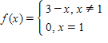.
​
Determine the following limit. (Hint: Use the graph to calculate the limit.)
​
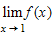
​
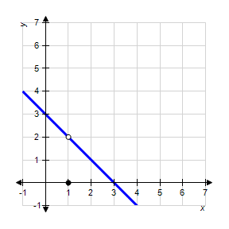
​
 | a. | 4
 | b. | 3
 | c. | 2
 | d. | 0
 | e. | does not exist

ANSWER: | c
POINTS: | 1
DIFFICULTY: | Medium
REFERENCES: | Section 1.2
QUESTION TYPE: | Multi-Mode (Multiple choice)
HAS VARIABLES: | True
LEARNING OBJECTIVES: | CALC062 - Estimate the limit of a function from its graph
OTHER: | Skill
DATE CREATED: | 1/11/2017 9:54 AM
DATE MODIFIED: | 1/11/2017 9:54 AM

6. Let 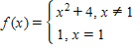.
​
Determine the following limit. (Hint: Use the graph to calculate the limit.)
​
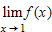
​
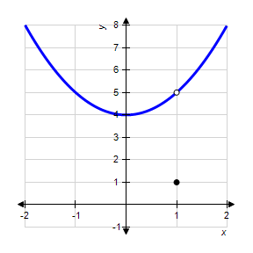
​
 | a. | 5
 | b. | 16
 | c. | 1
 | d. | 4
 | e. | does not exist.

ANSWER: | a
POINTS: | 1
DIFFICULTY: | Medium
REFERENCES: | Section 1.2
QUESTION TYPE: | Multi-Mode (Multiple choice)
HAS VARIABLES: | True
LEARNING OBJECTIVES: | CALC062 - Estimate the limit of a function from its graph
OTHER: | Skill
DATE CREATED: | 1/11/2017 9:54 AM
DATE MODIFIED: | 1/11/2017 9:54 AM

7. Determine the following limit. (Hint: Use the graph to calculate the limit.)
​
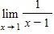
​
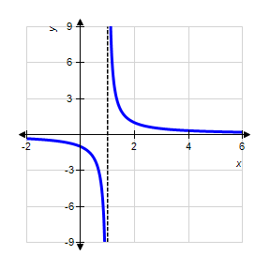
​
 | a. | –1
 | b. | 0
 | c. | –2
 | d. | 1
 | e. | does not exist

ANSWER: | e
POINTS: | 1
DIFFICULTY: | Medium
REFERENCES: | Section 1.2
QUESTION TYPE: | Multi-Mode (Multiple choice)
HAS VARIABLES: | True
LEARNING OBJECTIVES: | CALC062 - Estimate the limit of a function from its graph
OTHER: | Skill
DATE CREATED: | 1/11/2017 9:54 AM
DATE MODIFIED: | 1/11/2017 9:54 AM

8. A ring has an inner circumference of 9 centimeters. What is the radius of the ring? Round your answer to four decimal places.
​
 | a. | 0.7162 centimeter
 | b. | 2.8648 centimeters
 | c. | 1.4324 centimeters
 | d. | 1.6926 centimeters
 | e. | 8.2070 centimeters

ANSWER: | c
POINTS: | 1
DIFFICULTY: | Easy
REFERENCES: | Section 1.2
QUESTION TYPE: | Multi-Mode (Multiple choice)
HAS VARIABLES: | True
LEARNING OBJECTIVES: | CALC063 - Solve a linear equation in applications
OTHER: | Application
DATE CREATED: | 1/11/2017 9:54 AM
DATE MODIFIED: | 1/11/2017 9:54 AM

9. A ring has an inner circumference of 7 centimeters. If the ring's inner circumference can vary between 6 centimeters and 7.5 centimeters, how can the radius vary? Round your answer to five decimal places.
​
 | a. | Radius can vary between 3.64756 centimeters and 5.69932 centimeters.
 | b. | Radius can vary between 1.38198 centimeters and 1.54510 centimeters.
 | c. | Radius can vary between 0.95493 centimeter and 1.19366 centimeters.
 | d. | Radius can vary between 1.90986 centimeters and 2.38732 centimeters.
 | e. | Radius can vary between 0.11408 centimeter and 1.61408 centimeters.

ANSWER: | c
POINTS: | 1
DIFFICULTY: | Medium
REFERENCES: | Section 1.2
QUESTION TYPE: | Multi-Mode (Multiple choice)
HAS VARIABLES: | True
LEARNING OBJECTIVES: | CALC063 - Solve a linear equation in applications
OTHER: | Application
DATE CREATED: | 1/11/2017 9:54 AM
DATE MODIFIED: | 1/11/2017 9:54 AM

10. A sphere has a volume of 3.32 cubic inches. What is the radius of the sphere? Round your answer to four decimal places.
​
 | a. | 0.9254 inch
 | b. | 1.4690 inches
 | c. | 0.8903 inch
 | d. | 1.7806 inches
 | e. | 1.6148 inches

ANSWER: | a
POINTS: | 1
DIFFICULTY: | Easy
REFERENCES: | Section 1.2
QUESTION TYPE: | Multi-Mode (Multiple choice)
HAS VARIABLES: | True
LEARNING OBJECTIVES: | CALC064 - Solve a cubic equation in applications
OTHER: | Application
DATE CREATED: | 1/11/2017 9:54 AM
DATE MODIFIED: | 1/11/2017 9:54 AM

11. A sphere has a volume of 3.32 cubic inches. If the sphere's volume can vary between 2.52 cubic inches and 5.12 cubic inches, how can the radius vary? Round your answer to five decimal places.
​
 | a. | Radius can vary between 0.77563 inch and 1.10558 inches.
 | b. | Radius can vary between 0.12544 inch and 2.72544 inches.
 | c. | Radius can vary between 1.40684 inches and 2.00530 inches.
 | d. | Radius can vary between 1.34006 inches and 1.69726 inches.
 | e. | Radius can vary between 0.84418 inch and 1.06920 inches.

ANSWER: | e
POINTS: | 1
DIFFICULTY: | Medium
REFERENCES: | Section 1.2
QUESTION TYPE: | Multi-Mode (Multiple choice)
HAS VARIABLES: | True
LEARNING OBJECTIVES: | CALC063 - Solve a linear equation in applications
OTHER: | Application
DATE CREATED: | 1/11/2017 9:54 AM
DATE MODIFIED: | 1/11/2017 9:54 AM

12. Find the limit L.
​
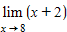
​
 | a.
 | b.
 | c.
 | d.
 | e. | none of the above

ANSWER: | a
POINTS: | 1
DIFFICULTY: | Easy
REFERENCES: | Section 1.2
QUESTION TYPE: | Multi-Mode (Multiple choice)
HAS VARIABLES: | True
LEARNING OBJECTIVES: | LCalc11.1.2.0 - Finding Limits Graphically and Numerically
OTHER: | Skill
DATE CREATED: | 1/11/2017 9:54 AM
DATE MODIFIED: | 1/11/2017 9:54 AM

13. Find the limit L.
​
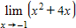
​
 | a.
 | b.
 | c.
 | d.
 | e. | none of the above

ANSWER: | d
POINTS: | 1
DIFFICULTY: | Easy
REFERENCES: | Section 1.2
QUESTION TYPE: | Multi-Mode (Multiple choice)
HAS VARIABLES: | True
LEARNING OBJECTIVES: | LCalc11.1.2.0 - Finding Limits Graphically and Numerically
OTHER: | Skill
DATE CREATED: | 1/11/2017 9:55 AM
DATE MODIFIED: | 1/11/2017 9:55 AM

14. What is the limit of as x approaches ?
​
 | a.
 | b.
 | c.
 | d.
 | e. | none of the above

ANSWER: | b
POINTS: | 1
DIFFICULTY: | Easy
REFERENCES: | Section 1.2
QUESTION TYPE: | Multi-Mode (Multiple choice)
HAS VARIABLES: | True
LEARNING OBJECTIVES: | LCalc11.1.2.0 - Finding Limits Graphically and Numerically
OTHER: | Skill
DATE CREATED: | 1/11/2017 9:55 AM
DATE MODIFIED: | 1/11/2017 9:55 AM

15. The graph of is shown in the figure. Find such that if , then .
​
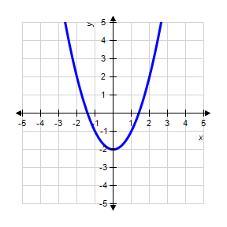
​
 | a.
 | b.
 | c.
 | d.
 | e. | None of the above

ANSWER: | a
POINTS: | 1
DIFFICULTY: | Medium
REFERENCES: | Section 1.2
QUESTION TYPE: | Multi-Mode (Multiple choice)
HAS VARIABLES: | True
LEARNING OBJECTIVES: | LCalc11.1.2.0 - Finding Limits Graphically and Numerically
OTHER: | Skill
DATE CREATED: | 1/11/2017 9:55 AM
DATE MODIFIED: | 1/11/2017 9:55 AM

1. ​Find the limit.
​
​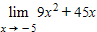
​
 | a. | ​405
 | b. | ​–180
 | c. | ​450
 | d. | ​–450
 | e. | ​0

ANSWER: | e
POINTS: | 1
QUESTION TYPE: | Multiple Choice
HAS VARIABLES: | True
DATE CREATED: | 1/11/2017 9:53 AM
DATE MODIFIED: | 1/11/2017 9:53 AM

2. Find the limit.
​
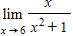
​
a.
b.
c.
d.
e.

ANSWER: | c
POINTS: | 1
DIFFICULTY: | Easy
REFERENCES: | Section 1.3
QUESTION TYPE: | Multi-Mode (Multiple choice)
HAS VARIABLES: | True
LEARNING OBJECTIVES: | CALC066 - Evaluate a limit using properties of limits
OTHER: | Skill
DATE CREATED: | 1/11/2017 9:53 AM
DATE MODIFIED: | 1/11/2017 9:53 AM

3. Find the limit. Round your answer to the whole number, if necessary.
​
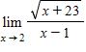
​
 | a. | 3
 | b. | –5
 | c. | –3
 | d. | 5
 | e. | 2

ANSWER: | d
POINTS: | 1
DIFFICULTY: | Medium
REFERENCES: | Section 1.3
QUESTION TYPE: | Multi-Mode (Multiple choice)
HAS VARIABLES: | True
LEARNING OBJECTIVES: | CALC066 - Evaluate a limit using properties of limits
OTHER: | Skill
DATE CREATED: | 1/11/2017 9:53 AM
DATE MODIFIED: | 1/11/2017 9:53 AM

4. ​Let and . Find the limit.
​
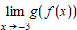
​
 | a. | ​100
 | b. | ​–27
 | c. | ​106
 | d. | ​1,000
 | e. | ​–8

ANSWER: | d
POINTS: | 1
QUESTION TYPE: | Multiple Choice
HAS VARIABLES: | True
DATE CREATED: | 1/11/2017 9:53 AM
DATE MODIFIED: | 1/11/2017 9:53 AM

5. ​Let and . Find the limit.
​
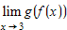
​
 | a. | ​
 | b. | ​
 | c. | ​
 | d. | ​
 | e. | ​

ANSWER: | b
POINTS: | 1
QUESTION TYPE: | Multiple Choice
HAS VARIABLES: | True
DATE CREATED: | 1/11/2017 9:53 AM
DATE MODIFIED: | 1/11/2017 9:53 AM

6. ​Let and . Find the limits.
​
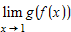​
​
 | a. | ​
 | b. | ​
 | c. | ​
 | d. | ​
 | e. | ​

ANSWER: | d
POINTS: | 1
QUESTION TYPE: | Multiple Choice
HAS VARIABLES: | True
DATE CREATED: | 1/11/2017 9:53 AM
DATE MODIFIED: | 1/11/2017 9:53 AM

7. Find the limit.
​
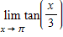
​
 | a.
 | b.
 | c.
 | d.
 | e. | does not exist

ANSWER: | b
POINTS: | 1
DIFFICULTY: | Medium
REFERENCES: | Section 1.3
QUESTION TYPE: | Multi-Mode (Multiple choice)
HAS VARIABLES: | True
LEARNING OBJECTIVES: | CALC068 - Evaluate the limit of the function
OTHER: | Skill
DATE CREATED: | 1/11/2017 9:53 AM
DATE MODIFIED: | 1/11/2017 9:53 AM

8. Find the limit.
​
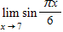
​
 | a.
 | b.
 | c.
 | d.
 | e. | 0

ANSWER: | b
POINTS: | 1
DIFFICULTY: | Easy
REFERENCES: | Section 1.3
QUESTION TYPE: | Multi-Mode (Multiple choice)
HAS VARIABLES: | True
LEARNING OBJECTIVES: | CALC066 - Evaluate a limit using properties of limits
OTHER: | Skill
DATE CREATED: | 1/11/2017 9:53 AM
DATE MODIFIED: | 1/11/2017 9:53 AM

9. Find the limit.
​
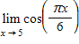
​
 | a.
 | b. | 0
 | c.
 | d.
 | e.

ANSWER: | d
POINTS: | 1
DIFFICULTY: | Medium
REFERENCES: | Section 1.3
QUESTION TYPE: | Multi-Mode (Multiple choice)
HAS VARIABLES: | True
LEARNING OBJECTIVES: | CALC066 - Evaluate a limit using properties of limits
OTHER: | Skill
DATE CREATED: | 1/11/2017 9:53 AM
DATE MODIFIED: | 1/11/2017 9:53 AM

10. Find the limit.
​
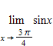
​
 | a.
 | b.
 | c.
 | d.
 | e. | does not exist

ANSWER: | d
POINTS: | 1
DIFFICULTY: | Medium
REFERENCES: | Section 1.3
QUESTION TYPE: | Multi-Mode (Multiple choice)
HAS VARIABLES: | True
LEARNING OBJECTIVES: | CALC066 - Evaluate a limit using properties of limits
OTHER: | Skill
DATE CREATED: | 1/11/2017 9:53 AM
DATE MODIFIED: | 1/11/2017 9:53 AM

11. Suppose that 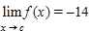 and 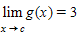. Find the following limit.
​
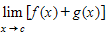
​
 | a. | 0
 | b. | 3
 | c. | –17
 | d. | –11
 | e. | –42

ANSWER: | d
POINTS: | 1
DIFFICULTY: | Medium
REFERENCES: | Section 1.3
QUESTION TYPE: | Multi-Mode (Multiple choice)
HAS VARIABLES: | True
LEARNING OBJECTIVES: | CALC069 - Evaluate the limit of a function using properties of limits
OTHER: | Skill
DATE CREATED: | 1/11/2017 9:53 AM
DATE MODIFIED: | 1/11/2017 9:53 AM

12. Suppose that 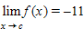 and 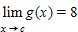. Find the following limit.
​
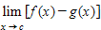
​
 | a. | –11
 | b. | –19
 | c. | –88
 | d. | ​–3
 | e. | 0

ANSWER: | b
POINTS: | 1
DIFFICULTY: | Medium
REFERENCES: | Section 1.3
QUESTION TYPE: | Multi-Mode (Multiple choice)
HAS VARIABLES: | True
LEARNING OBJECTIVES: | CALC069 - Evaluate the limit of a function using properties of limits
OTHER: | Skill
DATE CREATED: | 1/11/2017 9:53 AM
DATE MODIFIED: | 1/11/2017 9:53 AM

13. Suppose that 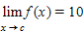 and 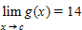. Find the following limit.
​
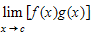
​
 | a. | –14
 | b. | –4
 | c. | 24
 | d. | 10
 | e. | 140

ANSWER: | e
POINTS: | 1
DIFFICULTY: | Medium
REFERENCES: | Section 1.3
QUESTION TYPE: | Multi-Mode (Multiple choice)
HAS VARIABLES: | True
LEARNING OBJECTIVES: | CALC069 - Evaluate the limit of a function using properties of limits
OTHER: | Skill
DATE CREATED: | 1/11/2017 9:53 AM
DATE MODIFIED: | 1/11/2017 9:53 AM

14. Suppose that 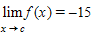​ and 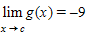. Find the following limit.
​
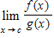
​
 | a. | ​135
 | b. | ​
 | c. | ​–135
 | d. | ​
 | e. | ​does not exist

ANSWER: | d
POINTS: | 1
QUESTION TYPE: | Multiple Choice
HAS VARIABLES: | True
DATE CREATED: | 1/11/2017 9:53 AM
DATE MODIFIED: | 1/11/2017 9:53 AM

15. Suppose that 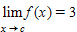. Find the following limit.
​
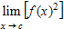
​
 | a. | 1
 | b. | 9
 | c. | 5
 | d. | 0
 | e. | 6

ANSWER: | b
POINTS: | 1
DIFFICULTY: | Medium
REFERENCES: | Section 1.3
QUESTION TYPE: | Multi-Mode (Multiple choice)
HAS VARIABLES: | True
LEARNING OBJECTIVES: | CALC069 - Evaluate the limit of a function using properties of limits
OTHER: | Skill
DATE CREATED: | 1/11/2017 9:53 AM
DATE MODIFIED: | 1/11/2017 9:53 AM

16. Suppose that . Find the following limit.
​
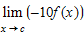
​
 | a. | 3
 | b. | 30
 | c. | –30
 | d.
 | e. | –10

ANSWER: | c
POINTS: | 1
DIFFICULTY: | Medium
REFERENCES: | Section 1.3
QUESTION TYPE: | Multi-Mode (Multiple choice)
HAS VARIABLES: | True
LEARNING OBJECTIVES: | CALC069 - Evaluate the limit of a function using properties of limits
OTHER: | Skill
DATE CREATED: | 1/11/2017 9:53 AM
DATE MODIFIED: | 1/11/2017 9:53 AM

17. ​Find the following limit (if it exists). Write a simpler function that agrees with the given function at all but one point.
​
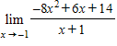
​
 | a. | ​6
 | b. | ​22
 | c. | ​–22
 | d. | ​–6
 | e. | ​does not exist

ANSWER: | b
POINTS: | 1
QUESTION TYPE: | Multiple Choice
HAS VARIABLES: | True
DATE CREATED: | 1/11/2017 9:53 AM
DATE MODIFIED: | 1/11/2017 9:53 AM

18. ​Find the limit (if it exists).
​
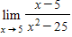
​
 | a. | ​
 | b. | ​
 | c. | ​20
 | d. | ​5
 | e. | ​

ANSWER: | a
POINTS: | 1
QUESTION TYPE: | Multiple Choice
HAS VARIABLES: | True
DATE CREATED: | 1/11/2017 9:53 AM
DATE MODIFIED: | 1/11/2017 9:53 AM

19. Find the limit (if it exists).
​
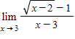
​
 | a. | 2
 | b. | 1
 | c. | 0
 | d.
 | e. | Limit does not exist

ANSWER: | d
POINTS: | 1
DIFFICULTY: | Medium
REFERENCES: | Section 1.3
QUESTION TYPE: | Multi-Mode (Multiple choice)
HAS VARIABLES: | True
LEARNING OBJECTIVES: | CALC071 - Evaluate the limit of a function analytically
OTHER: | Skill
DATE CREATED: | 1/11/2017 9:53 AM
DATE MODIFIED: | 1/11/2017 9:53 AM

20. ​Find the limit (if it exists).
​
​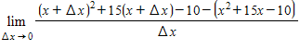
​
 | a. | ​
 | b. | ​
 | c. | ​
 | d. | ​
 | e. | ​does not exist

ANSWER: | b
POINTS: | 1
QUESTION TYPE: | Multiple Choice
HAS VARIABLES: | True
DATE CREATED: | 1/11/2017 9:53 AM
DATE MODIFIED: | 1/11/2017 9:53 AM

21. Determine the limit (if it exists).
​
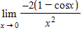
​
 | a. | –1
 | b. | –8
 | c. | 3
 | d. | –4
 | e. | does not exist

ANSWER: | a
POINTS: | 1
DIFFICULTY: | Medium
REFERENCES: | Section 1.3
QUESTION TYPE: | Multi-Mode (Multiple choice)
HAS VARIABLES: | True
LEARNING OBJECTIVES: | CALC071 - Evaluate the limit of a function analytically
OTHER: | Skill
DATE CREATED: | 1/11/2017 9:53 AM
DATE MODIFIED: | 1/11/2017 9:53 AM

22. Determine the limit (if it exists).
​
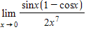
​
 | a. | 7
 | b. | 1
 | c. | 0
 | d. | 2
 | e. | does not exist

ANSWER: | e
POINTS: | 1
DIFFICULTY: | Medium
REFERENCES: | Section 1.3
QUESTION TYPE: | Multi-Mode (Multiple choice)
HAS VARIABLES: | True
LEARNING OBJECTIVES: | CALC071 - Evaluate the limit of a function analytically
OTHER: | Skill
DATE CREATED: | 1/11/2017 9:53 AM
DATE MODIFIED: | 1/11/2017 9:53 AM

23. Determine the limit (if it exists).
​
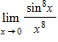
​
 | a. | 0
 | b. | 1
 | c. | 2
 | d.
 | e. | does not exist

ANSWER: | b
POINTS: | 1
DIFFICULTY: | Medium
REFERENCES: | Section 1.3
QUESTION TYPE: | Multi-Mode (Multiple choice)
HAS VARIABLES: | True
LEARNING OBJECTIVES: | CALC071 - Evaluate the limit of a function analytically
OTHER: | Skill
DATE CREATED: | 1/11/2017 9:53 AM
DATE MODIFIED: | 1/11/2017 9:53 AM

24. Find 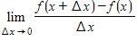where .
​
 | a. | 1
 | b. | 2
 | c. | –2
 | d. | 0
 | e. | Limit does not exist

ANSWER: | b
POINTS: | 1
DIFFICULTY: | Medium
REFERENCES: | Section 1.3
QUESTION TYPE: | Multi-Mode (Multiple choice)
HAS VARIABLES: | True
LEARNING OBJECTIVES: | CALC072 - Evaluate the limit of a difference quotient
OTHER: | Skill
DATE CREATED: | 1/11/2017 9:53 AM
DATE MODIFIED: | 1/11/2017 9:53 AM

1. Use the graph as shown to determine the following limits, and discuss the continuity of the function at .
​
(i) 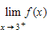 (ii) 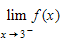 (iii) 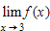
​
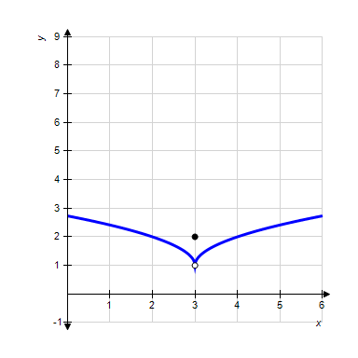
​
 | a. | 1, 1, 2, not continuous
 | b. | 2, 2, 2, continuous
 | c. | 4, 4, 4, not continuous
 | d. | 2, 2, 2, not continuous
 | e. | 1, 1, 2, continuous

ANSWER: | a
POINTS: | 1
DIFFICULTY: | Medium
REFERENCES: | Section 1.4
QUESTION TYPE: | Multi-Mode (Multiple choice)
HAS VARIABLES: | True
LEARNING OBJECTIVES: | CALC073 - Estimate a limit and points of discontinuity from a graph
OTHER: | Skill
DATE CREATED: | 1/11/2017 9:51 AM
DATE MODIFIED: | 1/11/2017 9:51 AM

2. Use the graph as shown to determine the following limits, and discuss the continuity of the function at .
​
(i) 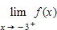 (ii) 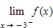 (iii) 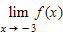
​
​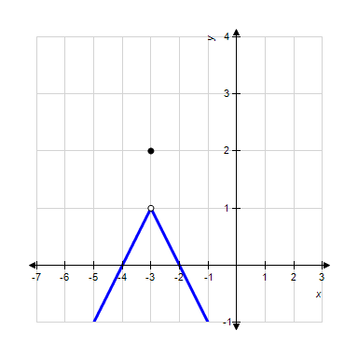
​
 | a. | 2, 2, 2, continuous
 | b. | 1, 1, 2, not continuous
 | c. | 2, 2, 2, not continuous
 | d. | –3, –3, –3, continuous
 | e. | 1, 1, 2, continuous

ANSWER: | b
POINTS: | 1
DIFFICULTY: | Medium
REFERENCES: | Section 1.4
QUESTION TYPE: | Multi-Mode (Multiple choice)
HAS VARIABLES: | True
LEARNING OBJECTIVES: | CALC073 - Estimate a limit and points of discontinuity from a graph
OTHER: | Skill
DATE CREATED: | 1/11/2017 9:51 AM
DATE MODIFIED: | 1/11/2017 9:51 AM

3. Use the graph to determine the following limits, and discuss the continuity of the function at .
​
(i) (ii) (iii)
​
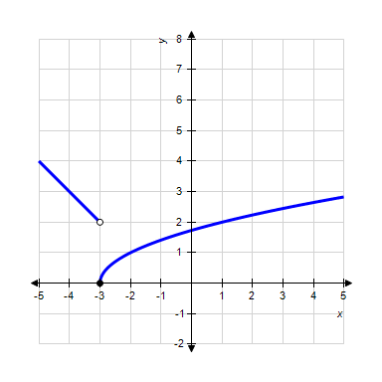
​
 | a. | 2, –2, does not exist, not continuous
 | b. | 2, 0, does not exist, not continuous
 | c. | 0, 2, 0, not continuous
 | d. | –3, 0, does not exist, not continuous
 | e. | ​0, 2, 0, continuous

ANSWER: | c
POINTS: | 1
DIFFICULTY: | Medium
REFERENCES: | Section 1.4
QUESTION TYPE: | Multi-Mode (Multiple choice)
HAS VARIABLES: | True
LEARNING OBJECTIVES: | CALC073 - Estimate a limit and points of discontinuity from a graph
OTHER: | Skill
DATE CREATED: | 1/11/2017 9:51 AM
DATE MODIFIED: | 1/11/2017 9:51 AM

4. Find the limit (if it exists).
​
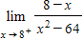
​
 | a.
 | b. | 0
 | c. | Limit does not exist.
 | d.
 | e.

ANSWER: | d
POINTS: | 1
DIFFICULTY: | Easy
REFERENCES: | Section 1.4
QUESTION TYPE: | Multi-Mode (Multiple choice)
HAS VARIABLES: | True
LEARNING OBJECTIVES: | CALC074 - Evaluate one-sided limits
OTHER: | Skill
DATE CREATED: | 1/11/2017 9:51 AM
DATE MODIFIED: | 1/11/2017 9:51 AM

5. Find the limit (if it exists).
​
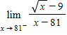
​
 | a. | 0
 | b.
 | c.
 | d.
 | e. | Limit does not exist.

ANSWER: | d
POINTS: | 1
DIFFICULTY: | Medium
REFERENCES: | Section 1.4
QUESTION TYPE: | Multi-Mode (Multiple choice)
HAS VARIABLES: | True
LEARNING OBJECTIVES: | CALC074 - Evaluate one-sided limits
OTHER: | Skill
DATE CREATED: | 1/11/2017 9:51 AM
DATE MODIFIED: | 1/11/2017 9:51 AM

6. Find the limit (if it exists).
​
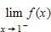, where 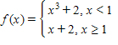
​
 | a. | Limit does not exist.
 | b. | 0
 | c. | 2
 | d. | 3
 | e. | 6

ANSWER: | d
POINTS: | 1
DIFFICULTY: | Medium
REFERENCES: | Section 1.4
QUESTION TYPE: | Multi-Mode (Multiple choice)
HAS VARIABLES: | True
LEARNING OBJECTIVES: | CALC074 - Evaluate one-sided limits
OTHER: | Skill
DATE CREATED: | 1/11/2017 9:51 AM
DATE MODIFIED: | 1/11/2017 9:51 AM

7. Find the limit (if it exists). Note that represents the greatest integer function.
​
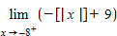
​
 | a. | 18
 | b. | –17
 | c. | 17
 | d. | –18
 | e. | does not exist

ANSWER: | c
POINTS: | 1
DIFFICULTY: | Medium
REFERENCES: | Section 1.4
QUESTION TYPE: | Multi-Mode (Multiple choice)
HAS VARIABLES: | True
LEARNING OBJECTIVES: | CALC074 - Evaluate one-sided limits
OTHER: | Skill
DATE CREATED: | 1/11/2017 9:51 AM
DATE MODIFIED: | 1/11/2017 9:51 AM

8. Find the limit (if it exists). Note that represents the greatest integer function.
​
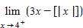
​
 | a. | 9
 | b. | Limit does not exist.
 | c. | 8
 | d. | 0
 | e. | 7

ANSWER: | c
POINTS: | 1
DIFFICULTY: | Medium
REFERENCES: | Section 1.4
QUESTION TYPE: | Multi-Mode (Multiple choice)
HAS VARIABLES: | True
LEARNING OBJECTIVES: | CALC074 - Evaluate one-sided limits
OTHER: | Skill
DATE CREATED: | 1/11/2017 9:51 AM
DATE MODIFIED: | 1/11/2017 9:51 AM

9. Discuss the continuity of the function 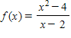.
​
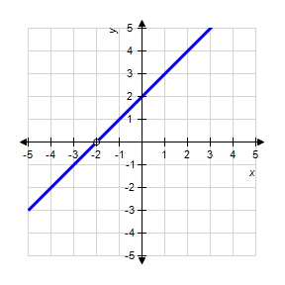
​
 | a. | is discontinuous at .
 | b. | is discontinuous at .
 | c. | is discontinuous at .
 | d. | is continuous for all real .
 | e. | is continuous at .

ANSWER: | c
POINTS: | 1
DIFFICULTY: | Easy
REFERENCES: | Section 1.4
QUESTION TYPE: | Multi-Mode (Multiple choice)
HAS VARIABLES: | True
LEARNING OBJECTIVES: | CALC075 - Identify the discontinuities of a function if any exist
OTHER: | Skill
DATE CREATED: | 1/11/2017 9:51 AM
DATE MODIFIED: | 1/11/2017 9:51 AM

10. Find the x-values (if any) at which the function is not continuous. Which of the discontinuities are removable?
​
 | a. | , removable
 | b. | , removable
 | c. | , not removable
 | d. | continuous everywhere
 | e. | , not removable

ANSWER: | d
POINTS: | 1
DIFFICULTY: | Medium
REFERENCES: | Section 1.4
QUESTION TYPE: | Multi-Mode (Multiple choice)
HAS VARIABLES: | True
LEARNING OBJECTIVES: | CALC076 - Identify the removable discontinuities of a function
OTHER: | Skill
DATE CREATED: | 1/11/2017 9:51 AM
DATE MODIFIED: | 1/11/2017 9:51 AM

11. Find the x-values (if any) at which 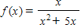 is not continuous.
​
 | a. | is not continuous at and has a removable discontinuity at .
 | b. | is not continuous at and both the discontinuities are nonremovable.
 | c. | is not continuous at and has a removable discontinuity at .
 | d. | is not continuous at and has a removable discontinuity at .
 | e. | is continuous for all real .

ANSWER: | d
POINTS: | 1
DIFFICULTY: | Easy
REFERENCES: | Section 1.4
QUESTION TYPE: | Multi-Mode (Multiple choice)
HAS VARIABLES: | True
LEARNING OBJECTIVES: | CALC076 - Identify the removable discontinuities of a function
OTHER: | Skill
DATE CREATED: | 1/11/2017 9:51 AM
DATE MODIFIED: | 1/11/2017 9:51 AM

12. Find the x-values (if any) at which the function 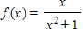 is not continuous. Which of the discontinuities are removable?
​
 | a. | discontinuous everywhere 000
 | b. | 1 and - , removable
 | c. | 1 and - , not removable
 | d. | continuous everywhere 000
 | e. | 0, removable

ANSWER: | d
POINTS: | 1
DIFFICULTY: | Medium
REFERENCES: | Section 1.4
QUESTION TYPE: | Multi-Mode (Multiple choice)
HAS VARIABLES: | True
LEARNING OBJECTIVES: | CALC076 - Identify the removable discontinuities of a function
OTHER: | Skill
DATE CREATED: | 1/11/2017 9:51 AM
DATE MODIFIED: | 1/11/2017 9:51 AM

13. Find the x-values (if any) at which the function 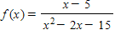 is not continuous. Which of the discontinuities are removable?
​
 | a. | no points of discontinuity
 | b. | (not removable), (removable)
 | c. | (removable), (not removable)
 | d. | no points of continuity
 | e. | (not removable), (not removable)

ANSWER: | c
POINTS: | 1
DIFFICULTY: | Medium
REFERENCES: | Section 1.4
QUESTION TYPE: | Multi-Mode (Multiple choice)
HAS VARIABLES: | True
LEARNING OBJECTIVES: | CALC076 - Identify the removable discontinuities of a function
OTHER: | Skill
DATE CREATED: | 1/11/2017 9:51 AM
DATE MODIFIED: | 1/11/2017 9:51 AM

14. Find the x-values (if any) at which 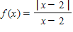 is not continuous.
​
 | a. | is not continuous at and the discontinuity is nonremovable.
 | b. | is not continuous at and the discontinuity is removable.
 | c. | is continuous for all real .
 | d. | is not continuous at and the discontinuity is removable.
 | e. | is not continuous at and is a removable discontinuity.

ANSWER: | a
POINTS: | 1
DIFFICULTY: | Medium
REFERENCES: | Section 1.4
QUESTION TYPE: | Multi-Mode (Multiple choice)
HAS VARIABLES: | True
LEARNING OBJECTIVES: | CALC076 - Identify the removable discontinuities of a function
OTHER: | Skill
DATE CREATED: | 1/11/2017 9:51 AM
DATE MODIFIED: | 1/11/2017 9:51 AM

15. Find the constant a such that the function
​
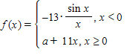
​
is continuous on the entire real line.
​
 | a. | 1
 | b. | –11
 | c. | 11
 | d. | 13
 | e. | –13

ANSWER: | e
POINTS: | 1
DIFFICULTY: | Medium
REFERENCES: | Section 1.4
QUESTION TYPE: | Multi-Mode (Multiple choice)
HAS VARIABLES: | True
LEARNING OBJECTIVES: | CALC077 - Identify the value of a parameter to ensure a function is continuous
OTHER: | Skill
DATE CREATED: | 1/11/2017 9:51 AM
DATE MODIFIED: | 1/11/2017 9:51 AM

16. Find the constants a and b such that the function
​
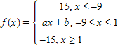
​
is continuous on the entire real line.
​
 | a. | ,
 | b. | ,
 | c. | ,
 | d. | ,
 | e. | ,

ANSWER: | c
POINTS: | 1
DIFFICULTY: | Medium
REFERENCES: | Section 1.4
QUESTION TYPE: | Multi-Mode (Multiple choice)
HAS VARIABLES: | True
LEARNING OBJECTIVES: | CALC077 - Identify the value of a parameter to ensure a function is continuous
OTHER: | Skill
DATE CREATED: | 1/11/2017 9:51 AM
DATE MODIFIED: | 1/11/2017 9:51 AM

17. Find the value of c guaranteed by the Intermediate Value Theorem.
​
, ,
​
 | a. | 1
 | b. | 5
 | c. | 7
 | d. | 2
 | e. | 6

ANSWER: | b
POINTS: | 1
DIFFICULTY: | Easy
REFERENCES: | Section 1.4
QUESTION TYPE: | Multi-Mode (Multiple choice)
HAS VARIABLES: | True
LEARNING OBJECTIVES: | CALC078 - Identify the value of c guaranteed by the Intermediate Value Theorem
OTHER: | Skill
DATE CREATED: | 1/11/2017 9:51 AM
DATE MODIFIED: | 1/11/2017 9:51 AM

18. Find the value of c guaranteed by the Intermediate Value Theorem.
​
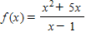, 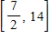,
​
 | a. | 9
 | b. | 2
 | c. | 1
 | d. | 7
 | e. | 8

ANSWER: | d
POINTS: | 1
DIFFICULTY: | Medium
REFERENCES: | Section 1.4
QUESTION TYPE: | Multi-Mode (Multiple choice)
HAS VARIABLES: | True
LEARNING OBJECTIVES: | CALC078 - Identify the value of c guaranteed by the Intermediate Value Theorem
OTHER: | Skill
DATE CREATED: | 1/11/2017 9:51 AM
DATE MODIFIED: | 1/11/2017 9:51 AM

19. A long distance phone service charges $0.55 for the first 8 minutes and $0.05 for each additional minute or fraction thereof. Use the greatest integer function to write the cost C of a call in terms of time t (in minutes).
​
a.
b.
c.
d.
e.

ANSWER: | e
POINTS: | 1
DIFFICULTY: | Medium
REFERENCES: | Section 1.4
QUESTION TYPE: | Multi-Mode (Multiple choice)
HAS VARIABLES: | True
LEARNING OBJECTIVES: | CALC038 - Create functions in applications
OTHER: | Application
DATE CREATED: | 1/11/2017 9:51 AM
DATE MODIFIED: | 1/11/2017 9:51 AM

20. Find all values of c such that is continuous on .
​
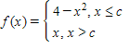
​
 | a.
 | b.
 | c.
 | d. | ,
 | e. | ,

ANSWER: | e
POINTS: | 1
DIFFICULTY: | Medium
REFERENCES: | Section 1.4
QUESTION TYPE: | Multi-Mode (Multiple choice)
HAS VARIABLES: | True
LEARNING OBJECTIVES: | CALC077 - Identify the value of a parameter to ensure a function is continuous
OTHER: | Skill
DATE CREATED: | 1/11/2017 9:51 AM
DATE MODIFIED: | 1/11/2017 9:51 AM

1. Determine whether 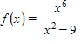 approaches or as x approaches from the left and from the right by completing the tables below.
 | –3.5 | –3.1 | –3.01 | –3.001
​
 | –2.999 | –2.99 | –2.9 | –2.5
​
 | a. | ,
 | b. | ,
 | c. | ​,
 | d. | ​,

ANSWER: | b
POINTS: | 1
DIFFICULTY: | Medium
REFERENCES: | Section 1.5
QUESTION TYPE: | Multi-Mode (Multiple choice)
HAS VARIABLES: | True
LEARNING OBJECTIVES: | CALC079 - Evaluate an infinite limit from a table of values
OTHER: | Skill
DATE CREATED: | 1/11/2017 9:49 AM
DATE MODIFIED: | 1/11/2017 9:49 AM

2. Find all the vertical asymptotes (if any) of the graph of the function 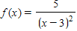.
​
 | a.
 | b.
 | c.
 | d.
 | e. | no vertical asymptotes

ANSWER: | d
POINTS: | 1
DIFFICULTY: | Easy
REFERENCES: | Section 1.5
QUESTION TYPE: | Multi-Mode (Multiple choice)
HAS VARIABLES: | True
LEARNING OBJECTIVES: | CALC080 - Identify the vertical asymptotes (if any) of the graph of a function
OTHER: | Skill
DATE CREATED: | 1/11/2017 9:49 AM
DATE MODIFIED: | 1/11/2017 9:49 AM

3. Find the vertical asymptotes (if any) of the function 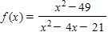.
​
 | a.
 | b.
 | c. | ​
 | d.
 | e.

ANSWER: | b
POINTS: | 1
DIFFICULTY: | Medium
REFERENCES: | Section 1.5
QUESTION TYPE: | Multi-Mode (Multiple choice)
HAS VARIABLES: | True
LEARNING OBJECTIVES: | CALC080 - Identify the vertical asymptotes (if any) of the graph of a function
OTHER: | Skill
DATE CREATED: | 1/11/2017 9:49 AM
DATE MODIFIED: | 1/11/2017 9:49 AM

4. Find all the vertical asymptotes (if any) of the graph of the function 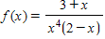.
​
 | a.
 | b.
 | c.
 | d. | ,
 | e. | no vertical asymptotes

ANSWER: | d
POINTS: | 1
DIFFICULTY: | Medium
REFERENCES: | Section 1.5
QUESTION TYPE: | Multi-Mode (Multiple choice)
HAS VARIABLES: | True
LEARNING OBJECTIVES: | CALC080 - Identify the vertical asymptotes (if any) of the graph of a function
OTHER: | Skill
DATE CREATED: | 1/11/2017 9:49 AM
DATE MODIFIED: | 1/11/2017 9:49 AM

5. Find all the vertical asymptotes (if any) of the graph of the function 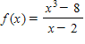.
​
 | a.
 | b.
 | c.
 | d.
 | e. | no vertical asymptotes

ANSWER: | e
POINTS: | 1
DIFFICULTY: | Medium
REFERENCES: | Section 1.5
QUESTION TYPE: | Multi-Mode (Multiple choice)
HAS VARIABLES: | True
LEARNING OBJECTIVES: | CALC080 - Identify the vertical asymptotes (if any) of the graph of a function
OTHER: | Skill
DATE CREATED: | 1/11/2017 9:49 AM
DATE MODIFIED: | 1/11/2017 9:49 AM

6. Find all vertical asymptotes (if any) of the function 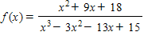.
​
a.
b.
c.
d.
e.

ANSWER: | a
POINTS: | 1
DIFFICULTY: | Medium
REFERENCES: | Section 1.5
QUESTION TYPE: | Multi-Mode (Multiple choice)
HAS VARIABLES: | True
LEARNING OBJECTIVES: | CALC080 - Identify the vertical asymptotes (if any) of the graph of a function
OTHER: | Skill
DATE CREATED: | 1/11/2017 9:49 AM
DATE MODIFIED: | 1/11/2017 9:49 AM

7. Find the vertical asymptotes (if any) of the function .
​
 | a.
 | b.
 | c.
 | d.
 | e. | no vertical asymptotes

ANSWER: | b
POINTS: | 1
DIFFICULTY: | Medium
REFERENCES: | Section 1.5
QUESTION TYPE: | Multi-Mode (Multiple choice)
HAS VARIABLES: | True
LEARNING OBJECTIVES: | CALC080 - Identify the vertical asymptotes (if any) of the graph of a function
OTHER: | Skill
DATE CREATED: | 1/11/2017 9:49 AM
DATE MODIFIED: | 1/11/2017 9:49 AM

8. Find the limit.
​
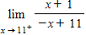
​
 | a. | 1
 | b.
 | c. | 0
 | d.
 | e. | –1

ANSWER: | d
POINTS: | 1
DIFFICULTY: | Medium
REFERENCES: | Section 1.5
QUESTION TYPE: | Multi-Mode (Multiple choice)
HAS VARIABLES: | True
LEARNING OBJECTIVES: | CALC074 - Evaluate one-sided limits
OTHER: | Skill
DATE CREATED: | 1/11/2017 9:49 AM
DATE MODIFIED: | 1/11/2017 9:49 AM

9. Find the limit.
​
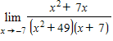
​
 | a.
 | b.
 | c. | 14
 | d. | –7
 | e. | –14

ANSWER: | b
POINTS: | 1
DIFFICULTY: | Medium
REFERENCES: | Section 1.5
QUESTION TYPE: | Multi-Mode (Multiple choice)
HAS VARIABLES: | True
LEARNING OBJECTIVES: | CALC081 - Evaluate the limit of a function
OTHER: | Skill
DATE CREATED: | 1/11/2017 9:49 AM
DATE MODIFIED: | 1/11/2017 9:49 AM

10. Find the limit.
​
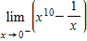
​
 | a. | 1
 | b. | 0
 | c.
 | d.
 | e.

ANSWER: | e
POINTS: | 1
DIFFICULTY: | Medium
REFERENCES: | Section 1.5
QUESTION TYPE: | Multi-Mode (Multiple choice)
HAS VARIABLES: | True
LEARNING OBJECTIVES: | CALC074 - Evaluate one-sided limits
OTHER: | Skill
DATE CREATED: | 1/11/2017 9:49 AM
DATE MODIFIED: | 1/11/2017 9:49 AM

11. Find the limit (if it exists).
​
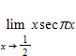
​
 | a.
 | b.
 | c. | 0
 | d.
 | e. | Limit does not exist

ANSWER: | e
POINTS: | 1
DIFFICULTY: | Medium
REFERENCES: | Section 1.5
QUESTION TYPE: | Multi-Mode (Multiple choice)
HAS VARIABLES: | True
LEARNING OBJECTIVES: | CALC082 - Identify a limit that does not exist
OTHER: | Skill
DATE CREATED: | 1/11/2017 9:50 AM
DATE MODIFIED: | 1/11/2017 9:50 AM

12. Use a graphing utility to graph the function 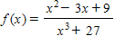 and determine the one-sided limit 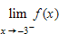.
​
 | a.
 | b.
 | c. | 0
 | d. | 27
 | e. | 18

ANSWER: | b
POINTS: | 1
DIFFICULTY: | Medium
REFERENCES: | Section 1.5
QUESTION TYPE: | Multi-Mode (Multiple choice)
HAS VARIABLES: | True
LEARNING OBJECTIVES: | CALC083 - Estimate one-sided limits from a graph
OTHER: | Skill
DATE CREATED: | 1/11/2017 9:50 AM
DATE MODIFIED: | 1/11/2017 9:50 AM

13. Use a graphing utility to graph the function 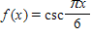 and determine the following one-sided limit.
​
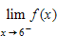
​
 | a.
 | b. | 6
 | c. | –6
 | d.
 | e. | 0

ANSWER: | d
POINTS: | 1
DIFFICULTY: | Medium
REFERENCES: | Section 1.5
QUESTION TYPE: | Multi-Mode (Multiple choice)
HAS VARIABLES: | True
LEARNING OBJECTIVES: | CALC083 - Estimate one-sided limits from a graph
OTHER: | Skill
DATE CREATED: | 1/11/2017 9:50 AM
DATE MODIFIED: | 1/11/2017 9:50 AM

14. A 25-foot ladder is leaning against a house (see figure). If the base of the ladder is pulled away from the house at a rate of 2 feet per second, the top will move down the wall at a rate of 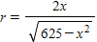 ft/sec, where x is the distance between the base of the ladder and the house. Find the rate r when x is 24 feet.
​
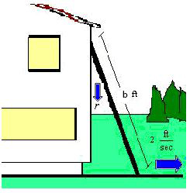
​
 | a. | r = ft/sec
 | b. | r = ft/sec
 | c. | ft/sec
 | d. | r = ft/sec
 | e. | r = ft/sec

ANSWER: | a
POINTS: | 1
DIFFICULTY: | Easy
REFERENCES: | Section 1.5
QUESTION TYPE: | Multi-Mode (Multiple choice)
HAS VARIABLES: | True
LEARNING OBJECTIVES: | CALC084 - Evaluate functions in applications
OTHER: | Application
DATE CREATED: | 1/11/2017 9:50 AM
DATE MODIFIED: | 1/11/2017 9:50 AM

15. A 30-foot ladder is leaning against a house (see figure). If the base of the ladder is pulled away from the house at a rate of 2 feet per second, the top will move down the wall at a rate of 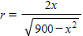 ft/sec, where x is the distance between the base of the ladder and the house. Find the limit of r as .
​
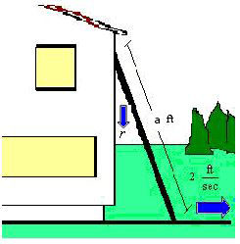
​
 | a.
 | b. | 60
 | c. | 0
 | d.
 | e. | 30

ANSWER: | d
POINTS: | 1
DIFFICULTY: | Medium
REFERENCES: | Section 1.5
QUESTION TYPE: | Multi-Mode (Multiple choice)
HAS VARIABLES: | True
LEARNING OBJECTIVES: | CALC085 - Evaluate limits in applications
OTHER: | Application
DATE CREATED: | 1/11/2017 9:50 AM
DATE MODIFIED: | 1/11/2017 9:50 AM

